Media Kit
Fill this out and send it back. Don't overthink it. Short answers are fine. We'll handle the writing.
THE BASICS
Name
Sam Hamer
City
St. Louis
Email for the contact form on your site and to confirm your Netlify Account
samhamer33@gmail.com
Niche / What you post about AND your tag line e.g. Health & Wellness, Tech, Fashion, Fitness
Home and Lifestyle
Your tag line e.g. “Dream content that actually sells”
Finding products that help you with daily life
YOUR ACCOUNTS - TikTok Youtube Instagram (SCREEN SHOTS OK!)
For each account: handle, follower count, like count, and whether it's active or a former account.
Account 1 @handle | followers | likes | active or forme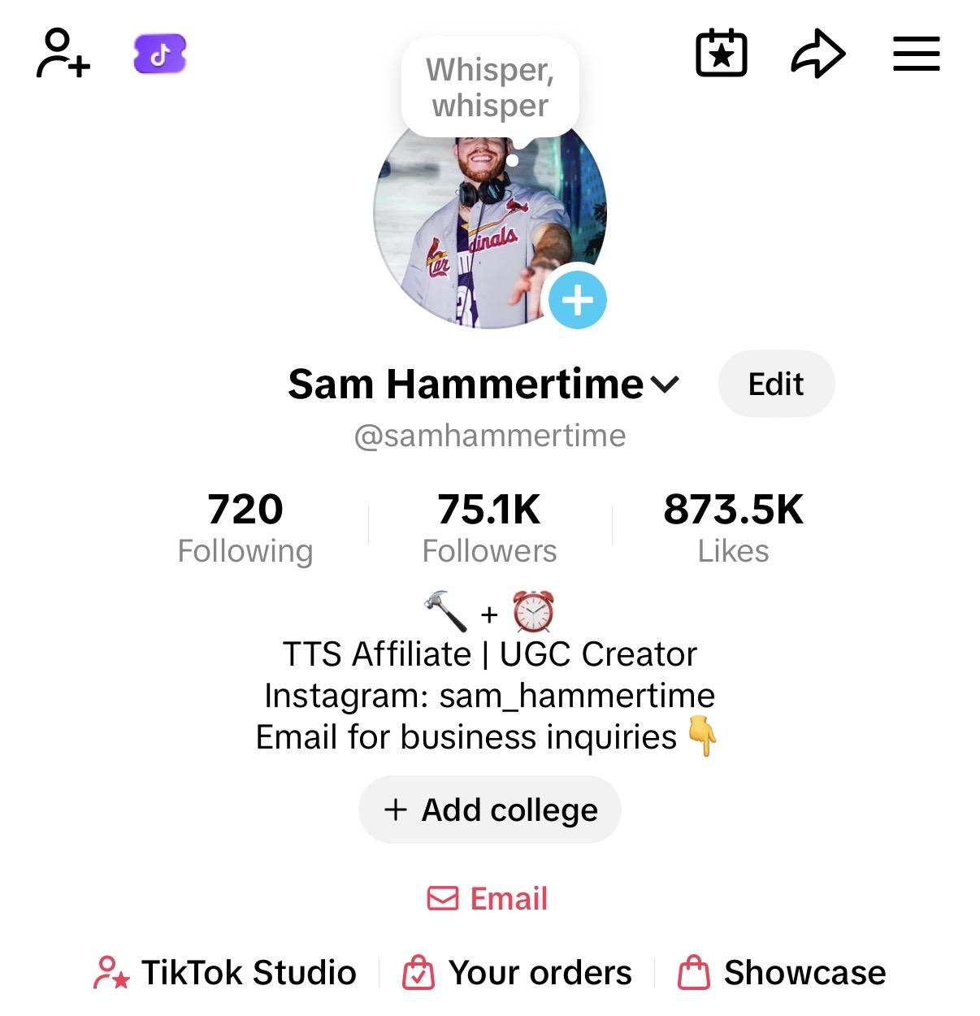
Account 2 @handle | followers | likes | active or former
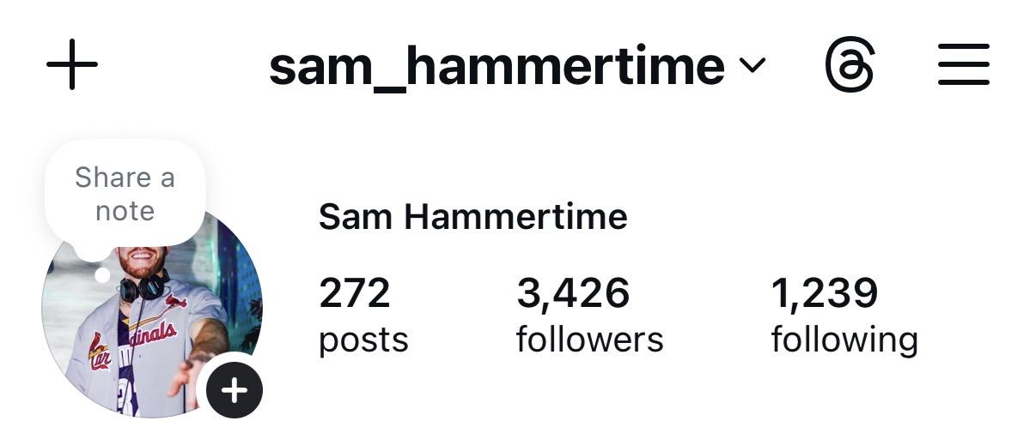
Account 3 @handle | followers | likes | active or former
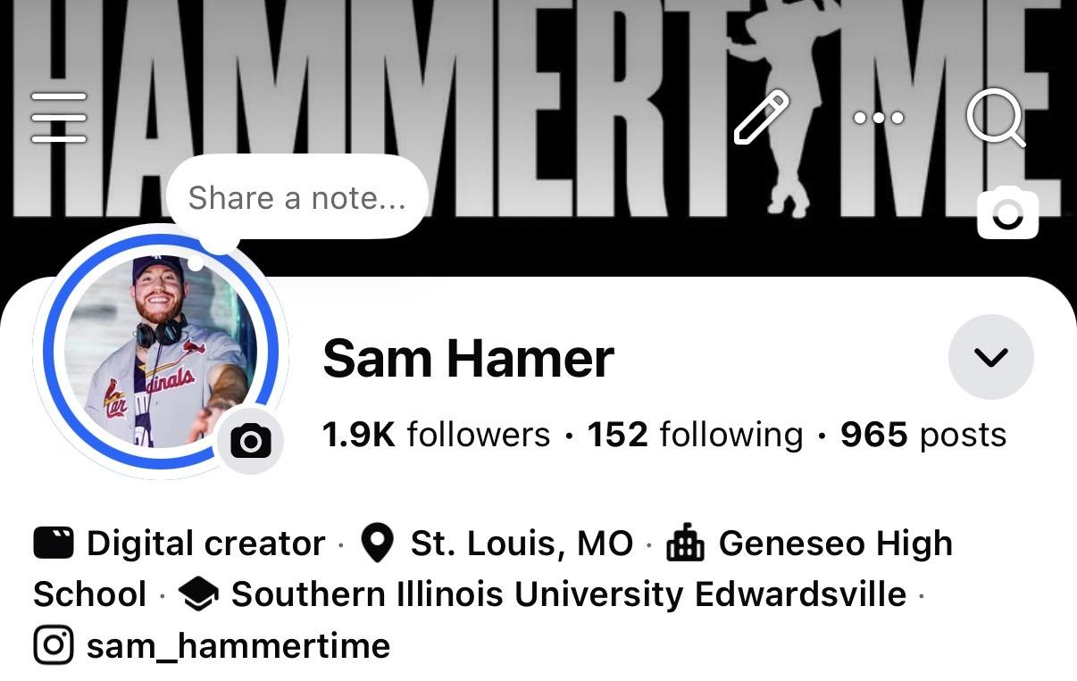
Account 4 @handle | followers | likes | active or former
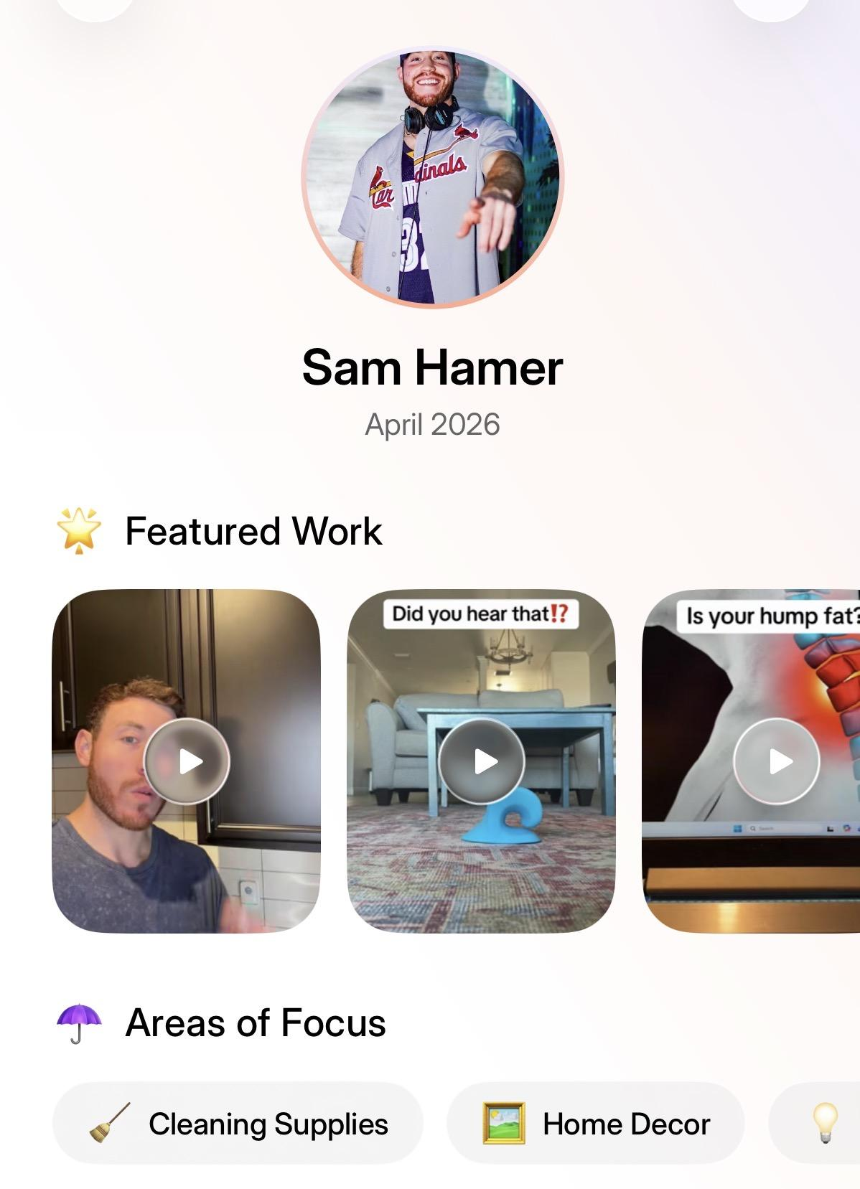
Add more:
VIDEOS (PICK YOUR BEST 4-5)
Copy the full URL from the address bar and paste below. (SCREEN SHOTS OK!)
Video 1
https://www.tiktok.com/@samhammertime/video/7618443652834102542
Video 2
https://www.tiktok.com/@samhammertime/video/7633258617201872142
Video 3
https://www.tiktok.com/@samhammertime/video/7609107076014476557
Video 4
https://www.tiktok.com/@samhammertime/video/7611392267680550158
Video 5
https://www.tiktok.com/@samhammertime/video/7609942995110022413
YOUR JOURNEY (5 BULLET POINTS, ROUGH DATES ARE FINE)
Just tell us what happened and when. e.g. "Early 2023 — started first account." We'll write it up.
Milestone 1
Started social media content in 2012. I’ve created on Vine, Facebook, YouTube, Instagram, and TikTok
Milestone 2
Generated millions of views and viral videos on Instagram and TikTok
Milestone 3
Generated over 23.5K GMV my first two months on TikTok Shop
Milestone 4
Generated over 75K followers on TikTok
Milestone 5
Snoop Dogg reposted a video of mine onto his Instagram page

YOUR STYLE
Favorite color(s) used as the accent color throughout the site
Black, neutral colors
Vibe e.g. Dark & moody, Clean & minimal, Bold, Streetwear, Professional
Clean, bold, professional
Any other links to include? Instagram, YouTube, Linktree, etc.

Anything else you want or don't want on your media kit?

PHOTOS (SEND THESE WITH THE FORM)

- Hero photo — one good photo of you (portrait preferred, clear face, decent lighting)
- TikTok profile screenshots — one per account, taken on desktop browser (tiktok.com/@yourhandle)
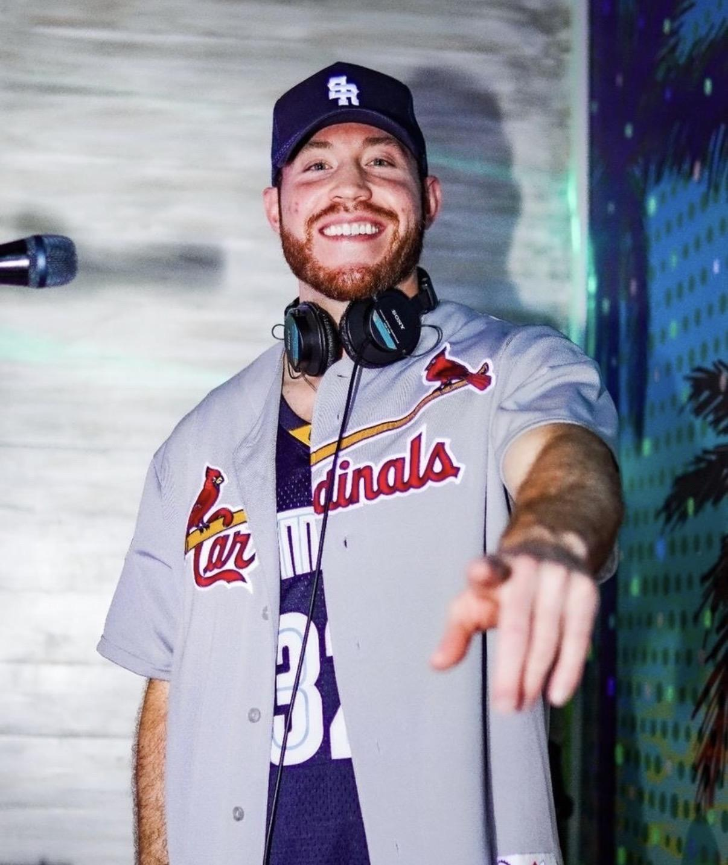
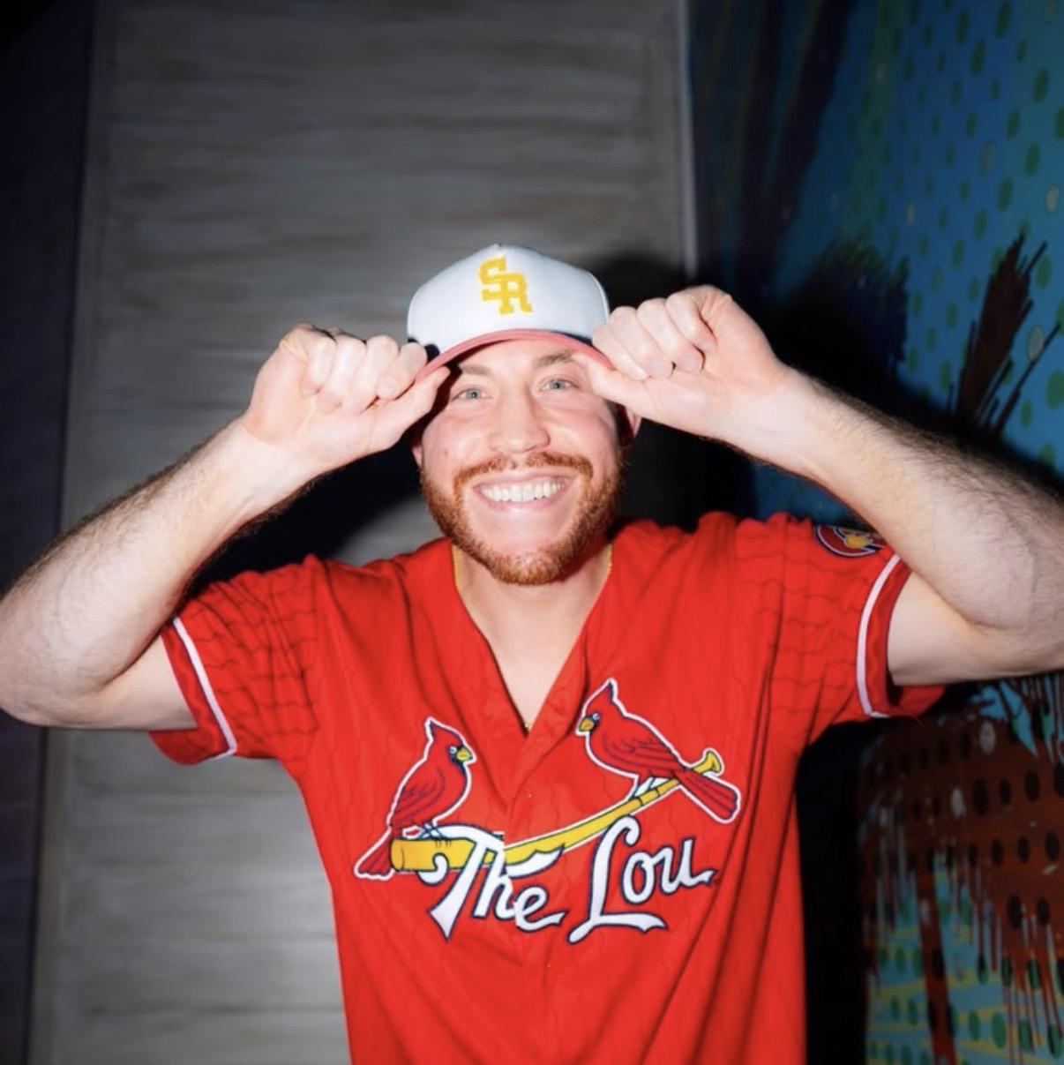
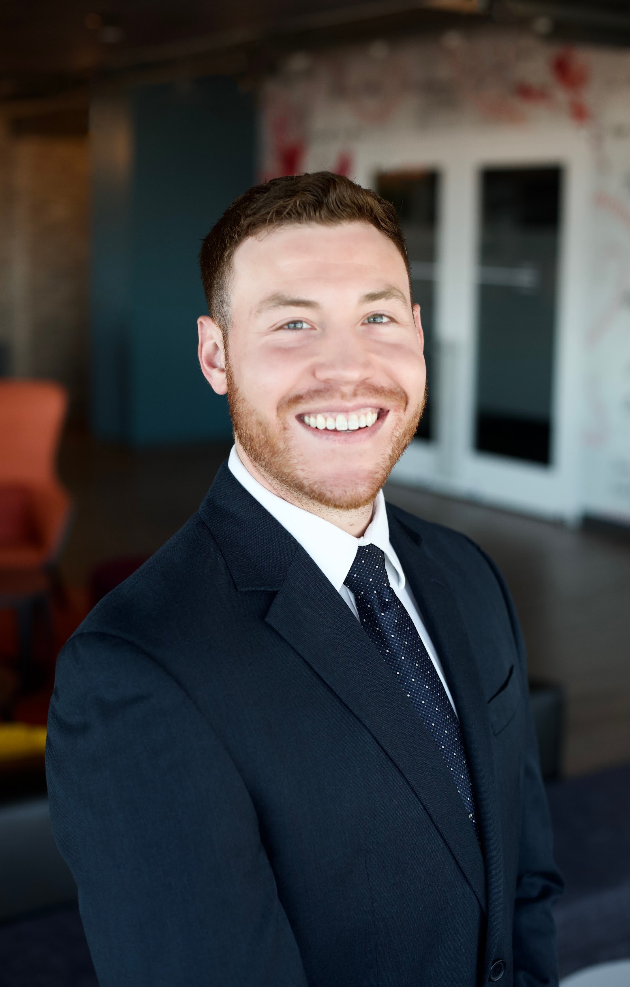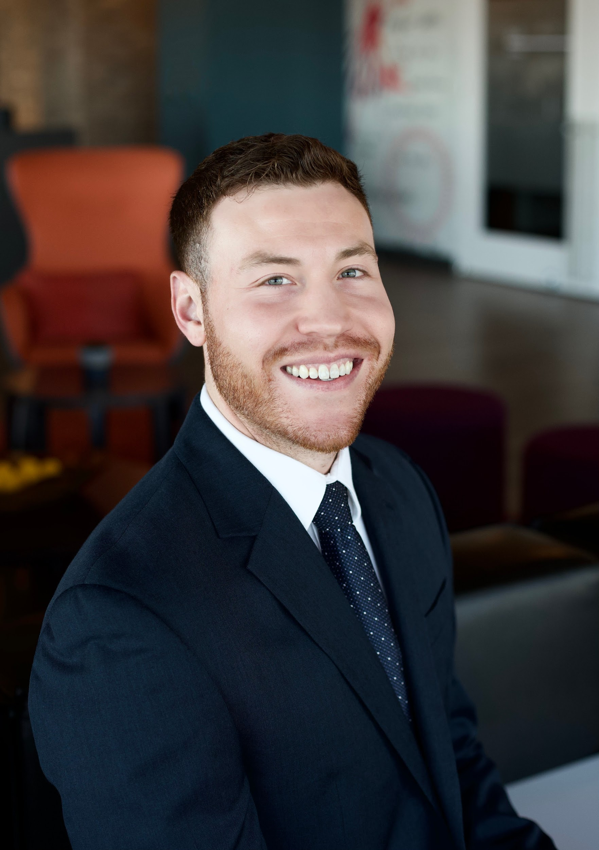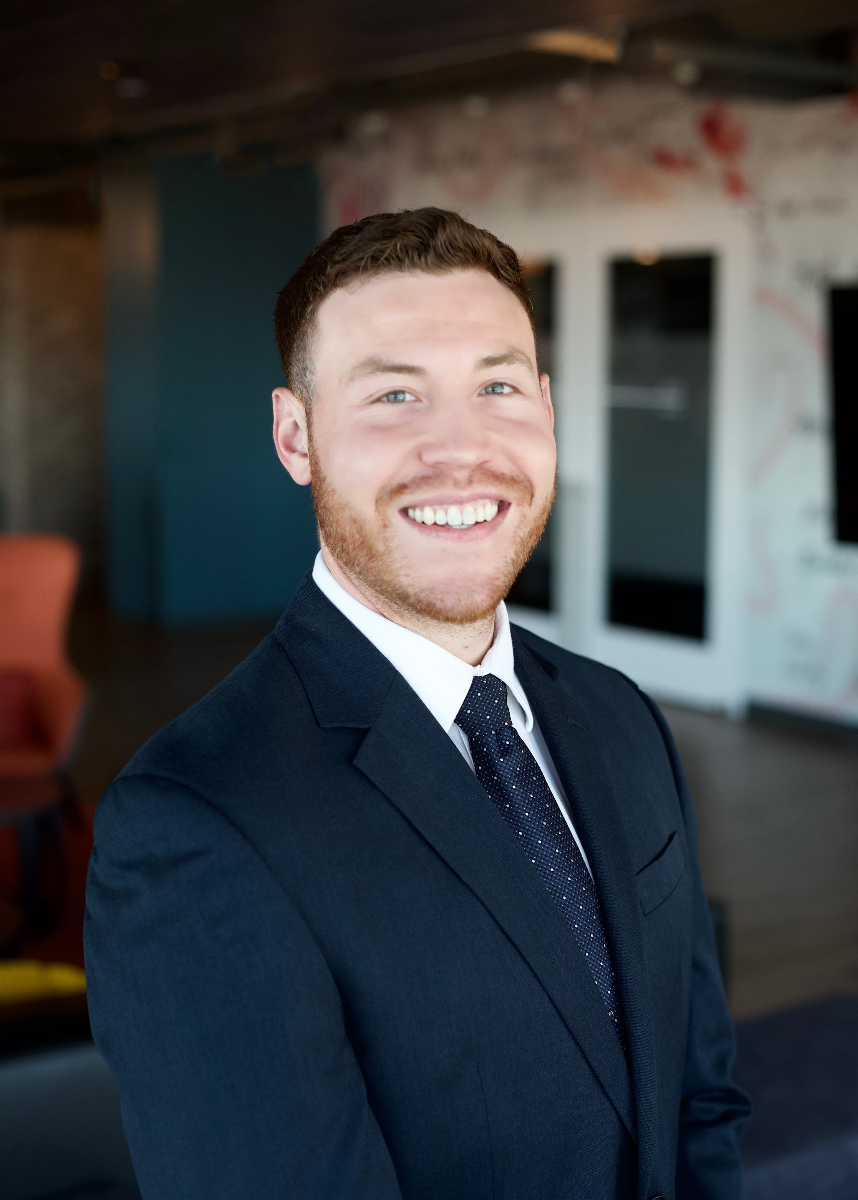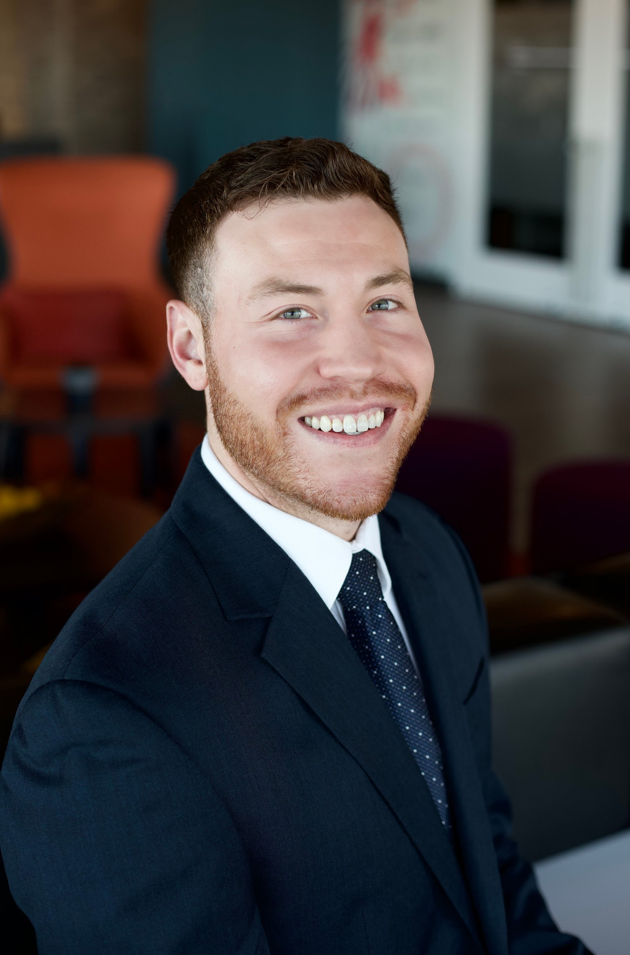
That's it. Send this back with your photos and we'll take it from there.

