Concept/Game Setting

Reference: To the Moon, Plague Tale, Inside Out, The Wonderful Wizard of Oz

**Process**

During our Game Idea brainstorming, Louis proposed an idea of a game of lantern/light, inside a dungeon. It requires the player to choose from navigating through and attacking enemies. We found that his idea similar to the game Darker and Darker with a dungeon concept.

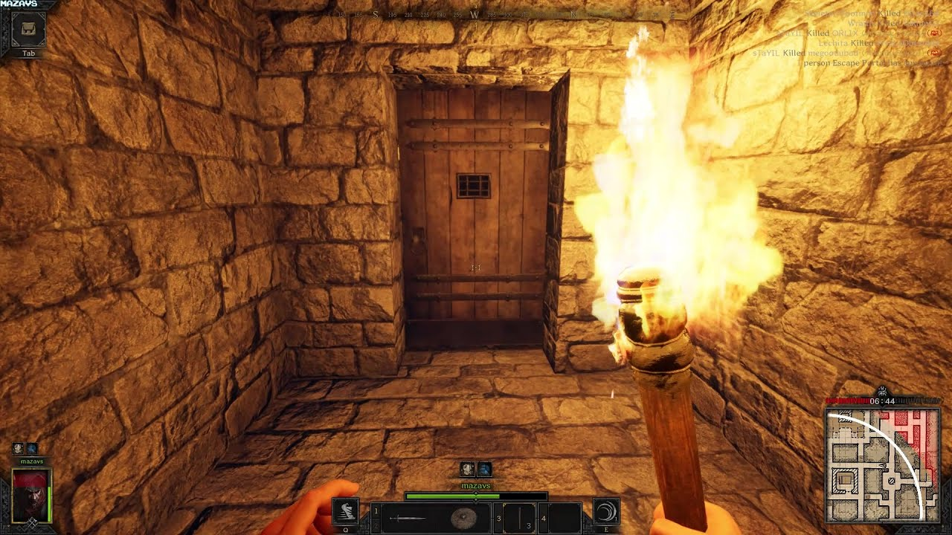

Darker and Darker

However, after discussions and found that the dungeon with roguelike settings is not realistic. We chose to have the game lean more to puzzle with less horror vibe. -discussed more in gameplay document.

Based on that, as we are still choosing to make game based on lighting, Plague Tale: Innocence has a similar setting with gameplay that we can take reference from: homeless protagonists trying to conquer difficulties to survive in a critical environment.

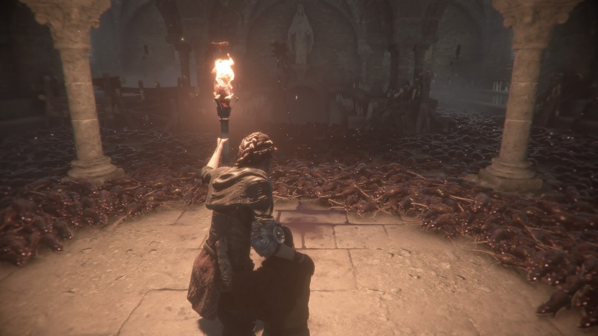

Plague Tale: Innocence

As we are building the game mechanics, we discovered that the setting should still be less horrific because puzzle game flow doesn’t intend to stress player a lot. Instead we want to create more memorable/deep narrative within the puzzles and worked out our final settings of the game.

**“A dead man recovered his soul by rewinding back in time and went to heaven in the end.”**

**The setting/Concept**

This game’s background story is in real world, but the gameplay is taken place in purgatory.

**Real world/Background**

The same as our world. In the early 2000s, a successful businessman, Darren, passed away after years of cancer. He was recognized as a genius car manufacturer and salesman (of car brand Orion) but few people knew that his late years were miserable. He lost his son in his 50s and his wife at 70s (Referenced from Once Upon a Time in America).

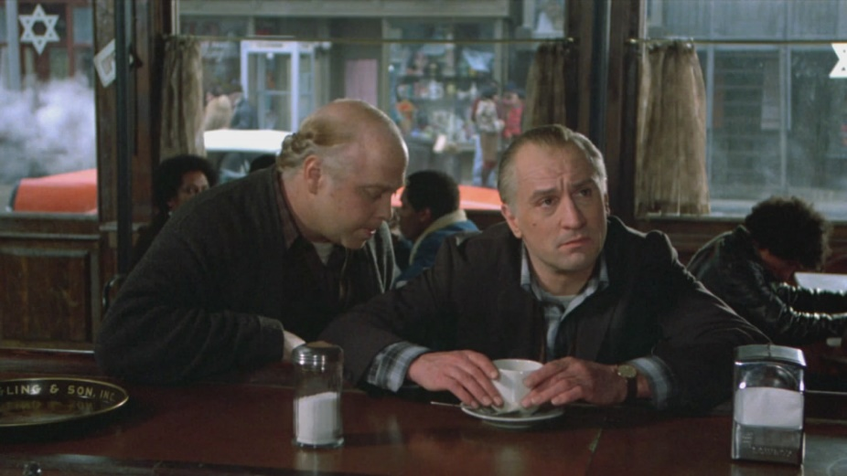

Once Upon a Time in America

**Purgatory**

After Death, Darren’s Soul fell into purgatory and he found himself colorless. He started his journey of re-discovering his past and go to heaven.

**Soul’s Color**

A person’s soul is colorful when he’s born. The soul gradually lose color due to different events in life. Inspired by Inside Out, but this is done reversely.

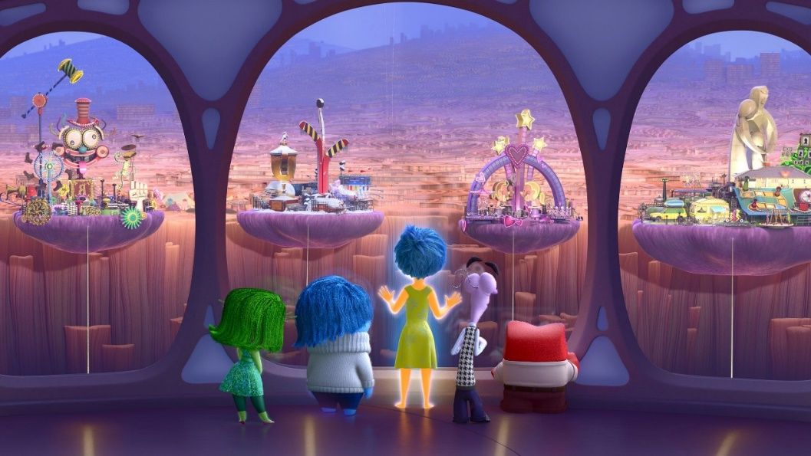

Inside Out

Likely, when a person lose their soul pieces, they lose some color of themselves and the pieces are permanently lost in the time.

**The Journey**

After death, everyone needs to go through a journey back in time to collect missing parts of their souls back. This part is inspired by the original Divine Comedy by Dante. During the journey, the dead need to go back in time, light up their memory parts and dismiss everything happened to them and everything they’ve done. In this process their soul will be more complete until the same condition at birth. Some ideas inspired by The Wonderful Wizard of Oz. (Tin Woodman)

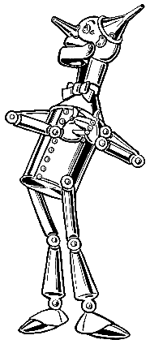

Tin Woodman in The Wonderful Wizard of Oz.

**Specific Methods for the purgatory journey**

In purgatory, there’s a beam of light containing the time and event of the past. However, the past is shrouded with fog and the light need to be guided towards the start. There are also different beams in the game world, representing possibilities of another timeline. When the timeline beam reaches certain events, they will experience the event again and choose to forget the existence of that forever and go on.

**Heaven**

Heaven in this world erases the memory and existence of the dead and give them the chance of rebirth as a new human being.

Level Concept