Team Vyv Design Guide

**Core Mechanic**

**_____________________________________________________________________________________**

Lasers

* **Lasers** act as the core mechanic of our puzzles, but also the guiding line for the players, pushing them towards progress in the game.
  + This is made obvious to players in that: our game is set in the dark, and the lasers provide illumination wherever they go.
  + The Lasers come from **emitters** and have the objective of reaching **laser** **receivers.** The lasers may also pass through **light checkpoints** that have various effects on the level when activated by the light.
    - This could be opening a door, granting access to the laser receiver, or other various effects.
* **Lasers** can be redirected with **mirrors** at 90-degree angles, changing the path of the light and allowing it to move through the map.
* **Lasers** may be solid or non-solid to the player
  + **Solid lasers** prevent the player from passing through them. If a player moves a mirror into a solid laser that would hit them, they are displaced to the side of the laser that they had access to before the mirror was placed.
    - This “displacement” mechanic is what allows us to make **Solid Laser**  puzzles that the player can’t just simply walk through with a mirror, displacing their way to the end.
  + **Non-solid lasers** the player can simply walk through. These are typically used in different puzzle designs than the solid lasers, otherwise the player may get confused (though there *is* visible / audible / interactive differences between the two) at least towards the beginning of the game.
    - Having permeable lasers like this is useful for teaching the player the core concept of laser / mirrors, without punishing them for experimentation or mistakes with a soft lock or even just additional complexity.

Mirrors

* **Mirrors** are what allow the player to traverse levels with **Solid lasers** in them, and the way that they interact with the environment.
* **Different forms of mirror can be moved in different ways :**
  + **Track Mirrors** have a set path that they can follow. A player may interact with them to push them along that path, back and forth. The mirror will follow their movement with WASD, as long as the direction matches the track.
  + **Freestanding Mirrors** can be moved either left and right, or up or down. The direction is determined by where the player is standing: if they are standing on the left or right of the mirror, the mirror will move with the player using A or D. If the player is standing on the top or bottom of the mirror, it may be moved up or down using W and S.
* Some mirrors may not be moved, these mirrors often have something special to them, such as:
  + Mirrors that function as such from both sides, or multi-directional mirrors.
  + Triangular mirrors, which you may think of as 3 mirrors placed in a triangle shape.
  + One-way mirrors, or mirrors that can reflect from one side yet may pass a laser through from the other side.
  + To be clear **some mirrors of these types *may*****be moved,** but often unmovable mirrors are of these types.
  + Mirrors of these types are useful for guiding the core design of a puzzle.
* Some mirrors may allow the player to pass through them yet also reflect light.
  + These mirrors are useful for allowing or even forcing the player to move to areas of the map with less light.

Supporting Mechanics

* **Checkpoints**
  + Checkpoints are puzzle objects on the map that may have light pass through them to activate various level functions, such as doors opening, receivers becoming accessible, or other functions
  + Checkpoints may be used as a difficulty scaler, as well as guide for the player in puzzle solving.
    - If the player knows that they must pass light through a given checkpoint, it eliminates puzzle solving options and therefore difficulty of the puzzle.
  + There are also **Big Checkpoints** in between levels, but not typically at the end of sections.
    - These checkpoints, once activated, serve to complete the puzzle and act as the emitter for the next one
    - Upon activation, particle effects and audio come up, and all puzzle elements are locked into place, completing the puzzle
* **Glass**
  + Allows light to pass through, yet not the player.
  + Implemented to increase complexity, yet also for the opportunity to add walls that the player can see through to **anticipate** and **foreshadow** puzzles.
    - They also give the game more of a connected feeling than having completely separate rooms with different emitters. Having one emitter that’s laser is used for multiple levels gives the sense of one larger level. Cooler experience for the player as they feel they are smarter for solving a bigger puzzle.
* **Colored Glass**
  + Colored glass will change the color of light that passes through it.
  + Useful for **colored receivers**, which may receive one or even more colors of light in order to activate.
  + This was implemented into our design to give us as designers more options to increase complexity, as well as to give an avenue for visual change to the mirrors to reduce confusion.
* **Laser Splitter**
  + Laser Splitter will be used to turn a laser emitter’s one laser into two.
  + Useful for increasing complexity, as well as giving **branching options** to the player.
    - If the light is the guide for the player through the game, and it goes in two directions, it gives the player options and branching choices.
  + When a laser is split, the laser will have to go to two separate receivers.
    - There is also potential for a multiple laser-receiving receiver, that would be one object yet receive two separate lasers
  + The splitter is also useful for multicolored laser puzzles, as you can have one emitter that splits into multiple colors that then go to a multi color receiver.
* **Timer**
  + The timer is used to create a sense of urgency in solving puzzles, though there isn’t any real punishment for not meeting the time.
  + A lever can be hit by the player at some place in the level, starting a mirror moving to a set location. Mirrors can then be moved by the player into solving positions. The position that the moving mirror reaches at the end of the timer solves the puzzle, given that all other mirrors are in the correct place.
  + If the player doesn’t move all the mirrors to the correct places in time, the lever resets, the movable mirrors return to their starting position, and the self-moving mirror also returns to its starting position.
* **Camera Type**
  + Our game will have a dynamic camera.
  + Purpose of this is to encourage exploration by the player, as well as increasing sense of discovery when one is made.

**References**

**_____________________________________________________________________________________**

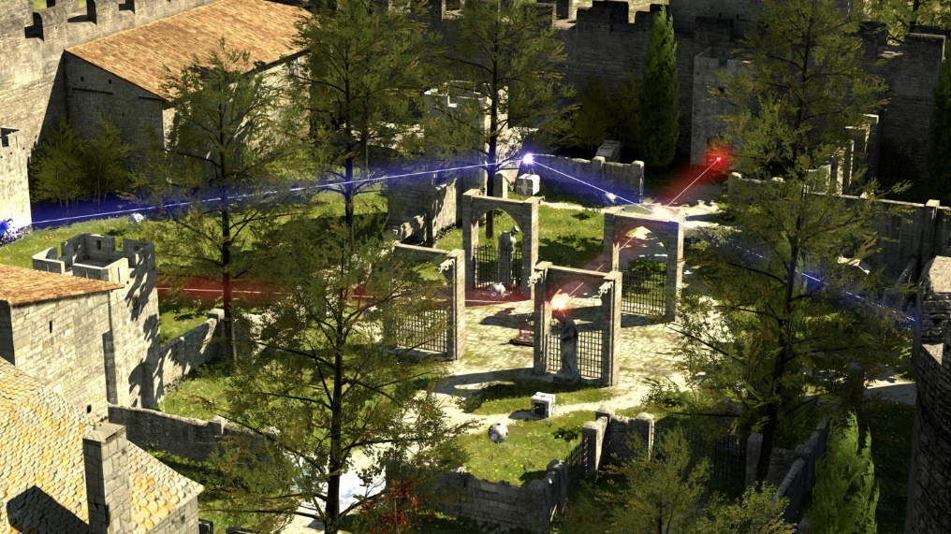**The Talos Principle**

* Informed our core concept, as well as helped shape different supporting mechanics.
  + Helped develop laser mechanics and inspired redirection with the use of mirrors.
* Informed our level design and the way we go about shaping our world *around* the puzzle

*The Talos Principle* didn’t directly influence any of our final designs; after all, their puzzle mechanics are obviously different than ours. That being said, I looked at a few screenshots of the game and immediately knew what the core concept of our puzzles would be: redirecting lasers with movable mirrors.

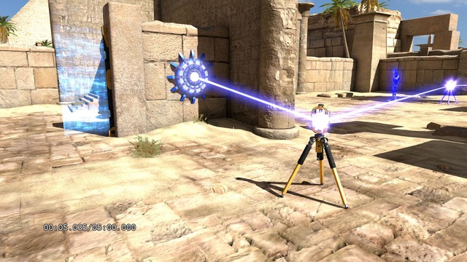

**Component: Emitter**

* The circular-spiked object stuck to the wall in the screenshot provided is *The Talos Principle’*s version of a laser emitter.
* Despite not emitting a laser before the player requests it to do so, it serves the same purpose as a laser emitter in our game.
* 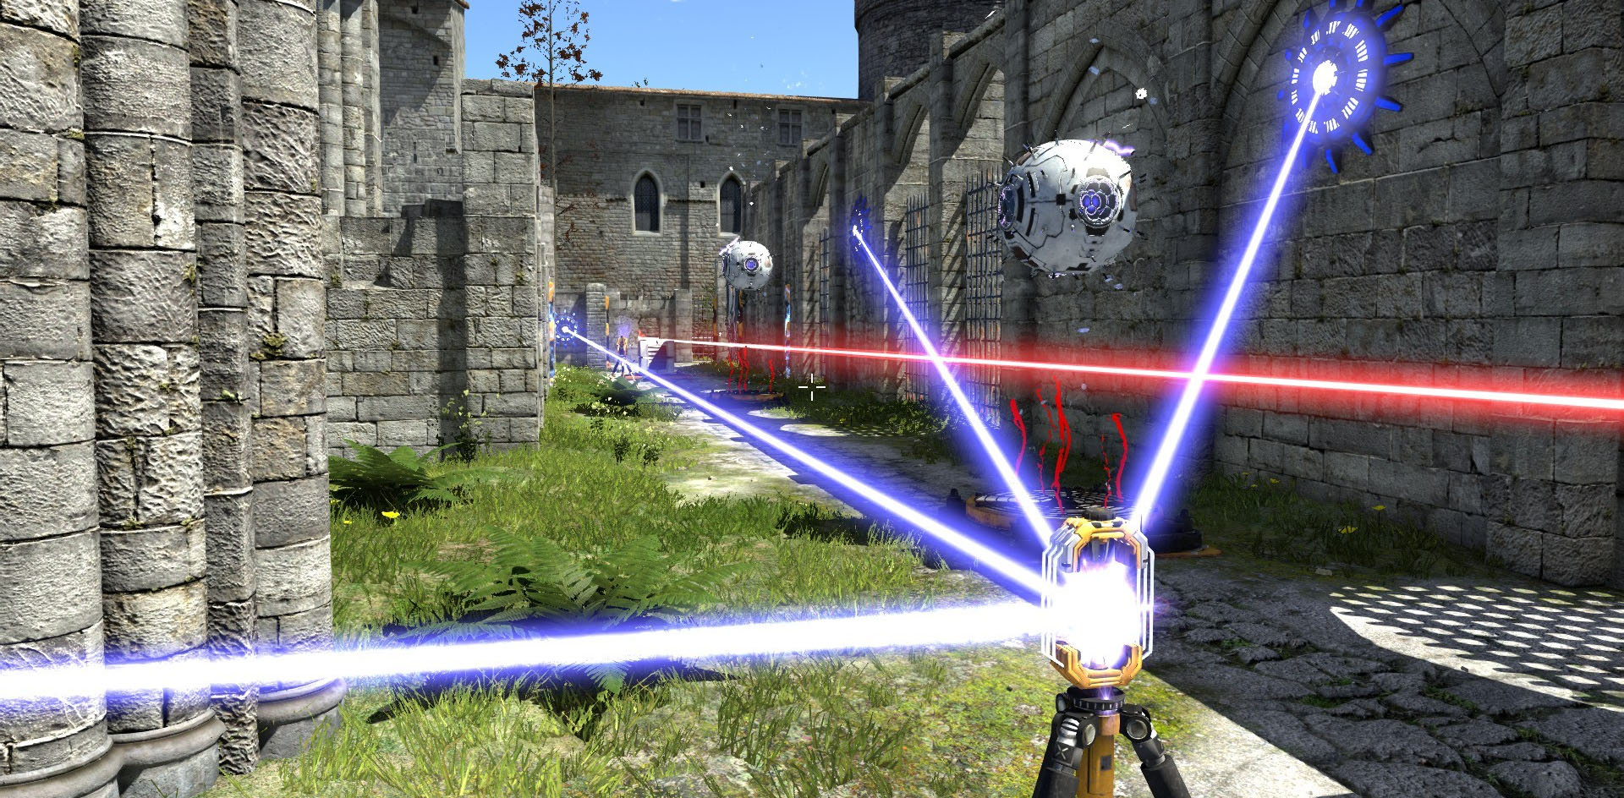It’s also worth noting that although I didn’t know this when referencing the game in my designs, these “emitters” also function as “receivers”, in that the goal of many of the puzzles in the game are connecting multiple of them together.

**Component: Mirror**

* *The Talos Principle* uses these receptacles as their “mirrors”.
* You can chain multiple together, you can move them around, etc, they essentially serve the same purpose.

**Relics Of Light**

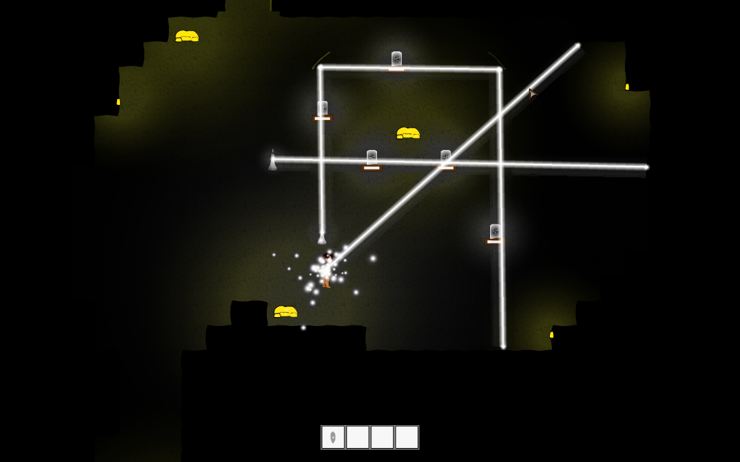

* *Relics of Light,* a DigiPen game made in GAM 150, is a top down 2d puzzle game similar to ours, as you use light beams to pass light through a series of “checkpoints” to solve the puzzle.
* The lasers in *Relics of Light*  act identically to our game’s non-solid mirrors. The game is different in that you may have multiple emitters that shoot light though the various checkpoints.
* The core concept of *Relics of Light* focuses on light passing through checkpoints, whereas in our game the core concept in the transmission of the light to from the emitter to the receiver, where checkpoints are more of a secondary, supporting mechanic.
* *Relics of Light* also features exclusively immovable mirrors, whereas our puzzles focus primarily on moving mirrors to solve puzzle