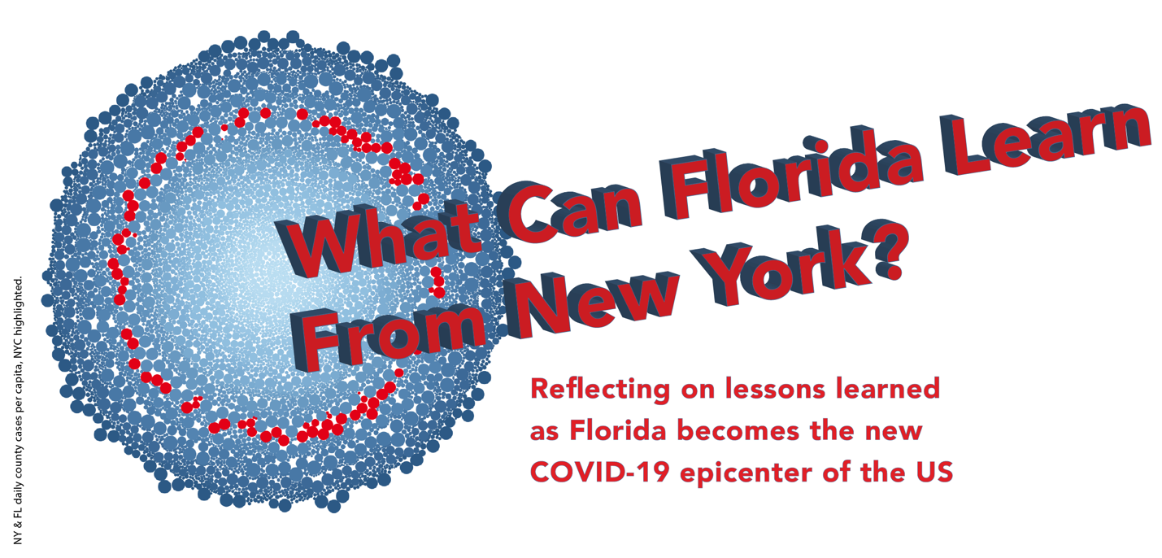

by Joaille Araujo, Tyler DeGroff, Shannon Ehmsen, Erinlea McGowan-Moniz, and Kunyu Zhang

*Access the COVID-19 Interactive Dashboard*[*here*](https://public.tableau.com/views/DGMD76Project1/Joaille)*.*

W

hen COVID-19 (i.e., the Coronavirus) was first detected in the U.S. in early 2020, federal and state agencies were unprepared for the devastating effect it would have on the country’s most vulnerable people; by June it had claimed 100,000 U.S. lives. New York state was hardest hit; its confirmed case count grew as it quickly became the epicenter of the outbreak in the U.S., and, eventually, the world. State and local governments strategized methods to keep citizens safe and slowly ramped up measures and restrictions at varying times and degrees as cases and deaths continued to climb.

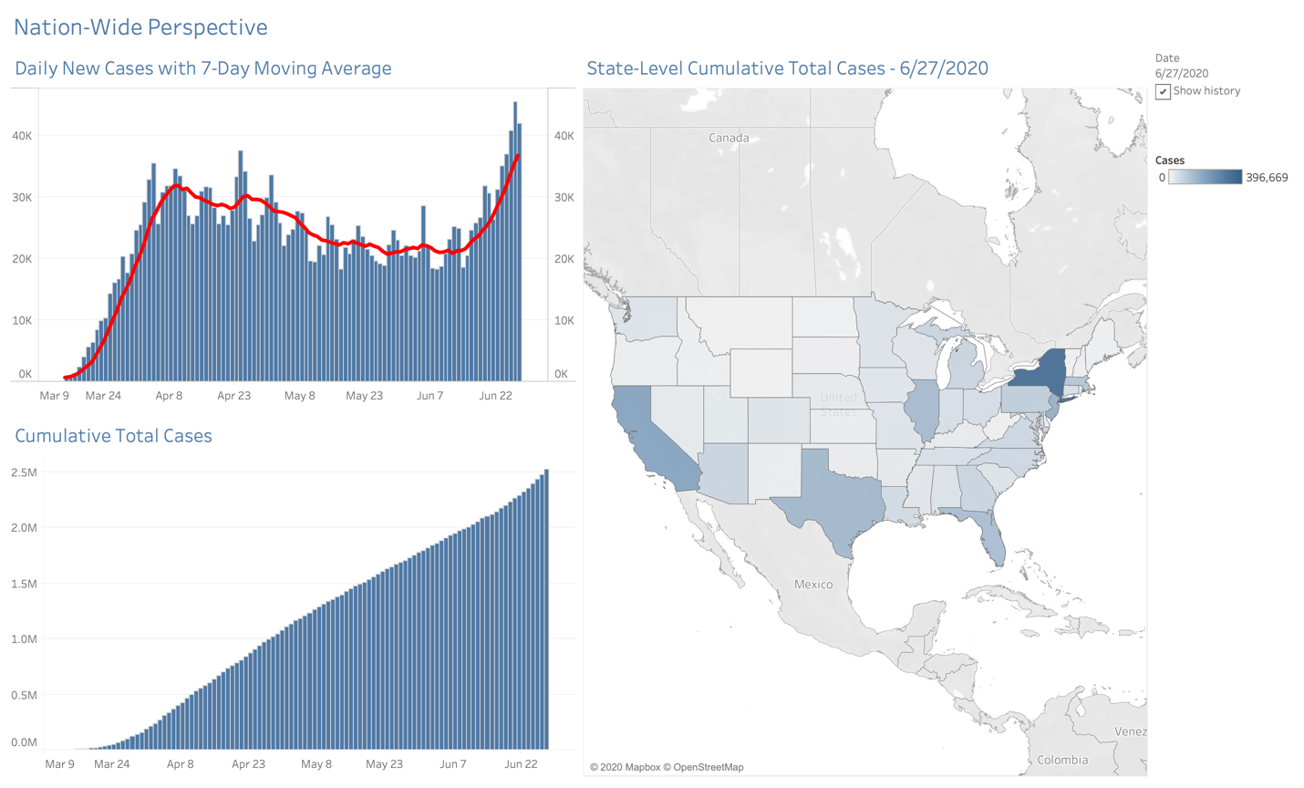

While New York City (NYC) was considered the epicenter of the outbreak at its peak, elsewhere, cases continued to grow exponentially. Data collected shows a high rate of COVID-19 cases in NYC; however, after accounting for population density, the growth rate in other New York counties surpassed NYC in terms of cases and subsequent deaths. Infection rates in other counties may have been influenced by visitors to NYC, due to the high number of daily commuters to the metro area and the city’s status as a popular tourist destination, combined with lack of early guidance from official sources and the high contagion rate of the virus.

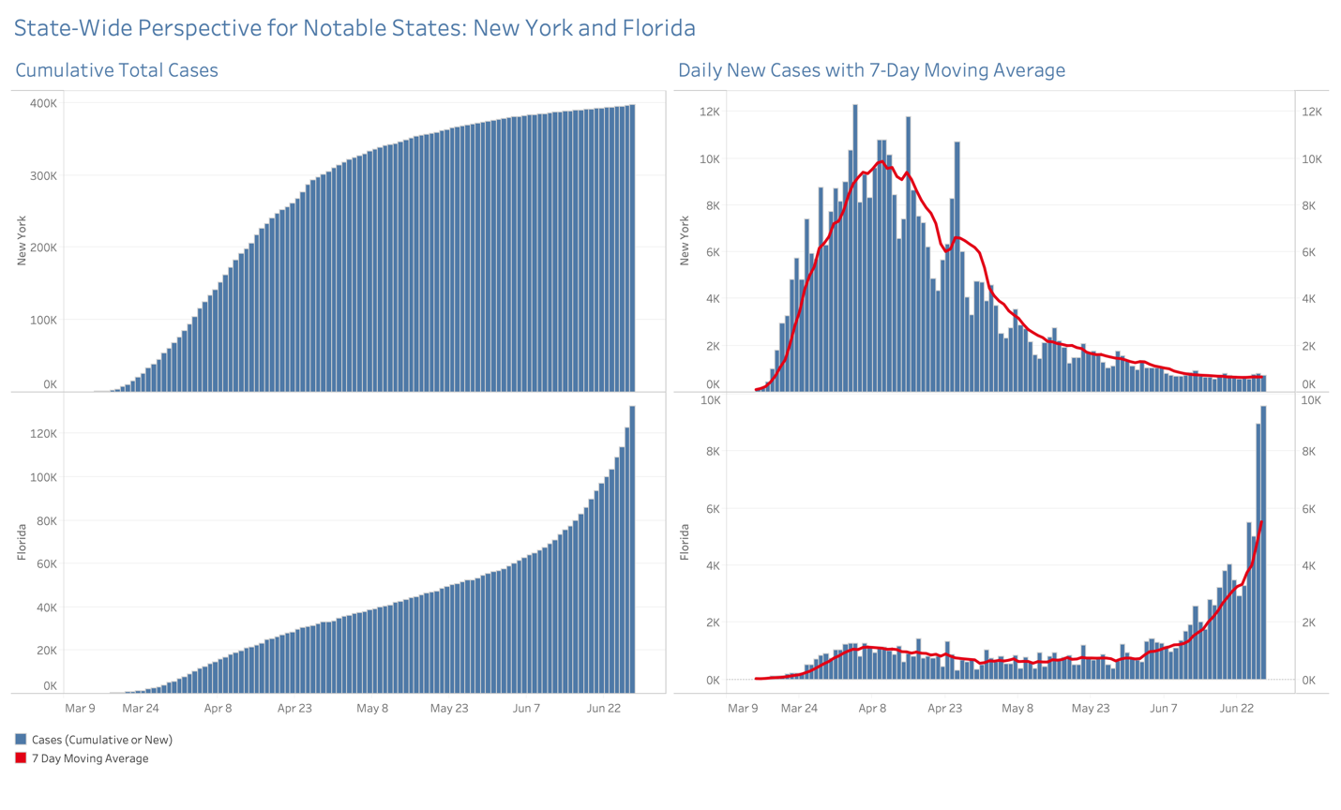

New York (city and state) are still experiencing high rates of infection. Other states have seen dramatic spikes in newly diagnosed cases as they begin to re-open and many residents resist public health warnings to wear masks. Whereas New York State’s COVID-19 cases peaked at 12,274 new infections reported April 4th, Florida, by contrast, set its own one-day record (9,580 new cases reported on June 27th, 2020).

As illustrated above, interesting patterns emerge. Cumulative case counts in New York state reached their inflection point at the beginning of May and have since consistently leveled off. Florida’s cumulative case count curve has progressed exponentially since mid of June, suggesting the virus has spread in an unencumbered fashion. Lastly, we observed Florida’s record-setting new case count on June 27th nearly doubled its previous 7-day average. Evidence suggests more dramatic case numbers may soon emerge from Florida.

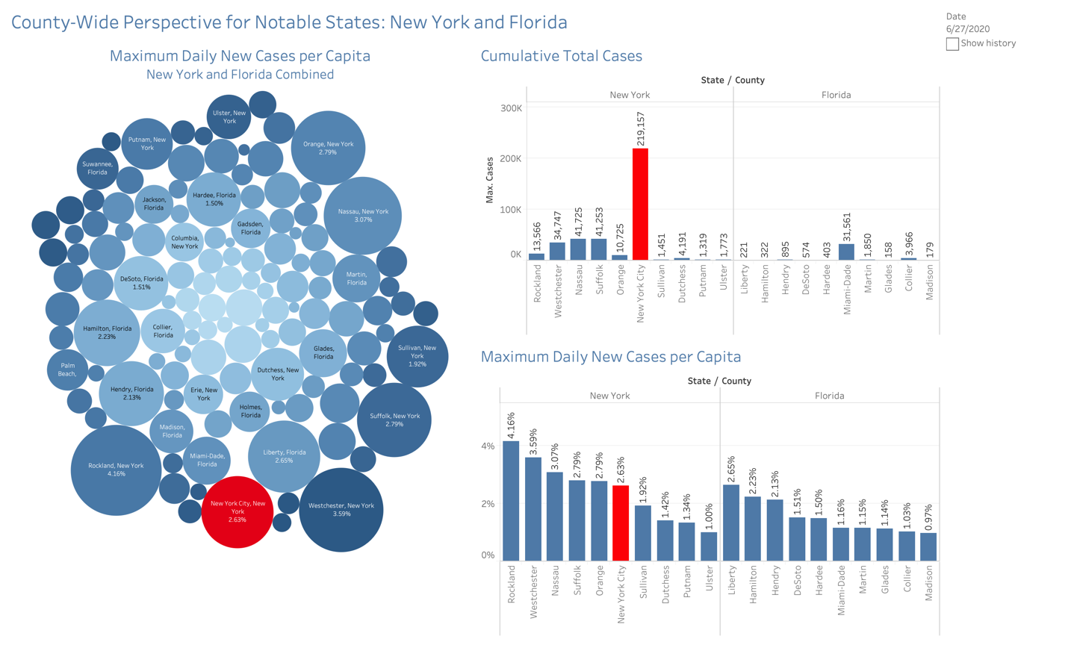

Most cases are concentrated in NYC and surrounding counties. The bigger bubble sizes represent more cases per capita, and darker red colors indicate a higher number of deaths per capita. Rockland, Nassau, Westchester, Suffolk, and Orange are the top five New York counties with COVID-19 cases per capita surrounding New York City. Rockland has the highest cases per capita, followed by Westchester. Rockland and Orange Counties have higher concentrations of ultra-Orthodox Jewish communities; due to cultural norms within these communities, social distancing was not adopted initially in March. NYC shows a higher death rate per capita than other counties, yet fewer cases per capita. However, the high volume of infected cases (over 219,000) overwhelmed the healthcare facilities and contributed to the higher number of deaths per capita in NYC.

In Florida, which has been affected state-wide, the three most concentrated areas of infection are in the relatively small Hendry, Hamilton, and Liberty Counties. Liberty has the highest number of cases per capita, but Hendry County has the highest number of deaths per capita. The lack of resources in smaller counties may have contributed to the advanced rates of infection.

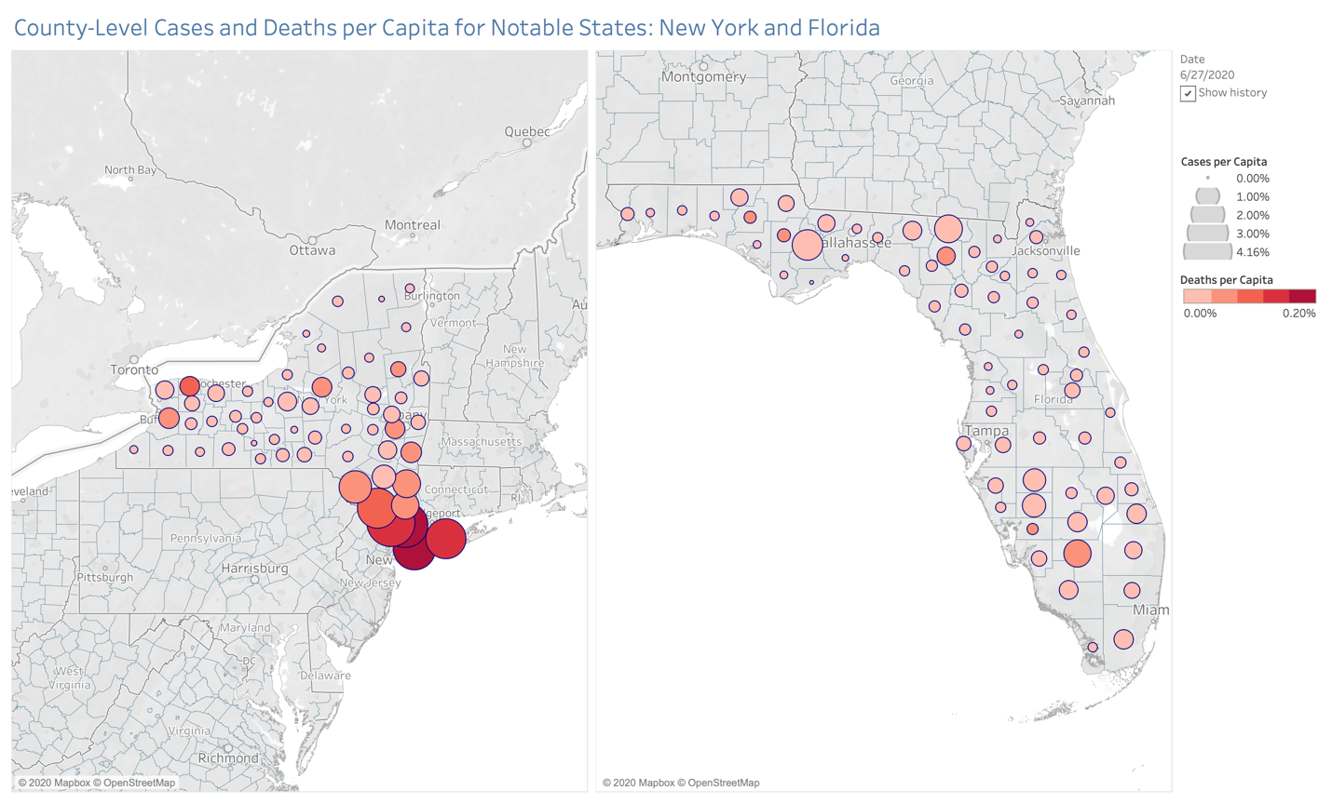

As cases in Florida continue to rise, the county-level health resources available to those diagnosed with COVID-19 must be considered; as each county’s division of resources may not be in proportion to the strain on their communities. The number of actual cases diverges from the value of cases per capita. As of June 27th, Liberty County in Florida reported 221 cases, or 0.02633% per capita, exceeding New York City’s Cases per capita which stands at 0.02624% with a total of 219,157. While Liberty County in Florida and NYC have the same amount of cases per capita (0.026%), the former’s 221 total reported cases is dwarfed by NYC’s 219,157. Less-populated states without the capacity to effectively slow the spread of COVID-19 need to be examined beyond their cases numbers, as the virus hits communities of all sizes.

References

ABC7NY. (2020). Coronavirus News: Concern over COVID-19 spread in Orthodox Jewish communities. https://7ny.tv/2YEfAa5

Armstrong, D., Goldman, H., & Clukey, K. (2020, May 28). Why New York Suffered When Other Cities Were Spared by Covid-19. *Bloomberg Business Journal*. https://bit.ly/3eJ4w19

New York Times. (2020). An Incalculable Loss. Retrieved from https://nyti.ms/31rWqpM

New York Times. (2020). Coronavirus (Covid-19) Data in the United States (commit 4d46f5f0b1853169c561d319398621d69c1becc3) [Cumulative counts of coronavirus cases in the United States, at the county level, over time.]. Retrieved from https://bit.ly/3eHLnwv

United States Census Bureau. (2010–2019). County Population Totals: 2010–2019 [Annual estimates of the resident population for counties.]. Retrieved from https://bit.ly/2ZjfeVt

United States Census Bureau. (2019). 2019 Census Bureau Region and Division Codes and State FIPS Codes (Version 2019) [Reference file for vintage 2019 Census Bureau Region and Division Codes, and State, County, Minor Civil Division, and Incorporated Place.]. Retrieved from https://bit.ly/3g6sXpp

United States Census Bureau. (2019). 2019 State, County, Minor Civil Division, and Incorporated Place FIPS Codes (Version 2019) [Reference file for vintage 2019 Census Bureau Region and Division Codes, and State, County, Minor Civil Division, and Incorporated Place.]. Retrieved from https://bit.ly/387nITK

Wadhera, R. K., Wadhera, P., Gaba, P., Figueroa, J. F., Maddox, K. E. J., Yeh, R. W., & Shen, C. (2020). Variation in COVID-19 hospitalizations and deaths across New York City boroughs. *Jama*.

Wall Street Journal. (2020). New York’s Ultra-Orthodox Jewish Community Warned About Large Funeral Crowds. Retrieved from https://on.wsj.com/2YGKAq0