Identification, Authentication, Authorization, and Accountability
标识，验证，授权和可问责性

标识，区别不同用户
验证，由密码或者所拥有的物品
授权，对权限和特权进行检查
可问责行，在标识了唯一主题后，可主体的动作记录在案。

验证是对身份的核实
知道的内容、拥有的物品、某人的身份（根据生物特征进行身份验证）。
强验证包括任意两种。
身份标识注意事项
When issuing identification values to users, the following should be in place:
• Each value should be unique, for user accountability.
• A standard naming scheme should be followed.
• The value should be nondescriptive of the user’s position or tasks.
• The value should not be shared between users.
访问控制回顾
• Identification
• Subjects supplying identification information
• Username, user ID, account number
• Authentication
• Verifying the identification information
• Passphrase, PIN value, biometric, one-time password, password
• Authorization
• Using criteria to make a determination of operations that subjects
can carry out on objects
• “I know who you are, now what am I going to allow you to do?”
• Accountability（可问责性）
• Audit logs and monitoring to track subject activities with objects

身份管理技术：
• Directories
• Web access management
• Password management
• Legacy(遗留) single sign-on
• Account management
• Profile(配置文件) update

目录
基于X.500标准和某种协议（大部分是LDAP。）
许多身份管理产品的主要作用是创建元目录或虚拟目录。两者区别是元目录含有身份数据，而虚拟目录没有。
缺点：目录服务无法管理许多遗留设备和应用程序，这些遗留的实体必须由他们继承的管理软件来管理。

Web访问管理
通常WAM工具需要提供单点登录功能。

密码管理
常用密码管理方法
• Password Synchronization（密码同步） Reduces the complexity of keeping up with different passwords for different systems.
• Self-Service Password Reset（自助密码重置） Reduces help-desk call volumes by allowing users to reset their own passwords.
• Assisted Password Reset（辅助密码重置） Reduces the resolution process for password issues for the help desk. This may include authentication with other types of
authentication mechanisms (biometrics, tokens).

遗留单点单点

账户管理

指配，指的是为相应业务过程而创建、维护和删除存在于一个或多个系统、目录或引用程序的用户对象与属性。

用户资料更新
企业身份管理解决方案采用用户资料更新技术，允许管理员在必要时以自动方式创建更改或删除这些用户资料。

联合
是一种编写身份以及与之相关联的权力。允许用户通过多个IT系统和企业的身份验证。

这些组件工作示意图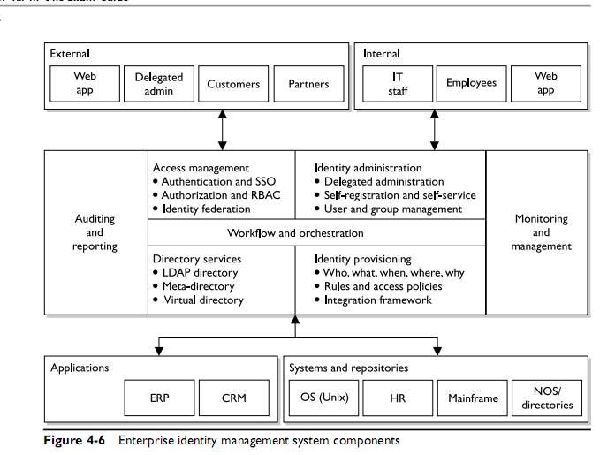

常用身份验证方法
- 访问控制和标记语言
XML

Service Provisioning Markup Language (SPML). 允许公司接口传递服务请求，并且接受对这些服务的公司供应访问，在遵循XML标准下，可以互操作。

（ eXtensible Access Control Markup Language (XACML)）为了确保发送公司和几首公司遵守相同的安全策略，XACML提供了功能。

- 生物测定学
两种
- 生理性生物测定，某个人所特有的身体特征
- 行为性生物测定，基于某种行为特点（如动态签名）

当拒绝一个已获授权的个人时，会出现1类错误（误拒绝率（False Rejection rate FRR））
当接受了一个冒名顶替者，会出现2类错误（误接受率（False Acceptance FAR））
评测一套生物学测定系统时，最重要的度量是交叉错误率（Crossover Error Rate CER) ，是一个百分数，代表拒绝率与误接受率等值的那个点。
CER 3的生物测定学系统要比CER 4的 系统准确度要搞。

- 密码
密码管理 （有效的安全保障是在适当的生成和更新密码，并能完全保密前提下）
如果用户自己选择密码，操作系统应该试试特定的密码需求。

攻击者寻找密码的途径
- 电子监控（监听流量，重放攻击）
- 访问密码文件
- 蛮力攻击（使用工具，通过组合来猜测）
- 字典攻击（使用成千上万单词的字典文件，或已经泄漏的密码进行比较）
- 社会工程
- 彩虹表，其中包含宜采用散列格式的所有可能密码。

密码检查器，用来测试密码强度。
密码散列与加密 ，增加salt的随机值。对密码进行散列，保证不包含明文密码。
密码生存期 Limit Logon Attempts A threshold can be set to allow only a certain number of unsuccessful logon attempts. After the threshold is met, the user’s account can be locked for a period of time or indefinitely, which requires an administrator to manually unlock the account. This protects against dictionary and other exhaustive attacks that continually submit credentials until the right combination of username and password is discovered.

4，感知密码
基于个人的事实或观点的信息，用于验证身份。例如你的吉他品牌。

- 一次性密码
令牌设备
同步

异步 （asynchronous token)
使用挑战/响应机制。验证服务器发送一个调整，用户将该指输入令牌设备， 令牌返回值

- 密钥
- 密码短语 ，某些情况下可以取代密码。在输入后程序会将其转换为虚密码。
- 存储卡，可以保存信息，但是不能处理信息。
- 智能卡，本身包含微处理器和集成电路，具有处理信息的能力。
接触式智能卡 有芯片
非接触式 有天线线圈
智能卡攻击方式
向智能卡引入一个错误，如改变输入电压，时钟频率。再检查加密函数结果，可能会获得加密密钥，这种攻击称为故障生成攻击（fault generation)
旁路攻击（非入侵式攻击，只查看某个组件的运作方式以及不同状态反应）
针对智能卡的差分功率分析（differential power analysis） 旁路攻击示例
电磁分析（electromagnetic analysis） 旁路攻击实力。他们用于数据收集。
微区探查（microprobing），使用针头和超声振动去除智能卡外部保护材料，随后直接连接智能卡的ROM来访问和操纵其中的数据。

授权
- 访问准则
使用角色
使用组
使用物理或逻辑位置
时间段或时间间隔
时间性访问，例如某某时间以前不能访问，因为你还没有入职
事务性约束。

- 默认为拒绝访问
注意授权蠕动（authorization creep） 指总部A的员工到了分部门C，但是还有A的权限。

- 知其所需，类似于最小特权原则，个人应当只被允许访问为履行其职责而需要的信息。
- 单点登录
- Kerberos
Kerberos主要组件
Key Distribution center KDC, 是最重要的组件。保存了用户和服务的秘密密钥。他提供身份验证以及密钥分发功能。
KDC 为委托人提供安全服务。委托人是用户、应用程序或网络服务。
KDC上的票证（ticket）由票证授予服务（Ticket Granting Service，TGS）生成。用于一个委托人对另一个委托人进行身份验证。
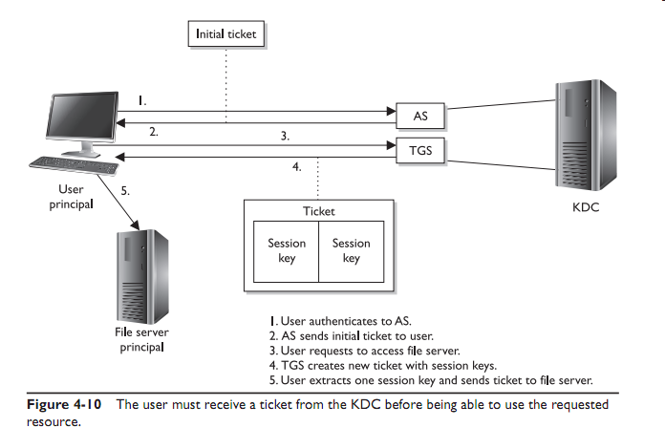
Kerberos弱点
单点故障、必须能够实施方式处理大量请求，秘密密钥存储在用户的工作站上，容易遭受密码猜测攻击。如果没有应用加密功能，它不能保护网络流量。如果密钥过短，它可能受蛮力攻击。

- SESAME
Secure European System for appolications in a Multi-vendor Environment.
对Kerboeros 的拓展和缺陷弥补。

SESAME不是通过票证验证，而是试用特权属性证书（Privileged Attribute Certificate,PAC）,PAC包含主体的身份、对客体访问能力、访问时间段以及PAC的生命期。
PAC有数字签名，因此客体确证期来自可信任的身份验证服务器，这种服务器称为特权属性服务器(Privileged Attribute Server,PAS) 扮演和KDC类似的角色

- 安全域
域是一组可用的资源。
安全域不仅在网络设备和区段，还可以应用于用户和进程
- 目录服务
- 瘦客户端（无盘工作站）

访问控制模型
DAC 自主访问控制模型
A system that uses discretionary access control (DAC) enables the owner of the resource to specify which subjects can access specific resources.
Many times department managers, or business unit managers, are the owners of the data within their specific department. Being the owner, they can specify who should have access and who should not.

MAC 强制访问控制模型
In a mandatory access control (MAC) model, users and data owners do not have as much freedom to determine who can access files. The operating system makes the final decision and can override the users’ wishes.

敏感度标签
It contains a classification and different categories. The classification indicates the sensitivity level, and the categories enforce need-to-know rules.
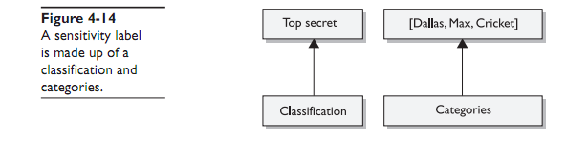
Role-Based Access Control 角色型访问控制
也称非自主访问控制（nondiscretionary access control）
RBAC模型是雇员流动性高的公司最适合使用的访问控制系统。

RBAC和DAC的区别
In an RBAC model, a role is defined in terms of the operations and tasks the role will carry out, whereas a DAC model outlines which subjects can access what objects.

核心RBAC
• Has a many-to-many relationship among individual users and privileges
• Session is a mapping between a user and a subset of assigned roles
• Accommodates traditional but robust group-based access control
层次化RBAC
- Role relation defining user membership and privilege inheritance.
2.Reflects organizational structures and functional delineations.
3. Two types of hierarchies:
a. 有限层次 Limited hierarchies— Only one level of hierarchy is allowed (Role 1 inherits from Role 2 and no other role)
b.普通层次 General hierarchies—Allows for many levels of hierarchies (Role 1 inherits Role 2 and Role 3’s permissions)

层次
Hierarchies are a natural means of structuring roles to reflect an organization’s lines of authority and responsibility. Role hierarchies define an inheritance relation among roles. Different separations of duties are provided under this model.
• Static Separation of Duty (SSD) Relations through RBAC This would be used to deter fraud by constraining the combination of privileges (such as, the user cannot be a member of both the Cashier and Accounts Receivable groups).
• Dynamic Separation of Duties (DSD) Relations through RBAC This would be used to deter fraud by constraining the combination of privileges that can be activated in any session (for instance, the user cannot be in both the Cashier and Cashier Supervisor roles at the same time, but the user can be a member of both). This one is a little more confusing. It means Joe is a member of both the Cashier and Cashier Supervisor. If he logs in as a Cashier, the Supervisor role is unavailable to him during that session. If he logs in as Cashier Supervisor, the Cashier role is unavailable to him during that session.

访问控制技术和方法
Access Control Models
• DAC Data owners decide who has access to resources, and ACLs are used to enforce the security policy.
• MAC Operating systems enforce the system’s security policy through the use of security labels.
• RBAC Access decisions are based on each subject’s role and/or functional position.

1规则性访问控制
2 限制性用户接口menus and shells, database views, and physically constrained interfaces
3访问控制矩阵 一般都具有DAC模型的属性。
功能=矩阵中的行 采用令牌、票证或密钥形势 主绑定在功能表中
ACL=矩阵中的列 客体绑定在ACL中
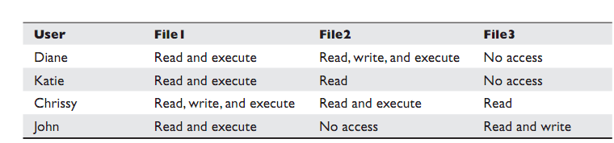

4内容相关访问控制
5上下文相关访问控制如防火墙的对TCP上下文的检查

访问控制管理
两种基本形势
集中式、分散式

集中式访问控制管理
RADIUS
通过某种身份协议（PAP、CHAP或EAP）达成一致。客户想访问服务器提供用户名和密码。
传输方式为UDP，
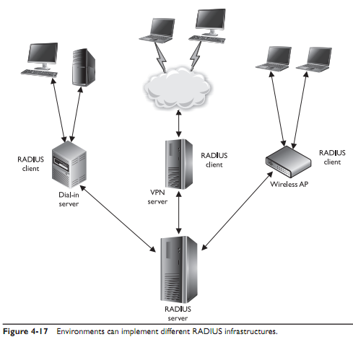

Tacacs
使用TCP传输，TACACS+会加密客户端和服务器之间的所有数据。
和RADIUS相同功能。，
RADIUS组合了身份验证和授权功能。TACACS_纯粹的AAA体系，单独处理身份验证、授权和问责功能。

两者区别图。
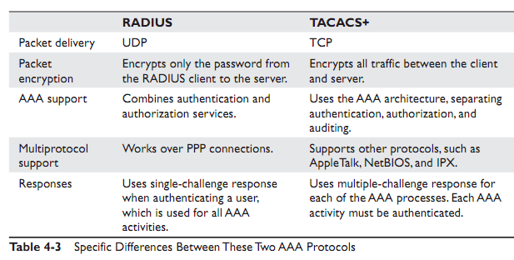
Diameter
RADIUS 和TACACS+是C/S协议，所以服务器不能像客户端主动发送买了。Diameter是一个对等协议，允许任何一端发起通信。

分散式访问控制管理
A decentralized access control administration method gives control of access to the people closer to the resources—the people who may better understand who should and should not have access to certain files, data, and resources.

Also, certain controls can overlap（重叠）, in which case actions may not be properly proscribed or restricted.

访问控制方法
访问控制层
Access control consists of three broad categories: administrative, technical, and physical.

Administrative Controls
Personnel Controls
Supervisory Structure
Security-Awareness Training
Testing

Physical Controls
Network Segregation
Perimeter（周边） Security
Computer Controls
Work Area Separation
Cabling(布线）
Control Zone

Technical Controls
System Access
Network Architecture
Network Access
Encryption and Protocols
Auditing

Access Control Types
• Deterrent Intended to discourage a potential attacker 威慑
• Preventive Intended to avoid an incident from occurring 预防
• Corrective Fixes components or systems after an incident has occurred 纠正
• Recovery Intended to bring controls back to regular operations 恢复
• Detective Helps identify an incident’s activities 检测
• Compensating Controls that provide for an alternative measure of control 补偿
• Directive Mandatory controls that have been put in place due to regulations or environmental requirements 指令

Accountability 可问责性
It is a good idea to keep the following in mind when dealing with auditing:
• Store the audits securely.
• The right audit tools will keep the size of the logs under control.
• The logs must be protected from any unauthorized changes in order to safeguard data.
• Train the right people to review the data in the right manner.
• Make sure the ability to delete logs is only available to administrators.
• Logs should contain activities of all high-privileged accounts (root, administrator).

The following gives a broad overview of the items and actions that can be audited and logged
• System-level events
• System performance
• Logon attempts (successful and unsuccessful)
• Logon ID
• Date and time of each logon attempt
• Lockouts of users and terminals
• Use of administration utilities
• Devices used
• Functions performed
• Requests to alter configuration files
• Application-level events
• Error messages
• Files opened and closed
• Modifications of files
• Security violations within application
• User-level events
• Identification and authentication attempts
• Files, services, and resources used
• Commands initiated
• Security violations

Review of Audit Information
Reviewing audit information manually can be overwhelming.

击键记录
If a company wants to use this type of auditing, it should state so in the security policy, address the issue in security-awareness

Protecting Audit Data and Log Information
audit logs should be protected by strict access control.

访问控制实践

Unauthorized Disclosure of Information

1 Object Reuse
Object reuse issues pertain to reassigning to a subject media that previously contained one or more objects.

2 Emanation发射 Security
TEMPEST技术 太贵！
白噪声或控制区

Access Control Monitoring
Network-Based IDSs
Host-Based IDSs
• Signature-based
• Pattern matching
• Stateful matching
• Anomaly-based • Statistical anomaly–based
• Protocol anomaly–based
• Traffic anomaly–based
• Rule- or Heuristic-based

Knowledge- or Signature-Based Intrusion Detection
State-Based IDSs 先要学习状态
Statistical Anomaly–Based IDS统计异常，需要先学习正常
Protocol Anomaly–Based IDS
Traffic Anomaly–Based IDS
Rule-Based IDS
IDS Types
It is important to understand the characteristics that make the different types of IDS technologies distinct. The following is a summary:
• Signature-based
• Pattern matching, similar to antivirus software
• Signatures must be continuously updated
• Cannot identify new attacks
• Two types:
• Pattern matching Compares packets to signatures
• Stateful matching Compares patterns to several activities at once
• Anomaly-based
• Behavioral-based system that learns the “normal” activities of an environment
• Can detect new attacks
• Also called behavior- or heuristic-based
• Three types:
• Statistical anomaly–based Creates a profile of “normal” and compares activities to this profile
• Protocol anomaly–based Identifies protocols used outside of their common bounds
• Traffic anomaly–based Identifies unusual activity in network traffic
• Rule-based
• Use of IF/THEN rule-based programming within expert systems
• Use of an expert system allows for artificial intelligence characteristics
• The more complex the rules, the more demands on software and hardware processing requirements
• Cannot detect new attacks

IDS Sensors
Network Traffic

入侵防御系统
- 蜜罐
- 网络嗅探器

A Few Threats to Access Control
Dictionary Attack
Several programs can enable an attacker (or proactive administrator) to identify user credentials. This type of program is fed lists (dictionaries) of commonly used words or combinations of characters, and then compares these values to capture passwords.
Countermeasures
To properly protect an environment against dictionary and other password attacks, the following practices should be followed:
• Do not allow passwords to be sent in cleartext.
• Encrypt the passwords with encryption algorithms or hashing functions.
• Employ one-time password tokens.
• Use hard-to-guess passwords.
• Rotate passwords frequently.
• Employ an IDS to detect suspicious behavior.
• Use dictionary cracking tools to find weak passwords chosen by users.
• Use special characters, numbers, and upper- and lowercase letters within the
password.
• Protect password files.

Brute Force Attacks
Brute force is defined as “trying every possible combination until the correct one is identified.” So in a brute force password attack, the software tool will see if the first letter is an “a” and continue through the alphabet until that single value is uncovered. Then the tool moves on to the second value
Countermeasures
For phone brute force attacks, auditing and monitoring of this type of activity should be in place to uncover patterns that could indicate a wardialing attack:
• Perform brute force attacks to find weaknesses and hanging modems.
• Make sure only necessary phone numbers are made public.
• Provide stringent access control methods that would make brute force attacks less successful.
• Monitor and audit for such activity.
• Employ an IDS to watch for suspicious activity.
• Set lockout thresholds.

Spoofing at Logon
Phishing
A similar type of attack is called pharming, which redirects a victim to a seemingly legitimate, yet fake, web site. In this type of attack, the attacker carries out something called DNS poisoning, in which a DNS server resolves a host name into an incorrect IP address.
Identity Theft
Countermeasures to phishing attacks include the following:
• Be skeptical of e-mails indicating you must make changes to your accounts,
or warnings stating an account will be terminated if you don’t perform some
online activity.
• Call the legitimate company to find out if this is a fraudulent message.
• Review the address bar to see if the domain name is correct.
• When submitting any type of financial information or credential data, an SSL
connection should be set up, which is indicated in the address bar (https://)
and a closed-padlock icon in the browser at the bottom-right corner.
• Do not click an HTML link within an e-mail. Type the URL out manually
instead.
• Do not accept e-mail in HTML format.

