When the question of websites for searching jobs arises, one website that comes to mind which is used globally is LinkedIn. Most of the job searching algorithms work only on the basis of tags. If tags match then you have your results. But model used by LinkedIn is vast in this perspective. It does not only match tags but also matches interests of the Recruiter and Candidate and how likely is the candidate to accept the job offer.
For this purpose LinkedIn used Gradient Boosted Decision Tree (GBDT) as of now, but they are moving toward the use of Neural networks because of the following drawbacks of GBDT:

- It does not work well with Sparse Databases
- It is not flexible in Model Engineering i.e, using different loss function is very difficult to achieve.
Below is the architecture we utilize for such a system, which first separates the potential candidate space for the job into skill groups. Then, a multi-armed bandit (Reinforcement learning) model is utilized to understand which group is more desirable based on the recruiter’s current intent, and the ranking of candidates within each skill group is updated based on the feedback.

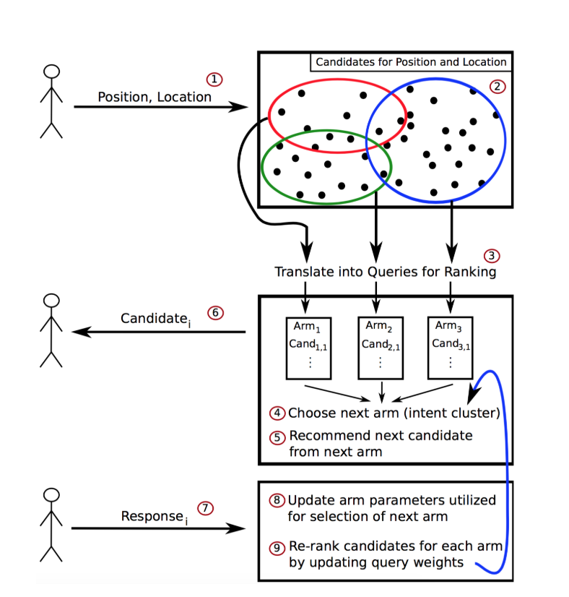

When applying these models to KTP, universities can upload their proposed projects for specific industry and the recruiters can search for projects in their respective domain and vice versa. Another possibility is that model matches projects on basis of similarity and help recruiters and university to contact each other. As the model used by LinkedIn also scores the profiles according to similarity in interest so this can be a good approach to use for KTP searches.

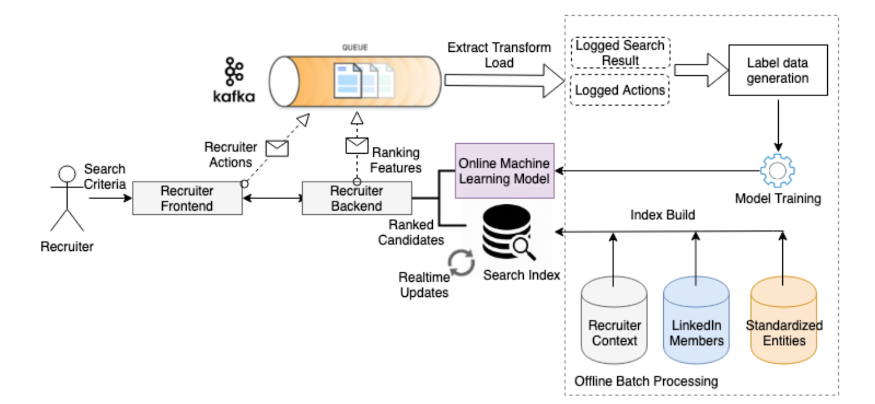
Another example is to use matrix completion problem to solve this problem. Natural language processing can be applied on project descriptions or on bio of the students can be applied to extract keywords and on similarity can be found by matrix completion. Same algorithm is used by Netflix, IMDB or many other e-commerce websites for recommending movies or products.
Another approach is the use of Elastic search which is used by Uber, Adobe and HEB Grocery stores. It is an opensource product that can be implemented on websites for data analysis and searching.

