Q: What is Grid Search?
A: Grid search is method of finding values of specific parameters from a rectangular grid of values.

Q: What is Model Selection?
A: Model selection is a process of selecting the best machine learning model from a collection of models for a specific dataset. Model selection can be applied for selecting best model from different models, selecting variable from the dataset or selecting best parametric value.

Q: What are two main criterion of model selection?
A: There are two main types of criteria on which model selection is done:
- Probabilistic Measures: Model selection on basis of in-sample error and complexity. Examples are AIC and BIC
- Resampling Methods: Model Selection on basis of estimated out-of-sample error. Example is K-Fold Cross-Validation
Q: What are some model selection techniques?
A: Some basic method used for model selection are:
- Akaike Information Criterion (AIC)
- Bayesian Information Criterion (BIC)
- K-fold Cross Validation
Q: What is AIC and BIC
A: AIC and BIC are used to compare the Statistical models on basis of variables or variable values. It takes into account how much is a variable contributing to solving a problem. For example, if we have a regression models which are being tested on basis of four variables A1, A2, A3 and A4, AIC and BIC try to fit regression model with different combinations of these variables and calculates the value using formula:
(2.18)

Here, K is number of parameters used to fit the model and log-likelihood checks if the model is a good fit or not.
(2.19)

Here, n is number of values in the dataset (sample size), k is number of parameters and is likelihood of model being a good fit.
Number of combinations for variables can be calculated by . Here N is number of total variables. Combination of these values are:
- A1
- A2
- A3
- A4
- A1, A2
- A1, A3
- A1, A4
- A2, A3
- A2, A4
- A3, A4
- A1, A2, A3
- A1, A2, A4
- A2, A3, A4
- A1, A3, A4
- A1, A2, A3, A4
As number of variables are 4 so number of combinations will be .
For each combination regression model is fit and AIC and BIC values are calculated using 2.18 and 2.19 respectively. Combination with the minimum value of AIC or BIC is selected as the best model.
Q: Compare AIC and BIC.
A: When comparing the two models BIC puts a higher penalty term than BIC, BIC is more tolerable than AIC at higher numbers.

Q: What is K-fold Cross-Validation?
A: When training a model, we have a dataset let’s say containing 100 observations. We can either take the whole dataset and train our model on it. After that we can test our model on the same dataset but this would be a bad practice as the model has already seen those observations and can predict accurately with 100% accuracy this time. Second scenario would be to divide our dataset into training and test dataset. We train model on training data and test accuracy on test data but doing this we lose test data while training. In this scenario K-fold cross validation comes into view. A simple representation of how K-fold cross validation works is shown in figure 2.4.
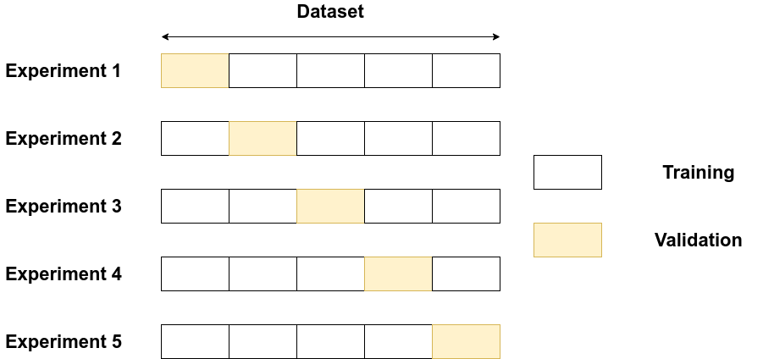
Figure 2.4: Data division in K-fold cross-validation
The example shown in 5-fold cross-validation. Dataset is divided into 5 parts where 4 parts are used as training and 1 part is used for testing. In all the experiments 1-5, all the dataset is used in training and over all score is calculated on basis of all 5 experiments.
Are you familiar with GridSearchCV function in scikit-learn’s model_selection package?
What are predefined hyperparameters?
What are the optimal values for the hyperparameters of a model?
Are you familiar with Cross-Validation?
What are grid parameters?
How is Grid search different from Random search?
Are you familiar with the difference between model parameter and hyperparameter? Can you provide an example?
Can hyperparameters affect our model performance in any way?
Considering decision tree as a hyperparameter, what should be the value for the maximum depth of the Decision Tree?
Considering decision tree as a hyperparameter, what should be the minimum sample split value for Decision Tree?
Considering decision tree as a hyperparameter, what value should I select for the minimum sample leaf for my Decision Tree?
Considering random forest as a hyperparameter, how many trees should I select in a Random Forest model?

