Part 1: GDB Session

Part 1.h
[tfrench@engr312-814 Lab00]$ gdb
GNU gdb (GDB) Red Hat Enterprise Linux 7.6.1-110.el7
Copyright (C) 2013 Free Software Foundation, Inc.
License GPLv3+: GNU GPL version 3 or later <http://gnu.org/licenses/gpl.html>
This is free software: you are free to change and redistribute it.
There is NO WARRANTY, to the extent permitted by law. Type "show copying"
and "show warranty" for details.
This GDB was configured as "x86_64-redhat-linux-gnu".
For bug reporting instructions, please see:
<http://www.gnu.org/software/gdb/bugs/>.
(gdb) print "John Doe"
$1 = "John Doe"
(gdb) print 345/10
$2 = 34
(gdb) print 345%10
$3 = 5
(gdb) p/d 345/10
$4 = 34
(gdb) p/t 345/10
$5 = 100010
(gdb) p/o 345/10
$6 = 042
(gdb) p/x 345/10
$7 = 0x22

These are the commands I executed in order to accomplish steps c-g of this lab.

Part 1.i
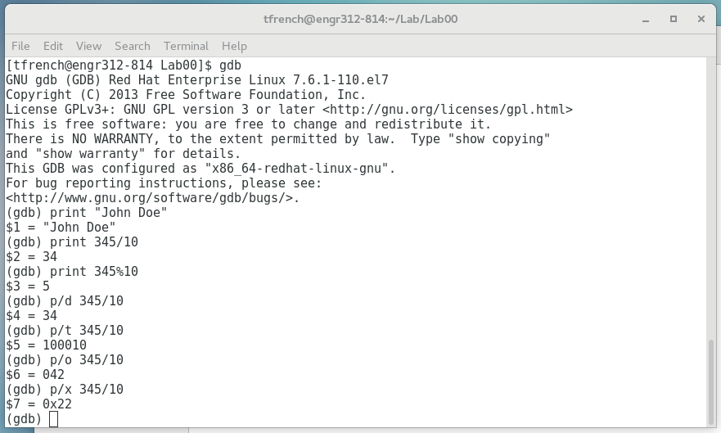
Part 2: Research

Part 2.a
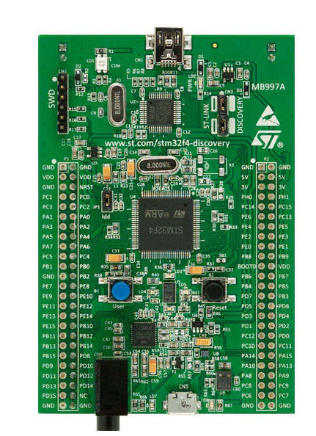 | The STM32F4DISCOVERY kit leverages the capabilities of the STM32F407 high performance microcontrollers, to allow users to easily develop applications featuring audio.

This is a picture of the board we will be using in future labs, along with a short description of what it does. (https://www.st.com/en/evaluation-tools/stm32f4discovery.html)

Part 2.b
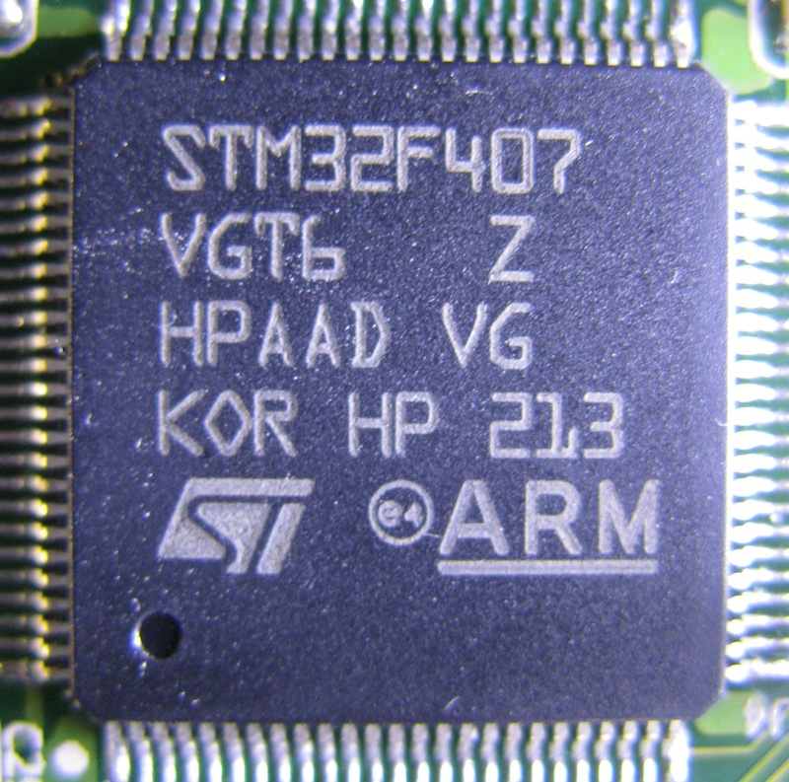 | High-performance and DSP with FPU, ARM Cortex-M4 MCU with 1 Mbyte Flash, 192 Kbyte RAM, 168 MHz CPU, Art Accelerator  - 1 Mbyte of 128 bit wide FLASH with 64 cache lines with prefetch for instructions and 8 cache lines for data.  - Ethernet MAC - 10/100 Mbit/s  - USB - 1 x USB OTG FS, 1 x USB OTX HS  - CRC calculation unit - CRC-32 (Ethernet)  - Hash processor - SHA-1, SHA-224, SHA-256, MD5, HMAC  - Cryptographic processor - DES, Triple-DES, AES-128, AES-192, AES-256  - Flexible static memory controller (FSMC) for 8 or 16 bit external memory  - Random number generator - 32 bit every 40 cycles of PLL48CLK

This is a picture of the microcontroller we will be using in future labs, along with a short description of what it does. (https://www.sciencezero.org/index.php?title=STM32F407_Microcontroller)
Part 3: Introduction
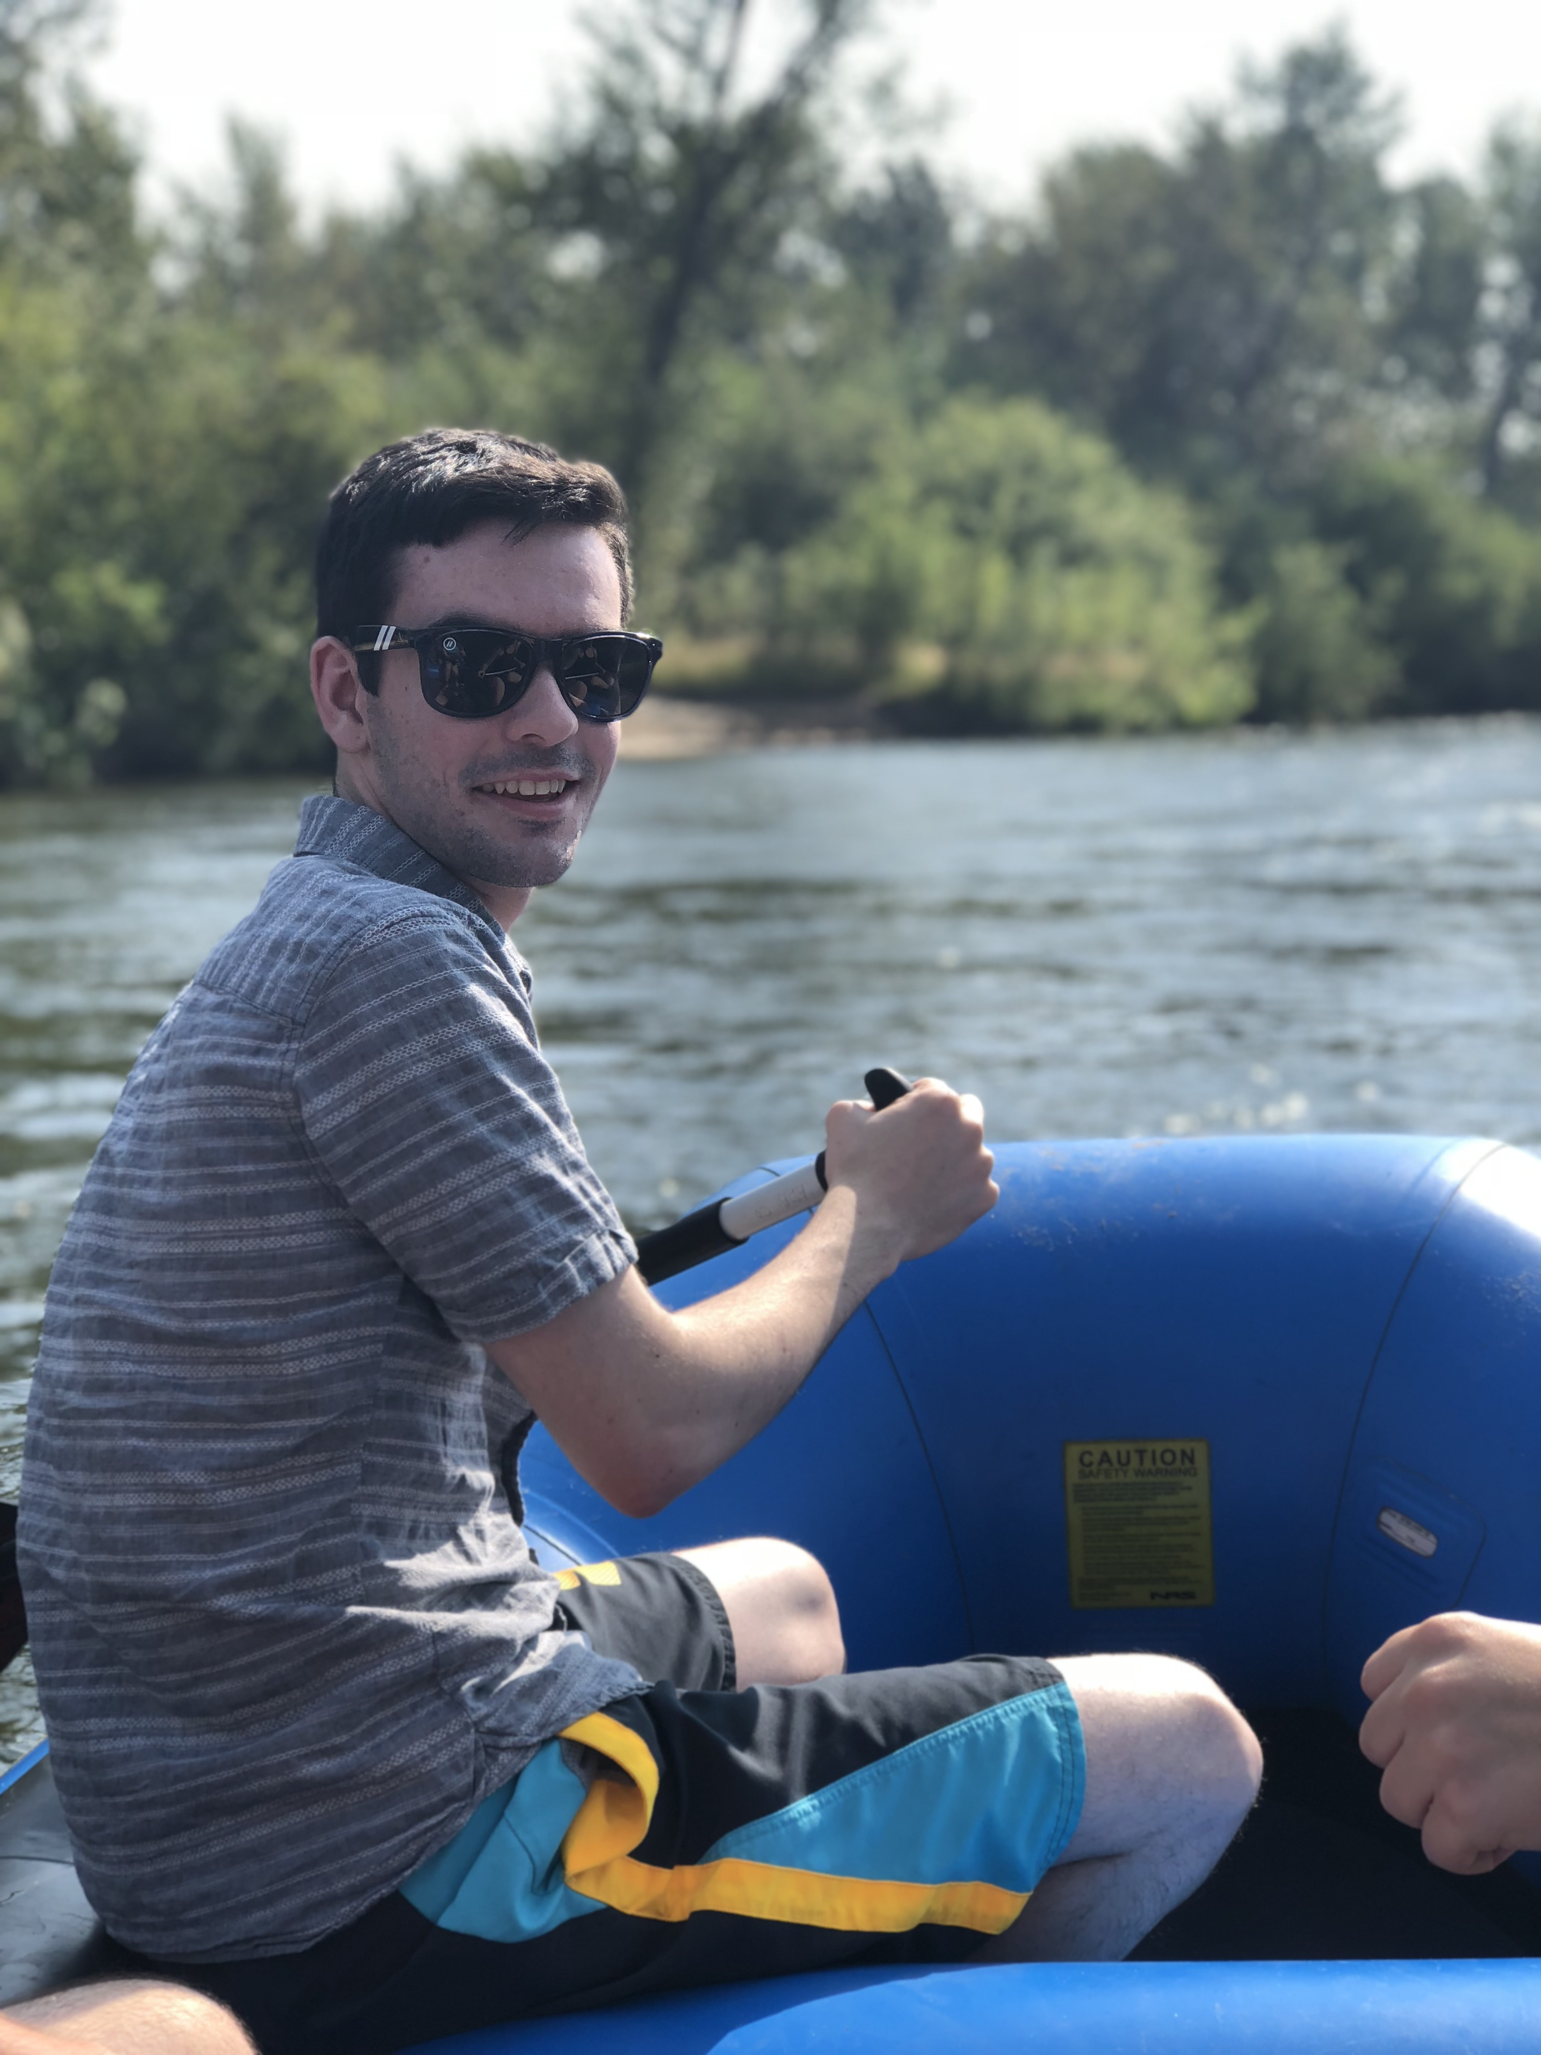
About Me: Tyler French

Hello! My name is Tyler French, and I am a third-year Computer Science major with an emphasis in Cybersecurity.

Within my major, I am very interested in web development and machine learning. Otherwise, I have interest in art, video game development, piano, and video games.

A fun fact is that I have an identical twin, but he doesn’t go here. I am from Tualatin, Oregon, which is about 20 minutes south of Portland.

