CPE301 – SPRING 2019

Design Assignment X

Student Name: Tyler Gardenhire

Student #: 8000450294

Student Email: gardenhi@unlv.nevada.edu

Primary Github address: [gardenhi@unlv.nevada.edu](mailto:gardenhi@unlv.nevada.edu)

Directory: https://github.com/tylergardenhire/submission_projects.git

Submit the following for all Labs:

1. In the document, for each task submit the modified or included code (only) with highlights and justifications of the modifications. Also, include the comments.
2. Use the previously create a Github repository with a random name (no CPE/301, Lastname, Firstname). Place all labs under the root folder ESD301/DA, sub-folder named LABXX, with one document and one video link file for each lab, place modified asm/c files named as LabXX-TYY.asm/c.
3. If multiple asm/c files or other libraries are used, create a folder LabXX-TYY and place these files inside the folder.
4. The folder should have a) Word document (see template), b) source code file(s) and other include files, c) text file with youtube video links (see template).

1. **COMPONENTS LIST AND CONNECTION BLOCK DIAGRAM w/ PINS**

Atmel Studio 7 w/ AVR assembly and simulator used

1. **INITIAL/MODIFIED/DEVELOPED CODE OF TASK 1/A**

Assembly Code for AVR ATMEGA328p microcontroller:

;

; Project1A.asm

;

; Created: 2/9/2019 11:21:57 PM

; Author : Tyler Gardenhire

start:

ldi r25, 0xFF ;upper register used for multiplicand (16-bit value)

ldi r24, 0xFF ;lower register used for multiplicand (16-bit value)

ldi r22, 0xFF ;register used for multiplier (8-bit value)

ldi r23, 0 ;register used to hold 0

loop: ;adds the multiplicand to itself multiplier number of times

add r18, r24 ;add bottom group of bits

adc r19, r25 ;if overflow, add next group of bits

adc r20, r23 ;if more overflow, add top group of bits

dec r22 ;r22 is now used as a "counter"

cp r22, r23 ;compare counter to zero

brne loop ;if they are not equal, jump to start of loop

done: jmp done

1. **DEVELOPED MODIFIED CODE OF TASK 2/A from TASK 1/A**

C++ code to verify Assembly code:

#include <iostream>

#include <cmath>

using namespace std;

int main()

{

int multiplicand, multiplier;

cout << "Multiplicand(16-bit value) = ";

cin >> hex >> multiplicand;

cout << "Multiplier(8-bit value) = ";

cin >> hex >> multiplier;

int result = multiplicand * multiplier;

cout << hex << result << endl;

return 0;

}

1. **SCHEMATICS**

N/A

1. **SCREENSHOTS OF EACH TASK OUTPUT (ATMEL STUDIO OUTPUT)**

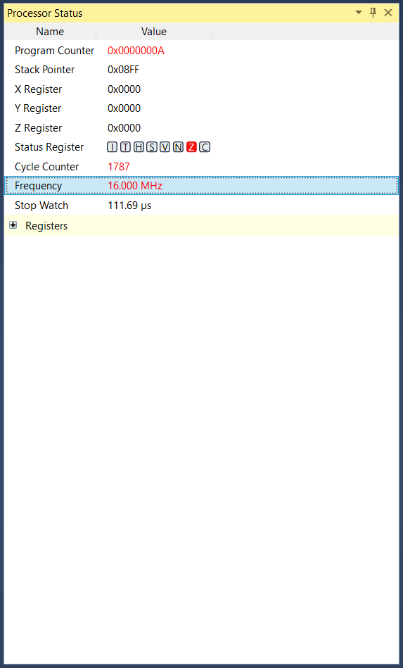Registers Before Execution Registers After Execution Execution Time

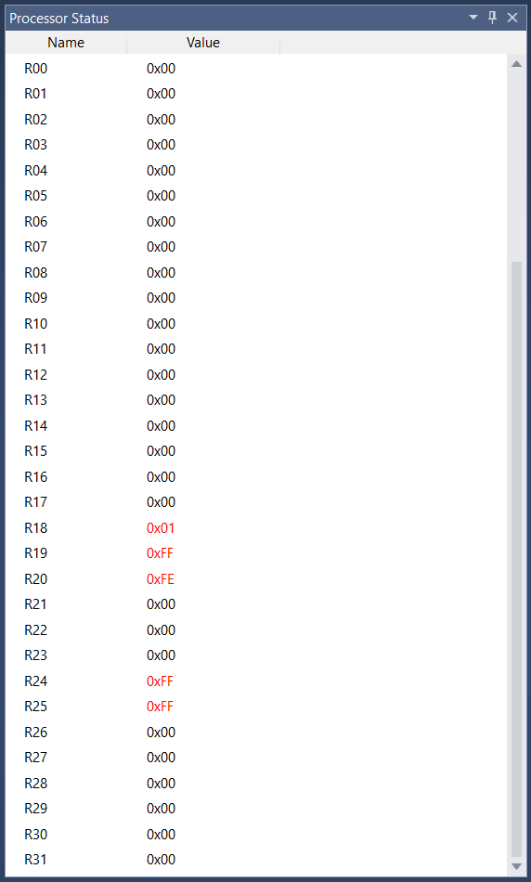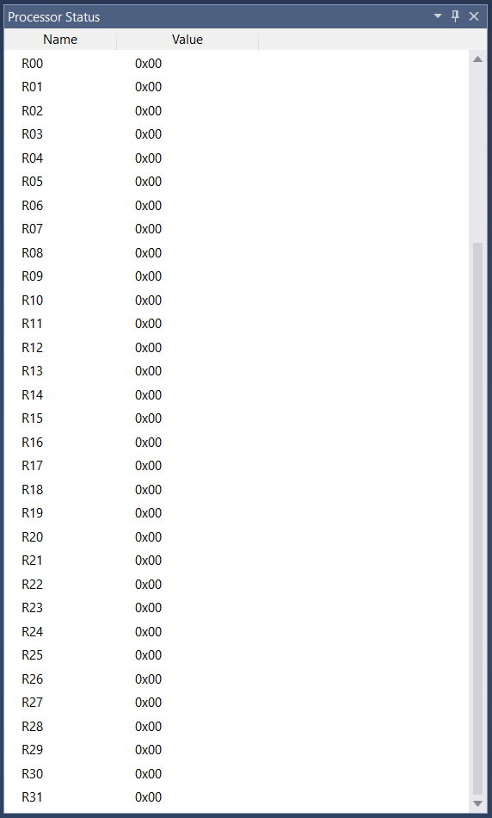

1. **SCREENSHOT OF EACH DEMO (BOARD SETUP)**

N/A

1. **VIDEO LINKS OF EACH DEMO**

N/A

1. **GITHUB LINK OF THIS DA**

https://github.com/tylergardenhire/submission_projects.git

**Student Academic Misconduct Policy**

<http://studentconduct.unlv.edu/misconduct/policy.html>

“This assignment submission is my own, original work”.

TYLER GARDENHIRE