CPE301 – SPRING 2019

Design Assignment 1B

Student Name: Tyler Gardenhire

Student #: 8000450294

Student Email: gardenhi@unlv.nevada.edu

Primary Github address: [gardenhi@unlv.nevada.edu](mailto:gardenhi@unlv.nevada.edu)

Directory: https://github.com/tylergardenhire/submission_projects.git

Submit the following for all Labs:

1. In the document, for each task submit the modified or included code (only) with highlights and justifications of the modifications. Also, include the comments.
2. Use the previously create a Github repository with a random name (no CPE/301, Lastname, Firstname). Place all labs under the root folder ESD301/DA, sub-folder named LABXX, with one document and one video link file for each lab, place modified asm/c files named as LabXX-TYY.asm/c.
3. If multiple asm/c files or other libraries are used, create a folder LabXX-TYY and place these files inside the folder.
4. The folder should have a) Word document (see template), b) source code file(s) and other include files, c) text file with youtube video links (see template).

1. **COMPONENTS LIST AND CONNECTION BLOCK DIAGRAM w/ PINS**

Atmel Studio 7 w/ AVR assembly and simulator used

1. **INITIAL/MODIFIED/DEVELOPED CODE OF TASK 1/A**

Assembly Code for AVR ATMEGA328p microcontroller:

;

; Project1B.asm

;

; Created: 2/23/2019 6:31:12 PM

; Author : Tyler Gardenhire

;

.include <m328pdef.inc> ;standard library

.EQU STARTADDS = 0x0200 ;starting address

.EQU DIVBY3 = 0x0400 ;starting address of numbers divisible by 3

.EQU NOTDIVBY3 = 0x0600 ;starting address of numbers not divisible by 3

ldi r20, 99 ;counter

ldi r21, 11 ;numbers stored in memory

ldi r22, 0 ;zero

ldi XL, low(STARTADDS) ;stores lower address value (0x00)

ldi XH, high(STARTADDS) ;stores higher address value (0x02)

ldi YL, low(DIVBY3) ;stores lower address value (0x00)

ldi YH, high(DIVBY3) ;stores higher address value (0x04)

ldi ZL, low(NOTDIVBY3) ;stores lower address value (0x00)

ldi ZH, high(NOTDIVBY3) ;stores higher address value (0x06)

store: st X+, r21 ;loop to store numbers

inc r21 ;increment the value to store

dec r20 ;decrement counter

brne store ;if counter not equal to 0, loop to store

ldi XL, low(STARTADDS) ;load lower address value to read values from

ldi XH, high(STARTADDS) ;load higher address value to read

ldi r20, 99 ;re-load counter

check: ld r23, X+ ;checks for divisibility by 3

mov r24, r23 ;use r24 as temp value for divisibility

divisibility: subi r24, 3 ;subtract by 3

breq divisibleby3 ;if 0, value is divisible by 3

brmi notdivisibleby3 ;if negative, value is not divisible by 3

rjmp divisibility ;if neither, loop back to divisibility

divisibleby3: st Y+, r23 ;store value in 0x0400 if divisible by 3

add r16, r23 ;add sum to r16

adc r17, r22 ;increase sum to 16 bits

dec r20 ;decrement counter

breq done ;if counter equals 0, done

rjmp check ;if not, check next value

notdivisibleby3: st Z+, r23 ;store value in 0x0600

add r18, r23 ;add sum to r18

adc r19, r22 ;increase sum to 16 bits

dec r20 ;decrement counter

breq done ;if counter equals 0, done

rjmp check ;if not, check next value

1. **DEVELOPED MODIFIED CODE OF TASK 2/A from TASK 1/A**

C++ code to verify Assembly code:

#include <iostream>

using namespace std;

int main()

{

int num = 11;

int div3sum, notdiv3sum;

for (int i = 0; i < 99; i++)

{

if ((num % 3) != 0)

notdiv3sum += num;

else

div3sum += num;

num++;

}

cout << "Sum of numbers divisible by 3 = " << hex << div3sum << endl;

cout << "Sum of numbers not divisible by 3 = " << hex << notdiv3sum << endl;

return 0;

}

1. **SCHEMATICS**

N/A

1. **SCREENSHOTS OF EACH TASK OUTPUT (ATMEL STUDIO OUTPUT)**

Task 1:

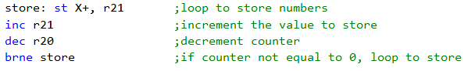

This portion of code uses the X pointer to store all 99 numbers.

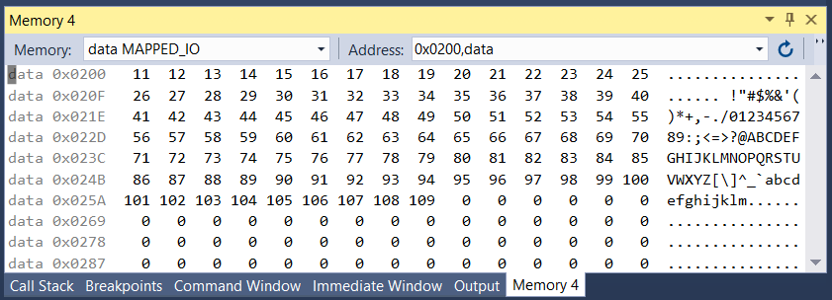

Starting address (STARTADDS) is 0x0200, all 99 numbers stored in consecutive order at this address.

Task 2:

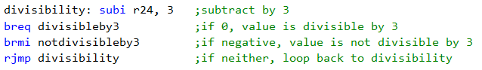

This portion of code determines whether the number is divisible by 3 or not by looping a subtract instruction. If the value ends up being 0, the number is divisible by 3 but if the value ends up being negative, the number is not divisible by 3.

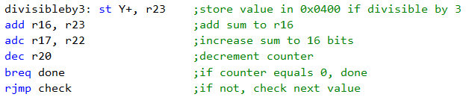

This portion of code stores all numbers divisible by 3 into the address located in the Y pointer (0x0400) and stores their sum into registers r16 and r17.

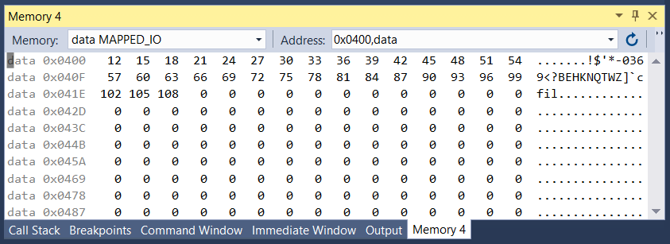

All numbers divisible by 3 are in order, starting at address 0x0400.

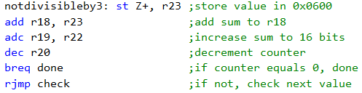

This portion of code stores all numbers not divisible by 3 into the address located in the Z pointer (0x0600) and stores their sum into registers r18 and r19.

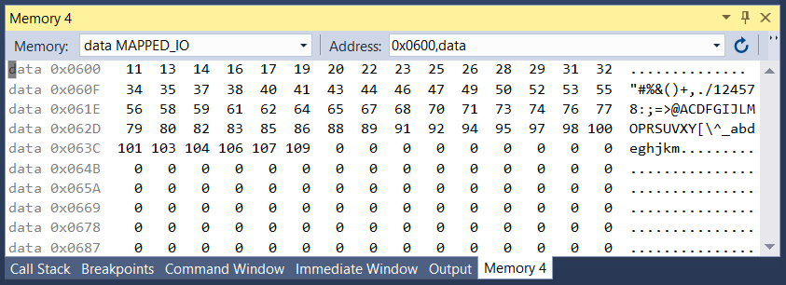

All numbers not divisible by 3 are in order, starting at address 0x0600.

Task 3:

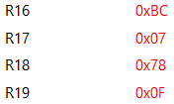

The screenshot above shows registers r16-r17 filled with the sum of numbers divisible by 3 (0x07BC) and registers r18-r19 filled with the sum of numbers not divisible by 3 (0x0F78).

Task 4:

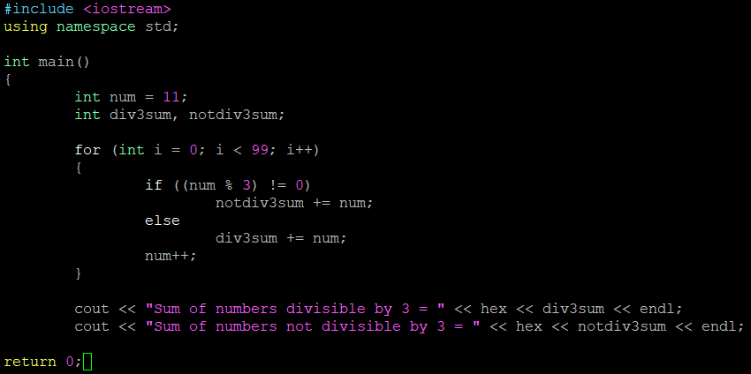This C++ code verifies the assembly code by using for loops and modulus to check for numbers divisible by 3.



The output of the C++ code verifies our above values (0x07BC and 0x0F78).

Task 5:

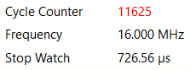

The above screenshot shows the execution time and cycle counter when using a frequency of 16 MHz.

1. **SCREENSHOT OF EACH DEMO (BOARD SETUP)**

N/A

1. **VIDEO LINKS OF EACH DEMO**

N/A

1. **GITHUB LINK OF THIS DA**

https://github.com/tylergardenhire/submission_projects.git

**Student Academic Misconduct Policy**

<http://studentconduct.unlv.edu/misconduct/policy.html>

“This assignment submission is my own, original work”.

TYLER GARDENHIRE