CPE301 – SPRING 2019

Design Assignment 3B

Student Name: Tyler Gardenhire

Student #: 8000450294

Student Email: gardenhi@unlv.nevada.edu

Primary Github address: [gardenhi@unlv.nevada.edu](mailto:gardenhi@unlv.nevada.edu)

Directory: https://github.com/tylergardenhire/submission_projects.git

Submit the following for all Labs:

1. In the document, for each task submit the modified or included code (only) with highlights and justifications of the modifications. Also, include the comments.
2. Use the previously create a Github repository with a random name (no CPE/301, Lastname, Firstname). Place all labs under the root folder ESD301/DA, sub-folder named LABXX, with one document and one video link file for each lab, place modified asm/c files named as LabXX-TYY.asm/c.
3. If multiple asm/c files or other libraries are used, create a folder LabXX-TYY and place these files inside the folder.
4. The folder should have a) Word document (see template), b) source code file(s) and other include files, c) text file with youtube video links (see template).

1. **COMPONENTS LIST AND CONNECTION BLOCK DIAGRAM w/ PINS**

Atmel Studio 7 w/ AVR assembly and simulator and Atmega328p board used.

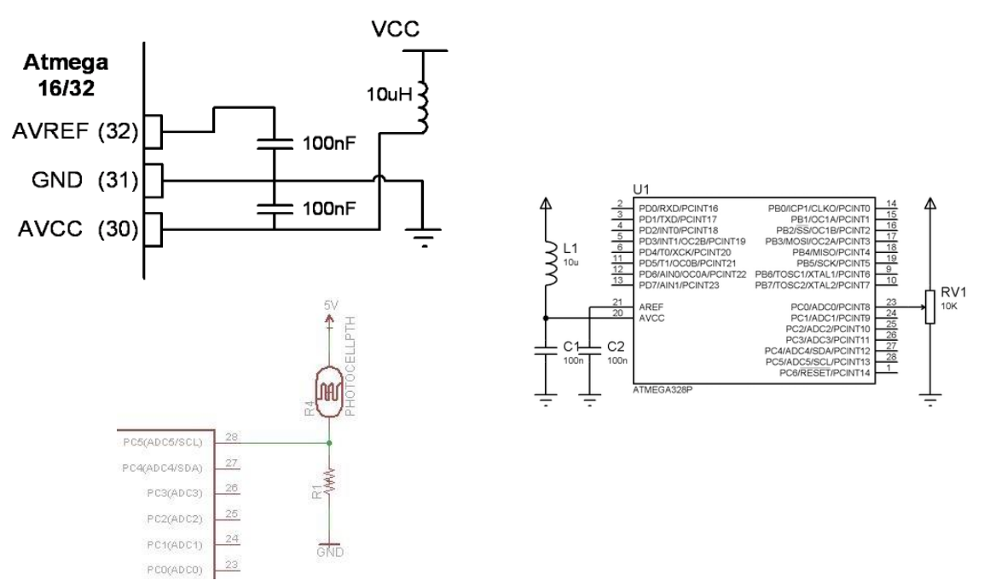

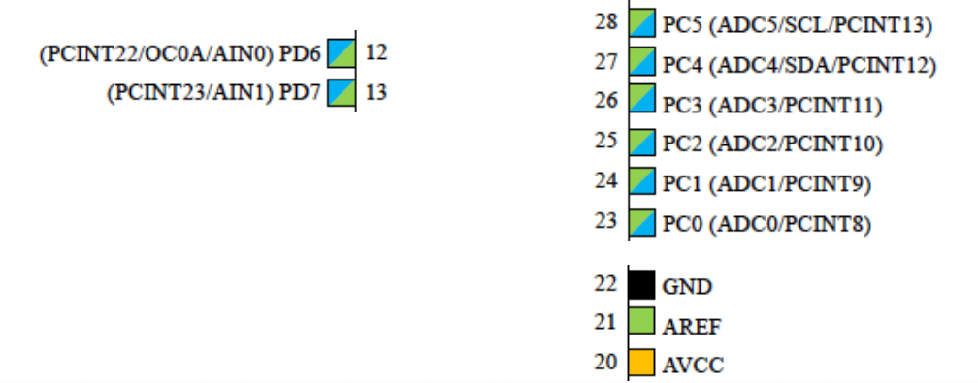

1. **INITIAL/MODIFIED/DEVELOPED CODE OF TASK 1/A**

Task 1 C code:

#define *F_CPU* 16000000UL

#define BAUD_RATE 9600

#include <avr/io.h>

#include <util/delay.h>

#include <avr/interrupt.h>

void timer_init ();

void usart_init ();

void adc_init ();

void usart_send (unsigned char ch);

int main (void)

{

timer_init ();

usart_init ();

adc_init ();

while (1)

{

ADCSRA|=(1<<ADSC);

while((ADCSRA&(1<<ADIF))==0); //finish conversion

ADCSRA |= (1<<ADIF);

int a = ADCL;

a = a | (ADCH<<8);

a = (a/1024.0) * 5000/10;

usart_send((a/100)+'0');

a = a % 100;

usart_send((a/10)+'0');

a = a % 10;

usart_send((a)+'0');

usart_send('\r');

*_delay_ms*(100);

}

return 0;

}

ISR (TIMER1_OVF_vect)

{

ADCSRA|=(1<<ADSC);

while((ADCSRA&(1<<ADIF))==0); //finish conversion

ADCSRA |= (1<<ADIF);

int a = ADCL;

a = a | (ADCH<<8);

a = (a/1024.0) * 5000/10;

usart_send((a/100)+'0');

a = a % 100;

usart_send((a/10)+'0');

a = a % 10;

usart_send((a)+'0');

usart_send('\r');

*_delay_ms*(100);

TCNT1 = 49911; //reset timer

}

void usart_init (void)

{

UCSR0B = (1<<TXEN0);

UCSR0C = (1<< UCSZ01)|(1<<UCSZ00);

UBRR0L = *F_CPU*/16/BAUD_RATE-1;

}

void adc_init (void)

{

//enable and setup adc

ADMUX = (0<<REFS1)| // Reference Selection Bits

(1<<REFS0)| // AVcc - external cap at AREF

(0<<ADLAR)| // ADC Left Adjust Result

(1<<MUX2)| // Analog Channel Selection Bits

(0<<MUX1)| // ADC4 (PC4 PIN27)

(1<<MUX0);

ADCSRA = (1<<ADEN)| // ADC Enable

(0<<ADSC)| // ADC Start Conversion

(0<<ADATE)| // ADC Auto Trigger Enable

(0<<ADIF)| // ADC Interrupt Flag

(0<<ADIE)| // ADC Interrupt Enable

(1<<ADPS2)| // ADC Prescaler Select Bits

(0<<ADPS1)|

(1<<ADPS0);

}

void timer_init (void)

{

TCCR1B |= 5; //set prescaler to 1024

TIMSK1 = (1 << TOIE1); //enable overflow flag

TCNT1 = 49911; //1 second delay is (0xFFFF)-TCNT=65535-15624=49911

sei();

}

void usart_send (unsigned char ch)

{

while (! (UCSR0A & (1<<UDRE0))); //wait until UDR0 is zero

UDR0 = ch; //transmit ch

}

void usart_print(char* str)

{

int i = 0;

while(str[i] != 0)

usart_send(str[i]);

}

1. **DEVELOPED MODIFIED CODE OF TASK 2/A from TASK 1/A**

N/A

1. **SCHEMATICS**

N/A

1. **SCREENSHOTS OF EACH TASK OUTPUT (ATMEL STUDIO OUTPUT)**

Task 1:

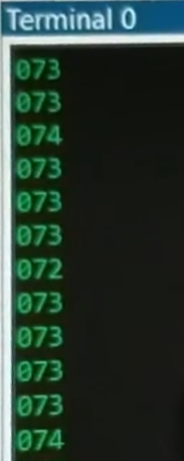

1. **SCREENSHOT OF EACH DEMO (BOARD SETUP)**

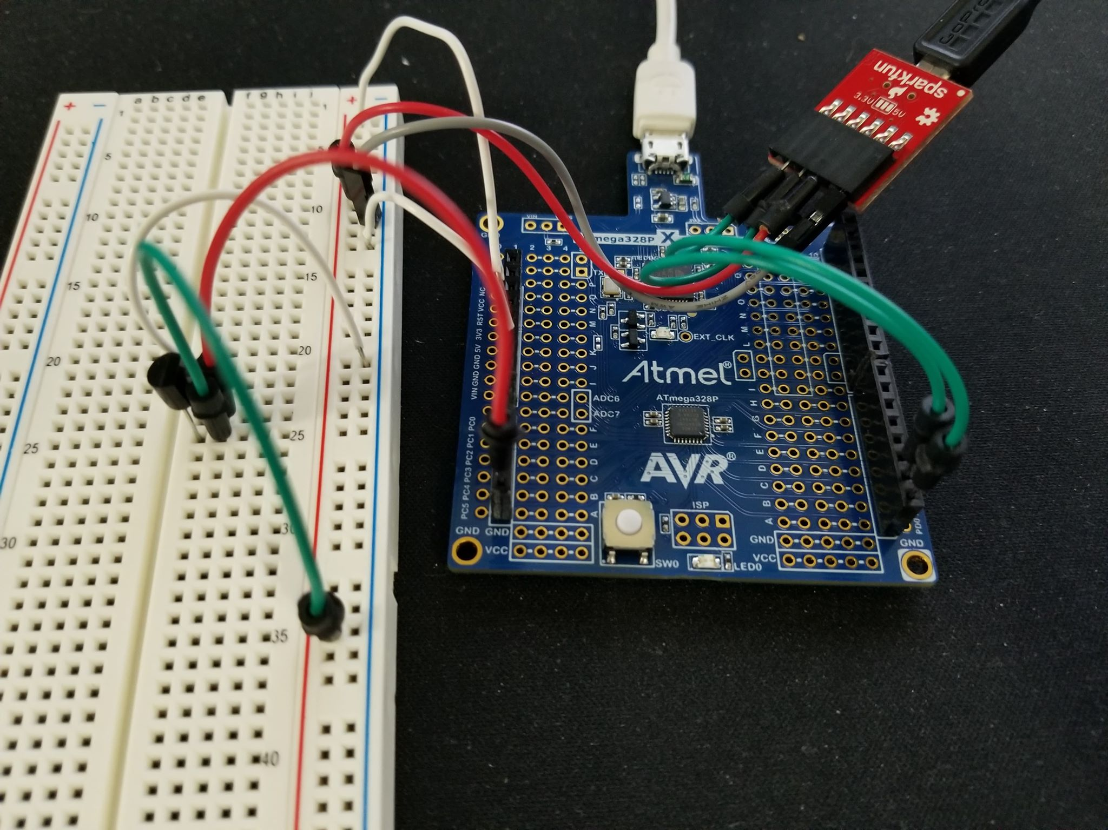

1. **VIDEO LINKS OF EACH DEMO**

<https://youtu.be/PsAJWG_PaiQ>

1. **GITHUB LINK OF THIS DA**

https://github.com/tylergardenhire/submission_projects.git

**Student Academic Misconduct Policy**

<http://studentconduct.unlv.edu/misconduct/policy.html>

“This assignment submission is my own, original work”.

TYLER GARDENHIRE