CPE301 – SPRING 2019

Design Assignment 4A

Student Name: Tyler Gardenhire

Student #: 8000450294

Student Email: gardenhi@unlv.nevada.edu

Primary Github address: [gardenhi@unlv.nevada.edu](mailto:gardenhi@unlv.nevada.edu)

Directory: https://github.com/tylergardenhire/submission_projects.git

Submit the following for all Labs:

1. In the document, for each task submit the modified or included code (only) with highlights and justifications of the modifications. Also, include the comments.
2. Use the previously create a Github repository with a random name (no CPE/301, Lastname, Firstname). Place all labs under the root folder ESD301/DA, sub-folder named LABXX, with one document and one video link file for each lab, place modified asm/c files named as LabXX-TYY.asm/c.
3. If multiple asm/c files or other libraries are used, create a folder LabXX-TYY and place these files inside the folder.
4. The folder should have a) Word document (see template), b) source code file(s) and other include files, c) text file with youtube video links (see template).

1. **COMPONENTS LIST AND CONNECTION BLOCK DIAGRAM w/ PINS**

Atmel Studio 7 w/ AVR assembly and simulator, Atmega328p board, DC motor, and potentiometer used.

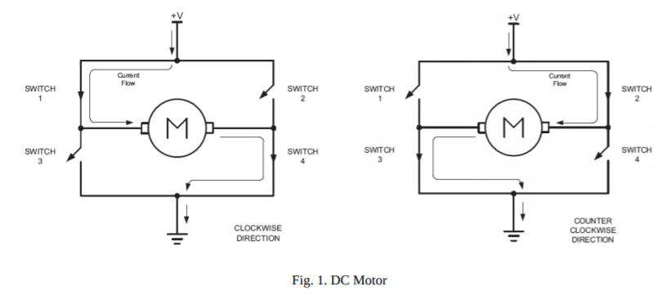

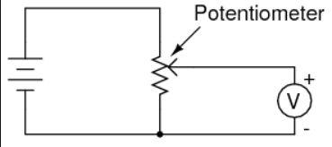

1. **INITIAL/MODIFIED/DEVELOPED CODE OF TASK 1/A**

Task 1 C code:

#define *F_CPU* 8000000UL

#include <avr/io.h>

#include <util/delay.h>

#define ENABLE 6

#define MTR_1 1

#define MTR_2 2

#define SW (PINC&(1<<1))

int main()

{

PORTC |= (1<<1); //Enable pull-up

DDRB |= 0b00000111; //PB0, PB1, and PB2 as outputs

PORTD &= ~(1<<ENABLE); //Enable = 0

PORTB &= ~(1<<MTR_1); //MTR_1 = 0

PORTB &= ~(1<<MTR_2); //MTR_2 = 0

DDRD |= (1<<6); //OC0A as output

OCR0A = 50;

//Fast PWM, non-inverted

TCCR0A = (1<<COM0A1) | (1<<WGM01) | (1<<WGM00);

TCCR0B = 0x02; //N = 8

while(1)

{

PORTD |= (1<<ENABLE); //Enable = 1

if(SW != 0) //if PD7 is high

{

//Clockwise Rotation

*_delay_ms*(20);

PORTB |= (1<<MTR_1); //MTR_1 = 1

PORTB &= (~(1<<MTR_2)); //MTR_2 = 0

}

else

{

//Off

*_delay_ms*(20);

PORTB &= (~(1<<MTR_1)); //MTR_1 = 0

PORTB &= (~(1<<MTR_2)); //MTR_2 = 0

}

*_delay_ms*(1000);

if (OCR0A > 250)

OCR0A = 50;

else

OCR0A = OCR0A + 25;

}

}

1. **DEVELOPED MODIFIED CODE OF TASK 2/A from TASK 1/A**

N/A

1. **SCHEMATICS**

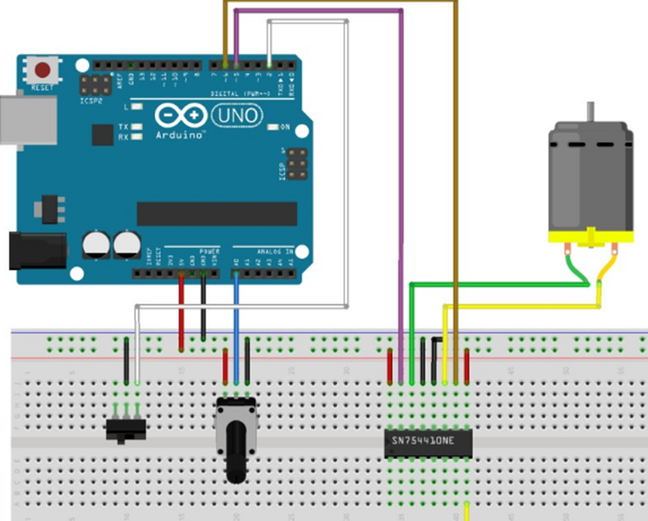N/A

1. **SCREENSHOTS OF EACH TASK OUTPUT (ATMEL STUDIO OUTPUT)**

N/A

1. **SCREENSHOT OF EACH DEMO (BOARD SETUP)**

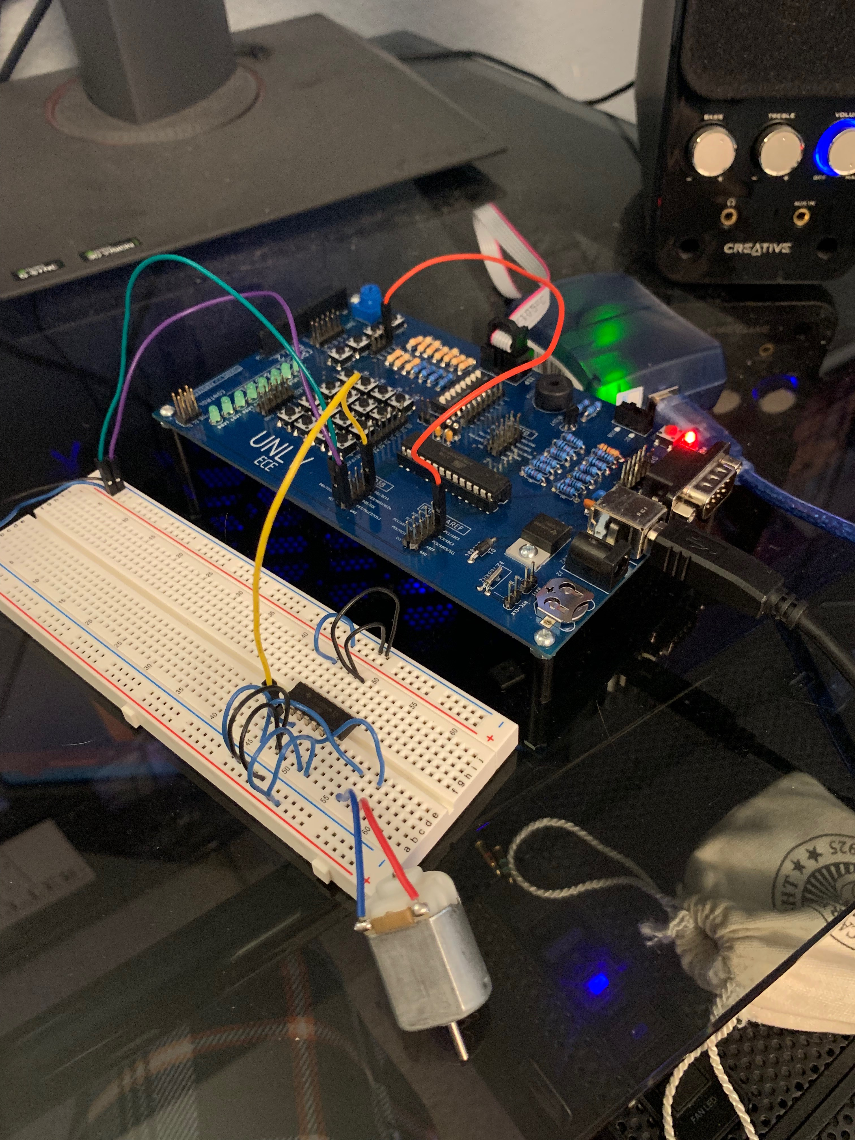

1. **VIDEO LINKS OF EACH DEMO**

<https://youtu.be/gByFVQdgRBs>

1. **GITHUB LINK OF THIS DA**

https://github.com/tylergardenhire/submission_projects.git

**Student Academic Misconduct Policy**

<http://studentconduct.unlv.edu/misconduct/policy.html>

“This assignment submission is my own, original work”.

TYLER GARDENHIRE