CPE301 – SPRING 2019

Design Assignment 5

Student Name: Tyler Gardenhire

Student #: 8000450294

Student Email: gardenhi@unlv.nevada.edu

Primary Github address: [gardenhi@unlv.nevada.edu](mailto:gardenhi@unlv.nevada.edu)

Directory: https://github.com/tylergardenhire/submission_projects.git

Submit the following for all Labs:

1. In the document, for each task submit the modified or included code (only) with highlights and justifications of the modifications. Also, include the comments.
2. Use the previously create a Github repository with a random name (no CPE/301, Lastname, Firstname). Place all labs under the root folder ESD301/DA, sub-folder named LABXX, with one document and one video link file for each lab, place modified asm/c files named as LabXX-TYY.asm/c.
3. If multiple asm/c files or other libraries are used, create a folder LabXX-TYY and place these files inside the folder.
4. The folder should have a) Word document (see template), b) source code file(s) and other include files, c) text file with youtube video links (see template).

1. **COMPONENTS LIST AND CONNECTION BLOCK DIAGRAM w/ PINS**

Atmel Studio 7 w/ AVR assembly and simulator, Atmega328p board.

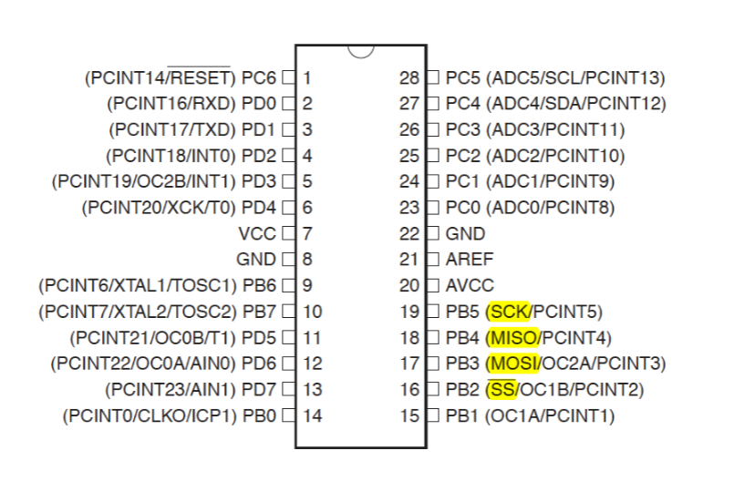

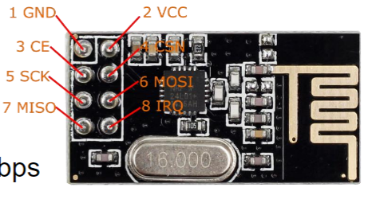

1. **INITIAL/MODIFIED/DEVELOPED CODE OF TASK 1/A**

Task 1 C code:

//set clock frequency

#define *F_CPU* 16000000UL

#include <avr/io.h>

#include <util/delay.h>

#include <avr/interrupt.h>

#include <stdbool.h>

#include <stdio.h>

#include <string.h>

// Set up UART for printf();

#define BAUD 9600

#include "inc\STDIO_UART.c"

// Include nRF24L01+ library

#include "inc\nrf24l01.c"

#include "inc\nrf24l01-mnemonics.h"

#include "inc\spi.c"

void print_config(void);

// Used in IRQ ISR

volatile bool message_received = false;

volatile bool status = false;

void ADC_init (void);

volatile unsigned char ADCtemp[5];

volatile *uint8_t* ADCvalue;

int main(void)

{

//set message to send

char tx_message[32]; //define string array

*strcpy*(tx_message,"It's working!"); //copy string into array

uart_init(); //initialize UART

ADC_init(); //initialize ADC

nrf24_init(); //initialize nRF24L01+

print_config();

nrf24_start_listening(); //listen to incoming messages

*strcpy*(tx_message,"Initializing Chat Room..."); //copy string into array

nrf24_send_message(tx_message);

while (1)

{

if (message_received)

{

//print message

message_received = false;

*printf*("Received Temperature: %s\n\n",nrf24_read_message());

// Send message as response

*_delay_ms*(500);

status = nrf24_send_message(ADCtemp);

if (status == true) *printf*("Temperature Successfully Sent\n\n");

}

}

}

//interrupt on IRQ pin

ISR(INT0_vect)

{

message_received = true;

}

//interrupt for Temperature Sensor

ISR(ADC_vect)

{

volatile unsigned int j=0;

char temp[5];

ADCvalue = (ADCH << 1); //shifts the value left to one place

*itoa*(ADCvalue, temp, 10); //converts integers to string

while (j<5) //transfers the temp string from itoa() to ADCtemp

{

ADCtemp[j] = temp[j];

j++;

}

}

//prints configuration

void print_config(void)

{

*uint8_t* data;

*printf*("Startup successful\n\n nRF24L01+ configured as:\n");

*printf*("-------------------------------------------\n");

nrf24_read(CONFIG,&data,1);

*printf*("CONFIG 0x%x\n",data);

nrf24_read(EN_AA,&data,1);

*printf*("EN_AA 0x%x\n",data);

nrf24_read(EN_RXADDR,&data,1);

*printf*("EN_RXADDR 0x%x\n",data);

nrf24_read(SETUP_RETR,&data,1);

*printf*("SETUP_RETR 0x%x\n",data);

nrf24_read(RF_CH,&data,1);

*printf*("RF_CH 0x%x\n",data);

nrf24_read(RF_SETUP,&data,1);

*printf*("RF_SETUP 0x%x\n",data);

nrf24_read(STATUS,&data,1);

*printf*("STATUS 0x%x\n",data);

nrf24_read(FEATURE,&data,1);

*printf*("FEATURE 0x%x\n",data);

*printf*("-------------------------------------------\n\n");

}

void ADC_init (void)

{

//ADC Multiplexer Selection Register

ADMUX = (1 << REFS0) | //voltage reference during conversion, "AVcc with external capacitor at AREF pin"

(1 << ADLAR); //left adjust ADC conversion result in ADC Data Register

//ADC Control and Status Register A

ADCSRA = (1 << ADEN) | // ADC enable

(1 << ADSC) | //ADC Start Conversion

(1 << ADATE) | //ADC Auto Trigger enable

(1 << ADIE) | //ADC Interrupt enable

(1 << ADPS2) |

(1 << ADPS1) |

(1 << ADPS0); //ADPS2:0 = 111 = 128 prescaler

}

1. **DEVELOPED MODIFIED CODE OF TASK 2/A from TASK 1/A**

N/A

1. **SCHEMATICS**

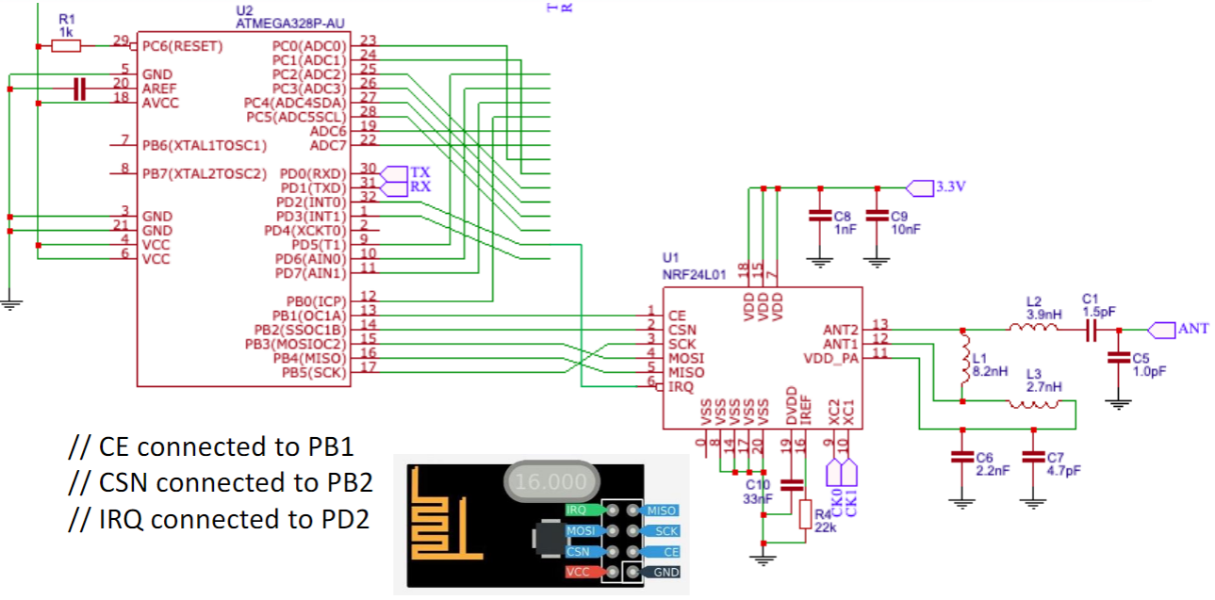N/A

1. **SCREENSHOTS OF EACH TASK OUTPUT (ATMEL STUDIO OUTPUT)**

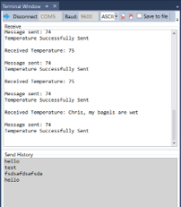

1. **SCREENSHOT OF EACH DEMO (BOARD SETUP)**

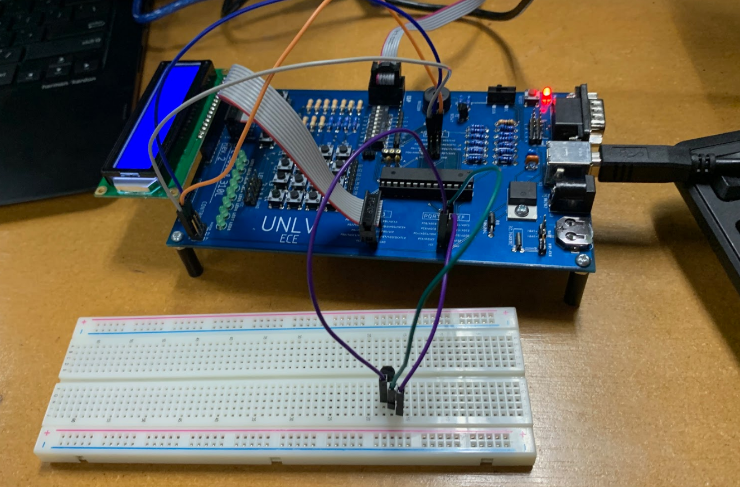

1. **VIDEO LINKS OF EACH DEMO**

N/A

1. **GITHUB LINK OF THIS DA**

https://github.com/tylergardenhire/submission_projects.git

**Student Academic Misconduct Policy**

<http://studentconduct.unlv.edu/misconduct/policy.html>

“This assignment submission is my own, original work”.

TYLER GARDENHIRE