Authors: Leslee Trinastic, Linh Do, and Peter Davis

[PCA record documentation for WCTC healthcare Center application]

**Disclaimer**

*\*\*the following documentation is based off of the Spring 2017 HIT Group’s project documentation, and is only inclusive, at times, of verbatim text in order to be consistent with the WCTC HealthCare Center documentation as a whole. Please reference the BRIT Systems documentation included in the WCTC HealthCare Center project file for additional resources, and citations.\*\**

**Table of Contents**

Disclaimer…………………………………………………………………………………….1

Table of Contents……………………………………………………………………………..2

Introduction…………………………………………………………………………………...3

Key Purpose Statement……………………………………………………………………….4

Scope of Work………………………………………………………………………………...5

Data Model…………………………………………………………………………………....6

The Future…………………………………………………………………………………….7

BIT Team Member and Faculty Information………………………………………………....8

Software Architecture………………………………………………………………………...9

**Introduction**

WCTC Healthcare Center is a web application built as a result of the collaboration between the BIT (Business Information Technology) Web and Software Developer and HIT (Health Information Technology) and Nursing programs at Waukesha County Technical College in the fall of 2017 (August - December) .

This document has been created to document the key facts about the development of the application. All information within this document is accurate to the best of the documenter’s ability on the date of submission, 12/19/2017. Given the nature of the application, it is very likely that changes will be made to the system after the time of submission of this document and any information found within this document should be verified as being up-to-date and accurate prior to taking action or making any decisions regarding the development and maintenance of the application. The documenter nor the BIT students named later in this document claim any responsibility nor obligation for the application.

Identifying a need for HIT students to have a software application which allowed them to practice entering mock Patient Care Assessment (PCA) Records into a hospital database, the Nursing faculty approached the BIT facility to request the creation of such an addition to the existing application. The project served as the final capstone project for the participating BIT students, of which there were three. While the project was introduced, monitored, and verified by faculty from both programs, the project was generally lead and executed by the students from the BIT program. This document is intended to be a high-level overview of the PCA Record application development. Any questions regarding the development of the application should be directed to BIT faculty.

It is important to note that WCTC Healthcare Center is meant to house “mock” data and not real patient health records. It is not HIPPA Compliant. Going forward, the application will be maintained and further developed by future BIT students and faculty.

**Key Purposes of System**

The key purpose of WCTC Healthcare Center is to provide a tool which may be used in conjunction with HIT coursework to allow students to practice entering electronic birth records into a database system in a manner which is similar to what is currently found in the healthcare industry.

The Patient Care Assessment (PCA)s Record consists of Vital and Body System information that nurses have to manually enter on a paper PCA Record document. The key requirement requested by the Nursing Group was to create a digital PCA record that allowed nursing student to enter in Vital and Body System information.

Other key requirements included the ability to keep a history of edits to the PCA Record, and to display the history of edits on the preferred device, the iPad. Nursing instructors need visibility to what students users are doing in the system, and records of historical data were required by the instructors.

While there were many other features and documents which were identified as “nice-to-haves,” the requirements outlined here comprise the key purpose of the Records in Phase one.

**Phase One Development Scope**

Much time and effort by both the Nursing Group and BIT students was spent in determining what the scope of this phase of development should be. Setting an appropriate scope proved to be the key challenge in the early development phases of the application. Both parties see many potential additional uses for the application beyond what was delivered in phase 1, and it is the hope of both parties that the application will gain additional functionality.

Currently, WCTC Healthcare Center – PCA Records has delivered the key system purposes as defined in the “Key Purposes of System” section of this document.

Users are required to login to the application with usernames and passwords. Once logged in the user will be able to navigate to the PCA Records by going through the checked-in patients. The user can then create, edit, view details, and view history details from this section.

Additionally, historical detail records of edits has been provided and includes details about edits that users take in the application, such as editing a file after it has been created and saved.

**Data Model**

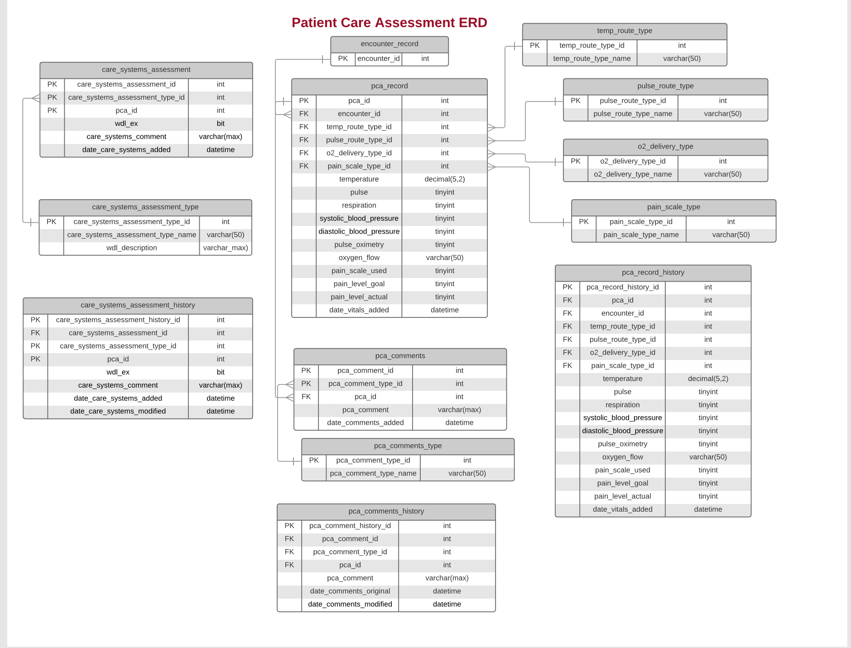

**BIT Team Member and Faculty Information**

**Faculty Instructors**

Andrew Kjell

Matthew Green

**Student Developers**

Leslee Trinastic

Linh Ament

Peter Davis

**The Future**

The WCTC Healthcare Center application was designed and developed with the hope and expectation that future BIT students would continue to develop the application and add new features and functionally as identified by facility and end user input. The developers believe they have created a data model which will be an extendable foundation off of which to base future growth.

**Software Architecture- Class/Folder Structure**

The project solution is organized into a class and file structure that is standard for a ASP .NET 4.5.2 application developed in Visual Studio. Much of the solution has been configured with the defaults provided by Visual Studio/ ASP .NET convention. Following is an outline of the current file structure of the solution, which highlights customizations.

*\*\*the following documentation is exclusive of the HIT Group’s project, and is only inclusive of the additional files that have been added by the Nursing Group to the overall architecture of the whole WCTC HealthCare Center application. For more information on the overall structure of the project, please see the most updated documentation of the HIT Group’s WCTC HealthCare Center application. \*\**

**Controllers**

The Controllers folder contains all the controllers currently available in the application. These are based off of the model classes/ data model. More information about the configuration of each controller is provided in the “Software Architecture- Class Configuration” section of the accompanying HIT Group’s WCTC HealthCare Center document.

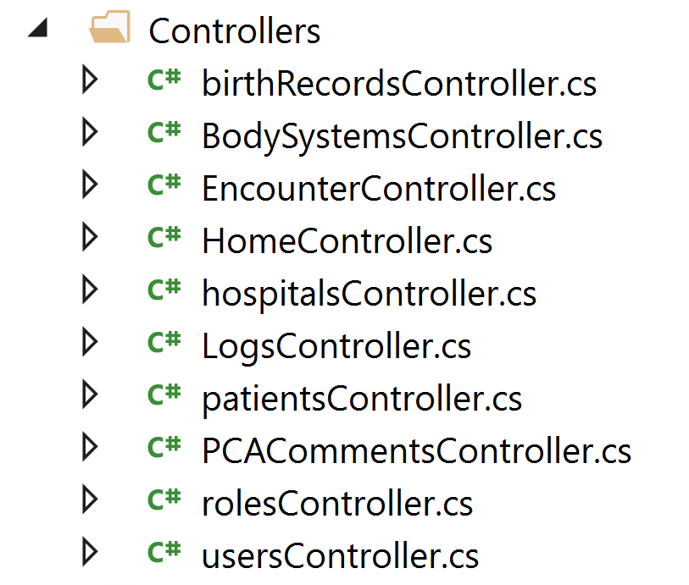

**Models**

The Models folder contains all the data model classes currently needed to support the application.

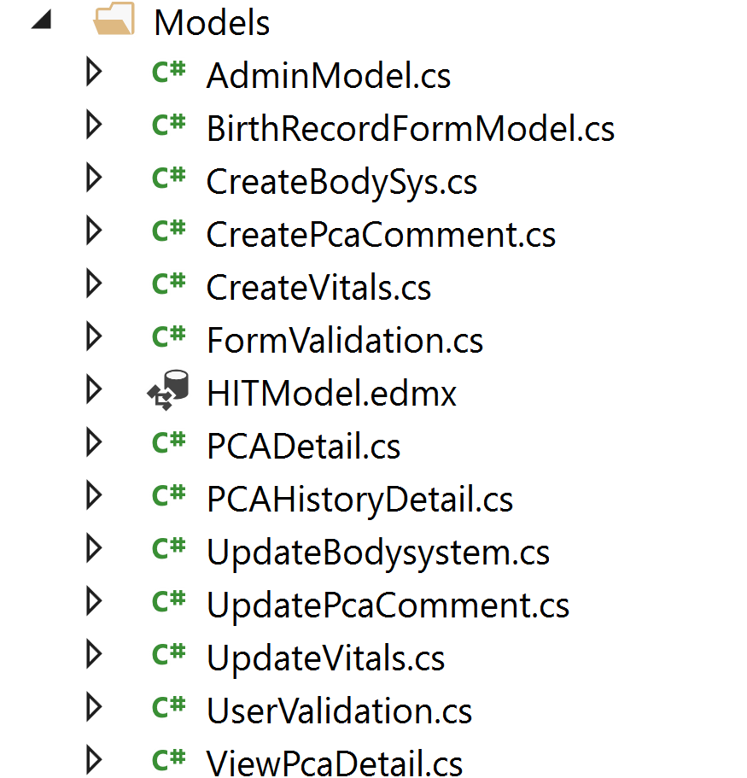

**Views**

The Views folder contains all of the views (cshtml pages) currently required by the application. These views have been highly customized to meet the requirements of the project. The views are divided into folders related to the organization of the data model of the application. Further information about these views should be obtained by reading the files themselves.

