runfile('/home/tdh5188/workspace/comp596/Convnet-Music-Classification/test_soundfile.py', wdir='/home/tdh5188/workspace/comp596/Convnet-Music-Classification')
plotting waveform

getting input files from web
preprocessing songs
plotting

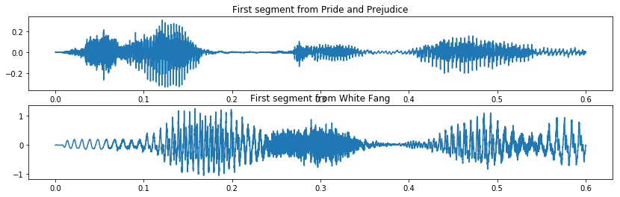

CREATING A SPECTROGRAM

1) Enframe the audio
defining function enframe

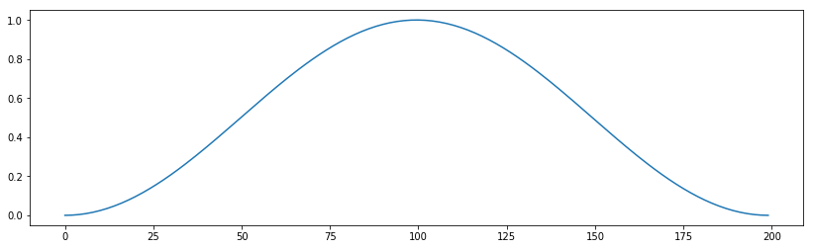

plotting frame 12 of each song

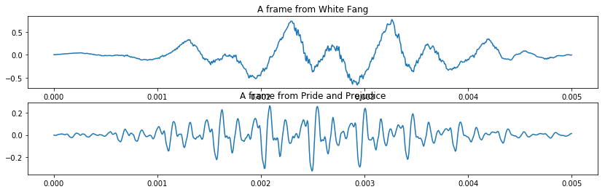

2) Create STFT from the frames
defining function stft
testing function

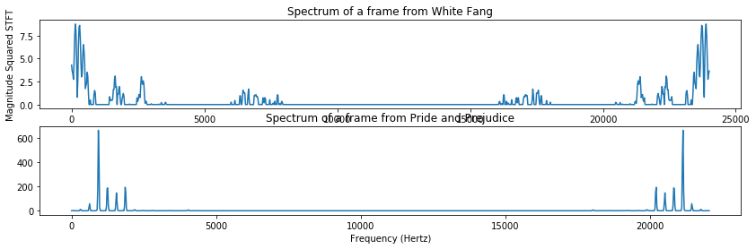

preprocessing on plots

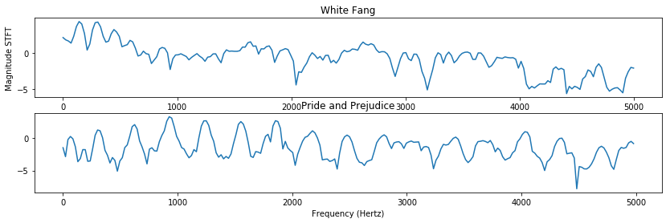

3) Compute Level
defining function stft2level
testing function
22050

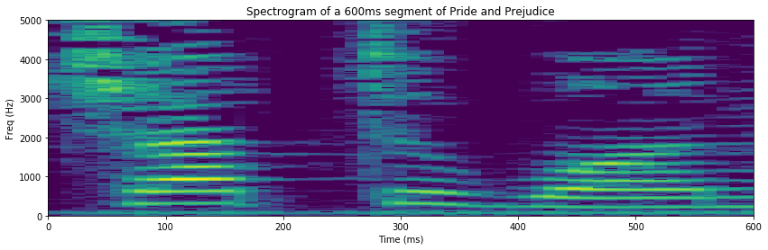

Spectrogram Function
defining function sgram
computing same spectrogram as above

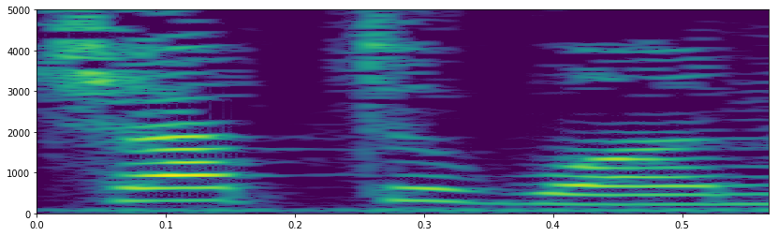

Wideband/Narrowband spectrogram
wideband spectrogram for "Pride and Prejudice"

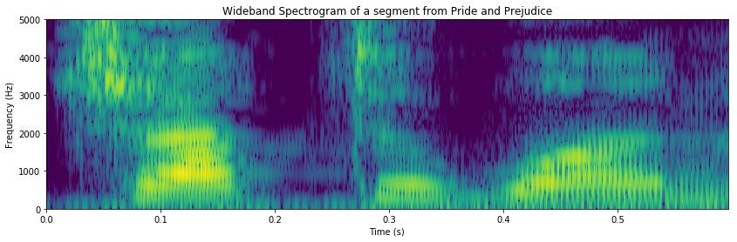

wideband spectrogram for "White Fang"

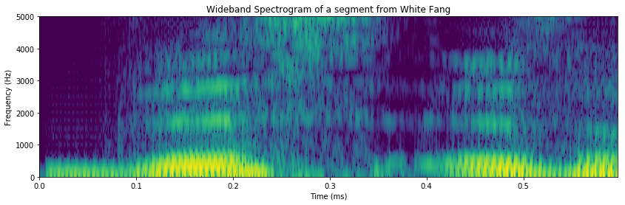

narrowband spectrogram for "White Fang"

