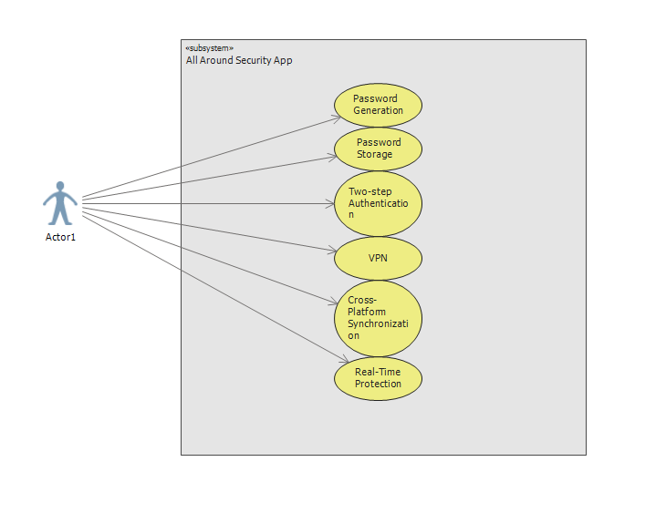

* *Content: Split the use case “Two-step Authentication” into more detailed use cases.*
* *Content: Add one or two “extend” and “include” use cases.*
* *Visual: Stretch use cases’ containers horizontally to prevent wrapping from breaking words.*
* *Wording: Rename “Actor1” to “User.”*

|  |
| --- |
| **Password Generation and Storage** |
| **Brief Description:** Actor generates a password |
| **Preconditions:** Actor has registered account and wants to generate a password |
| **Basic flow of events:**   1. Actor logs into the system 2. System authenticates actor and grants access 3. Actor chooses generate password 4. Actor fills password specification 5. System will generate password based on specifications based on the user 6. System asks if password is sufficient for Actor 7. Actor accepts password 8. System asks if Actor would like to store and encrypt password in the database for use in the future |
| **Extensions:**   1. System fails to authenticate actor 2. System informs actor and rejects log in attempt 3. System fails to generate password 4. System informs actor and asks to try again 5. System fails to store and encrypt password 6. System informs actor and asks to restart the whole process |
| **Post Conditions:** Password is generated and stored |
| **Special Requirements:** Actor has a verified account and is using the application on a compatible device |

* *Content: Add some categories as follow:*
  + - * *Primary Actor: User*
      * *Level: Sea level*
      * *Stakeholders: User*
* *Wording: Change “Actor” to “User.”*