My City in Space and Time

Concept Sketches

by Tyler Hill

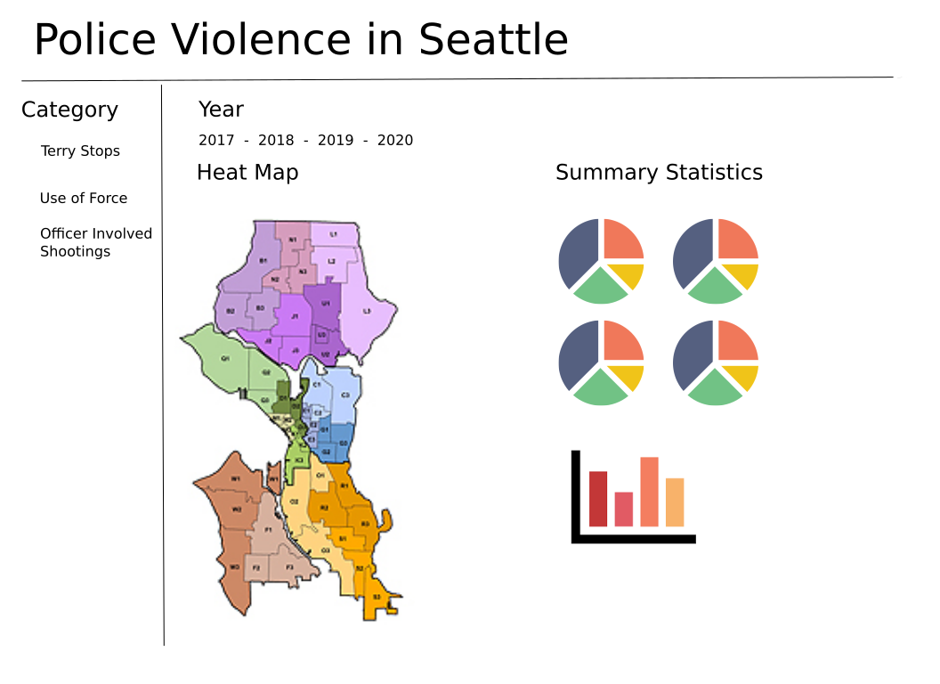I’d like to explore police violence in the city of Seattle over time, comparing how location, race, gender, and age factor into violent police interactions. To do this I will use several data sets available through the City of Seattle’s Open Data Program website. Specifically I found 3 police related csv data sets that include Terry stops, use of force, and officer involved shootings from 2017 to 2020. My intent is to create a shiny app can visualize the spatial relationships of police violence in Seattle over time. The basic layout of this app can be seen below.

The app will have three major categories of data to explore as can be seen in the options on the left hand side of the figure above. Each data set will be visualized similarly with a heat map showing absolute numbers of incidents after selecting a year and hovering over a given predefined area (I will probably use SPD Beat designations) of the map.

To the right of the heat map will be summary statistics. I am not sure yet how this will exactly break down but I am thinking it will be per year and if I have the ability to refine this further I would like to be able to break down these statistics further by selecting an area on the map as well. The pie charts above will summarize racial and gender proportions of the subjects and officers involved. The bar chart will summarize the age of the subject and I may do another summarizing the age of the officer (or their time spent on the force).