Examining Seattle Police Department

Terry Stop Data

By Tyler Hill

INSH 5302

A report summarizing my findings for the

My City in Time and Space - Assignment

My original goal for this project was to examine SPD use of force through analyzing several data sets. This ended up being to ambitious a goal for the two week time frame as I was also learning R shiny from scratch and wanted to present a well constructed project. I believe I made the right decision to pare down the scope to only examining the SPD Terry Stop data set and focusing on delivering a higher quality final product.

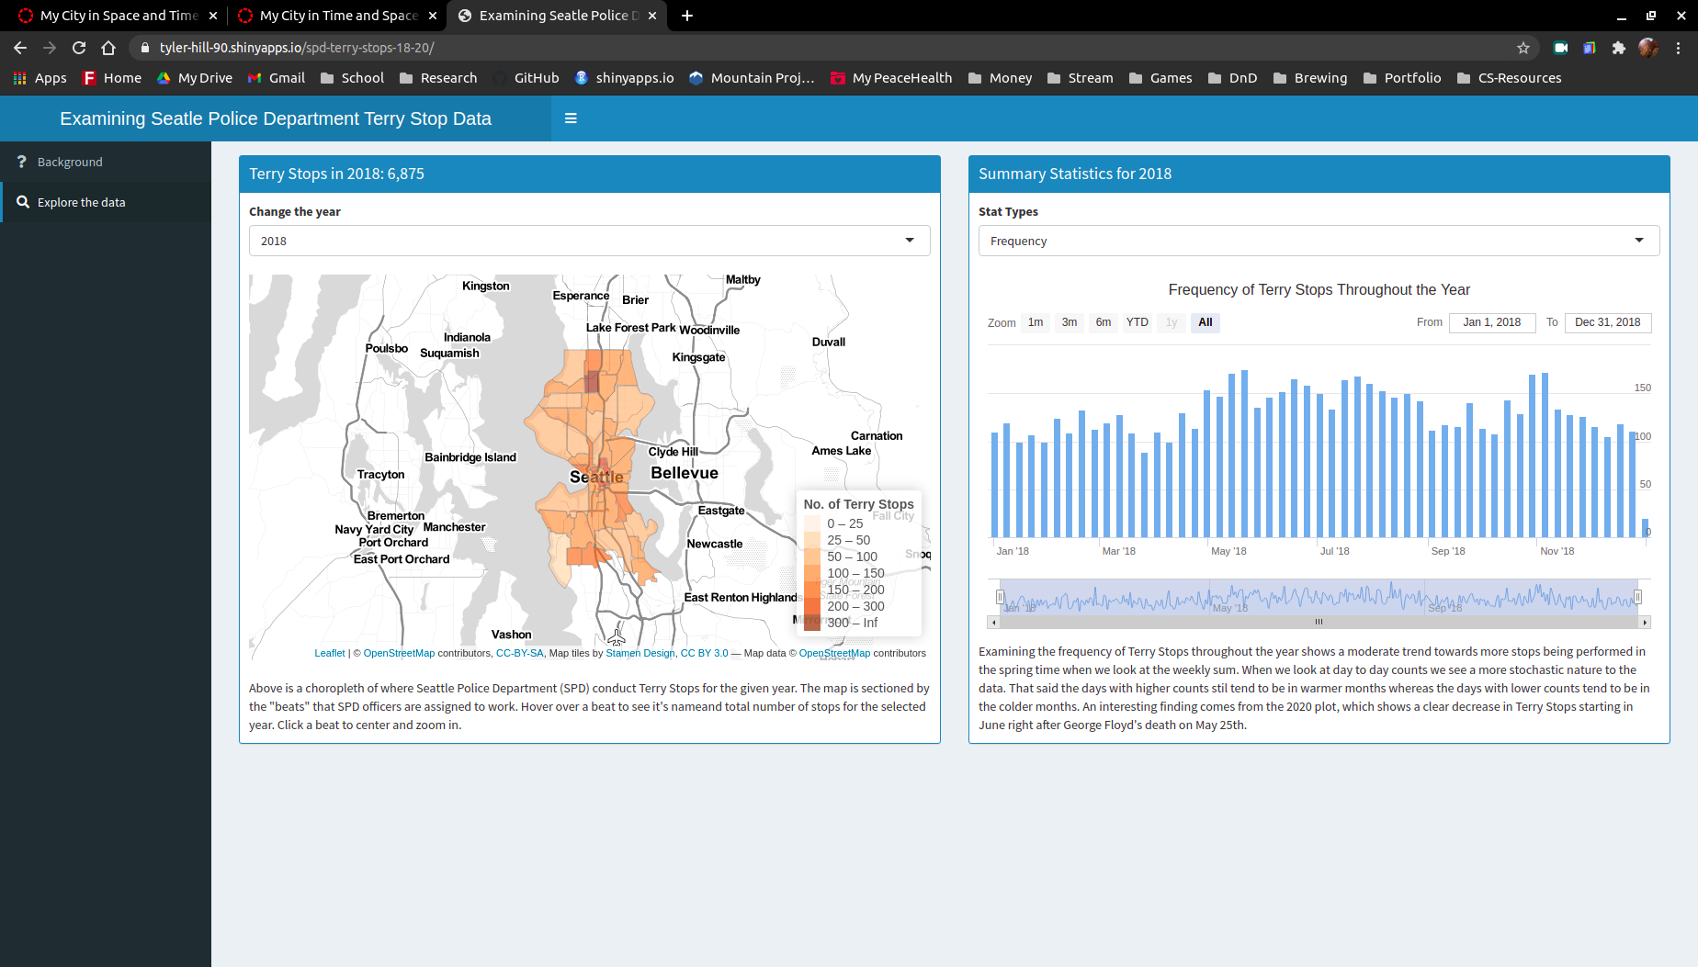

Overall I think the data dashboard does a good job of analyzing the Terry Stop data and telling a story of how SPD has gone about conducting Terry Stops over time. The chorpleth map shows where in Seattle Terry Stops are most likely to occur for the given year. We can see that certain beats remain as hot spots over time whereas others grow or diminish. It is also interesting to explore how the subject race changes between the different beats. We can clearly see that the hot-spot beats have a higher representation of black and brown subjects.

The Frequency chart offers a lot of interaction and shows how the frequency of Terry Stops is influenced by the season and most notably we can see a clear drop off in frequency after the killing of George Floyd on May 25th, 2020.

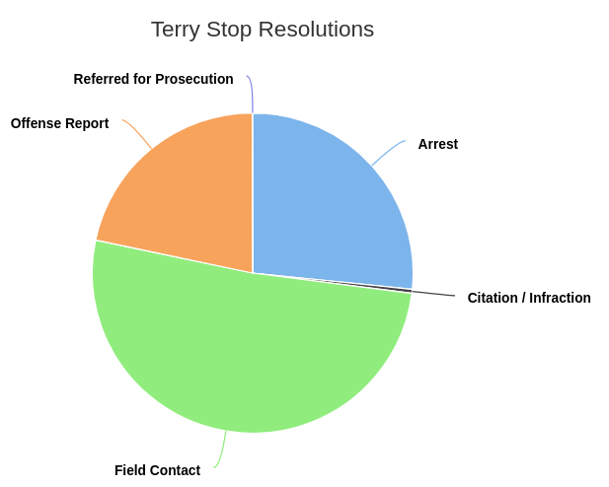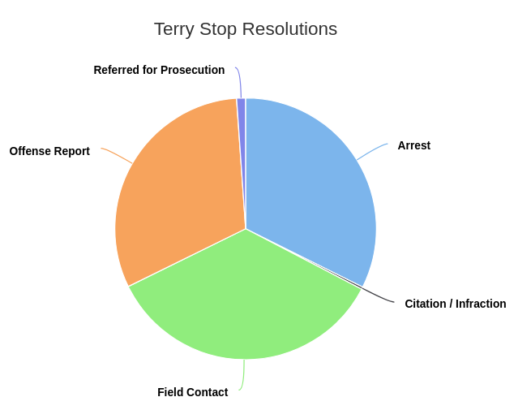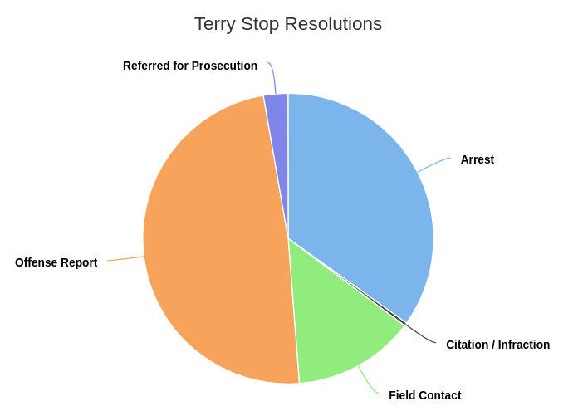

The Resolution charts tell a clear story as well. We can see SPD steadily decreases their use of the Offense Reported resolution and increases their use of the Field Contact. This potential policy change may result in less negative press for SPD.

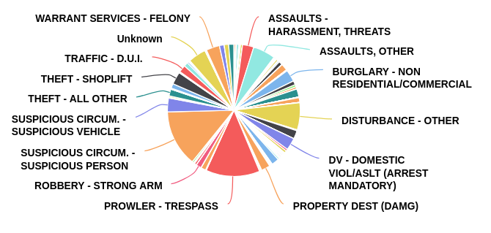The Call Type chart is my most “busy”

chart and I struggled about whether to include it or not. Ultimately I decided to include it as it helps move the data’s narrative forward since we can clearly see that the largest categories pretty vague, alluding to possible officer profiling. If I had more time I would have liked to clean this plot up a bit by binning the categories further.

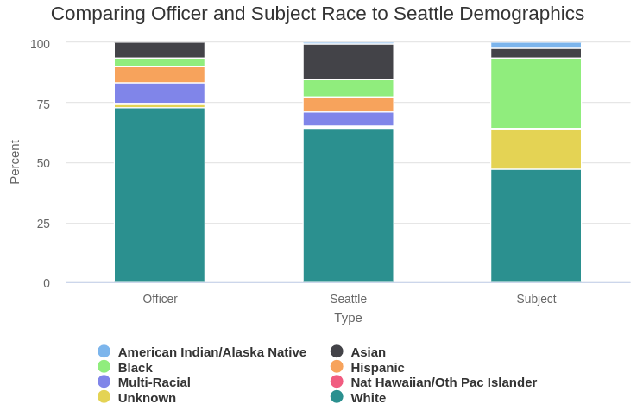I think plots comparing race in Terry Stops tells the clearest story. White officers are over represented and black subjects are over represented. This narrative reflects what we see in the issues at the heart of the BLM movement.

The rest of the plots tell their own stories but don’t contribute as much to the narrative I am trying to convey of how racial profiling insidiously undermines the use of Terry Stops by SPD. Overall I think my project provides an interactive user experience that explores this dataset throughout time and space, all while driving home the story that SPD needs to do a better job of addressing racial disparity issues in how they conduct Terry Stops.