**Website Development Project**

**(11/21)**

1. Install Brackets (Text Editor) and Google Chrome (Browser).

Install the Brackets text editor (<https://brackets.io>) and Google Chrome (<https://www.google.com/chrome/>) on your laptop.

1. Web Development Languages

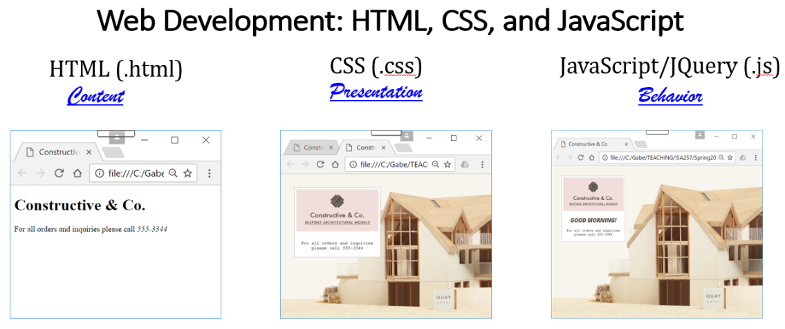

Behavior

Content

Presentation

1. Web Development Methods

From scratch Use Drag-Drop Menu Use CSS Framework

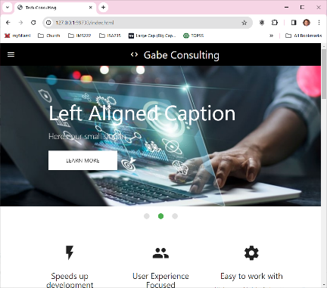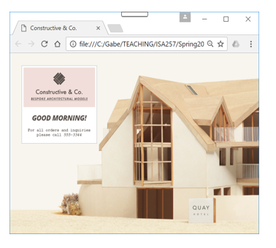[](https://gabelee2.wixsite.com/isa235ai) (Full coding) (Zero coding) (Mixed)

1. [MaterializeCSS](https://materializecss.com/) – CSS Framework

**Hands-On Exercise**

1. Download 'WebDevelopment.zip' from Canvas > Modules > Module 9 and unzip it.
2. Open Brackets. Go to the 'File' menu, select 'Open Folder', choose the 'WebDevelopment' folder, and click 'Open'. Then, select 'index.html' from the left pane in Brackets.
3. In the right pane of Brackets, locate and change “Gabe Consulting” to “Your Name Consulting”. Click the 'Live View' button to preview the changes.
4. Download your preferred JPG images (four) from [Google Images](https://images.google.com/) for the slideshow and save them in the 'WebDevelopment' folder. Locate the line img src="Technology-Consultant01.jpg" in your HTML, and replace "Technology-Consultant01.jpg" with the filename of your downloaded image. Repeat this process for the remaining images.
5. Go to the “About Me” section and replace the image and content as desired.
6. In the “Follow Our Site” section, link the LinkedIn icon to your LinkedIn page. To do this, copy the URL of your LinkedIn profile. Then, in Brackets, find the LinkedIn icon's code and change the current href=”https://www.linkedin.com/in/younghwa-lee-78862a36/” to href=”your LinkedIn URL”.
7. To enable form data to be sent to your email, use formsubmit.io:

* Visit <https://formsubmit.io/>and sign up with your email account and password.
* Check your email for a message from formsubmit.io and confirm your email address.
* In the “Contact Us” section of your website, change <form action="https://formsubmit.co/gabelee@miamioh.edu" method="POST" class="col s12"> to <form action="https://formsubmit.co/your email address" method="POST" class="col s12">.

1. Create your free Github webserver
   * GitHub Account Set Up

* Go to GitHub.com and click Sign Up button to create an account
* Enter your email and password and username
* There will be some extra steps with questions to ask and validation
* Choose Free use option

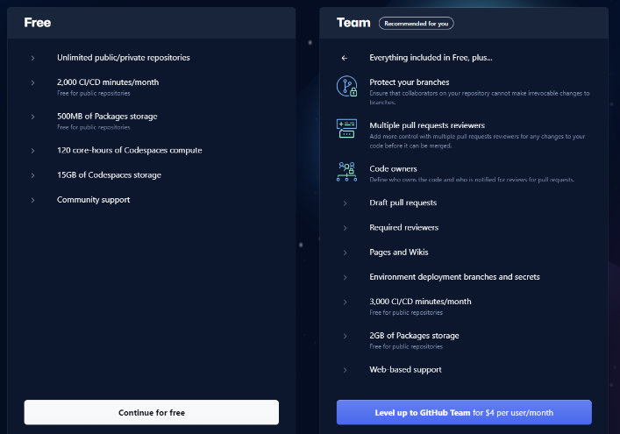

* Create New Repository and Upload Files
* Assuming that you successfully access GitHub page, go to top right corner and click + sign dropdown and select New Repository.

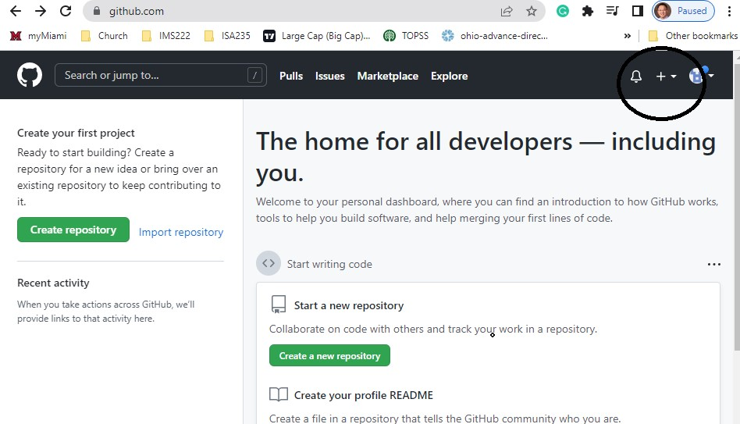

* Enter your repository name and check “Add a README file” option and click green Create repository button at the bottom.

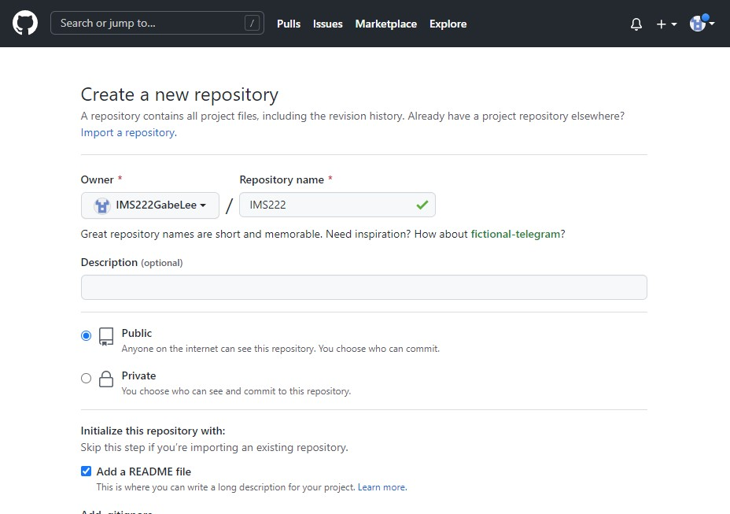

ISA235GABE

ISA235

* Go to Add file and select Upload files option.

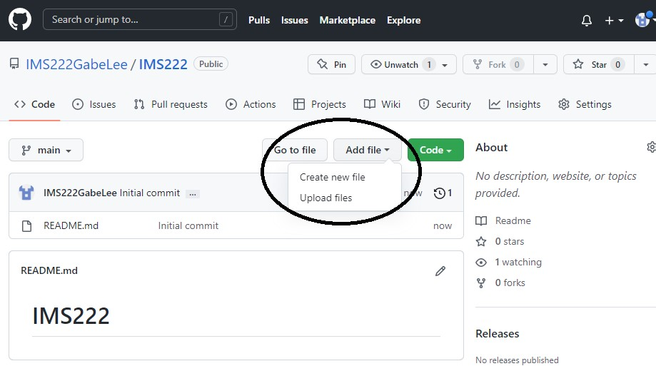

ISA235GABE/ISA235

ISA235

ISA235GABE

* Drag files from your File Explore (Windows) or Finder(Mac) or click choose your files to select the files to upload to GitHub.

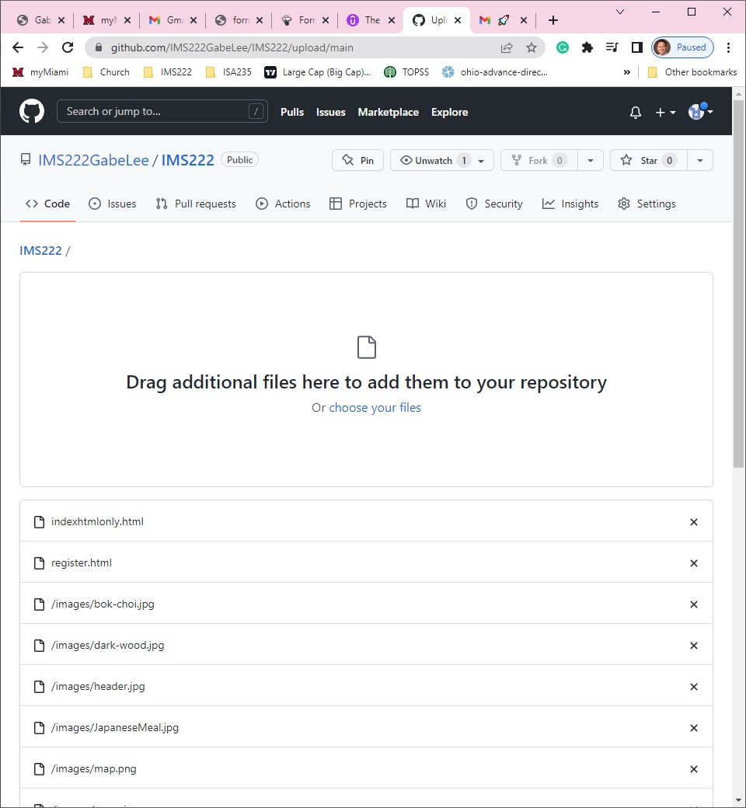

ISA235GABE/ISA235

ISA235/

* Click Settings tab.

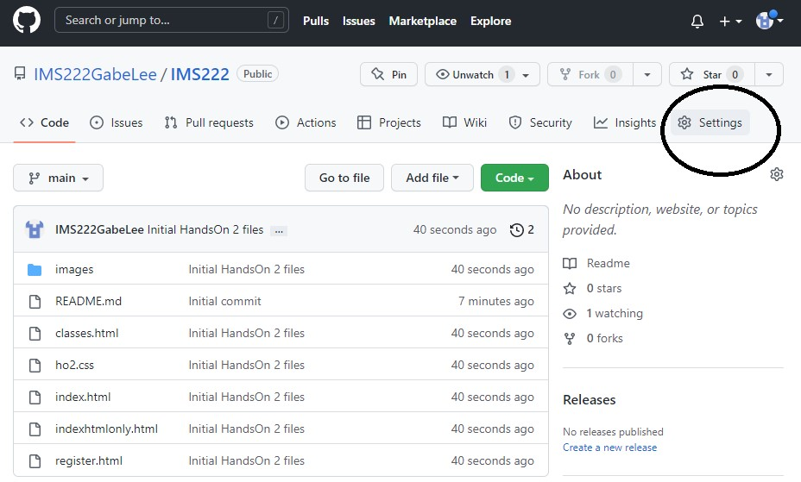

ISA235GABE/ISA235

ISA235GABE

* Click Pages in left hand side pane.

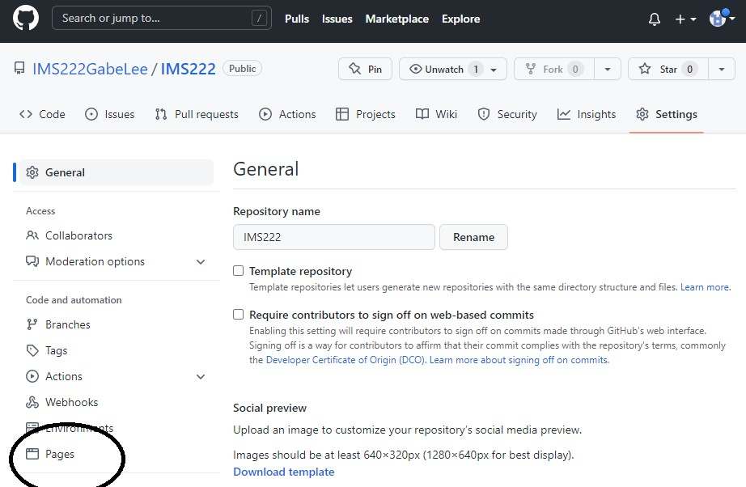

ISA235

ISA235GABE/ISA235

* Go to Branch and select main and click save.

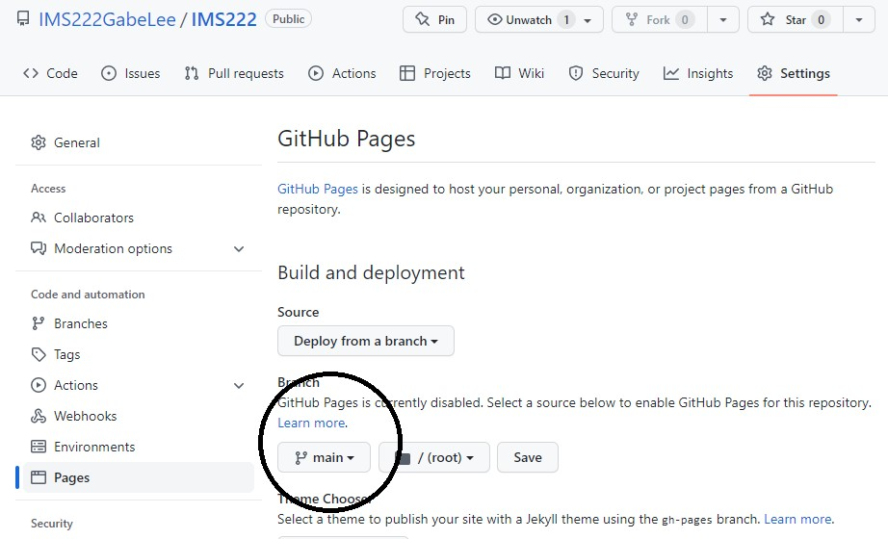

ISA235GABE/ISA235

* Then you will see the message that Your site is live with URL info. It will **take a few minutes**. Click the link.

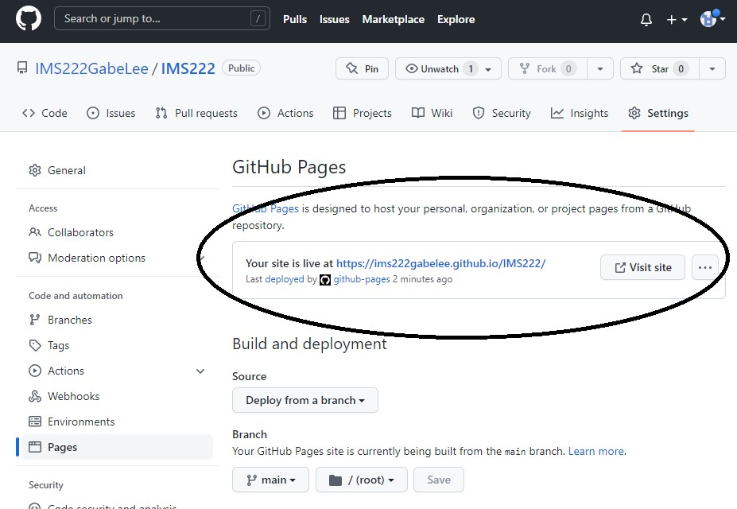

ISA235GABE/ISA235

# Check Form Data Submission

* Try to submit the form data by filling out the form and clicking submit button. For successful form submission, there needs one time activation of formsubmit.co. For doing this, after clicking the submit button, you need to go to the email account you used in your <form action =”youremailaddressused“>. Then, you will get an email for the activation. Click the email and Activation button inside.