**CS3305-XL Assignment 5**

**Requirements:**

The goal of this assignment is to reinforce using queues in C++ programs. Specifically, the assignment is to do problem #6 on page 434 of the textbook. The write-up for problem #6 is provided here for your convenience:

The Queues chapter has a linked-list implementation of a queue. This implementation used two named pointers called front_ptr and rear_ptr to point to the front and the rear nodes of the queue (linked list). A circular linked list is similar to a regular linked list, except that the pointer field in the “last node” points back to the “first node.” (Of course, after this change it is no longer clear which node, if any, is intrinsically “first.”)If we use a circular linked list, then we need only one pointer to implement a queue, since the front node and the rear node are adjacent nodes, as shown by the following diagram:

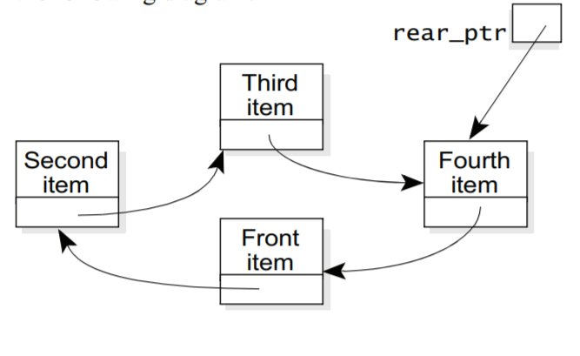

In the diagram we have called the single pointer rear_ptr, because it points to the last node in the queue. It turns out that this gives a more efficient implementation than having it point to the first node in the queue.   
Redo the queue class using a circular linked list.

Design and implement the standard queue functions listed below. In a test program in file called **test_queue.cpp** write your main function (**main()**)and test every function listed.

1. Function **enqueue(…)** adds an object to the end of the queue. That is, the top value is printed first; while the bottom value ( the new element that is added) is printed last.
2. Function **dequeue(…)** removes an object from the front of the queue. That is, the top value is printed first (this should not include the element that was removed); while the bottom value is printed last.
3. Function **top(…)** displays the object in the front of the queue. This function makes no change to the contents of the queue
4. Function **size (…)** gives the size of the queue.

**Sample Output:**

**Submitting Assignment**

Submit your assignment zip file through D2L using the appropriate assignment link. Please use the submission guidelines provided in D2L