**C Sc 335 Analysis and Design Artifacts for Final Project**

*Each team member completes this form SOLO, renames it with their last name, places it into the Eclipse project, then pushes the project to Github*

**1. Team Name:**  _MonarchHorvat_________

**3. Team Members**: _Tyler Horvat________ ____Hayden Monarch______________

___________________________

**4. Candidate Objects or Class Hierarchies**

List the most important objects, or an inheritance hierarchy name, and the single responsibility of each.

|  |  |
| --- | --- |
| **Candidate Object** | **Single Responsibility in 1 or 2 sentences** |
| Song | Holds song name, artist, times played in last 24 hours, and song length |
| Student | Has student name, and password as well as minutes remaining on account, number of songs picked in a day |
| Jukebox | Controls user access to songs, coordinates song playing |
| SongQueue | FIFO queue to hold order of song picks, first in queue gets played first. |
|  |  |
|  |  |
|  |  |
|  |  |
|  |  |
|  |  |

**5. Sequence Diagram 1:** Your team UML Sequence Diagram should show the most important scenario you can think of. Your sequence diagram should show most of your objects from above and how they communicate with each other.

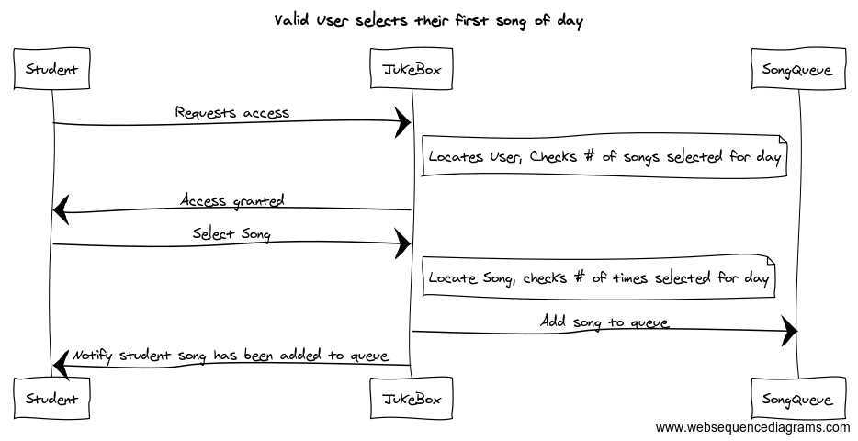

**6. Sequence Diagram 2:** Your team UML Sequence Diagram should show the seconf most important scenario you can think of. Your sequence diagram should show most of your objects from above and how they communicate with each other.

