**C Sc 335 Analysis and Design Artifacts for Final Project**

*Each team member completes this form SOLO, renames it with their last name, places it into the Eclipse project, then pushes the project to Github*

**1. Team Name:**  MonarchHorvat

**3. Team Members**: Hayden Monarch Tyler Horvat

**4. Candidate Objects or Class Hierarchies**

List the most important objects, or an inheritance hierarchy name, and the single responsibility of each.

|  |  |
| --- | --- |
| **Candidate Object** | **Single Responsibility in 1 or 2 sentences** |
| MP3Player GUI | Coordinates all of the functionality between controllers and provides GUI layout for the Mp3 player. |
| User | Keeps all of the necessary information for each user class including time limit, song limit. |
| Accounts | Keeps track of all users within an account class |
| SongsList | Stores all of the songs and LIFO functionality |

**5. Sequence Diagram 1:** Your team UML Sequence Diagram should show the most important scenario you can think of. Your sequence diagram should show most of your objects from above and how they communicate with each other.

*This Sequence Diagram must be created with the sequence diagram editor* [https://www.websequencediagrams.com/#](https://www.websequencediagrams.com/)

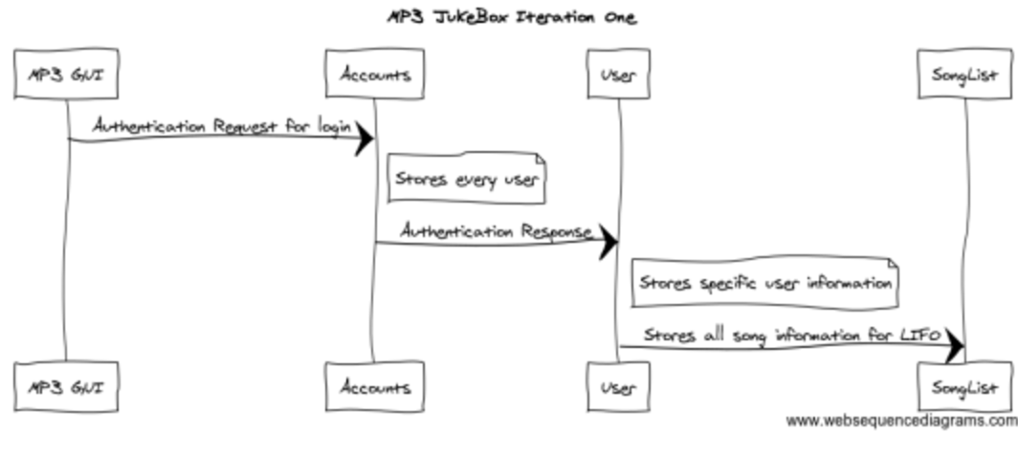

**6. Sequence Diagram 2:** Your team UML Sequence Diagram should show the seconf most important scenario you can think of. Your sequence diagram should show most of your objects from above and how they communicate with each other.

*This Sequence Diagram must be created with the sequence diagram editor* [https://www.websequencediagrams.com/#](https://www.websequencediagrams.com/)

