How to Add Unity Games to the SEC Games Website

By Tyler Hunt

1. 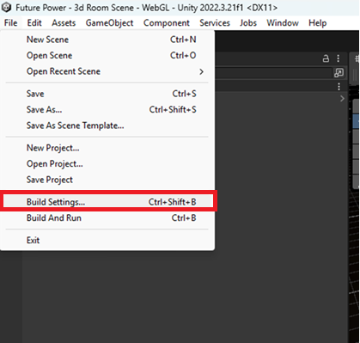Go to Build Settings
2. 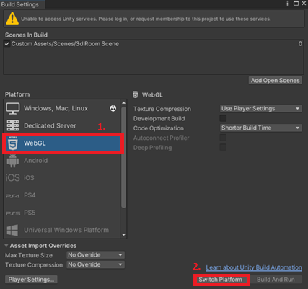Select WebGL and select “Switch Platform” (if you chose WebGL originally, you can skip this step)
3. 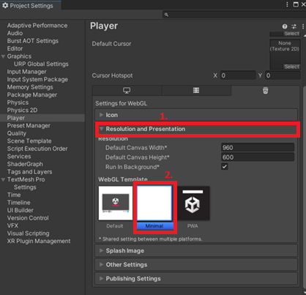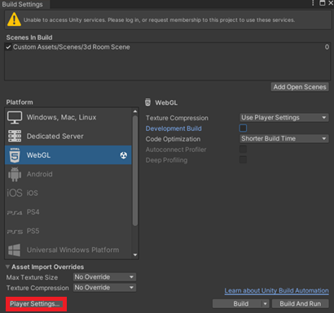Once this is finished, select player settings > Resolution and Presentation > Minimal.
4. 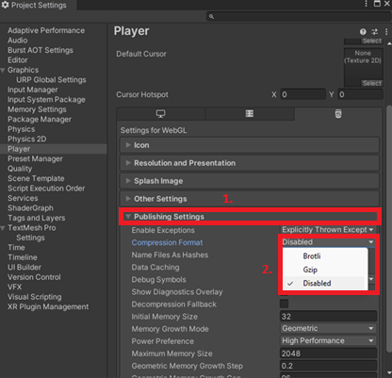Go to Publishing Settings > Compression Format > Disabled
5. 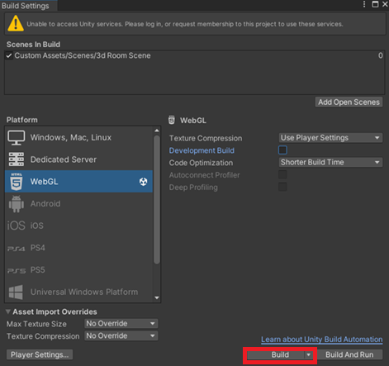Close Player Settings and select Build. Choose any directory to save the build
6. A screenshot of a computer

   AI-generated content may be incorrect.Place the meta.json file into your new folder, and edit with any text editor
7. A screenshot of a computer

   AI-generated content may be incorrect.Replace the fields with your game information. Slug is the URL (e.g. secgames.com/game/your-url) and aliases are fallback names for if the game name is taken (put at least one name here)
8. A screenshot of a computer

   AI-generated content may be incorrect.A screenshot of a computer

   AI-generated content may be incorrect.Drop the whole build folder into /sec-unity-website/public
9. You’re done, you should see a new button on the home page, navbar and your game should load

