Chloride-conductance calibration: sampling plan and laboratory cost options
  - Steamboat Hills geothermal outflow, Steamboat Creek (SBRR and SBGG)
Tyler Irvin, University of Nevada, Reno
2026-10-29

Summary
I am calibrating continuous specific conductance from two in-stream loggers (SBRR at Rhodes Road above the thermal inflow, and SBGG at Geiger Grade below it) against laboratory chloride. Method: paired grab samples bracket logger readings; chloride (and major ions, alkalinity, field pH/temperature/conductance) is measured at the lab, and I fit time-aware models (linear, GAM, random forest) validated with rolling-origin cross-validation. Application: the calibrated record gives continuous chloride flux, which is the standard tracer for thermal-water discharge at Steamboat (Sorey and Spielman 2008, 2017). It lets us ask whether the 2025 Lower Sinter Terrace eruption changed outflow, and it replaces the sparse, expensive chemistry that has limited the discharge record. Reasoning: a Monte Carlo test on the real logger record (with the days the loggers sat in open air removed) shows daily sampling gives a reconstruction error of about 3-4% of mean conductance, while biweekly sampling gives about 8-10%, and 7-13% depending on the start day, so a short intensive window followed by monthly samples across a full year captures both fast variability and seasonal stability. Hypothesis: one site-specific relationship between conductance and chloride holds through the year, with deviations during storms and snowmelt from dilution. Value: once calibrated, the loggers give a continuous chloride and thermal-discharge record for a small fraction of the cost of regular chemistry, and the same samples provide the end-member chemistry for the mixing and reactive-transport work.

Sampling plan
Phase | Sites | Cadence and timing | What is measured
Intensive calibration | SBRR, SBGG | Daily (or sub-daily) for 5, 7 or 14 days; start fall/winter 2026 | Cl, anions, cations, alkalinity (package set below); field pH, temperature, conductance
Monthly seasonal sampling | SBRR, SBGG | Once a month for 5 or 12 months after the intensive window | Same package
Storm / snowmelt | SBRR, SBGG | 1 to 4 events, 2 samples per event | Same package
Extra sites (Full tier only) | SBW_0001, SBW_0002, active fissure (access permitting) | Quarterly | Same package
Isotopes | SBRR, SBGG (subset) | About one sample per site per season with a regular visit | delta-18O, delta-D
QA | All | 10% duplicates and blanks | Same package

Sample counts by tier.
Tier | Intensive (daily) | Monthly | Storm / melt | Extra sites | QA (10%) | Chemistry samples | Isotope samples
Lean | 10 | 10 | 0 | 0 | 2 | 22 | 4
Recommended | 14 | 24 | 2 | 0 | 4 | 44 | 8
Full | 28 | 24 | 8 | 12 | 8 | 80 | 16

Laboratory cost options
Analyte packages and planning prices. These are my estimates, not ALS quotes; replace with the ALS quotation before using the totals in the proposal.
Package | What it includes | Planning price per sample
A: Chloride core | Chloride by IC (EPA 300.0) and alkalinity | $45
B: Major ions (recommended) | A, plus sulfate, fluoride, bromide (IC); Na, K, Ca, Mg, B, Li, Si (ICP); TDS | $135
C: Major ions plus trace elements | B, plus an ICP-MS trace-element suite like the one used on the 2026 field samples | $225
Isotopes | delta-18O and delta-D, outside stable-isotope laboratory | $40

Estimated total laboratory cost for one year (chemistry plus isotopes). Excludes shipping, bottles, and field time.
Tier | Chemistry samples | Isotope samples | Package A | Package B | Package C
Lean | 22 | 4 | $1,150 | $3,130 | $5,110
Recommended | 44 | 8 | $2,300 | $6,260 | $10,220
Full | 80 | 16 | $4,240 | $11,440 | $18,640
Recommended option: the Recommended tier with package B, about 44 chemistry samples and 8 isotope samples, roughly $6,260 for the year. It is the smallest design that covers a full seasonal cycle at both stations, includes the ions needed for the mixing-model cross-check, and keeps the daily window short enough to be done in the field by one person. The Lean tier gives a first calibration but no seasonal test; the Full tier adds the fissure and resort wells and a longer daily window, and depends on Ormat access.
Notes for the cost discussion. (1) ALS lab pricing depends on method set, turnaround time and any UNR or project discount, so the totals above scale directly with the package prices in Table 2. (2) Shipping, sample bottles, filters and sampling supplies are not included. (3) Tier totals can be reduced by running packages A or B on routine samples and C only on the quarterly subset.

Equations used for the conductance proxy, model fitting and sampling-error test
1. Specific conductance from logger conductivity. The loggers record raw electrical conductivity $EC$ at water temperature $T$ (degrees C). I remove the temperature effect with the USGS non-linear compensation (coefficient $a=0.0191$ per degree C, to be recalibrated against field checks):
$$SC_{25}=\frac{EC}{1+a (T−25)}$$
2. Chloride from specific conductance (the proxy). Chloride is the conservative tracer of thermal water, and in this system conductance tracks chloride because chloride and sodium dominate the thermal fluid. The simplest model is a linear regression, fitted to paired samples:
$${Cl}_{t}=β_{0}+β_{1} SC_{25,t}+ε_{t}$$
The generalized additive model (GAM) adds smooth terms for conductance and temperature and a seasonal harmonic ($d$ is day of year; splines with $k=4$):
$${Cl}_{t}=β_{0}+f_{1}(SC_{25,t})+f_{2}(T_{t})+β_{3}sin​\left({2πd_{t}}/{365}\right)+β_{4}cos​\left({2πd_{t}}/{365}\right)+ε_{t}$$
A random forest on the same predictors is the skill benchmark. Models are scored with rolling-origin (blocked, time-aware) cross-validation: each fold trains on all samples up to time $t_{k}$ and predicts the next block, so autocorrelation cannot inflate skill:
$$RMSE=\sqrt{\frac{1}{n}\sum_{i=1}^{n}{{\left({Cl}_{i}−{\hat{Cl}}_{i}\right)}^{2}}}$$
3. Monte Carlo sampling-interval test. For a candidate sampling interval of $f$ days and a logger step of $Δt$ minutes, the number of logger steps between samples is $n_{f}=f⋅1440/Δt$. For draw $j=1,…,200$ a random start offset $o_{j}∼U\{1,…,n_{f}\}$ selects samples at steps $o_{j},o_{j}+n_{f},o_{j}+2n_{f},…$. The full series is rebuilt by linear interpolation between those samples, and the error against the dense record $y_{t}$ is
$${RMSE}_{f,j}=\sqrt{\frac{1}{N}\sum_{t=1}^{N}{{\left(y_{t}−{\hat{y}}_{t}^{(f,j)}\right)}^{2}}}, \text{reported as }100 \frac{\overline{{RMSE}_{f}}}{\overset{‾}{y}} \text{percent of the mean.}$$
4. Chloride flux and thermal discharge. With discharge $Q$ and concentration $C$, chloride mass flux is the integral of $C Q$, computed by the trapezoid rule; the thermal-water inflow between SBRR (upstream) and SBBV (downstream) uses an end-member chloride $C_{TW}=820$ mg/L (Sorey and Colvard 1992):
$$M=∫C(t) Q(t) dt, Q_{TW}=\frac{Q_{BV} C_{BV}−Q_{RR} C_{RR}}{C_{TW}}$$

Conductivity record and the data each analysis uses
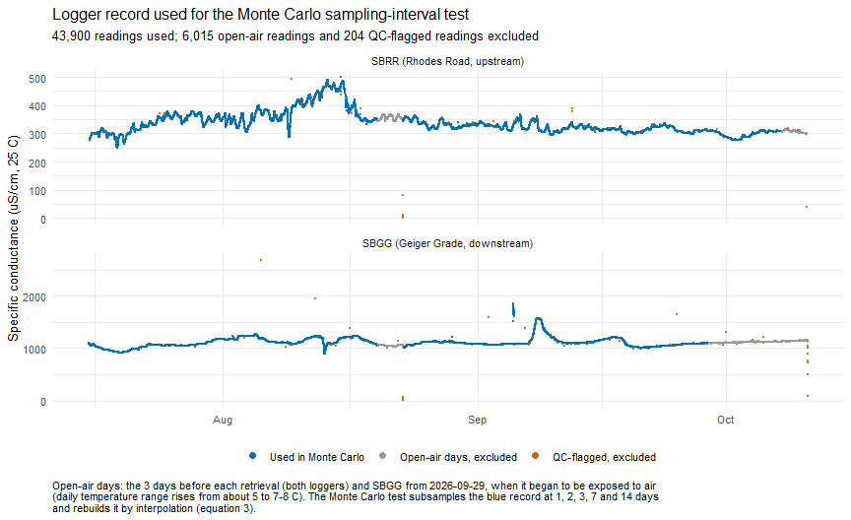
Figure 1
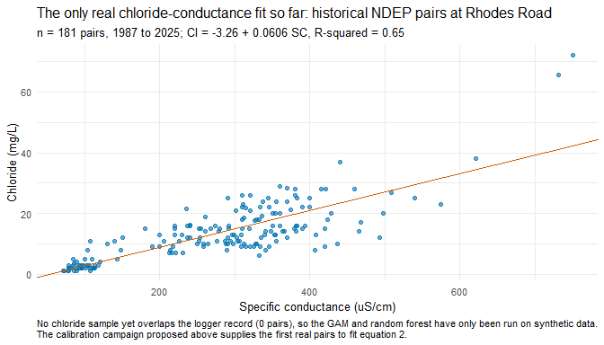
Figure 2

Why the proposed sampling interval matters: error grows with days between samples
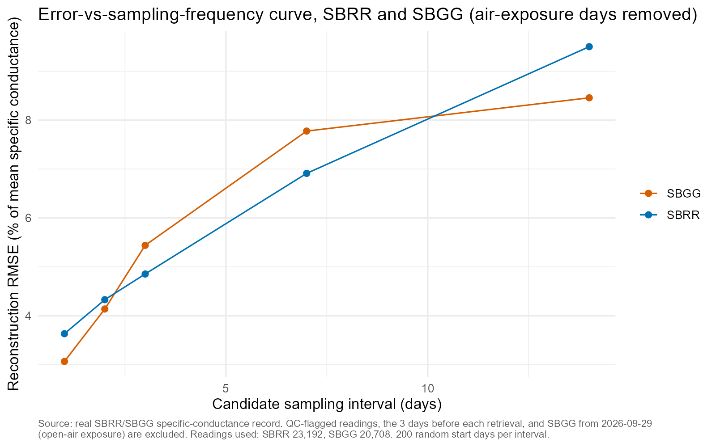
Reconstruction error of the conductance record against the candidate interval between samples, SBRR and SBGG (200 random start days per interval; QC-flagged readings, open-air days before retrieval, and SBGG after 2026-09-29 excluded). Mean error rises from about 3-4% of mean conductance with daily samples to about 8-10% at 14 days.

What the GAM has and has not been run on
The sampling interval in this plan comes from the Monte Carlo test on the real logger record (Figures 1 and 3). The chloride models themselves, including the GAM, have not been fitted to real paired data, because no chloride sample yet overlaps the logger record (zero pairs). They have been run only as a code test on a simulated data set (simulate_synthetic_pairs() in 03_chloride_models.R): 60 samples every three days from 1 May 2026, with
$$SC=300+40sin​\left({2πd}/{365}\right)+N(0,15), T=15+8sin​\left({2π(d−60)}/{365}\right)+N(0,1.5),$$
$$Cl=1+0.071 SC_{\text{lag}}+0.1 T_{\text{lag}}+N(0,1.5),$$
where the lag is six days. The slope 0.071 comes from the single real SBRR pair (Cl 17.1 mg/L at 241 uS/cm on 2026-05-01), so the simulated chloride stays in a realistic range; every other value is made up. Because the data were generated from a known linear rule, the exercise shows only that the fitting and cross-validation code runs and recovers a known relationship. It does not show how well a GAM will perform on Steamboat Creek, and it did not influence the sampling interval. The only real fit is the linear regression on 181 historical NDEP pairs in Figure 2, which predates the loggers. The calibration samples proposed in this document supply the first real pairs for the GAM.

