**Ongoing Technical Analysis of Financial markets and Crypto**

***For sure financial advice - More on Substack & Twitter***

[*Tylerisyoung.Substack.com*](www.tylerisyoung.substack.com)  
[*Twitter.com/TylerisYoung*](www.twitter.com/Tylerisyoung)  
_________________________

**The Fundamentals**

Zoom in on browser/mobile to see charts

Read: [Modern Monetary Theory - Slow at first, then all at once.](./mmt.html)

**The Macroeconomic Backdrop**

The macroeconomics problem displayed in a single chart: 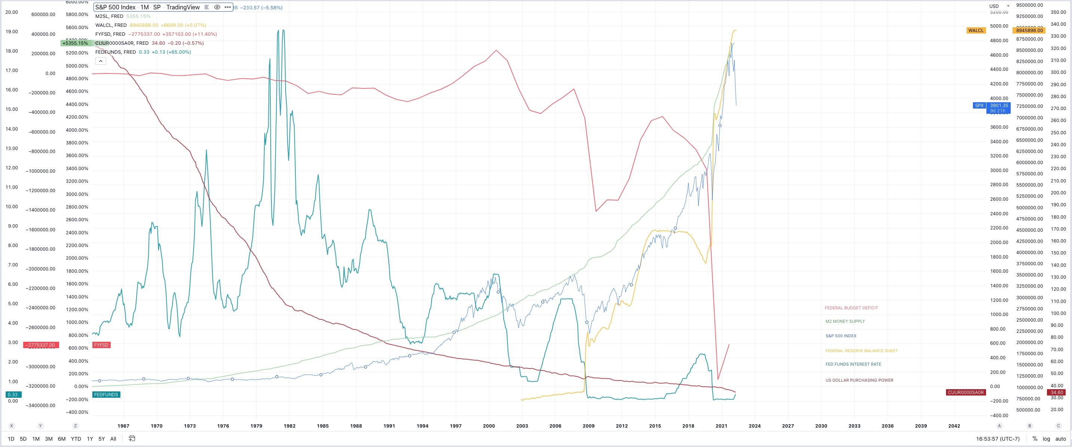

Ongoing Technical Analysis

*5/29/2022*

**Traditional Markets**

* Gavin Newsom [suggests](https://www.gov.ca.gov/2022/03/23/governor-newsom-proposes-11-billion-relief-package-for-californians-facing-higher-gas-prices/) oil price stimulus to combat inflation - lol Fight inflation by giving people more money to spend… right. Inflation is always a monetary phenomenon - more money chasing the same goods results in higher prices. Next will come price controls which are even worse. Taxes on energy and necessities are always regressive as seen in Europe and well covered by Zero Hedge and Doomberg.
* Running to take Newsom’s spot as governor, Micheal Shellenberger has a much better understanding of the economy and energy markets as described in his own [Substack.](https://substack.com/profile/2255433-michael-shellenberger) I wish him luck in his candidacy.
* China’s small-medium banks are insolvent? - Customers unable to access funds for a month. Lots of turmoil due to ridiculous lock downs, occams razor pivoting towards China will not open up until Europe is in official recession. US and Europe already in recession, but the time it’s acknowledged, it will be nearly over if it still likely ends with a fed pivot. [via Reuters](https://www.reuters.com/markets/asia/chinese-depositors-left-dark-three-local-banks-freeze-deposits-2022-05-18/)
* China is [loosening](https://www.bloomberg.com/news/articles/2022-05-20/china-cuts-borrowing-costs-by-record-to-boost-loan-demand) by record amounts to make up for weak (or collapsing) housing market in China who does a lot more adjustable rate loans. (Evergrande’s toxic balance sheet?) China needs citizens taking new loans so they’re cutting rates, debt driven systems need more debt and inflationary bailouts. Current system is tight and desperate for new money.
* Oil likely to rally further if China opens, inflation will continue even if YOY numbers go down slightly.
* Bear market rally confirmed in traditional markets, back to risk on, temporary and short term mean reversion setting up for potential or likely lower lows in line with the high time frame mean reversion after decade long bubble in risk.
* Fed announces only two more hikes, then data dependent, Powell is great at letting the markets know what should be expected.
* Redfin [reporting](https://www.redfin.com/news/housing-market-update-price-drops-surge-to-19pct/) 1/5 home sellers drop prices last month
* Redfin “The monthly mortgage payment on the median asking price home declined slightly from a record high to $2,425 at the current 5.1% mortgage rate. This was up 42% from $1,708 a year earlier, when mortgage rates were 2.95%…Pending home sales were down 5.4% year over year.”
* Fed Raising rates resulting in huge mortgage rate increase, highest since 2008, bond prices set to rally as safe haven compared to real estate.
* University of Michigan “home buying conditions” are the worst they’ve been since the 1980’s - [Zero Hedge](https://www.zerohedge.com/personal-finance/umich-sentiment-tumbles-accelerates-may-home-buying-confidence-collapse)

**Crypto Markets**

* BTC playing catch up over the weekend, riskiest of risk assets will lag. Eventual decoupling will result in BTC being risk off, but this still seems like a distant future.
* BTC Peak Fear and greed index recently reached 8 (now 10) - Extreme fear, good long term buy indicator despite potential further downside.
* Alt/BTC pair is likely to continue to bleed until BTC shows monthly strength, BTC maxi’s always have a good point.

**Charts**

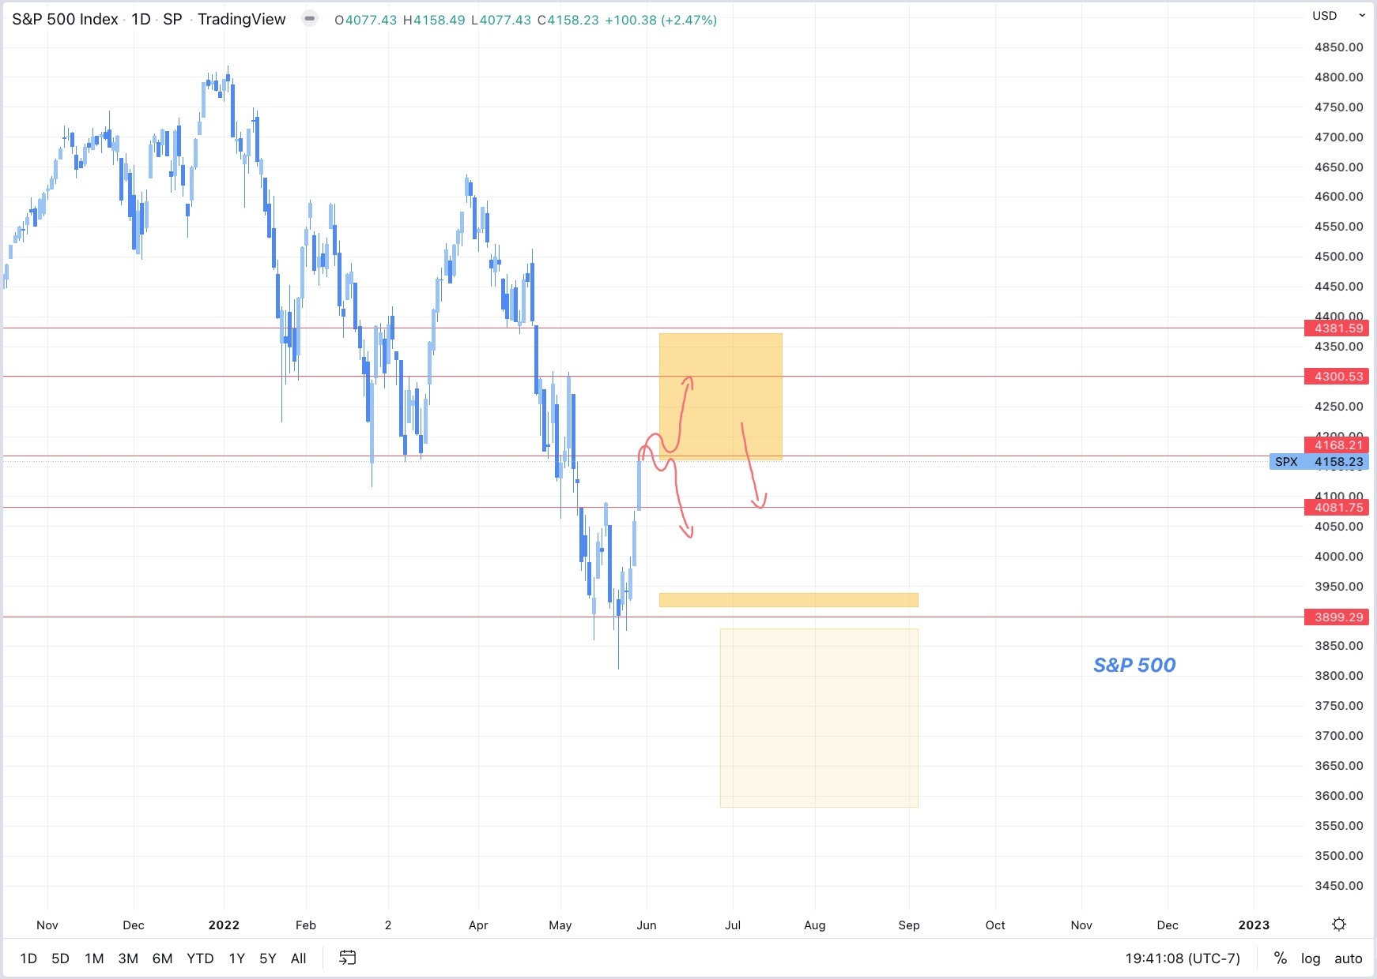

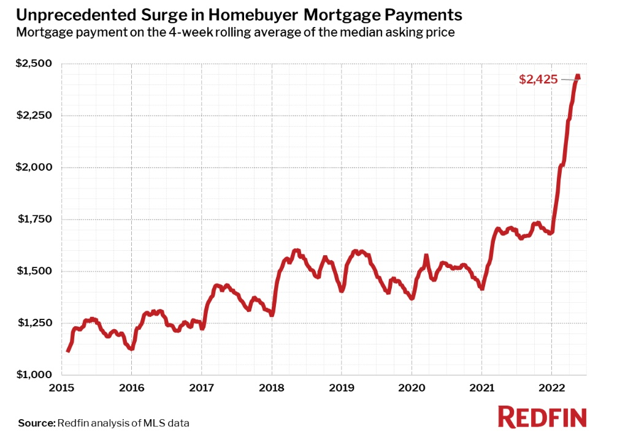

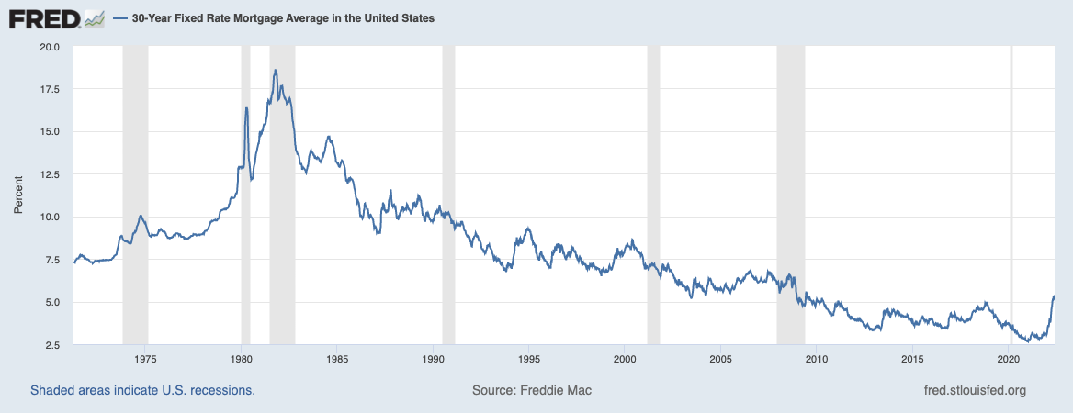

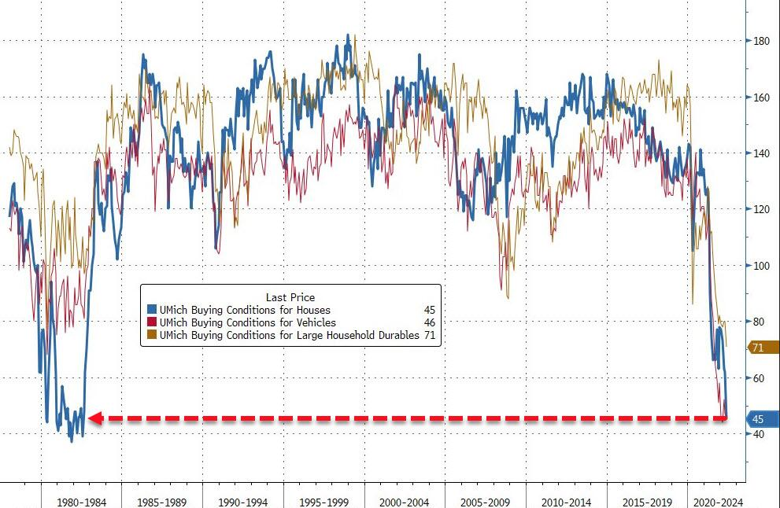

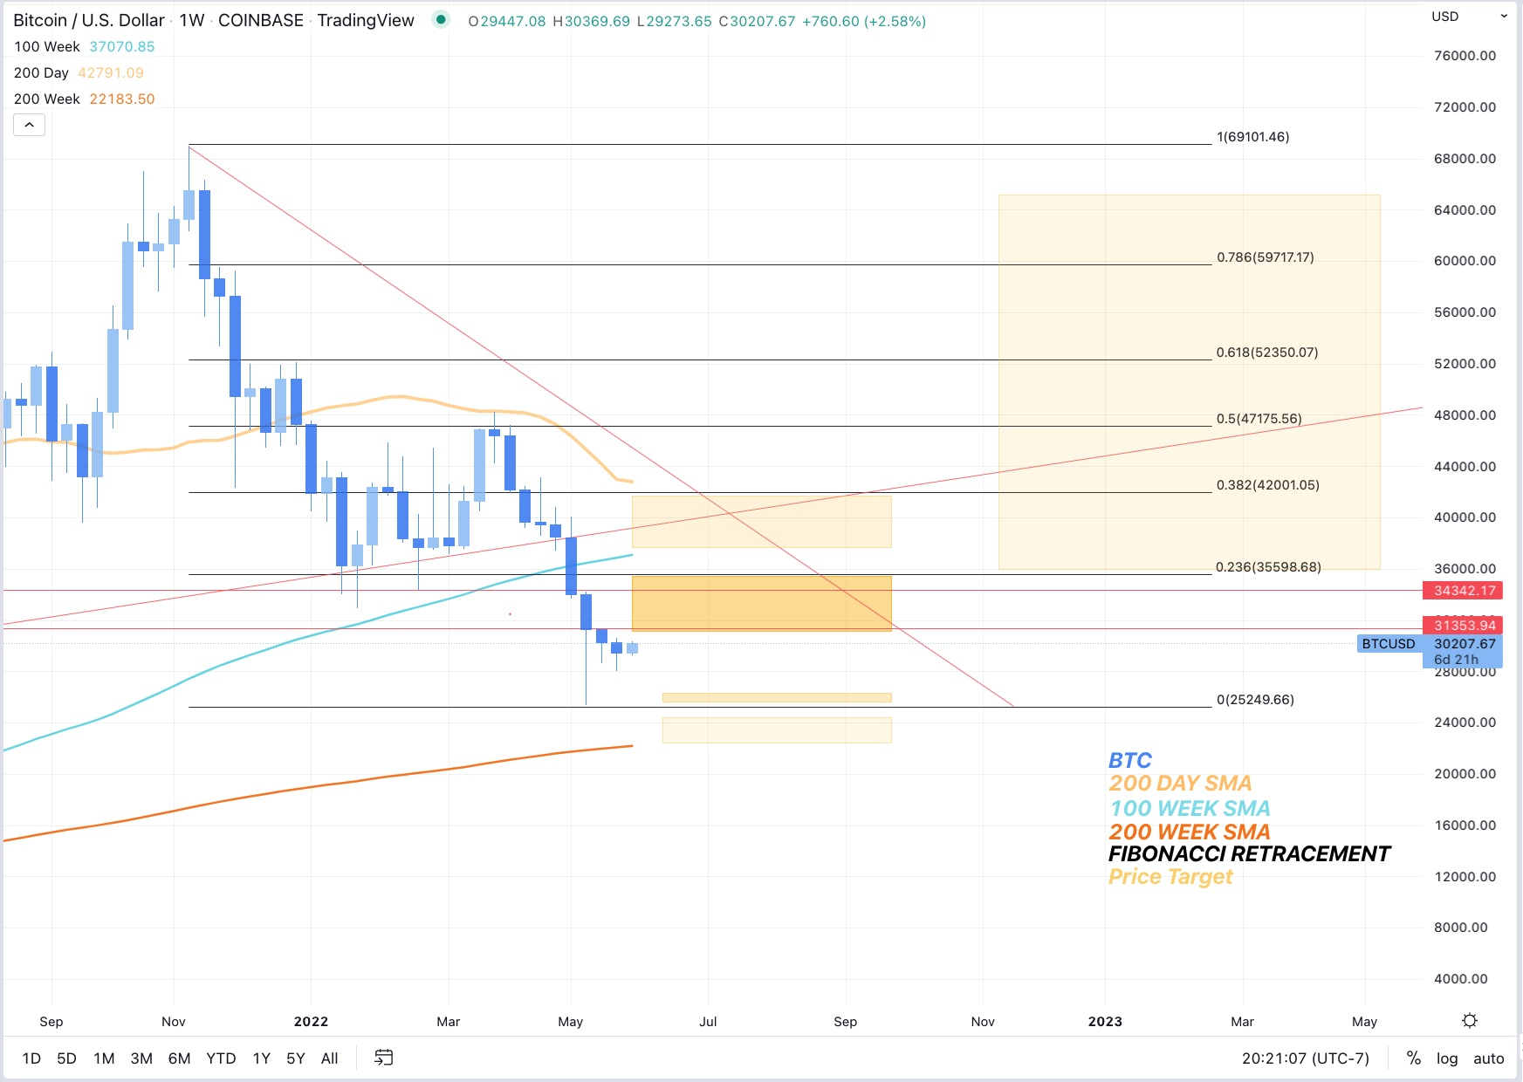

*5/27/2022*

* Traditional markets are having a nice rally after solid support at S&P:3900, now above 4100. Still low call volume.
* Volatility will likely remain high for several weeks.
* Consumer savings accounts shredded, American’s are not able to adjust spending to keep up with newly higher prices. - chart from Zero hedge.
* BTC Down, everything else up, correlation with risk is breaking, but not in the fun direction. Price action closes hourly low below the range low, Longs getting trimmed until clarity in PA. BTC is the most risky of risk on assets, will potentially rally last under a bear market rally.
* BTC dominance likely to continue to stay flat or rise whether we go up or down, Alts have been rekt with no end in sight, good prices, but no strength in BTC means alts could drop another 60%+ from here.
* Lumber futures are down big at peak building season, houses should be being built but no one’s buying wood, long term housing shortage will continue until prices fall significantly.
* NYT changes tune on Ukraine war - Ukraine can’t win. (While typing I defaulted to writing “we can’t win” - American’s don’t want or need another proxy war.)
* Voter turnout hits record numbers in Georgia as Dems switch sides leading to massive positive swing for Republicans, could foreshadow future problems for Dems as many have already been forecasting, potentially even more reason for a FED pivot prior to November.

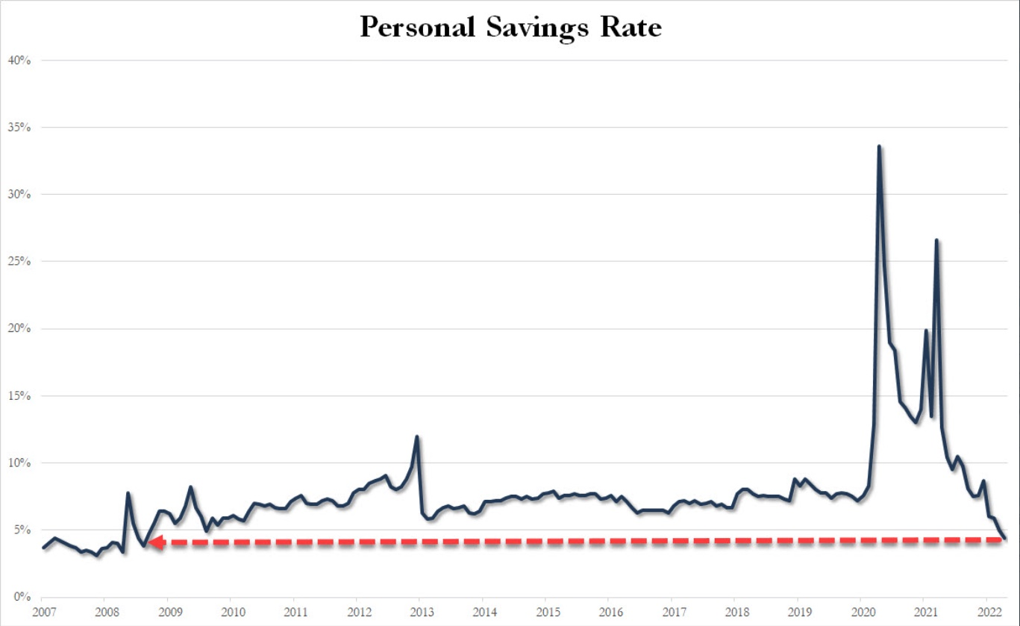

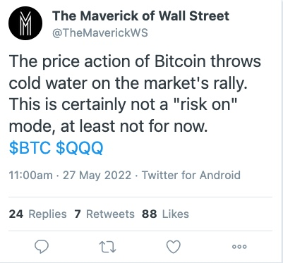 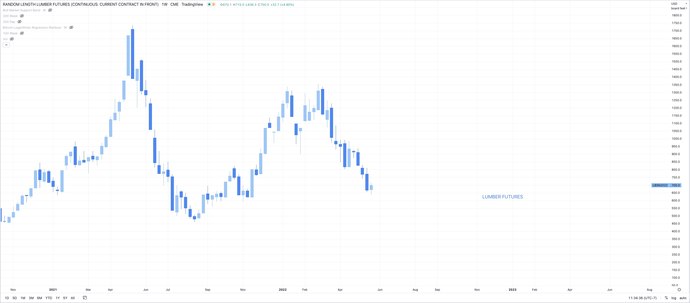 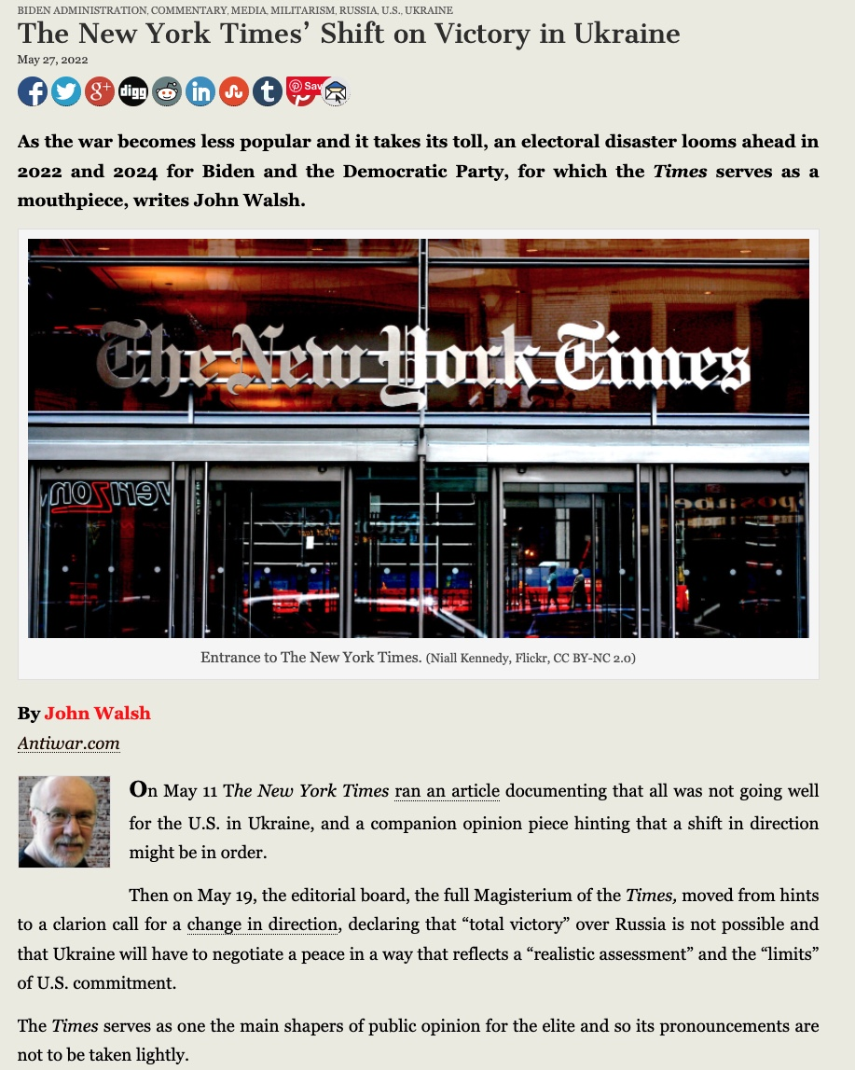 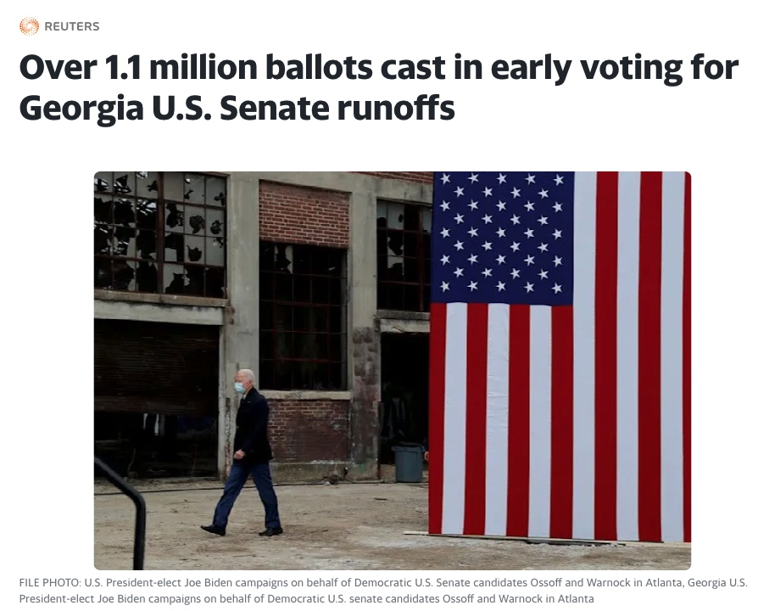

*5/25/2022*   
**Short term outlook:**

* DXY and US10YR threatening to roll over (a point for the bulls, finally)
* S&P & QQQ (&BTC) looking at a bear market rally, possibly 7-15% from bottom
* BTC target 35k then possibly run the 25K lows if bottom falls out of tradfi
* Ideally 10 year falls for the right reason (inflation expectations down) rather than the wrong reason (growth expectations down)
* Call option volume remains low, all markets still waiting for buyers despite massively oversold conditions

**Longer term outlook:**  
Base case is:

* Possible bounce here
* Possible lower lows after - lots of entities looking for exit liquidity and a rotation out of growth to value and commodities for what is potentially a commodity driven stagflationary supercycle - this would not be great but it’s potentially unavoidable (though with more QE, growth will come back as well)
* Possible rally into November midterms,
* Fed may sell Mortgage backed securities back into the market despite rapid rise in rates, housing will take a hit regardless
* Fed hiking could stop Q4 2022 (Currently market is pricing in later 2023 or 2024 - but they won’t get that far) at which point when the hiking stops, the low will already be in, markets are forward looking and will recover far before the economy does.
* Economy looking at higher unemployment, lower wage growth, higher consumer credit to come, increased home sales and defaults, etc. real stagflation driven mainly by monetary QE, but also sanctions, and supply chains, all with no real painless solution that isn’t more governmental jobs programs/Universal basic income/ socialized losses to subsidize government errors etc.
* They will try to inflate the long term debt bubble a few more times before they let it pop and try to implement CBDC’s as the savior, by this time BTC will be in the “early majority” stage of the adoption curve and by enough people learning about the faults BTC corrects in the monetary system, traditional finance will become fractured towards a dual system solution, one forever inflating, one forever deflating.

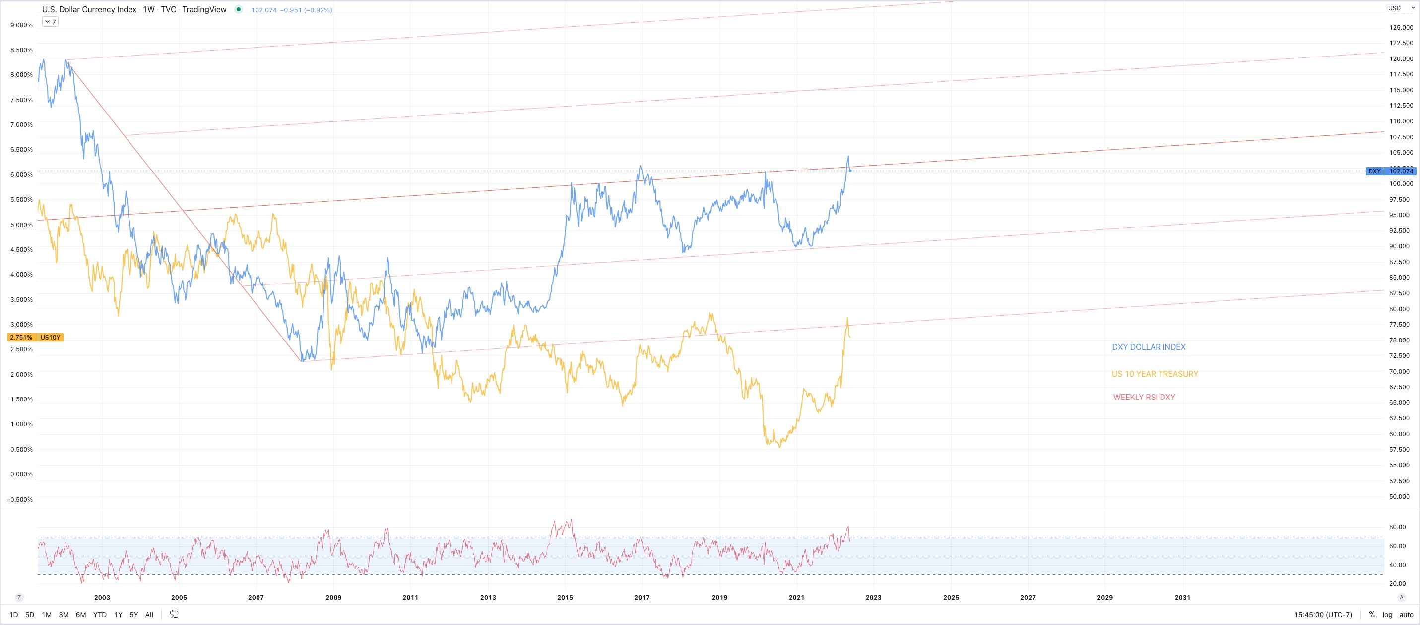

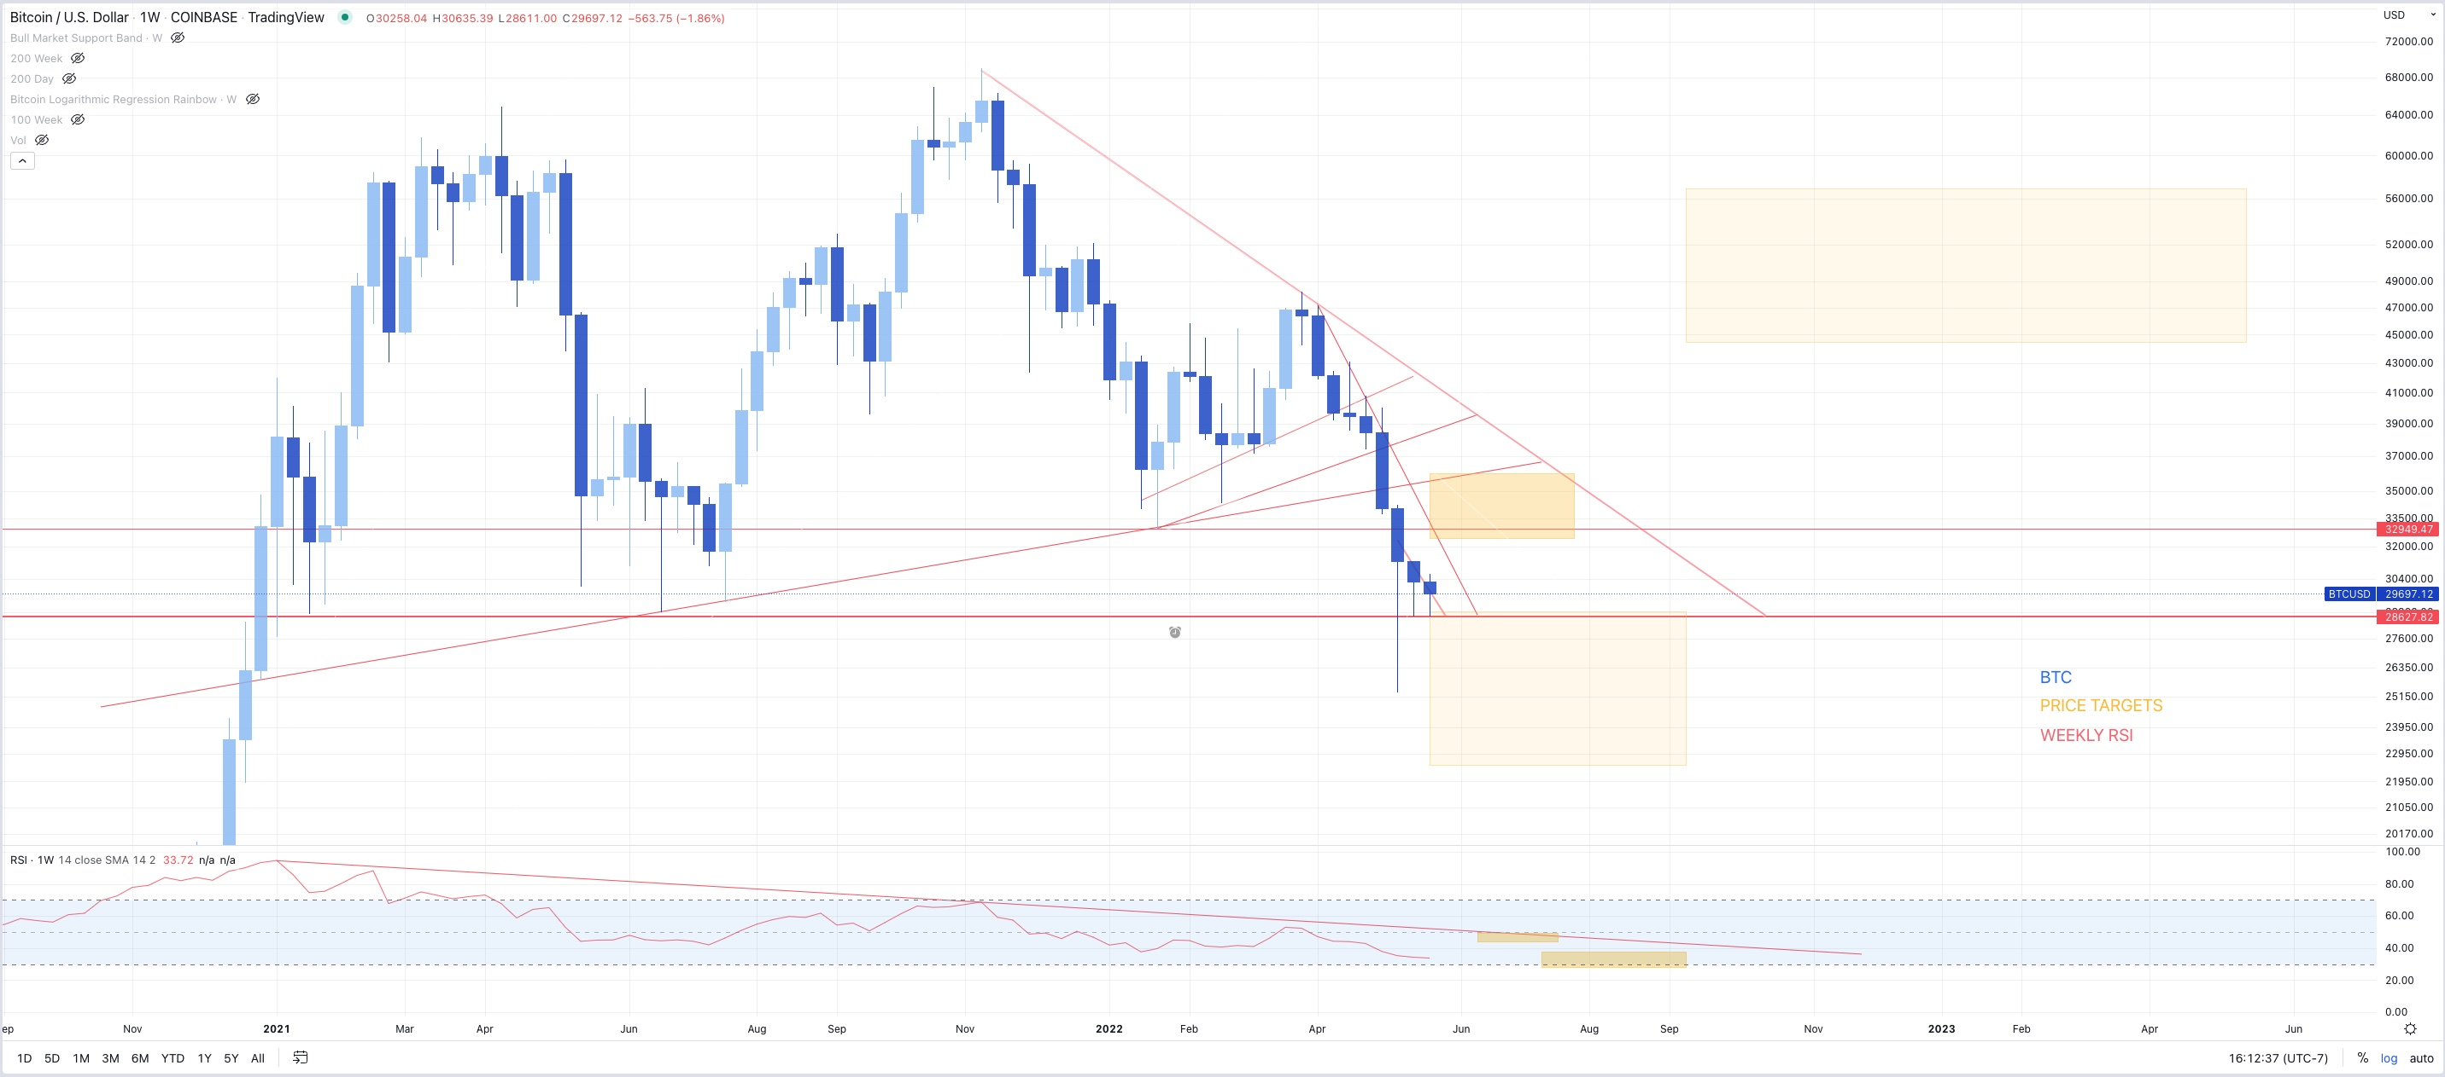 _________________________________________________________  
**5/24/2022**   
- Bear market rally in QQQ less obvious  
- Was Friday rally enough to calm these extreme oversold conditions?  
- Larger uncertainty now  
- Still bullish on long term price trend and eventual FED pivot, possibly before NOV midterms, but short term pain seems imminent

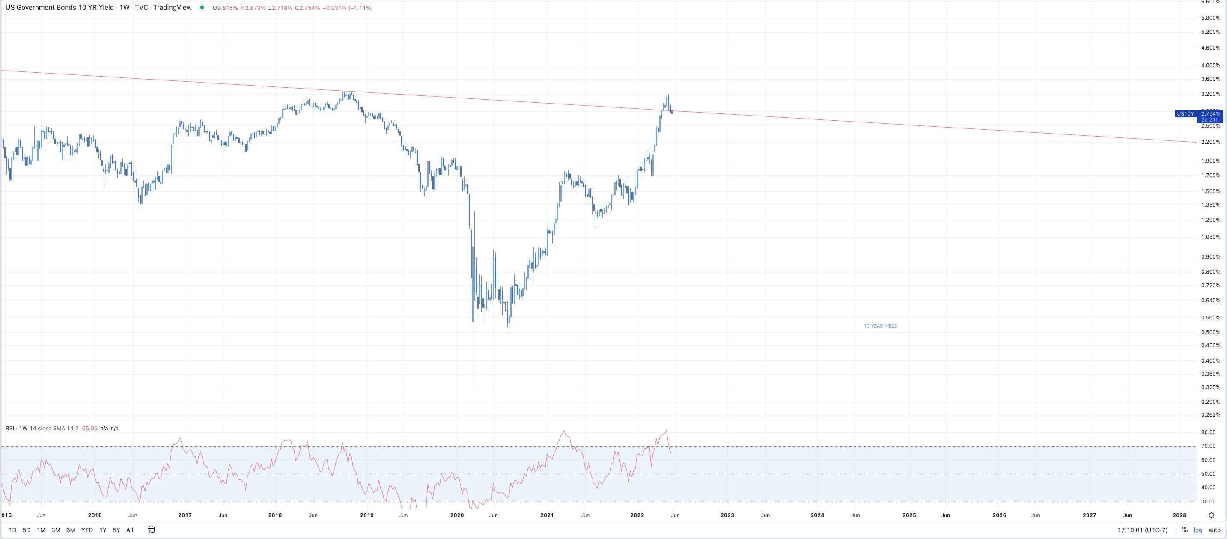 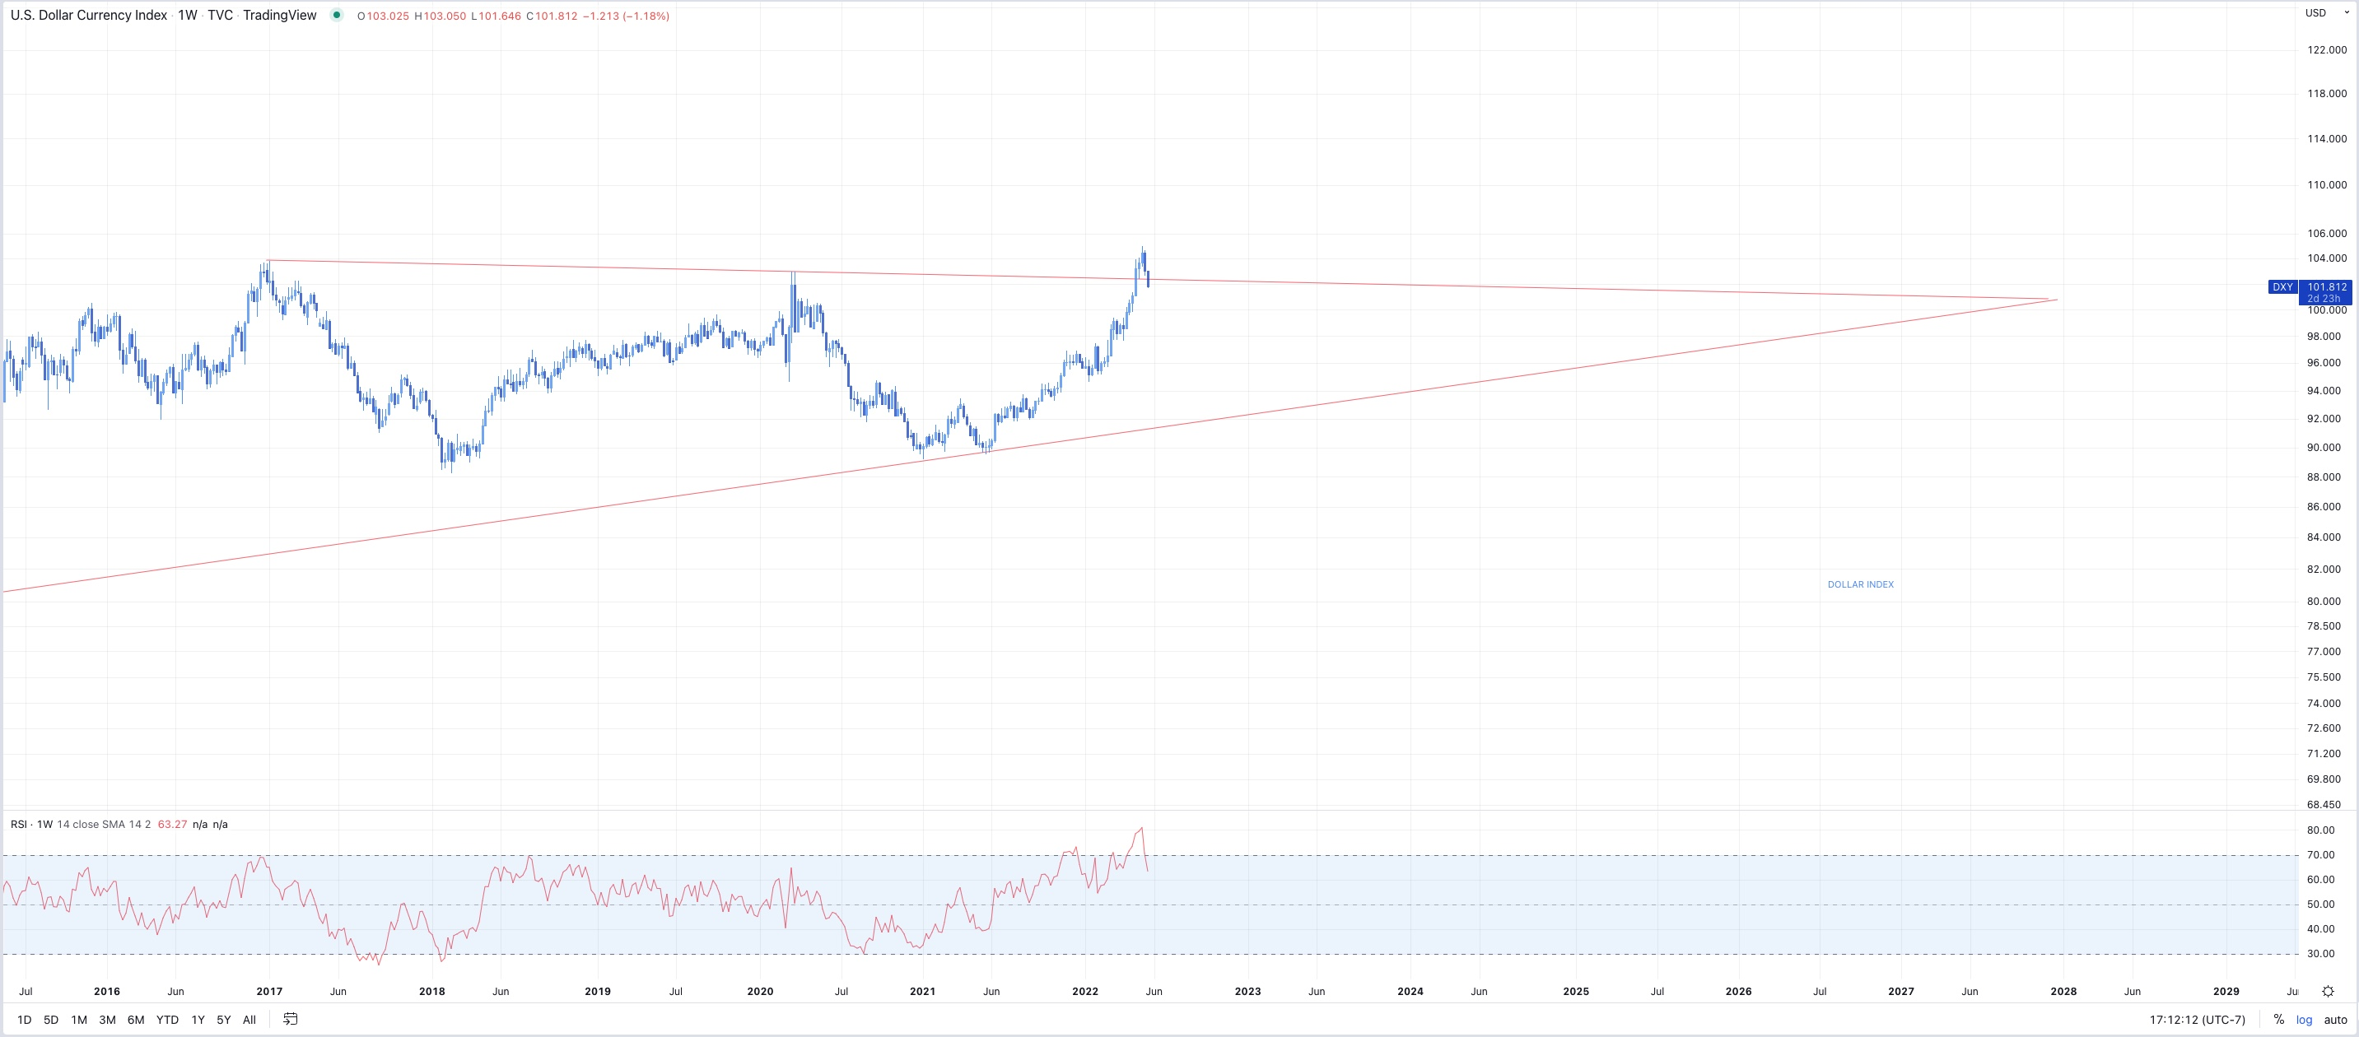

_________________________________________________________  
**5/23/2022**   
- Possible bounce here, then we’ll see. Markets on edge, everything oversold but still waiting for buyers.

