A: 94

B: 10

C: 800

D: 11

E: 82

F: 135

G: 417

H: 9

I: 16

J: 46

K: 3

L: 160

M: 544

N: 18

O: 102

P: 75

Q: 47

R: 5

S: 15

T: 6

U: 24

V: 345

W: 12

X: 63

Y: 127

Z: 145

A gourmet soda, hand-finished with natural and artificial flavors and only the freshest and highest quality ingredients.

INGREDIENTS: CARBONATED WATER, HIGH FRUCTOSE CORN SYRUP, CARAMEL COLOR, VANILLA EXTRACT, NATURAL AND ARTIFICAL FLAVORS, PHOSPHORIC ACID, SODIUM BENZOATE (PRESERVES FRESHNESS), HONEY ESSENCE, ACACIA SASSAFRAS EXTRACT

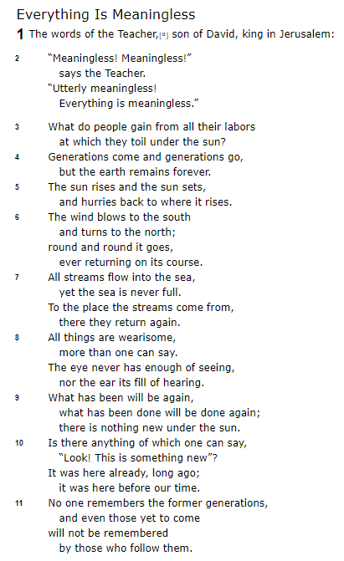

FINAL ANSWER:

____ ____ ____ ____ ____ ____ ____ ____ ____ ____ ____ ____ ____