🌍 Project Overview: Secure Industrial IoT Air Quality Monitor
This project is an End-to-End IoT ecosystem designed for critical indoor air quality monitoring. It leverages the ESP32 as the central processing unit, communicating securely via MQTTS (encrypted MQTT) with a Raspberry Pi gateway.

🛠 Tech Stack
- Hardware: ESP32 (MCU), ENS160 (MOX Gas Sensor: eCO2, TVOC, IAQ), AHT21 (Precision Temp/Humidity).
- Firmware: Native C++ using ESP-IDF v5.5, following Object-Oriented Programming (OOP) principles.
- OS: FreeRTOS (Multitasking and Queue-based synchronization).
- Security: MQTTS protocol (MQTT over TLS/SSL) with OpenSSL and CA Certificate validation.
- Backend: Raspberry Pi running a Mosquitto Broker and a Python-based local data logger (CSV).

🏗 Software Architecture
The system is built on a decoupled concurrency model:
- Sensor Layer (SensorManager): Encapsulates I2C communication. It implements a dynamic compensation algorithm where AHT21 data is injected into the ENS160's registers to calibrate gas readings based on ambient conditions.
- Communication Layer (WifiManager & MqttClient): Manages automatic reconnection and the TLS handshake. It uses certificate-based authentication to ensure data integrity and prevent eavesdropping.
- Synchronization: A FreeRTOS xQueue is utilized to pass data structures (SensorData) between the sensing task and the transmission task, ensuring no data loss during network fluctuations.

🛡 Solved Engineering Challenges
- Boot-Loop Debugging: Resolved a critical Hardware Watchdog error (RTCWDT_RTC_RESET) by restructuring the hardware initialization sequence, moving it from static constructors to the FreeRTOS task flow (Lazy Initialization).
- Memory Optimization: Manually tuned task stacks to 8KB to accommodate the OpenSSL heap requirements for TLS handshakes without triggering a stack overflow.
- Data Integrity: Developed a Python bridge for the receiver end that validates JSON payloads and performs persistent logging in CSV format with server-side timestamps.

📊 Measurement Capabilities
- eCO2: CO2 equivalent for ventilation monitoring.
- TVOC: Total Volatile Organic Compounds.
- IAQ: Air Quality Index (1-5) following international standards.
- T/H: High-precision ambient monitoring.

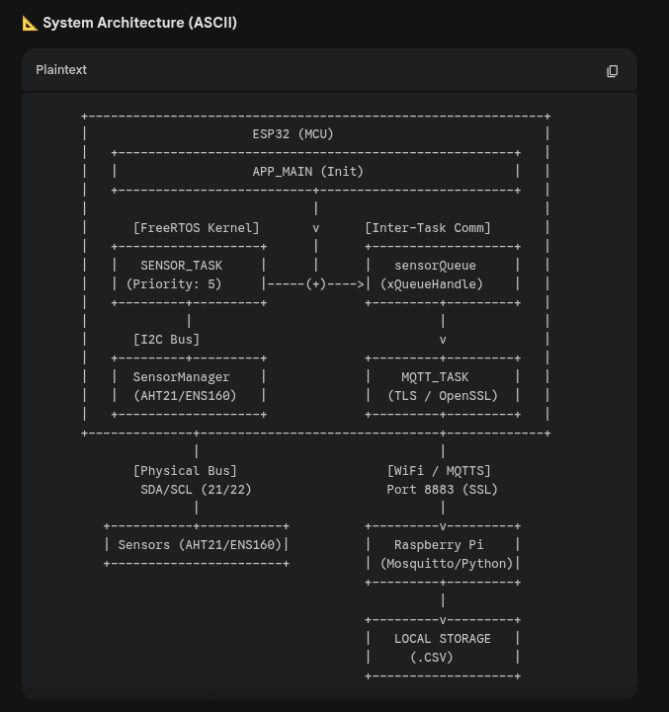

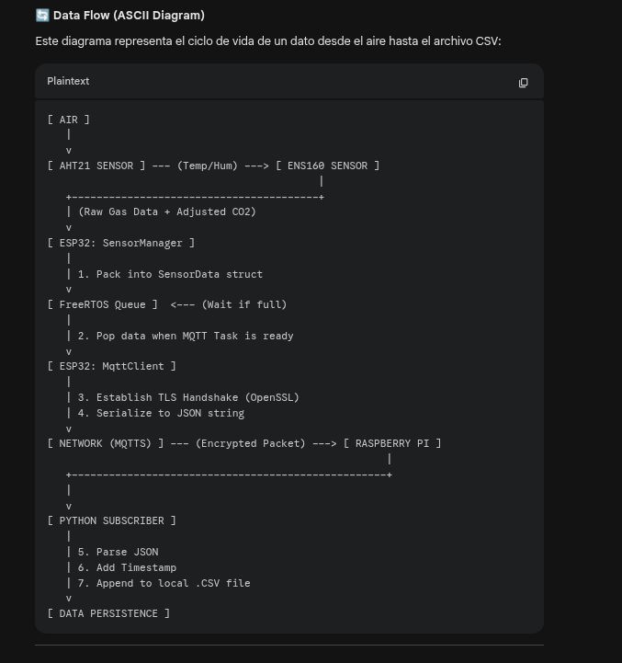

2. Technical Challenges & Debugging
- Watchdog Reset Issue (RTCWDT_RTC_RESET):
  - Cause: During early development, the ESP32 entered a boot loop. Diagnosis showed that global static object constructors were attempting to access I2C hardware before the RTOS kernel had fully initialized.
  - Solution: Migrated to Lazy Initialization within the tasks, ensuring NVS flash and network stacks were stabilized before hardware interaction.
- Memory Management (Stack Overflow):
  - Cause: Utilizing MQTTS (TLS/SSL) is resource-intensive. The default 4KB task stack was insufficient for the OpenSSL handshake process.
  - Solution: Increased the MQTT task stack to 8KB and reconfigured the Flash partition to 4MB to accommodate the larger binary size.
3. Sensor Calibration & Compensation Unlike basic implementations, this firmware performs dynamic compensation. The AHT21 provides real-time Temperature and Humidity data, which is injected into the ENS160's compensation registers (0x13-0x16). This corrects the gas sensor readings based on environmental conditions, preventing "drift."
4. Network Security Security is handled at the transport layer. The MQTT client loads a CA Certificate in PEM format to verify the broker's identity on port 8883, preventing "Man-in-the-Middle" attacks within the local network.

