Tyler Tiede LabVIEW Project Proposal

Title: Soccer Free Kick

Email: tjt4

Hardware List:

* 2x HiTEC Servo Motor
* Pololu 0J5005 USB Servo Controller
* Micro USB cable
* Webcam
* Foam sheets for floor/walls/goal/ball holder construction
* Wooden blocks for “defenders”
* Ball
* Overhead camera mount
* USB-6001 DAQ
* 2 Wires for Servo Power

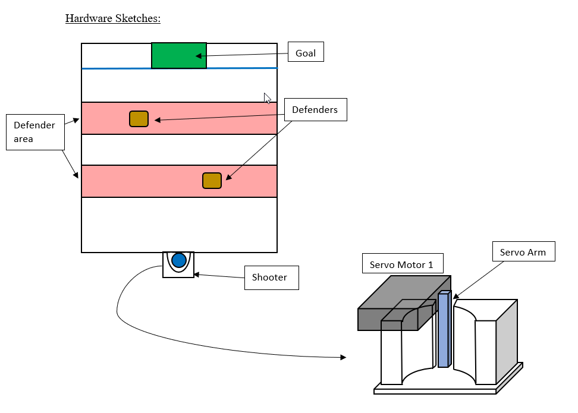Hardware Sketches:

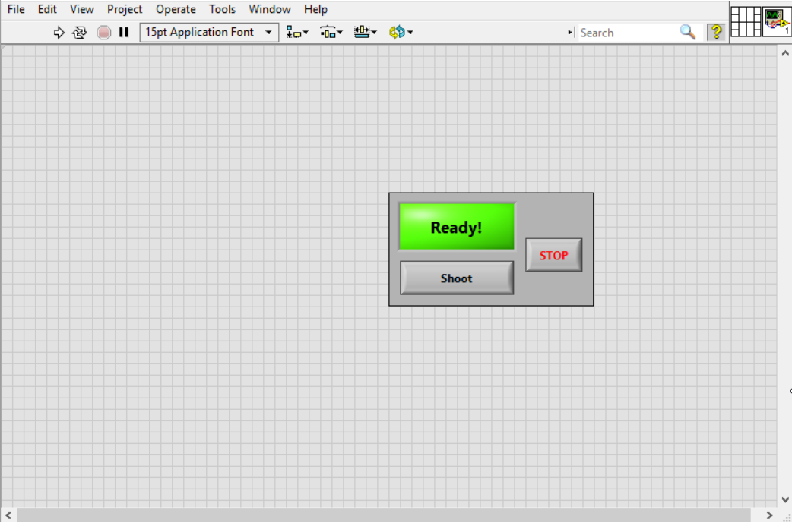User Interface:

User input: Users will be able to place one defender in each of the two “defender area” bands on the board, as well as move the goal laterally along the back edge of the box. Users will also have to place the ball once the program has calculated the correct angle, as well as press a button to shoot the ball.

Output: The LabVIEW program will output positions for the two Servo motors positions. A DAQ will also output 5V to power the Servo motors.

Measurements: The LabVIEW program will be taking measurements from the camera overhead of the positions of the two “defenders” and the goal placement. The camera has a framerate of 60fps. (Data acquisition frequency may change as the project progresses for optimization)

Stage 5 Grading: By stage 5 I expect to be able to control the two servo motors from LabVIEW and be able to shoot the ball at various angles. I also expect to have the apparatus constructed.

Flowchart:

User moves the defender and goal into the desired location

Shoot ball

LabVIEW program calculates angle

Camera measures the position of the defenders and goal placement