**How to access CEDS**

**(Login information for Computational Environment for Data Science)**

1. Connect with the web client: <https://rdweb.wvd.microsoft.com/arm/webclient>
2. You will land on a Microsoft login page and be prompted to enter your credentials – this is your UVA email address ([user@virginia.edu](mailto:user@virginia.edu)) and the password you use to access other UVA resources (like Collab, SIS or MS OneDrive).

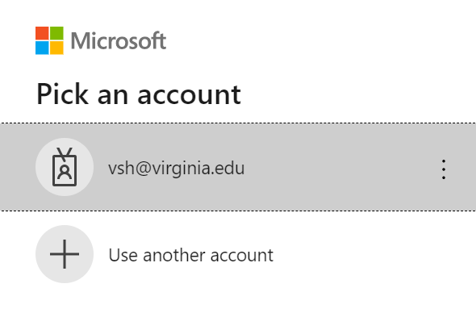

1. If you see a Netbadge login page, use the computing ID (left side of the @virginia.edu address) and the password for Collab, SIS or OneDrive.

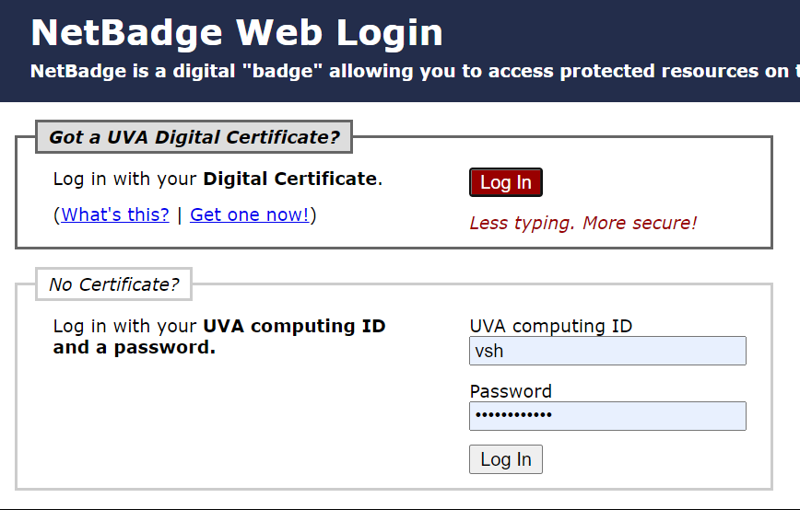

1. You may encounter an extra security step (Duo 2-factor authentication) – in which case choose an option and respond accordingly:

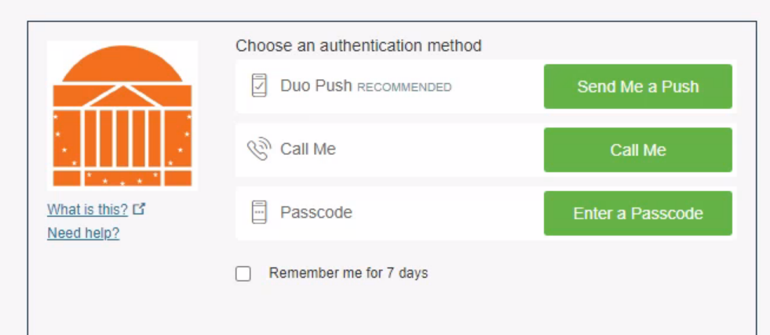

1. Once you enter your information, you will be taken to web page with 2 options for remote desktop. Choose the first one entitled “Data Science Virtual Desktop”:

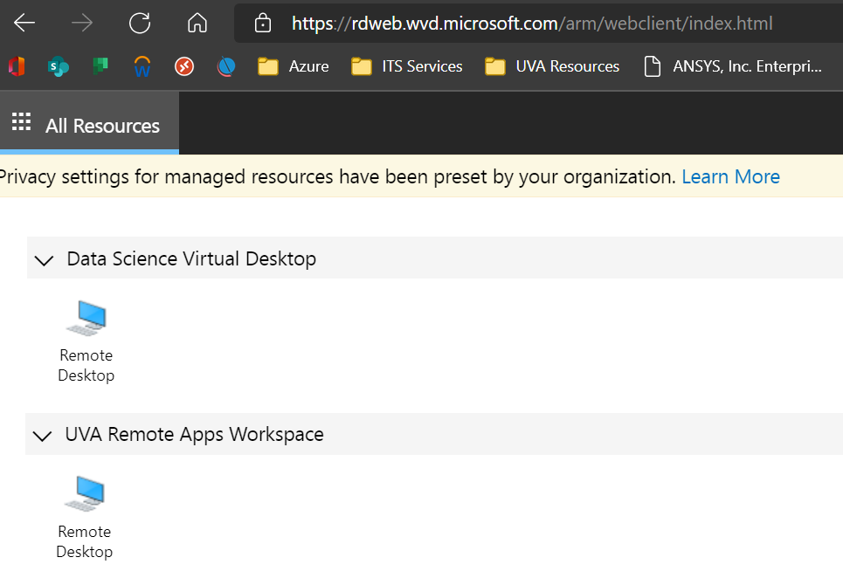

1. Click the remote desktop icon to open the Data Science Virtual Desktop. You will be prompted for information about accessing local resources – click the box to allow “File Transer (preview)”, then click Allow:

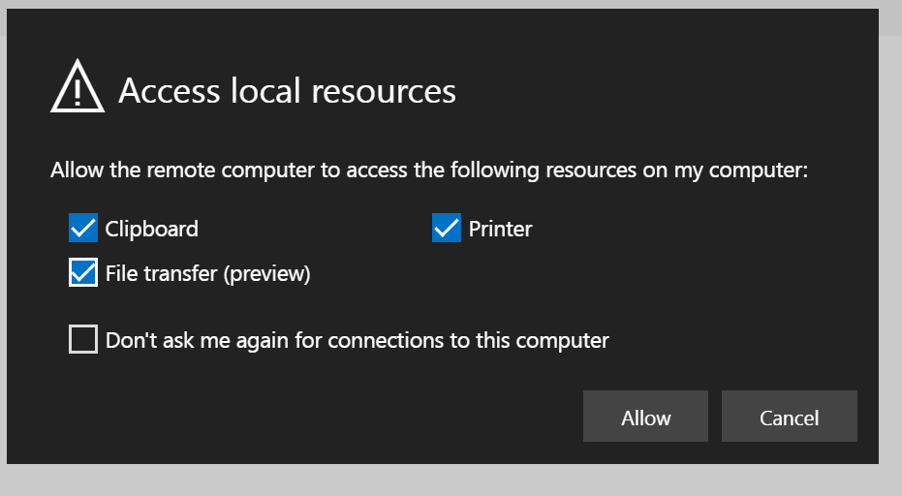

1. You will see a dialog box that says Connecting and launching “Remote Desktop” – starting your VM, this may take up to 5 mins. Allow this process to FULLY complete.

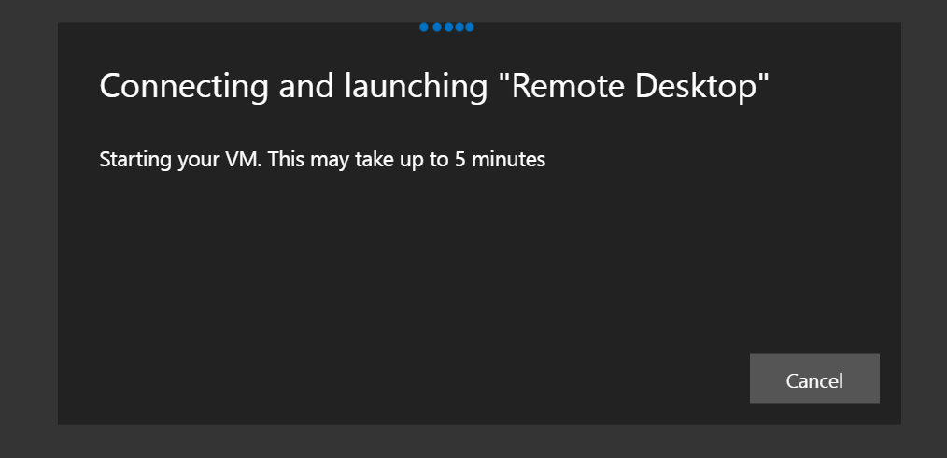

1. Once more, you will be prompted for your UVA credentials – again, use the same computing ID and password you used before, and hit submit:

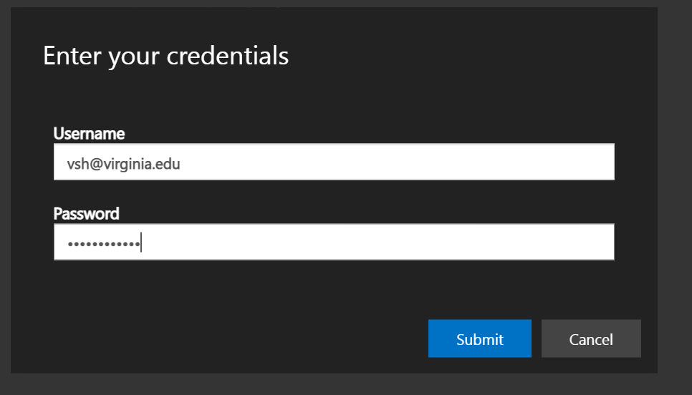

1. Your profile will be created and you will then see the base CEDS working desktop:

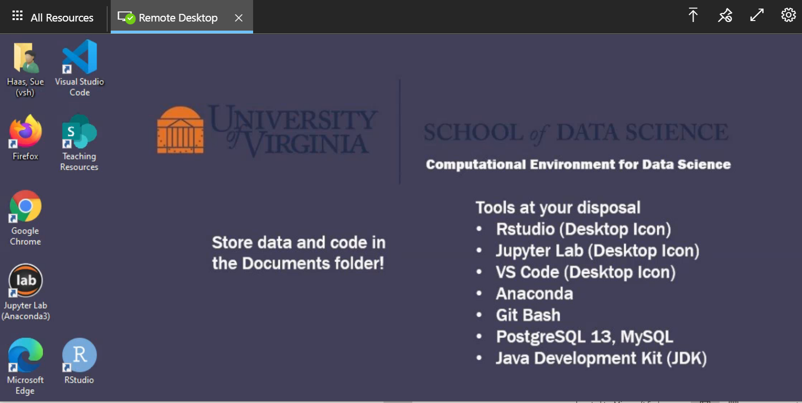

1. 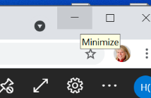Success! You are now in the CEDS environment. Please note that you can minimize this browser session just like any other web session by utilizing standard browser functionality (for example, underscore in Chrome:
2. To end your session, you can simply close the browser window as you would normally do or sign out of the remote desktop client (upper left, open your profile and sign out):

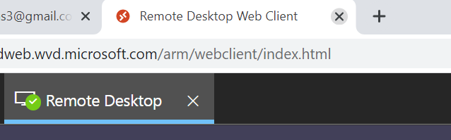

OR

