CS 370 — Revised Lab 7 Use Cases
  - Minecraft Server Anti-Cheat System (MSACS) | Revision based on instructor feedback

Revision summary
- Reduced the diagram to five core user-goal use cases; alerts, evidence capture, and logging are included in the normal flows instead of being separate ovals.
- Removed ambiguous <<include>> and <<extend>> relationships; all diagram lines are explicit actor–use case associations.
- Added five primary-level description tables, plus a revised summary-level table and two sub-function tables.
- Used existing SRS requirements as the source of planned behavior. Sprint 1 demonstrated server setup and plugin loading, not live anti-cheat detection.

Use-case diagram
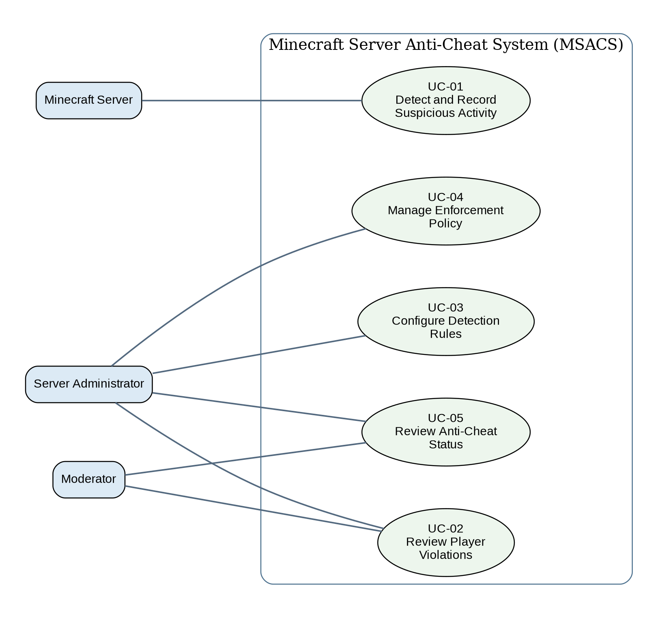
UML note: rectangles represent external actors here for readability; the ellipses are the system use cases. Solid lines are associations. There are no include/extend dependencies to misinterpret.

Traceability
ID | Use case | SRS requirement(s)
SUM-01 | Monitor and Protect Minecraft Server | R.1–R.4
UC-01 | Detect and Record Suspicious Activity | R.1, R.1.1–R.1.4, R.2, R.2.1, R.3.2, R.3.3, R.4
UC-02 | Review Player Violations | R.2, R.2.2, R.3.4
UC-03 | Configure Detection Rules | R.3, R.3.1, R.3.4
UC-04 | Manage Enforcement Policy | R.3.2–R.3.4
UC-05 | Review Anti-Cheat Status | UI-1, R.3.4
SF-01 | Evaluate Player Movement | R.1.1–R.1.4
SF-02 | Record Violation and Notify Staff | R.2, R.2.1
Note: UC-05 is grounded in UI-1 on SRS page 5. The SRS does not currently specify a separate watchlist capability; add one only if the SRS is formally expanded.

Summary-Level Use Case — SUM-01
Use Case ID | SUM-01
Name | Monitor and Protect Minecraft Server
Level | Summary
Scope | Minecraft Server Anti-Cheat System (MSACS)
Primary Actors | Minecraft Server; Server Administrator
Supporting Actors | Moderator; Player
Goal | Evaluate server-side player activity, record suspected violations, provide authorized staff with review information, and apply configured escalation.
Trigger | A player is connected and the enabled server-side monitoring receives gameplay events.
Preconditions | The compatible Minecraft server and anti-cheat component are running; configured checks and permissions are available.
Main Success Flow | 1. Server provides valid player activity events.  2. Anti-cheat evaluates enabled rules and exemptions.  3. Suspicious activity meeting a rule produces a violation record.  4. Authorized online staff receive an alert.  5. Authorized staff can inspect recent violations.  6. If configured escalation conditions are satisfied, the server issues a kick; in alert-only mode, no kick occurs.
Alternate Flows | A1. Normal/exempt activity: no violation is recorded.  A2. Invalid movement sample: ignore it and continue monitoring other players.  A3. Logging failure: report the problem; invalid records must not trigger enforcement.  A4. No permitted staff online: store the record for later review.
Postconditions | Any detected violation has a stored record and applicable alert/action; monitoring continues.
Related Primary Cases | UC-01, UC-02, UC-03, UC-04, UC-05
Status: Proposed system behavior from SRS; verify through implementation/testing before claiming completion.

UC-01 — Detect and Record Suspicious Activity
ID / Level | UC-01 / Primary
Primary Actor | Minecraft Server
Goal | Detect configured abnormal movement and create a reviewable record.
Trigger | Server delivers a player movement event.
Preconditions | Monitoring is enabled; the movement event is valid; relevant check is enabled.
Main Success Flow | 1. Receive a valid player movement event.  2. Determine whether teleportation, authorized flight, or another configured exemption applies.  3. Calculate distance and elapsed time or evaluate the airborne-motion rule.  4. Compare observed movement with the applicable configured threshold.  5. If a rule is violated, create a violation record containing ID, player ID, time, check, observed value, threshold, and action.  6. Notify online staff with alert permission.  7. Evaluate the selected alert-only/escalation policy.
Alternate Flows | A1. Exempt or ordinary activity: no violation.  A2. Invalid sample or player disconnect: stop processing only that sample/player.  A3. Log write error: report to console and do not automatically enforce based on an invalid record.
Postconditions | Valid violations are recorded and alerts/actions follow configuration.
Requirements | R.1–R.2.1; R.3.2–R.3.3; R.4
Status: Proposed system behavior from SRS; verify through implementation/testing before claiming completion.

UC-02 — Review Player Violations
ID / Level | UC-02 / Primary
Primary Actor | Authorized Moderator or Administrator
Goal | Inspect recent evidence of a player’s suspicious activity.
Trigger | Staff requests violation history for a selected player.
Preconditions | User has the required permission; records are available.
Main Success Flow | 1. Staff enters the violation-history command and player identifier.  2. System checks permission.  3. System finds the player’s 20 most recent violations.  4. System displays timestamps, check names, measured values, thresholds, and actions.  5. Staff assesses whether any follow-up is warranted.
Alternate Flows | A1. Unauthorized staff: deny access and return an understandable error.  A2. No violations: display an empty-history message.  A3. Invalid player identifier: show command usage guidance.
Postconditions | The requesting authorized staff member can review available history; no records are modified.
Requirements | R.2, R.2.2, R.3.4, UI-4, NFR-S1
Status: Proposed system behavior from SRS; verify through implementation/testing before claiming completion.

UC-03 — Configure Detection Rules
ID / Level | UC-03 / Primary
Primary Actor | Server Administrator
Goal | Enable/disable detection checks and adjust valid movement thresholds and exemptions.
Trigger | Administrator submits a configuration change.
Preconditions | Administrator has configuration permission; anti-cheat is installed.
Main Success Flow | 1. Administrator opens a configuration command or documented file.  2. Administrator selects a check and updated enabled status/threshold/exemption setting.  3. System validates permission, field, type, and accepted range.  4. System saves the valid configuration.  5. Subsequent events use the updated rule; system confirms the change.
Alternate Flows | A1. Out-of-range or malformed input: reject without altering prior configuration.  A2. Unauthorized actor: deny and show permission error.  A3. Save fails: report error and retain the previous valid configuration.
Postconditions | A valid updated configuration is in effect, or previous configuration remains unchanged.
Requirements | R.3, R.3.1, R.3.4, UI-3
Status: Proposed system behavior from SRS; verify through implementation/testing before claiming completion.

UC-04 — Manage Enforcement Policy
ID / Level | UC-04 / Primary
Primary Actor | Server Administrator
Goal | Set alert-only behavior or kick escalation thresholds.
Trigger | Administrator requests enforcement policy settings.
Preconditions | Administrator has required permission.
Main Success Flow | 1. Administrator chooses alert-only or kick escalation mode.  2. For escalation, administrator supplies violation count and time window.  3. System validates count, time window, and permission.  4. System stores the new policy.  5. Upon later valid recorded violations, the policy is evaluated.  6. In alert-only mode, the system reports without kicking; in kick mode, it issues a kick only when the configured conditions are satisfied.
Alternate Flows | A1. Invalid count/window: reject change and keep existing policy.  A2. Unauthorized actor: deny change.  A3. Missing/invalid violation records: do not auto-enforce.
Postconditions | A valid enforcement policy is stored; later actions follow its rules.
Requirements | R.3.2, R.3.3, R.3.4; SRS data model EnforcementPolicy
Status: Proposed system behavior from SRS; verify through implementation/testing before claiming completion.

UC-05 — Review Anti-Cheat Status
ID / Level | UC-05 / Primary
Primary Actor | Authorized Administrator or Moderator
Goal | See which anti-cheat checks are enabled and their current state.
Trigger | Staff runs the anti-cheat status command.
Preconditions | Anti-cheat is loaded; staff is authorized for this command as configured.
Main Success Flow | 1. Staff issues status command.  2. System validates command and applicable permissions.  3. System reads current check configuration.  4. System displays implemented checks and whether each is enabled.  5. Staff uses the display to evaluate monitoring coverage.
Alternate Flows | A1. Invalid command: show helpful usage.  A2. Insufficient permission: show denial.  A3. Configuration read error: show error without crashing server.
Postconditions | Authorized staff see the current check status; configuration remains unchanged.
Requirements | UI-1, UI-3; R.3.4
Status: Proposed system behavior from SRS; verify through implementation/testing before claiming completion.

Sub-function — SF-01 Evaluate Player Movement
ID / Level | SF-01 / Sub-function
Parent | UC-01 Detect and Record Suspicious Activity
Actor | Minecraft Server
Trigger | Valid player movement sample arrives.
Preconditions | Movement check enabled.
Main Flow | 1. Inspect event for teleportation, flight, or configured exemption.  2. If not exempt, calculate horizontal distance / elapsed time.  3. Evaluate threshold and applicable airborne-motion rule.  4. Return result: no violation or detected check type and measured value.
Alternates | Exempt or invalid sample: return no actionable violation.
Postconditions | A rule evaluation result is available to UC-01.
Requirements | R.1.1–R.1.4
Status: Proposed system behavior from SRS; verify through implementation/testing before claiming completion.

Sub-function — SF-02 Record Violation and Notify Staff
ID / Level | SF-02 / Sub-function
Parent | UC-01 Detect and Record Suspicious Activity
Actor | Minecraft Server
Trigger | UC-01 detects a valid rule violation.
Preconditions | Player and check identities are known.
Main Flow | 1. Assign unique violation ID.  2. Store player ID, timestamp, check, observed value, threshold, and action.  3. Identify online staff with alert permission.  4. Send alert with player, check, time, and measured value.
Alternates | Storage failure: log error, avoid action on invalid record. No staff online: retain record for later history lookup.
Postconditions | Violation is stored when persistence succeeds; permitted staff alerted when online.
Requirements | R.2, R.2.1, UI-2
Status: Proposed system behavior from SRS; verify through implementation/testing before claiming completion.

Implementation and submission checklist
- Synchronize the original SRS use-case references and remove unsupported watchlist claims unless a watchlist requirement is approved.
- Replace the old Lab 7 diagram with the revised five-use-case diagram and keep one description table per page.
- Confirm which staff roles are permitted to use the status command (the SRS requires authorized staff).
- Implement and test movement checks, logging, history, configuration, and escalation before claiming those features work.
- Capture tests for normal movement, high speed, permitted flight/teleportation, invalid settings, denied permissions, restart persistence, and workload/latency.
- Use Sprint 1 screenshots only as proof of server connection and plugin installation.
Source documents: annotated Lab 7 use cases, CS 370 SRS Team AntiCheat, Minecraft AntiCheat Sprint 1 Report; instructor feedback dated Oct. 24, 2026.

