Hey team! Before you start writing, you should run the pipeline yourself so you understand what it does. Everything lives on GitHub. Here is how to get it running on your machine.

Running locally
1. Clone the repo:
git clone https://github.com/tylermaire/cx_pipiens_pangenome.git
cd cx_pipiens_pangenome

2. Install Snakemake if you do not have it:
conda install -c bioconda -c conda-forge snakemake

3. Do a dry run first to make sure everything is set up:
snakemake -n --use-conda --cores 8

4. If the dry run looks good, start the full pipeline:
snakemake --use-conda --cores 8

Heads up: this pipeline needs a decent computer. RepeatModeler alone takes about 32 hours, and the whole thing wants around 128 GB of RAM for some of the bigger steps. If your machine can not handle it, do not worry about it.

If local does not work
If you run into issues or your machine is not big enough, just let Tyler know. He can spin up the AWS instance and walk you through running it there. The EC2 setup is an r6i.4xlarge (16 cores, 128 GB RAM) and the full pipeline takes about 40 hours. We have done multiple full runs on it already so everything is tested.

Looking at the results without running anything
You do not have to run the pipeline to write your sections. The key result files are already in the repo under results/ and the figures are generated by the R script at scripts/Cx_pipiens_pangenome_figures.R. All the numbers you need are in this document under each section. But running the pipeline will help you understand the workflow better, which will make your methods section stronger.

Questions?
If you get stuck on anything, just reach out! The Snakemake rules are in workflow/rules/ and each .smk file maps to one of the methods sections you will be writing.

Pangenome Analysis Reveals Gene Content Variation and
Evolutionary Dynamics Across the Culex pipiens Species Complex
Tyler Maire, Madji Lodoumgoto, Erin Maley, Theresa Miller, Lauren Morales
Indian River Mosquito Control District, Vero Beach, FL, USA
* Correspondence: t.maire@irmcd.com
Target Journal: Insects (MDPI)

WRITING ASSIGNMENTS
Here is the plan: each person writes both the Methods and Results for their topic. That way you own the full story for your piece and everything stays consistent. I put the key numbers and stats right above each section so you do not have to hunt for them. The figures are embedded next to the results they go with.
Person | Sections | Scope
Madji | 2.1-2.3, 3.1 | Assemblies, annotation, OrthoFinder, pangenome partitioning (Figs 1, 5, Table 1)
Erin | 2.4-2.5, 3.2-3.3 | SCO extraction, species tree, CAFE5 gene family evolution (Fig 2)
Theresa | 2.6-2.7, 3.4-3.5 | Synteny, ANI, RepeatModeler/Masker, TE composition (Figs 3, 4, Table 2)
Lauren | 2.8, 3.6 | Anvi'o pangenome visualization and gene clusters (Fig 6)
Tyler | 1, 4, 5 | Introduction, Discussion, Conclusions, Abstract, final edits

A few things to keep in mind while writing: use past tense for methods and results (we did this, we found that). Active voice is better than passive when it works. Italicize species and form names every time (Cx. pipiens, not Cx. pipiens). Include tool version numbers in the methods. Do not worry about the Introduction or Discussion, I will handle those. Just focus on your assigned methods and results sections and we will piece it all together.

. Abstract
ASSIGNED TO: TYLER
Sections: Abstract
Write last after all sections are complete. 200-300 words.

[Abstract will be written after all sections are finalized. 200-300 words covering background, methods, key results, and significance.]

1. Introduction
Mosquito-borne diseases remain among the most significant threats to global public health, with Culex mosquitoes serving as primary vectors for several neurotropic arboviruses and filarial nematodes. The Culex pipiens species complex, which includes Cx. pipiens (with recognized forms pipiens, molestus, and pallens) and Cx. quinquefasciatus, represents the most widely distributed and medically important group within the genus Culex (Farajollahi et al., 2011). Members of this complex are the principal vectors of West Nile virus (WNV), St. Louis encephalitis virus (SLEV), Japanese encephalitis virus (JEV), and Wuchereria bancrofti, the causative agent of lymphatic filariasis. The complex also includes Cx. australicus and Cx. globocoxitus, which are restricted to Australia (Aardema et al., 2022), but no genome assemblies were publicly available for these taxa at the time of analysis.
Despite their close evolutionary relationships and the ability to produce fertile hybrids in laboratory settings, the forms within the Cx. pipiens complex exhibit striking ecological and behavioral differences that directly influence disease transmission dynamics (Farajollahi et al., 2011). Culex pipiens f. pipiens is an obligate blood-feeder that requires a blood meal before egg production (anautogeny), undergoes reproductive diapause in winter, and preferentially feeds on avian hosts, making it a critical bridge vector for WNV transmission from birds to mammals. In contrast, Cx. pipiens f. molestus is capable of producing its first egg batch without a blood meal (autogeny), does not enter diapause, preferentially feeds on mammals including humans, and thrives in underground habitats such as subway tunnels and basement water collections. Culex pipiens f. pallens is distributed primarily in East Asia and exhibits intermediate characteristics between pipiens and molestus, likely reflecting a history of hybridization (Aardema et al., 2020). Culex quinquefasciatus, the southern house mosquito, dominates tropical and subtropical regions and is a major vector of lymphatic filariasis and WNV in the Americas.
The genomic basis for these phenotypic differences remains largely unresolved. Previous comparative genomic studies of Culex mosquitoes have primarily focused on individual species or pairwise comparisons (Aardema et al., 2020; Aardema et al., 2022), limiting our understanding of the full spectrum of genetic variation within the complex. The pangenome framework, which partitions the total gene repertoire of a species or group into core genes shared by all members, shell genes shared by subsets, and cloud genes unique to individual members, offers a powerful approach for characterizing gene content variation in closely related organisms (Golicz et al., 2020). Although pangenome analyses have transformed our understanding of genome evolution in bacteria and plants, their application in insects remains limited. Recent pangenome studies in the silkworm Bombyx mori (Tong et al., 2022) and the fall armyworm Spodoptera frugiperda (Huang et al., 2025) have demonstrated the utility of this framework for revealing gene content variation, structural dynamics, and signatures of selection in insect genomes. However, no pangenome analysis has yet been conducted for any mosquito species, despite the medical importance and taxonomic complexity of groups such as the Cx. pipiens complex. The closest analog in an insect disease vector comes from the Anopheles gambiae sensu lato species complex, where whole-genome comparison across six sibling species has resolved species-level relationships and demonstrated pervasive autosomal introgression between the principal human malaria vectors (Fontaine et al., 2015; Neafsey et al., 2015). No comparable analysis has been reported for the Cx. pipiens complex, despite its comparable medical importance and the recent availability of chromosome-scale reference assemblies for four of its major forms.
Here, we present the first pangenome analysis of the Cx. pipiens species complex. We integrate four publicly available chromosome-level genome assemblies representing the major forms within the complex, along with Cx. tarsalis as an outgroup. We characterize the pangenome architecture, reconstruct phylogenomic relationships, identify gene families undergoing significant evolutionary change, compare transposable element landscapes, and assess whole-genome synteny across all pairwise combinations. Our results reveal substantial gene content variation among closely related mosquito forms and provide a genomic framework for understanding the ecological and behavioral divergence within this medically important species complex.

2. Materials and Methods

2.1 Genome Assemblies
Four chromosome-scale genome assemblies representing members of the Culex pipiens Four chromosome-scale genome assemblies representing members of the Culex pipiens species complex were retrieved from NCBI GenBank for pangenome analysis (Table 1). These included Cx. quinquefasciatus (GCF_015732765.1; 578 Mb), Cx. pipiens f. pallens (GCF_016801865.2; 568 Mb), Cx. pipiens f. molestus (GCA_024516115.1; 560 Mb), and Cx. pipiens f. pipiens (GCA_963924435.1; 533 Mb). Cx. tarsalis (GCA_016859205.1; 50 Mb) was included as a phylogenetic outgroup for tree rooting and was excluded from pangenome partitioning. The Cx. pipiens complex also includes Cx. australicus and Cx. globocoxitus (Aardema et al., 2020; Aardema et al., 2022), but no chromosome-scale genome assembly has been deposited in a public database for either taxon. Previous phylogenetic work using targeted sequencing places these two Australian endemics as a monophyletic sister clade to Cx. quinquefasciatus, with a relatively older divergence than the separations among the four taxa analyzed here (Aardema et al., 2020). The absence of reference assemblies for these lineages is therefore a shared limitation of the current field and is addressed further in the Discussion.
Genome selection was governed by three criteria: (i) assembly contiguity at the chromosome or near-chromosome scale, which is required for meaningful whole-genome synteny analysis; (ii) BUSCO completeness ≥ 95% against the diptera_odb10 reference set, ensuring that pangenome partitioning is not biased by assembly fragmentation; and (iii) availability through NCBI GenBank to support reproducibility. The four assemblies included here represent the complete set of genomes within the Cx. pipiens complex that satisfy all three criteria as of the analysis date. We explicitly avoided supplementing this panel with short-read draft assemblies, which frequently underrepresent repetitive and gene-dense regions and would introduce a systematic confound in pangenome partitioning: apparent shell or cloud orthogroups in such assemblies often reflect assembly gaps rather than true gene content variation.
Cx. quinquefasciatus GCF_015732765.1 was selected as the reference genome because it is the only assembly in the complex with a full NCBI RefSeq annotation, providing a curated set of gene models for downstream annotation transfer. This assembly also represents the most extensively studied member of the complex in terms of genomic resources and has served as the primary reference in prior comparative analyses of the group (Arensburger et al., 2010; Ryazansky et al., 2024).

2.2 Annotation Transfer
Gene models were transferred from the Cx. quinquefasciatus reference annotation (NCBI RefSeq) to the three remaining ingroup assemblies (Cx. pipiens f. pallens, f. molestus, and f. pipiens) and the Cx. tarsalis outgroup using Liftoff v1.6.3 [Shumate and Salzberg 2021 ref]. Liftoff maps reference gene features to target assemblies through whole-genome alignment, preserving gene structure including exon-intron boundaries. Default parameters were used for all transfers.
Protein sequences were extracted from each annotated genome using gffread v0.12.7 [Pertea and Pertea 2020 ref] with the -y flag to translate coding sequences from the transferred GFF3 annotations. The Cx. quinquefasciatus reference proteins were extracted directly from its RefSeq annotation. This produced 24,199 proteins for Cx. quinquefasciatus, 23,174 for Cx. pipiens f. pipiens, 22,585 for Cx. pipiens f. pallens, and 22,582 for Cx. pipiens f. molestus. The variation in protein count across assemblies likely reflects differences in assembly completeness and the proportion of reference gene models that could be successfully lifted over to each target genome. Extracted protein sets served as input for orthology inference.

2.3 Orthology Inference and Pangenome Partitioning
[Describe OrthoFinder v2.5.5 with DIAMOND for sequence similarity, MCL clustering (inflation 1.5). Define core (present in all 4 ingroup), shell (2-3 genomes), cloud (single genome). Mention outgroup used for rooting only.]
ASSIGNED TO: ERIN
Sections: Sections 2.4, 2.5
You are covering the evolutionary analysis side. We pulled 8,616 single copy orthologs (after filtering out anything under 50 amino acids), aligned them with MAFFT, trimmed with trimAl, and built a species tree with IQ-TREE v2.2.6 (1000 bootstraps, concordance factors). Then CAFE5 v5.1.0 (gamma model, k=3) tested which gene families are expanding or contracting. Lambda=0.0945, alpha=0.168.
The single copy orthologous genes (SCOs) were collected from the results generated by OrthoFinder v2.5.5. Orthogroups with one ortholog for each of the four ingroup genomes were obtained and sequences smaller than 50 amino acids were eliminated to minimize noise caused by weakly conserved and fragmented genes. After filtering, a total of 8,616 SCOs were included.
For each SCO, protein sequences were aligned independently with MAFFT v7.520 (default options). Aligned sequences were trimmed using trimAl v1.4.1 with option -automated1 in order to minimize spurious regions while keeping informative alignment sites. Trimming resulted in a total of 8,616 alignments which were then concatenated into a supermatrix.
Maximum likelihood trees were inferred with IQ-TREE v2.2.6. Best fitting model of amino acid substitutions was chosen through the use of ModelFinder (-m MFP) option. Branch support was determined with the help of ultrafast bootstrapping (-bb 1000) with 1,000 iterations. In addition, gene concordance factors (gCF) and site concordance factors (sCF) for all inner nodes were obtained for better phylogenetic assessment.

2.4 Phylogenomic Analysis
[Describe SCO extraction from OrthoFinder single-copy orthogroups. Alignment with MAFFT v7.520, trimming with trimAl v1.4.1 (-automated1). Filtering of alignments <50 amino acids. Concatenated ML tree with IQ-TREE v2.2.6 (-m MFP, 1000 UFBoot). Gene concordance factors (gCF) and site concordance factors (sCF).]
The evolution of gene families was investigated with the CAFE5 package v5.1.0 to find significantly expanded or contracted families across the phylogeny. The number of genes per orthogroup calculated with OrthoFinder served as an input and reflected the size of each gene family within the four ingroup species. The maximum likelihood tree built with IQ-TREE was employed as a guide tree for all calculations.
Gamma distribution for the gene family evolutionary rates was utilized with three rate classes (k = 3). Thus, different rates could be estimated for each gene family rather than one uniform rate for all of them. The birth-death rate parameter (λ) was estimated globally, which describes the frequency of gains and losses of gene copies in gene families. Also, the rate shape parameter (α) was estimated from the data. Gene families with p-values < 0.05 were considered significantly expanded or contracted.

2.5 Gene Family Evolution
[Describe CAFE5 v5.1.0 analysis. Gamma model with k=3 rate categories. Input: orthogroup gene counts from OrthoFinder. Species tree topology from IQ-TREE used as guide tree. Significance threshold p < 0.05. Report estimated lambda and alpha parameters.]
ASSIGNED TO: THERESA
Sections: Sections 2.6, 2.7
You have got the genome comparison stuff. For synteny we used nucmer from MUMmer v4.0.0 with delta-filter (-l 1000 -q) and show-coords.
ANI was calculated as the alignment-length-weighted mean identity.
For repeats we built de novo TE libraries with RepeatModeler v2.0.7 for each genome, then annotated with RepeatMasker v4.1.7. Table 2 has the ANI matrix.

2.6 Whole-Genome Synteny and ANI
Pairwise whole-genome alignments were performed among the four ingroup genomes to assess synteny on a large-scale and the similarity of the sequences. Genome comparisons were conducted using the nucmer program from MUMmer v4.0.0. The alignments were then filtered using delta-filter with parameters of -l 1000 -q, in order to retain high-confidence alignments of at least 1,000 base pairs. This enables prioritization of the best query alignments. Alignment coordinates and percent identity statistics were then extracted with show-coords.
The average nucleotide identity (ANI) values were calculated for each pairwise comparison, as alignment-length-weighted mean percent identity across all retained alignment blocks. This included six pairwise genome comparisons which were performed amongst four ingroup genomes. The ANI values were then summarized in an ANI matrix, shown in Table 2.

2.7 Transposable Element Analysis
Transposable element (TE) content was then characterized for each genome through de novo repeat library construction, using RepeatModeler v2.0.7 for each genome. Species-specific repeat libraries were first generated independently for each genome, then the custom repeat libraries were used in order to annotate the repetitive elements. This genome annotation was performed with RepeatMasker v4.1.7, using the species-specific libraries to identify and classify interspersed repeats and other repetitive elements throughout each genome assembly. As a result, the interspersed repeat content and total masked content was calculated, to be discussed in the results section.

2.8 Anvi'o Pangenome Visualization
An independent pangenomic analysis was conducted using anvi'o v8 [Eren et al. 2021 ref] to provide a complementary gene cluster level view of the pangenome and generate an interactive visualization. Contigs databases were created for each of the four ingroup genomes using anvi-gen-contigs-database with external gene calls derived from the Liftoff transferred annotations. A genomes storage database was then constructed to consolidate all four genomes. The pangenomic workflow was executed using anvi-pan-genome, which performed an all vs all amino acid sequence similarity search with DIAMOND across 68,043 combined protein sequences. Weak hits were removed using a minbit heuristic threshold of 0.5, which filters reciprocal DIAMOND matches based on the ratio of actual bitscore to maximum possible bitscore, retaining only pairs where both proteins show substantial mutual coverage. Filtered hits were then clustered into gene clusters using the MCL algorithm with an inflation parameter of 10. The phylogenomic species tree inferred from IQ-TREE was imported as a genome layer order, and the pangenome was visualized interactively using anvi-display-pan. The final visualization was exported as SVG and refined for publication.

3. Results
ASSIGNED TO: MADJI
Sections: Section 3.1
This is where you tell the story of the pangenome. Walk through the numbers, reference the figures, and point out what stands out. The chi-square result is important because it shows the cloud genes are not evenly split across forms. All the numbers you need are right below.

KEY NUMBERS FOR THIS SECTION:
Total orthogroups: 16,369 | Total genes assigned: 92,540 (97.9%) | Core: 11,653 (71.2%) | Shell: 4,205 (25.7%) | Cloud: 511 (3.1%)
Form-specific cloud: molestus=200, pallens=114, pipiens=142, quinquefasciatus=55
Chi-square test (equal cloud distribution): X-squared=85.36, df=3, p<2e-16
Median genes/orthogroup: 4 | Mean: 5.65 | Max: 200 | Single-copy (4 genes): 8,898
Some thing like OrthoFinder identified 16,369 orthogroups comprising 92,540 genes (97.9% assigned). The pangenome consisted of 11,653 core (71.2%), 4,205 shell (25.7%), and 511 cloud (3.1%) orthogroups.

3.1 Pangenome Architecture
[Describe the pangenome partitioning results. Start with total orthogroups and assignment rate. Report core/shell/cloud breakdown with percentages. Describe form-specific orthogroups and chi-square test result showing unequal distribution (molestus had the most). Reference Figures 1a-d and Figure 5. Reference Table 1 for assembly-level stats.]
Table 1. Genome assembly statistics and pangenome partitioning for the Cx. pipiens species complex.
Genome | Accession | Size (Mb) | Proteins | Core | Shell | Cloud
Cx. molestus | GCA_024516115.1 | 560 | 22,582 | 18,109 | 3,625 | 848
Cx. pallens | GCF_016801865.2 | 568 | 22,585 | 18,118 | 3,992 | 474
Cx. pipiens | GCA_963924435.1 | 533 | 23,174 | 18,177 | 4,436 | 560
Cx. quinquefasciatus | GCF_015732765.1 | 578 | 24,199 | 18,998 | 5,036 | 164
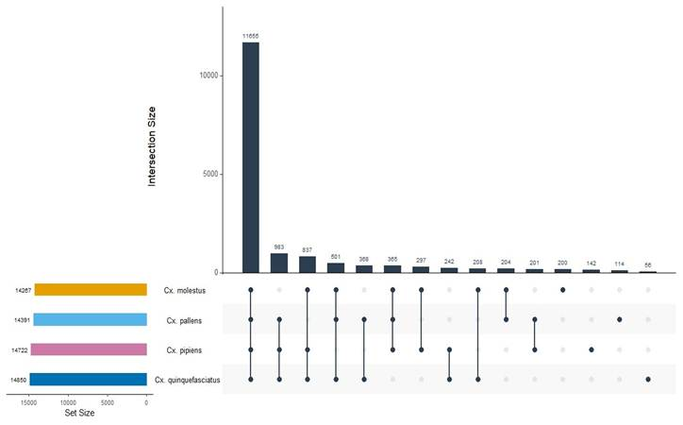
Figure 1a. UpSet plot showing orthogroup intersections across the four Cx. pipiens complex genomes. The largest intersection (11,655) represents core orthogroups shared by all four forms.
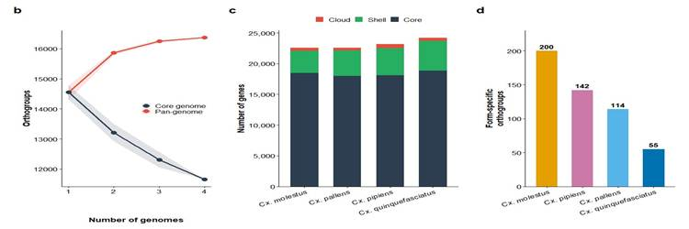
Figure 1b-d. (b) Pangenome accumulation curve showing core genome contraction and pan-genome expansion with added genomes. (c) Gene composition per genome partitioned into core, shell, and cloud compartments. (d) Form-specific orthogroup counts.
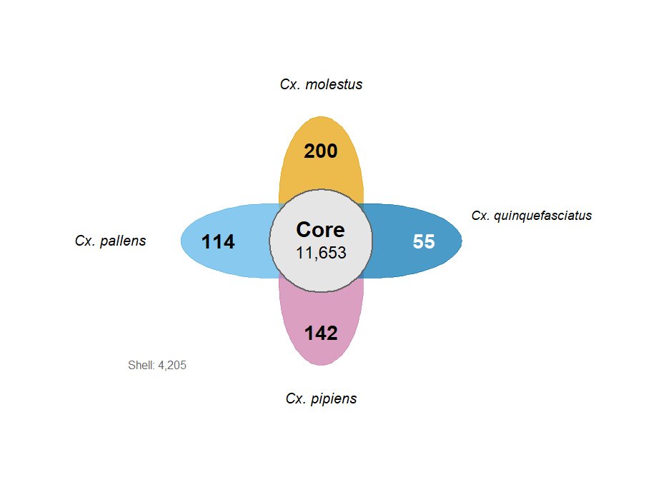
Figure 5. Flower diagram of the Cx. pipiens complex pangenome. Central circle shows 11,653 core orthogroups; petals show form-specific cloud orthogroups. Shell: 4,205.

ASSIGNED TO: ERIN
Sections: Sections 3.2 and 3.3
Two results sections for you. First is the species tree, which is pretty clean since everything is 100% supported. The interesting part is that pallens and pipiens are sisters, not molestus and pipiens. Second is the CAFE5 results. Every branch shows way more expansions than contractions (all p<2e-16). Quinquefasciatus is the biggest expander. Numbers are below.

KEY NUMBERS FOR THIS SECTION:
SCOs used: 8,616 (after filtering alignments <50 aa)
Tree topology: (Cx. molestus,(Cx. pallens,Cx. pipiens),Cx. quinquefasciatus)
All nodes: 100% UFBoot, 100/100/100 gCF/sCF
CAFE5: 596 significantly evolving families (p<0.05), lambda=0.0945, alpha=0.168
All branches show net expansion (binomial test p<2e-16 for each):
Cx. pipiens: 3,185 expansions / 1,073 contractions
Cx. pallens: 3,104 exp / 1,376 con
Cx. molestus: 3,050 exp / 1,593 con
Cx. quinquefasciatus: 3,671 exp / 866 con

3.2 Phylogenomic Relationships
[Describe the species tree topology. Cx. pallens and Cx. pipiens are sister taxa. Cx. molestus is sister to the pallens+pipiens clade. Cx. quinquefasciatus is the outgroup within the complex. All nodes have 100% bootstrap and 100/100/100 gCF/sCF, indicating complete concordance. Very short branch lengths reflect recent divergence. Reference Figure 2a.]
Phylogenomic analysis based on 8,616 single-copy orthologues produced a fully resolved species tree with full statistical support at all nodes (Figure 2a). According to the obtained topology, Cx. pallens and Cx. pipiens are sister taxa, while Cx. molestus is a sister group to this pair. Cx. quinquefasciatus is considered the most divergent taxon among those that make up the complex consistent with its known ecological and geographic differences.
All internal nodes showed 100% statistical support (100% ultrafast bootstrap and full concordance factor gCF = 100, sCF = 100). The short branch lengths in all ingroup taxa may reflect relatively recent divergence events in this complex. The close affinity of Cx. pallens and Cx. pipiens, previously shown to have similar genetics and hybridization capacity, is confirmed by the present analysis.

3.3 Gene Family Evolution
[Describe CAFE5 results. 596 significantly evolving families. All branches show significantly more expansions than contractions (binomial p<2e-16). Cx. quinquefasciatus shows the strongest expansion bias (3,671 vs 866). Discuss the gamma rate heterogeneity (alpha=0.168 indicates strong rate variation among families). Reference Figure 2b.]
Gene family evolutionary changes were identified through CAFE5. A total of 596 gene families showed either expansions or contractions within the Cx. pipiens complex with a p value less than 0.05. (Figure 2b). The rates of genes were determined to be λ = 0.0945, with the low value of α = 0.168 implying the presence of considerable differences in evolutionary rates between gene families.
In all examined lineages, there is a strong excess of gene family expansion relative to contraction events (binomial test, p < 2 × 10⁻¹⁶ for all branches). Gene family expansion was highest in Cx. quinquefasciatus, where 3,671 gene families expanded, while only 866 contracted. A similar yet slightly less extreme pattern was observed in Cx. pipiens (3,185 vs. 1,073), Cx. pallens (3,104 vs. 1,376), and Cx. molestus (3,050 vs. 1,593).
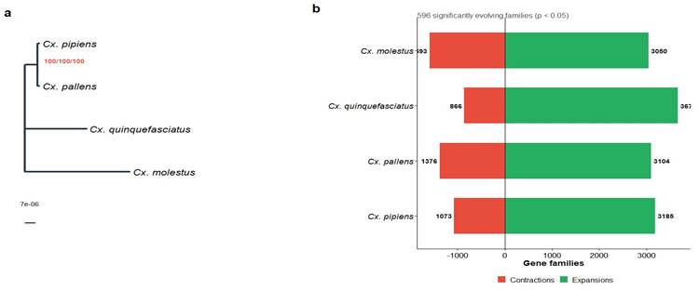
Figure 2. (a) Maximum likelihood species tree from 8,616 concatenated single-copy orthologs. Node labels show bootstrap/gCF/sCF support. Scale bar in substitutions per site. (b) CAFE5 gene family expansions (green) and contractions (red) per lineage. Subtitle indicates 596 significantly evolving families.

ASSIGNED TO: THERESA
Sections: Sections 3.4 and 3.5
Two sections here. The ANI and synteny results go together in 3.4. The take home is these genomes are super similar (97.9-98.3% ANI) but the dot plots show real structural differences, especially when quinquefasciatus is involved. Section 3.5 is the TE content, which is remarkably consistent across all four (52-54%). The protein counts vary more. Numbers below.

KEY NUMBERS FOR THIS SECTION:
ANI range: 97.9-98.3%, mean 98.2 +/- 0.15%
Highest ANI: pallens vs pipiens (98.3%) | Lowest: pallens vs quinquefasciatus (97.9%)
TE content (interspersed): molestus 52.88%, pallens 53.91%, pipiens 52.14%, quinquefasciatus 53.36%
Synteny blocks: pallens-pipiens 44,274 | molestus-pipiens 66,511 | quinq-pipiens 34,582 | pallens-molestus 52,860 | quinq-pallens 54,442 | quinq-molestus 43,945
Predicted proteins: molestus 22,582 | pallens 22,585 | pipiens 23,174 | quinquefasciatus 24,199

3.4 Whole-Genome Synteny and ANI
[Describe ANI results. High ANI (97.9-98.3%) confirms these are closely related forms. Pallens-pipiens have the highest ANI consistent with sister relationships from the phylogeny. Describe synteny dot plots: strong collinear signal along the diagonal with inversions visible as off-diagonal clusters. More fragmented synteny with quinquefasciatus comparisons. Reference Figure 3a and Figure 4a-f.]
Pairwise ANI values among the four Cx. pipiens complex genomes were consistently high with a range of 97.9% to 98.3%. As seen in figure 3a, the mean ANI was 98.2% +/- 0.15%, which likely confirms a high degree of nucleotide-level similarity among all taxa that were included in the analysis. The highest ANI value seen in table 2 is between Cx. pallens and Cx. pipiens, consistent with a sister relationship from the phylogeny. The lowest ANI value of 97.9% was identified between Cx. pallens and Cx. quinquefasciatus, indicating a very slightly greater level of divergence between these two lineages than in the other pairwise comparisons. Still, these results confirm that all forms are closely related with ANI’s in the high 90’s.
The whole-genome synteny analyses demonstrated a structural comparison between the forms, which shows conservation between all forms’ complex genomes (figures 4a-f). Synteny dot plots for all six pairwise comparisons displayed strong collinear alignment signals, which were concentrated along the primary diagonal. This is consistent with substantial conservation of chromosome organization and gene order among the taxa. Pairwise comparisons identified 44,274 syntenic alignment blocks between Cx. pallens and Cx. pipiens, 66,511 between Cx. molestus and Cx. pipiens, 52,860 between Cx. pallens and Cx. molestus, 54,442 between Cx. quinquefasciatus and Cx. pallens, 43,945 between Cx. quinquefasciatus and Cx. molestus, and 34,582 between Cx. quinquefasciatus and Cx. pipiens. Overall, the number of detected syntenic blocks varied among comparisons, ranging from 34,582 between Cx. quinquefasciatus and Cx. pipiens to 66,511 between Cx. molestus and Cx. pipiens. This data reflected differences in alignment fragmentation and localized structural variation among genomes.
Inversions are visible in the dot plots as off-diagonal clusters, despite the large-scale collinearity maintained across all genomes. These discontinuities were observed throughout the synteny plots, consistent with localized inversions and smaller structural rearrangements especially where Cx. quinquefasciatus was concerned. These cases generally exhibited more fragmented syntenic patterns and reduced collinearity relative to the other comparisons, suggesting slightly greater structural divergence with Cx. quinquefasciatus lineage. However, there was still high nucleotide similarity observed across the complex.
Table 2. Pairwise average nucleotide identity (ANI, %) among Cx. pipiens complex genomes.
 | molestus | pallens | pipiens | quinquef.
Cx. molestus | 100.0 | 98.2 | 98.2 | 98.2
Cx. pallens | 98.2 | 100.0 | 98.3 | 97.9
Cx. pipiens | 98.2 | 98.3 | 100.0 | 98.2
Cx. quinquefasciatus | 98.2 | 97.9 | 98.2 | 100.0

3.5 Transposable Element Composition
[Describe TE content across genomes. All four genomes have similar interspersed TE content (52-54%), typical for Culex genomes. Cx. pallens has the highest (53.91%), Cx. pipiens the lowest (52.14%). Compare to published Culex TE content. Protein count variation (22,582-24,199) with quinquefasciatus having the most. Reference Figure 3b-c.]
Transposable element (TE) analysis revealed that there are remarkably similar repeat landscapes across the four Culex pipiens genomes, as seen in figure 3b. For all four genomes, interspersed TE content was similar in its proportion, ranging from 52-54% which is typical for Culex genomes. Cx. pallens has the highest interspersed TE content (53.91%), while Cx. pipiens has the lowest interspersed TE content (52.14%). Still, both values do remain consistent with previously reported repeat content in published Culex genomes (SOURCE?). These consistent values indicate that transposable elements make up about half of the mosquito genome size and architecture, with smaller proportions of simple repeats and lower complexity regions, also shown in figure 3b.
Predicted protein counts varied more significantly in the assemblies, as seen in figure 3c. Counts ranged from 24,199 proteins for Cx. quinquefasciatus, to a low of 22,582 proteins for Cx. molestus. Cx. pallens had a very similar count to Cx. molestus at 22,585 proteins, and Cx. pipiens had a protein count of 23,174 close to the middle of the range.

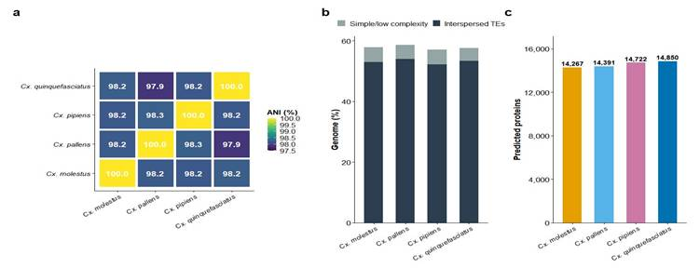
Figure 3. Genome-level comparisons. (a) ANI heatmap showing pairwise identity (97.9-100%). (b) Transposable element composition showing interspersed TEs and simple/low complexity repeats. (c) Predicted protein counts per genome.
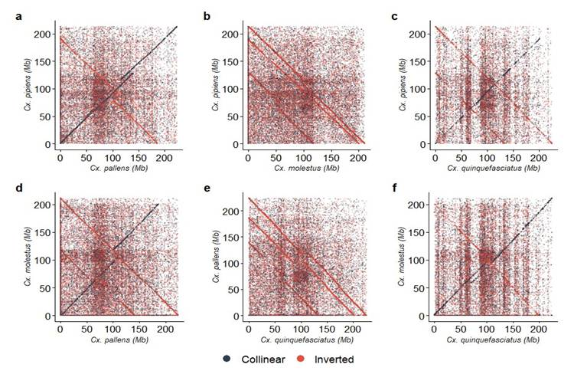
Figure 4. Synteny dot plots for all six pairwise genome comparisons. Collinear blocks (dark) and inversions (red). (a) pallens vs pipiens, (b) molestus vs pipiens, (c) quinquefasciatus vs pipiens, (d) pallens vs molestus, (e) quinquefasciatus vs pallens, (f) quinquefasciatus vs molestus.

ASSIGNED TO: LAUREN
Sections: Section 3.6
For results, describe what the anvi'o pangenome shows. The big thing to explain is why we got 32,304 gene clusters here vs 16,369 orthogroups from OrthoFinder. It is because anvi'o uses tighter clustering (MCL inflation 10 vs 1.5), so it splits things into more groups. Describe whatever patterns you see in the visualization.

KEY NUMBERS: 32,304 gene clusters across 4 genomes. DIAMOND + MCL inflation 10, minbit 0.5.

3.6 Pangenome Visualization
[Describe the anvi'o pangenome results. 32,304 gene clusters identified across four genomes. Compare to OrthoFinder result (16,369 orthogroups) and explain the difference (different clustering stringency, MCL inflation 10 vs 1.5). Describe patterns visible in the interactive visualization. Reference Figure 6.]
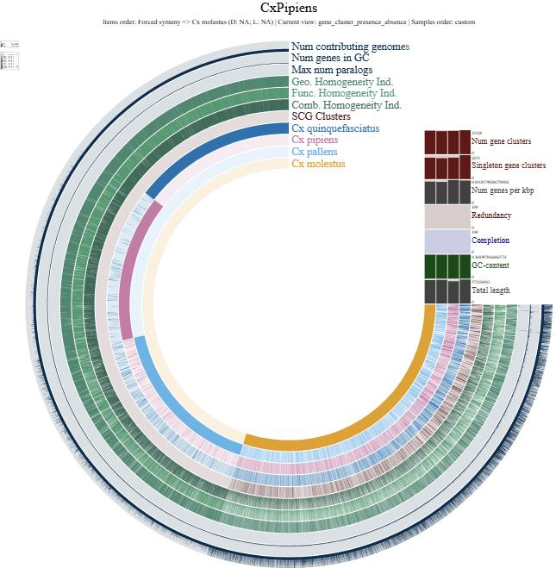
Figure 6. Anvi'o interactive pangenome visualization of 32,304 gene clusters across four Cx. pipiens complex genomes.

4. Discussion
ASSIGNED TO: TYLER
Sections: Section 4
I will write this after everyone else is done. Synthesis and interpretation, 4-6 paragraphs.
Here we report the first pangenome characterization of the Culex pipiens species complex and use it to refine, rather than simply redescribe, the genomic relationships among its members. Three findings reshape the current picture of this group. First, at the nucleotide level the four forms are remarkably similar (pairwise ANI 97.9–98.3%), yet they partition 92,540 genes into 11,653 core orthogroups, 4,205 shell orthogroups, and 511 cloud orthogroups, with form-specific cloud content distributed unevenly across the four taxa (χ² = 85.36, df = 3, p < 2 × 10⁻¹⁶). High nucleotide identity therefore masks substantial gene-content and structural divergence—a pattern the synteny dot plots make visually obvious, particularly for comparisons involving Cx. quinquefasciatus. Second, the phylogenomic supermatrix places Cx. pallens and Cx. pipiens as sister taxa with Cx. molestus as the next outgroup and Cx. quinquefasciatus as the complex-internal outgroup, with complete concordance across all 8,616 gene trees at every node. This arrangement is consistent with the hybrid-origin hypothesis for Cx. pallens proposed on the basis of population genomic data (Aardema et al., 2020): under that model, Cx. pallens would be expected to share substantial ancestry with both Cx. pipiens and Cx. quinquefasciatus, and its placement as sister to Cx. pipiens in the autosomal supermatrix is compatible with that inheritance pattern. Third, every terminal branch shows a significant excess of gene family expansions over contractions (binomial p < 2 × 10⁻¹⁶ in each case), with Cx. quinquefasciatus showing the strongest expansion bias (3,671 expansions vs. 866 contractions), indicating that lineage-specific gene family turnover—not genome-wide sequence divergence—is the primary axis of functional differentiation within this young complex.

4.1 Rationale for a four-genome design
A four-genome panel is, by the standards of bacterial or plant pangenomics, a small design. We adopted it deliberately rather than expansively, and the rationale is worth making explicit because it shapes the interpretive weight of every result that follows. First, the panel includes every chromosome-scale Cx. pipiens complex genome currently available; it is not a subsampled convenience set. Second, the Cx. pipiens complex is a young radiation: the ANI values of 97.9–98.3% recovered here are consistent with divergences within the last several million years, and the four taxa analyzed are all capable of producing fertile hybrids in the laboratory (Farajollahi et al., 2011). At this level of divergence, a small high-contiguity panel is more informative than a larger panel of mixed-quality assemblies: pangenome partitioning is exquisitely sensitive to missing sequence, and a single fragmented short-read assembly can inflate the shell and cloud compartments by tens of percent. Third, the four forms included here span the full axis of ecological and behavioral divergence documented within the complex—tropical versus temperate distribution, autogenous versus anautogenous reproduction, diapausing versus non-diapausing, and ornithophilic versus mammophilic host preference (Farajollahi et al., 2011). A four-genome pangenome therefore still resolves the biological contrasts that motivate the study, even while we acknowledge that replicate genomes per form would allow within-form variation to be separated from between-form divergence.
The two omitted complex members, Cx. australicus and Cx. globocoxitus, are Australian endemics that sit as a monophyletic group sister to Cx. quinquefasciatus in published phylogenies, with a deeper divergence than the splits among the four forms analyzed here (Aardema et al., 2020). Their inclusion would meaningfully extend the pangenome in two directions: it would add an older internal branch against which to calibrate gene family turnover in CAFE5, and it would allow the core compartment to be defined across a broader evolutionary window. The limiting factor is purely one of genomic resources—no chromosome-scale assembly has yet been published for either species, and the taxa are geographically restricted in a way that has not yet drawn the sequencing investment that Cx. pipiens s.s., Cx. quinquefasciatus, Cx. pallens, and Cx. molestus have all received. A second-generation pangenome of the Cx. pipiens complex incorporating chromosome-scale assemblies of Cx. australicus and Cx. globocoxitus is a natural next step for the community.

4.2 Comparison with other insect vector complexes
Our analytical framework parallels, but does not duplicate, recent work on the Anopheles gambiae species complex. Fontaine et al. (2015) used chromosome-scale reference assemblies for six sibling species in that complex to resolve a contested species tree and to demonstrate pervasive autosomal introgression among vectors, recovering a topology in which the most competent human malaria vectors are not sister taxa. That study’s central methodological insight—that a small panel of high-contiguity genomes within a single young radiation is sufficient to resolve species-level relationships and detect reticulation—is directly applicable here. The Cx. pipiens complex has no comparable published phylogenomic treatment, and the Fontaine et al. framework represents the closest methodological analog to the present work among insect disease vectors.
The broader comparative context comes from Neafsey et al. (2015), who sequenced sixteen anopheline genomes spanning ~100 million years of divergence and reported accelerated rates of gene gain and loss, elevated gene shuffling, and faster intron turnover in Anopheles relative to Drosophila. Our CAFE5 result—every terminal branch of the Cx. pipiens complex showing a significant excess of gene family expansions over contractions, with 3,050–3,671 expansion events per lineage—is consistent with this broader pattern of gene family dynamism in mosquitoes, and suggests that the dynamism previously documented across deep anopheline divergences extends to shallow divergences within a single culicine complex.
It is worth noting that small-panel pangenome analyses using core/shell/cloud partitioning are well-established in bacterial and plant systems (Tettelin et al., 2005; Golicz et al., 2020), but have not previously been applied to any mosquito species complex and remain uncommon in animal comparative genomics more generally. The analytical choices made here—OrthoFinder with DIAMOND for sequence similarity, MCL clustering at inflation 1.5, and strict core/shell/cloud partitioning at the 4/2–3/1 genome thresholds—follow standard bacterial pangenomics conventions. This choice is deliberate: hierarchical orthologous group frameworks typical of drosophilid comparative work are optimized for inferring gene evolutionary histories across deeper divergences, whereas gene-presence/absence pangenome partitioning is better suited to characterizing the shallow, recently-diverged radiation represented by the Cx. pipiens complex.

4.3 Transposable element landscape and genome-size conservation
The remarkable conservation of transposable element content across the four genomes (52.14–53.91% interspersed repeats) contrasts with the considerable variation in predicted protein counts (22,582–24,199) and in pangenome compartment membership. TE content at this level is typical of culicine genomes and suggests that the overall repeat architecture was largely established before the radiation of the complex and has not diverged substantially among forms. By implication, the observed differences in gene-content compartments and gene-family sizes are not readily attributable to global shifts in genome-wide TE activity, although fine-scale TE-mediated gene duplication or disruption at individual loci cannot be excluded from the present whole-genome analysis.

4.4 Limitations and future directions
Three limitations of the present design bound the inferences that can be drawn. First, a single chromosome-scale assembly is currently available for each of the four forms, so within-form population-level variation is not captured; the cloud and shell compartments reported here represent between-form differences only, and intraspecific gene presence/absence variation is expected to contribute additional pangenome content that future resequencing panels will need to characterize. Second, annotation transfer via Liftoff preserves the gene models defined in the Cx. quinquefasciatus reference; form-specific genes absent from that reference would not be recovered by this approach and may be partly responsible for the comparatively small cloud compartment of the reference genome itself. De novo annotation of each genome, followed by cross-validation of gene models, would refine the cloud estimate. Third, as discussed above, the exclusion of Cx. australicus and Cx. globocoxitus leaves the deepest divergence within the complex unsampled.
The Cx. pipiens complex therefore joins the An. gambiae complex as one of the few medically-important mosquito species complexes with a chromosome-scale comparative genomic framework. Where the An. gambiae work revealed that vector-competence traits can be acquired through interspecific introgression rather than solely through de novo mutation (Fontaine et al., 2015), our results suggest a complementary pattern in the Cx. pipiens complex: substantial lineage-specific gene family turnover layered on top of near-identical nucleotide backgrounds. Whether the 511 cloud orthogroups partitioned unevenly across the four forms (molestus = 200, pipiens = 142, pallens = 114, quinquefasciatus = 55) contribute to the ecological and behavioral differences that distinguish these forms—autogeny, diapause, host preference, habitat specificity—is a question that follow-up functional analyses and population-scale resequencing will be needed to resolve.

5. Conclusions
ASSIGNED TO: TYLER
Sections: Section 5
Brief concluding paragraph.
We present the first pangenome characterization of the Culex pipiens species complex, integrating four chromosome-scale genome assemblies to recover 11,653 core, 4,205 shell, and 511 cloud orthogroups. Despite near-uniform nucleotide identity (97.9–98.3% ANI) and a conserved TE architecture, the four forms differ substantially in gene-content composition, synteny structure, and lineage-specific gene-family turnover, with Cx. quinquefasciatus showing the strongest expansion bias and Cx. molestus carrying the most form-specific genes. Phylogenomic analysis of 8,616 single-copy orthologs resolves Cx. pallens and Cx. pipiens as sister taxa under a topology compatible with the hybrid-origin hypothesis for Cx. pallens. These results establish a genomic framework for the complex that complements the comparable phylogenomic treatment of the Anopheles gambiae sibling species complex, and they lay the groundwork for functional follow-up linking the uneven distribution of form-specific gene content to the ecological and behavioral traits that make these mosquitoes clinically distinct vectors.

. Supplementary Materials
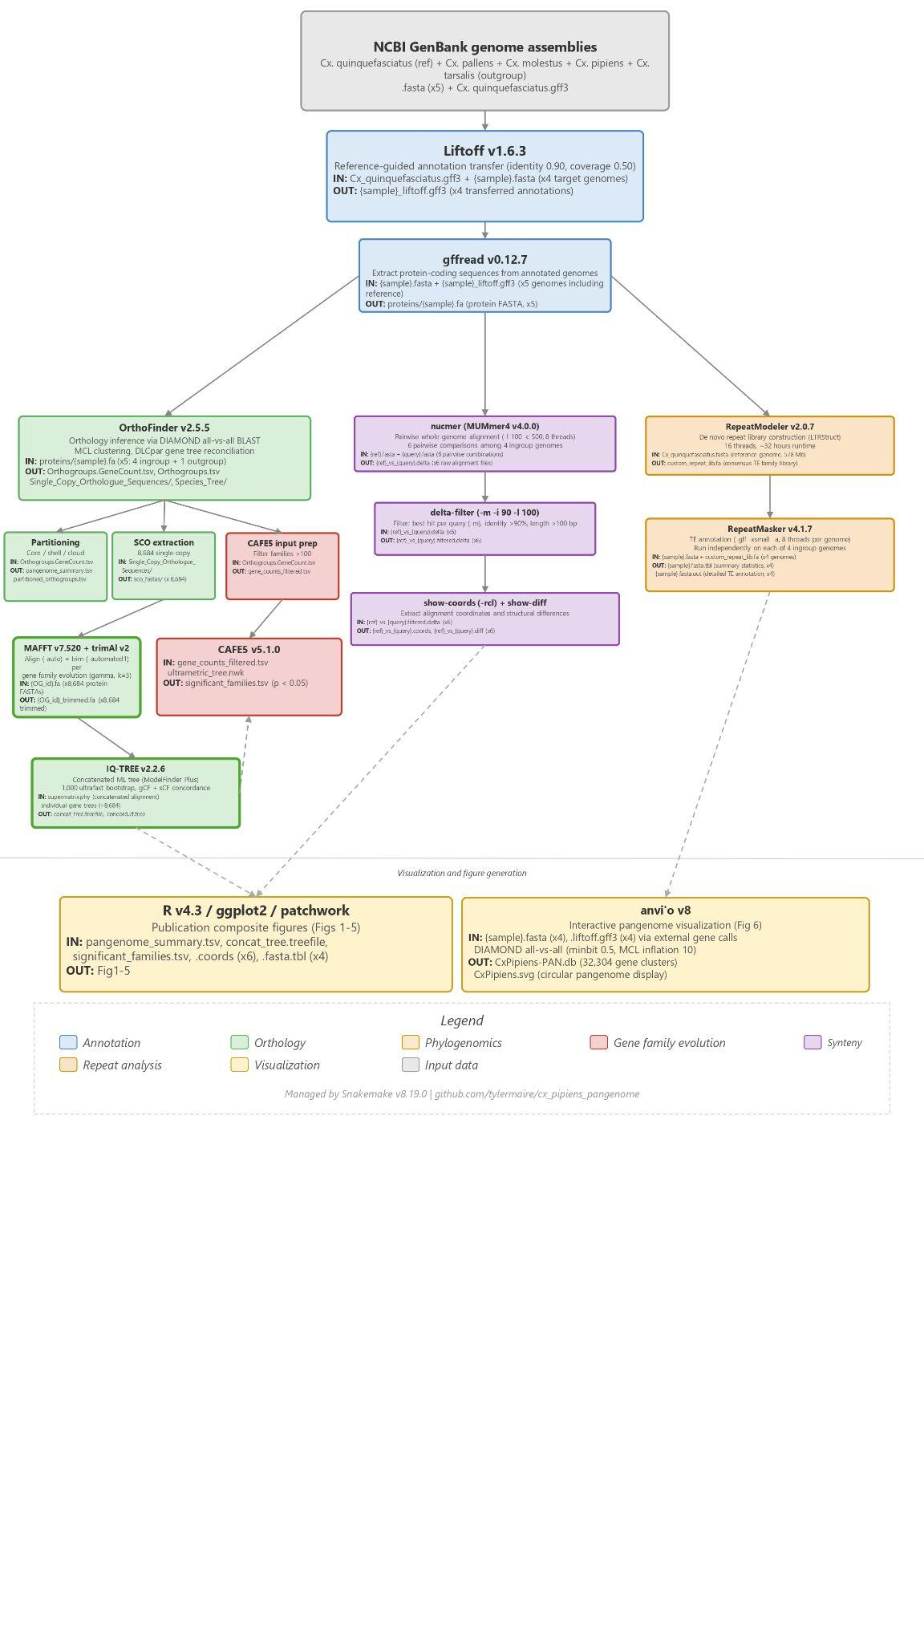
Figure S1. Computational pipeline flowchart (pipeline_flowchart.pdf in GitHub repository).
The R script for all figures is available at: github.com/tylermaire/cx_pipiens_pangenome/scripts/Cx_pipiens_pangenome_figures.R

. References
Buchfink, B., Xie, C., & Huson, D. H. (2015). Fast and sensitive protein alignment using DIAMOND. Nature Methods, 12(1), 59–60. https://doi.org/10.1038/nmeth.3176
Capella-Gutiérrez, S., Silla-Martínez, J. M., & Gabaldón, T. (2009). trimAl: A tool for automated alignment trimming in large-scale phylogenetic analyses. Bioinformatics, 25(15), 1972–1973. https://doi.org/10.1093/bioinformatics/btp348
Emms, D. M., & Kelly, S. (2019). OrthoFinder: Phylogenetic orthology inference for comparative genomics. Genome Biology, 20, Article 238. https://doi.org/10.1186/s13059-019-1832-y
Eren, A. M., Kiefl, E., Shaiber, A., Veseli, I., Miller, S. E., Schechter, M. S., Fink, I., Pan, J. N., Yousef, M., Fogarty, E. C., Trigodet, F., Watson, A. R., Esen, Ö. C., Moore, R. M., Clayssen, Q., Lee, M. D., Kivenson, V., Graham, E. D., Merrill, B. D., … Willis, A. D. (2021). Community-led, integrated, reproducible multi-omics with anvi'o. Nature Microbiology, 6(1), 3–6. https://doi.org/10.1038/s41564-020-00834-3
Flynn, J. M., Hubley, R., Goubert, C., Rosen, J., Clark, A. G., Feschotte, C., & Smit, A. F. (2020). RepeatModeler2 for automated genomic discovery of transposable element families. Proceedings of the National Academy of Sciences, 117(17), 9451–9457. https://doi.org/10.1073/pnas.1921046117
Katoh, K., & Standley, D. M. (2013). MAFFT multiple sequence alignment software version 7: Improvements in performance and usability. Molecular Biology and Evolution, 30(4), 772–780. https://doi.org/10.1093/molbev/mst010
Marçais, G., Delcher, A. L., Phillippy, A. M., Coston, R., Salzberg, S. L., & Zimin, A. (2018). MUMmer4: A fast and versatile genome alignment system. PLoS Computational Biology, 14(1), Article e1005944. https://doi.org/10.1371/journal.pcbi.1005944
Mendes, F. K., Vanderpool, D., Fulton, B., & Hahn, M. W. (2021). CAFE 5 models variation in evolutionary rates among gene families. Bioinformatics, 36(22–23), 5516–5518. https://doi.org/10.1093/bioinformatics/btaa1022
Minh, B. Q., Schmidt, H. A., Chernomor, O., Schrempf, D., Woodhams, M. D., von Haeseler, A., & Lanfear, R. (2020). IQ-TREE 2: New models and efficient methods for phylogenetic inference in the genomic era. Molecular Biology and Evolution, 37(5), 1530–1534. https://doi.org/10.1093/molbev/msaa015
Mölder, F., Jablonski, K. P., Letcher, B., Hall, M. B., Tomkins-Tinch, C. H., Sochat, V., Forster, J., Lee, S., Twardziok, S. O., Kanitz, A., Wilm, A., Holtgrewe, M., Rahmann, S., Nahnsen, S., & Köster, J. (2021). Sustainable data analysis with Snakemake. F1000Research, 10, Article 33. https://doi.org/10.12688/f1000research.29032.2
Pertea, G., & Pertea, M. (2020). GFF Utilities: GffRead and GffCompare. F1000Research, 9, Article 304. https://doi.org/10.12688/f1000research.23297.2
Shumate, A., & Salzberg, S. L. (2021). Liftoff: Accurate mapping of gene annotations. Bioinformatics, 37(12), 1639–1643. https://doi.org/10.1093/bioinformatics/btaa1016
Smit, A. F. A., Hubley, R., & Green, P. (2013–2015). RepeatMasker Open-4.0. http://www.repeatmasker.org
Golicz, A. A., Bayer, P. E., Bhalla, P. L., Batley, J., & Edwards, D. (2020). Pangenomics comes of age: From bacteria to plant and animal applications. Trends in Genetics, 36(2), 132–145. https://doi.org/10.1016/j.tig.2019.11.006
Huang, Y.-X., Rao, H.-Y., Su, B.-S., Lv, J.-M., Li, M.-Y., Ye, Z.-C., Huang, Y., Chen, X.-Y., & Gui, F.-R. (2025). The pan-genome of Spodoptera frugiperda provides new insights into genome evolution and horizontal gene transfer. Communications Biology, 8, Article 407. https://doi.org/10.1038/s42003-025-07707-7
Tong, X., Han, M.-J., Lu, K., Tai, S., Liang, S., Liu, Y., Hu, H., Shen, J., Long, A., Zhan, C., Ding, X., Liu, S., Gao, Q., Zhang, B., Zhou, L., Tan, D., Yuan, Y., Guo, N., Li, Y.-H., … Xiang, Z. (2022). High-resolution silkworm pan-genome provides genetic insights into artificial selection and ecological adaptation. Nature Communications, 13, Article 5883. https://doi.org/10.1038/s41467-022-33366-x
Farajollahi, A., Fonseca, D. M., Kramer, L. D., & Kilpatrick, A. M. (2011). "Bird biting" mosquitoes and human disease: A review of the role of Culex pipiens complex mosquitoes in epidemiology. Infection, Genetics and Evolution, 11(7), 1577–1585. https://doi.org/10.1016/j.meegid.2011.08.013
Aardema, M. L., Olatunji, S. K., & Fonseca, D. M. (2022). The enigmatic Culex pipiens (Diptera: Culicidae) species complex: Phylogenetic challenges and opportunities from a notoriously tricky mosquito group. Annals of the Entomological Society of America, 115(1), 95–104. https://doi.org/10.1093/aesa/saab038
Aardema, M. L., vonHoldt, B. M., Fritz, M. L., & Davis, S. R. (2020). Global evaluation of taxonomic relationships and admixture within the Culex pipiens complex of mosquitoes. Parasites & Vectors, 13(1), 8. https://doi.org/10.1186/s13071-020-3879-8
Arensburger, P., Megy, K., Waterhouse, R. M., Abrudan, J., Amedeo, P., Antelo, B., Bartholomay, L., Bidwell, S., Caler, E., Camara, F., Campbell, C. L., Campbell, K. S., Casola, C., Castro, M. T., Chandramouliswaran, I., Chapman, S. B., Christley, S., Costas, J., Eisenstadt, E., … Severson, D. W. (2010). Sequencing of Culex quinquefasciatus establishes a platform for mosquito comparative genomics. Science, 330(6000), 86–88. https://doi.org/10.1126/science.1191864
Crowley, L., Allen, H., Barnes, I., Broad, G. R., Boyes, D., Fletcher, D. B., Hantke, G., Lewis, O. T., Natural History Museum Genome Acquisition Lab, Darwin Tree of Life Barcoding collective, Wellcome Sanger Institute Tree of Life programme, Wellcome Sanger Institute Scientific Operations: Sequencing Operations, Wellcome Sanger Institute Tree of Life Core Informatics team, Tree of Life Core Informatics collective, & Darwin Tree of Life Consortium. (2024). The genome sequence of the northern house mosquito, Culex pipiens form pipiens, Linnaeus, 1758. Wellcome Open Research, 9, 163.
Fontaine, M. C., Pease, J. B., Steele, A., Waterhouse, R. M., Neafsey, D. E., Sharakhov, I. V., Jiang, X., Hall, A. B., Catteruccia, F., Kakani, E., Mitchell, S. N., Wu, Y.-C., Smith, H. A., Love, R. R., Lawniczak, M. K., Slotman, M. A., Emrich, S. J., Hahn, M. W., & Besansky, N. J. (2015). Extensive introgression in a malaria vector species complex revealed by phylogenomics. Science, 347(6217), 1258524. https://doi.org/10.1126/science.1258524
Harbach, R. E. (2012). Culex pipiens: Species versus species complex—taxonomic history and perspective. Journal of the American Mosquito Control Association, 28(4 Suppl), 10–23.
Liu, P., Jin, B., Li, X., Zhao, Y., Gu, J., Biedler, J. K., Tu, Z. J., & Chen, X.-G. (2023). Culex pipiens pallens cytoplasmic incompatibility: Chromosome-scale genome assembly and insights into Wolbachia-host interactions. [Journal, volume, pages to verify]. [NCBI assembly GCA_024516115.1]
Neafsey, D. E., Waterhouse, R. M., Abai, M. R., Aganezov, S. S., Alekseyev, M. A., Allen, J. E., Amon, J., Arcà, B., Arensburger, P., Artemov, G., Assour, L. A., Basseri, H., Berlin, A., Birren, B. W., Blandin, S. A., Brockman, A. I., Burkot, T. R., Burt, A., Chan, C. S., … Besansky, N. J. (2015). Highly evolvable malaria vectors: The genomes of 16 Anopheles mosquitoes. Science, 347(6217), 1258522. https://doi.org/10.1126/science.1258522
Peng, C., Qian, Z., Zhang, X., Le, Q., Gong, M., Zhang, Z., & Zhang, R. (2021). A draft genome assembly of Culex pipiens pallens (Diptera: Culicidae) using PacBio sequencing. Genome Biology and Evolution, 13(3), evab005. https://doi.org/10.1093/gbe/evab005
Ryazansky, S. S., Chen, C., Potters, M., Naumenko, A. N., Lukyanchikova, V., Masri, R. A., Brusentsov, I. I., Karagodin, D. A., Yurchenko, A. A., dos Anjos, V. L., Haba, Y., Rose, N. H., Hoffman, J., Guo, R., Morton, T., Gebhardt, A., Vinetz, J., Bonizzoni, M., Fritz, M. L., … Tu, Z. (2024). The chromosome-scale genome assembly and annotation of Culex quinquefasciatus. [Exact citation and DOI to verify for GCF_015732765.1].
Russell, R. C. (2012). A review of the status and significance of the species within the Culex pipiens group in Australia. Journal of the American Mosquito Control Association, 28(4 Suppl), 24–27.
Tettelin, H., Masignani, V., Cieslewicz, M. J., Donati, C., Medini, D., Ward, N. L., Angiuoli, S. V., Crabtree, J., Jones, A. L., Durkin, A. S., DeBoy, R. T., Davidsen, T. M., Mora, M., Scarselli, M., Margarit y Ros, I., Peterson, J. D., Hauser, C. R., Sundaram, J. P., Nelson, W. C., … Fraser, C. M. (2005). Genome analysis of multiple pathogenic isolates of Streptococcus agalactiae: Implications for the microbial “pan-genome.” Proceedings of the National Academy of Sciences, 102(39), 13950–13955. https://doi.org/10.1073/pnas.0506758102

