

Brand Style Guide

Canvassing Intelligence Platform
Version 1.0 · April 2026 · Confidential

This guide governs how the Canvara brand is presented across all surfaces — digital, print, and in the field. Consistency builds trust. Trust builds campaigns.

1. Brand foundation

Mission
Canvara gives campaigns the intelligence to listen at scale, understand what moves voters, and reach the right person with the right message at the right moment.

Brand personality

Authoritative | We handle serious political work. The brand speaks with confidence and precision.
Intelligent | Data-driven, analytical, methodical. We surface insight from noise.
Nonpartisan | We serve any campaign. The brand is never ideological in tone or color.
Field-native | Built for people who are actually out there talking to voters — not just strategists in offices.
Trustworthy | Campaigns share their most sensitive data with us. Every brand choice reinforces reliability.

Voice and tone
Canvara communicates with the directness of a seasoned field director and the precision of a data analyst. Never corporate-speak. Never partisan. Never cute.

DO | DON'T
Direct: "Your canvassers knocked 247 doors today." | Vague: "Great engagement across the district today!"
Data-forward: "Education is the top issue in Precinct 14 this week." | Partisan: any language that reads as Dem or Rep
Action-oriented: "Approve this message — it goes to 3,400 voters." | Overclaiming: "Revolutionary AI will win your election"
Plain English always — no jargon the canvasser would not understand | Tech-bro: "Leverage synergies to optimize outreach velocity"

2. The logo

The mark
The Canvara mark is a bold C-arc with two gold endpoint dots. The arc traces the path a canvasser walks through a neighborhood. The open right side suggests forward momentum and open dialogue. The two gold dots represent the points of contact — where the canvasser starts and where the conversation lands. Clean, geometric, scalable from a 32px favicon to a printed banner.

Primary logo — light background

Primary lockup: icon + wordmark + tagline. Use on documents, presentations, website headers, and print materials on light backgrounds.

Primary logo — dark background

Dark lockup: Use on navy backgrounds, email headers, dark-mode UI, and campaign swag.

Horizontal lockup

Horizontal lockup: Use in app headers, email banners, and tight horizontal spaces. Wordmark right of icon — never stacked in this variant.

Icon mark variants

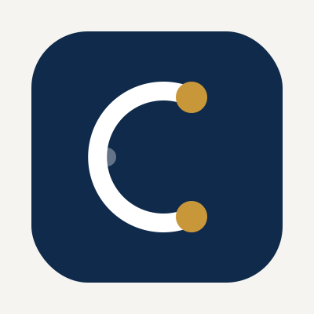  On navy — primary | 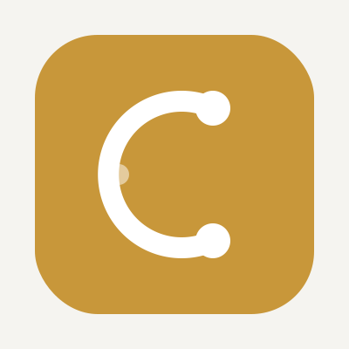  On gold — accent
Icon-only mark for app icons, favicons, social avatars, and badge applications. Minimum size: 32px digital / 0.5 in. print.

Logo construction

Icon | Bold C-arc with rounded caps. Two gold endpoint dots at arc tips. Soft centered dot in white at 35% opacity. Set in a rounded-square badge.
Wordmark | CANVARA in tracked serif capitals (Georgia or equivalent). Letter-spacing 5–6pt. Never set in sans-serif.
Tagline lockup | CANVASSING INTELLIGENCE in small tracked sans-serif (Arial, 11–13pt, letter-spacing 2.5–3pt) beneath wordmark. Slate blue color.
Clear space | Minimum clear space = height of the icon mark on all four sides of the complete lockup.
Minimum size | 32px icon for digital. 0.5 inch icon height for print. Never smaller — the arc detail is lost below this threshold.

Logo misuse — never do this

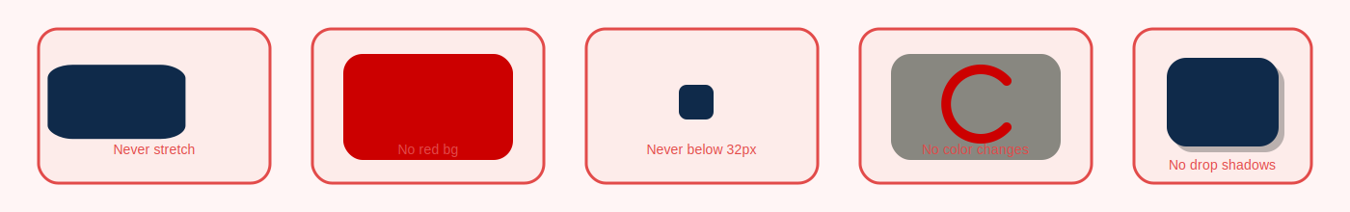
Never stretch, rotate, recolor, add effects, or place on red or low-contrast backgrounds.

DO | DON'T
Use approved SVG, PNG (transparent), or PDF files | Stretch, skew, or rotate any element
Maintain proportions — scale uniformly only | Recreate or redraw the arc from scratch
Keep gold dots always #C8973A | Change any colors in the logo
Use on navy, white, stone, or gold backgrounds only | Add drop shadows, outlines, or glow effects
Maintain clear space on all sides | Place on red backgrounds (partisan signal)
 | Use low-resolution rasters for print

3. Color system

Primary and secondary palette
Canvara's palette is built on authority and trust. Navy is the foundation — it carries weight and seriousness. Gold is the signal: used sparingly for emphasis, calls to action, and the brand mark's key touchpoints. White and Stone provide breathing room.

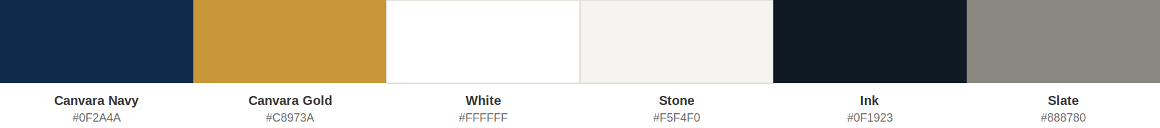

Canvara Navy #0F2A4A | Primary background, headlines, icon badge, dark surfaces. RGB 15, 42, 74.
Canvara Gold #C8973A | Accent, signal dots, CTA buttons, emphasis. Use sparingly. RGB 200, 151, 58.
White #FFFFFF | Primary text on dark, clean space, light-mode surfaces. RGB 255, 255, 255.
Stone #F5F4F0 | Page backgrounds, card fills, document surfaces. RGB 245, 244, 240.
Ink #0F1923 | Body text on light backgrounds. Deeper than navy for readability. RGB 15, 25, 35.
Slate #888780 | Captions, metadata, secondary text, tagline color. RGB 136, 135, 128.
Navy Light #1E3A5A | Hover states, icon badge inner color on dark. RGB 30, 58, 90.
Rule #D3D1C7 | Dividers, borders, card strokes. RGB 211, 209, 199.

Color usage rules

DO | DON'T
Use Navy as the primary brand color in all marketing | Use Gold as a background for large areas of text
Use Gold sparingly — one or two uses per surface maximum | Mix Navy and Gold in equal proportions — Gold is always the accent
Ensure 4.5:1 minimum contrast ratio for all body text (WCAG AA) | Use red or blue in brand contexts (partisan signal risk)
White text on Navy. Navy or Ink text on White or Stone. | Use gradients — the brand is flat and authoritative
Always use exact hex values — never approximate brand colors | Use off-brand colors like purple, green, or teal in primary contexts

4. Typography

Type system
Canvara uses a two-family type system: a classical serif for headlines and the wordmark, and a clean geometric sans for body and UI. The pairing creates authoritative-but-accessible communications — the serif conveys permanence and credibility, the sans ensures clarity and efficiency.

Display / Wordmark | Georgia Bold — tracked uppercase, letter-spacing 5–6pt. Navy only. Never set the wordmark in sans-serif.
Headline (H1) | Georgia Bold, 36–48pt. Report titles, section headers in documents.
Headline (H2) | Georgia Bold or Arial Bold, 24–32pt. Section breaks, slide titles.
Subhead | Arial Bold, 14–18pt. Letter-spacing 0.05em. Navy or Ink.
Body | Arial Regular, 11–12pt. Ink (#0F1923). Line-height 1.7. Never serif for body.
Caption / Meta | Arial Regular, 9–10pt. Slate (#888780). Letter-spacing 0.03em.
UI labels / badges | Arial Medium, 10–12pt. All-caps with 0.08em tracking. Used for tags, status labels, section labels.
Data / IDs | Courier New or system mono. Voter IDs, support scores, stats, code references.

Typography rules

DO | DON'T
Serif for headlines and the wordmark — always | Use more than two type families anywhere
Sans-serif for body, UI, captions — always | Use decorative, script, or display novelty fonts
Track uppercase labels at 0.06–0.08em | Set body text in serif — Georgia is for display only
Body line-height 1.6–1.7 minimum | Bold body text mid-paragraph — use a subhead instead
Use Georgia for document section titles | Mix more than two weights (Regular + Bold only)

5. Brand applications

Digital

Website header | Full lockup (icon + wordmark + tagline) on Navy. White text. Gold CTA button. Min height 64px.
App header (mobile) | Horizontal lockup on Navy. White wordmark. 48px height.
Email header | Horizontal lockup centered on Navy. Max width 600px. Padding 24px top/bottom.
Social avatar | Icon mark only on Navy, 400×400px minimum. No wordmark at this size.
Social cover | Full lockup on Navy left third. Field photography right with 60% Navy overlay.
Favicon | Icon mark only, 32×32px. Test legibility before deploying — the arc must remain visible.
OG / social card | Wordmark + tagline centered on Navy. 1200×630px. Gold horizontal rule as the only accent.
Domain | canvara.io — primary. Pursue canvara.com via domain broker. Use canvara.io on all materials until .com is secured.

Print and field

Campaign materials | Stone background. Navy type. Gold rule accent. Full lockup top-left or top-center.
Business cards | Navy front: white wordmark centered, gold rule, title in Slate. White back: contact in Ink.
Letterhead | Navy top bar (1 inch). Horizontal lockup white left-aligned. Body area white, Ink text.
Walk lists / field sheets | Stone background. Navy header bar with white horizontal lockup. Functional, clean.
Presentation decks | Title slides: Navy background, white and gold type. Content slides: white background, Navy type.

6. Naming and legal conventions

Company name | Canvara — capital C, lowercase rest. Never all-caps CANVARA in body text (all-caps is wordmark only).
Walk & Talk | Always ampersand. Always title case. "Walk & Talk" — not "walk and talk."
Feature names | Lowercase in body text: "persuasion mode," "gather phase," "walk & talk mode."
Phase names | Capitalize as proper nouns: Gather Phase, Modeling Phase, Craft Phase, Persuade Phase.
AI references | "AI-assisted" or "AI-powered" — never "robot," "bot," or anthropomorphized language.
First use in doc | Canvara™ — include ™ on first use in any document until USPTO registration is confirmed.
After registration | Canvara® — switch to ® once USPTO registration is confirmed (Classes 35 + 42).
Domain | canvara.io in all materials. Pursue canvara.com acquisition in parallel via domain broker.
Social handles | @canvaraio (Instagram), @canvara (X/Twitter if available), Canvara (LinkedIn company page).

7. Quick reference

ELEMENT | VALUE | NOTES
Primary color | #0F2A4A Canvara Navy | All headlines, icon, dark backgrounds
Accent color | #C8973A Canvara Gold | CTA, signal dots, emphasis — use sparingly
Body text | #0F1923 Ink | Body text on white / stone backgrounds
Secondary text | #888780 Slate | Captions, metadata, tagline
Background | #F5F4F0 Stone | Page/card bg in light-mode UI and print
Borders | #D3D1C7 Rule | 0.5px dividers, card borders
Headline font | Georgia Bold | Tracked caps for wordmark; sentence case for headlines
Body font | Arial Regular | All UI, body copy, captions, labels
Logo min size | 32px digital / 0.5in print | Icon mark minimum. Test arc legibility.
Clear space | 1× icon height on all sides | Around the complete logo lockup
Border radius | 8px elements / 12px cards | Never more than 20px
Motion | 200ms ease | All transitions. No spring or bounce.
Domain | canvara.io (primary) | Pursue canvara.com via GoDaddy Domain Broker
Trademark | Classes 35 + 42 USPTO | File intent-to-use application immediately


Brand Style Guide · Version 1.0 · April 2026 · Confidential

