Tyler Osso
Professor Dr. Soule
CS4701
25 May 2026
Pathfinding and Search Algorithms
This research paper aims to summarize the 5 search algorithms implemented for project 1 and the results found from testing. The 5 search algorithms were Breadth-first search, Uniform cost search, Greedy or best-first search, and A* search (with the two heuristics being Manhattan and Euclidean). The uniformed searches performed their goals properly in finding the lower cost or steps while the informed also accomplished the task but with much higher efficiency (less states explored relatively). The results were as follows:
MAP1 Stupid
Algorithm | Path Length (Steps) | Path Cost | States Explored (Closed List) | States Remaining  (Open List)
BFS | 14 | 39 | 339 | 54
UCS | 14 | 39 | 341 | 82
GBF | 14 | 39 | 14 | 27
A*-M | 14 | 39 | 134 | 39
A*-E | 14 | 39 | 156 | 41

MAP2 Simple
Algorithm | Path Length (Steps) | Path Cost | States Explored (Closed List) | States Remaining  (Open List)
BFS | 22 | 98 | 658 | 64
UCS | 22 | 78 | 914 | 118
GBF | 22 | 78 | 36 | 35
A*-M | 22 | 78 | 462 | 79
A*-E | 22 | 78 | 530 | 94

MAP3 Complex
Algorithm | Path Length (Steps) | Path Cost | States Explored (Closed List) | States Remaining  (Open List)
BFS | 14 | 131 | 291 | 52
UCS | 38 | 83 | 1016 | 115
GBF | 14 | 131 | 14 | 27
A*-M | 38 | 83 | 574 | 175
A*-E | 38 | 83 | 689 | 189

Visualization figures are attached at the end of the write up.

Based on the results they fall in line with the general purpose of each. This is especially apparent when we look at map 3 with the higher terrain variability and complexity.
- The Breadth First Search worked as designed finding the path with the fewest steps regardless of cost (by design). Visually it searches all available directions evenly. Logically, though, the algorithm works at finding the goal state blindly with using the least depth accessing all open states at the current depth before moving on. Implementation involved a queue to hold open list investigating and moving them to the closed list. Compared to the other algorithms it had the path length with the fewest steps but became inefficient in terms of states explored to reach the goal state especially when impassible barrier cases like the water in map 2 because of the design of having to investigate ALL states at a depth prior to going to the next level. However, it was the most efficient at finding the goal states out of the uninformed with the fewest states explored.
- Uniform Cost is similar to the Breadth First Search in that it performs a singular job very well but it has to find the goal state blindly so overall efficiency for states explored is going to be poor. The UCS works by exploring each state available and ordering the open list keeping the goal state with the lowest cost. In this way it performed its job well finding the path with the lowest cost at the cost of the highest number of states explored.
- Greedy Best Fit is the first informed search used in the project. The lowest path length (number of steps to get closest to the goal based on the given heuristic in this case Manhattan) regardless of cost using the informed goal state. It does this by using the closest node according the heuristic which (in this case) also gave us the fewest steps. We can see the pros and cons of this method by focusing on the states explored and path cost. In scenarios like map 3 where there is a passable terrain at a high cost this algorithm opts to choose the shortest path at the detriment of path cost, however it shines by being the most efficient by far (fewer states explored) especially on more complex maps like map 3 where it shines by being exponentially more efficient than the other methods.
- A-Star with a Manhattan heuristic was the most efficient at getting the lowest Path Cost with the fewest number of explored states in the complex map. It excelled at finding the lowest cost when the path was traversable between the start and end states where greedy best fit did not when the option to climb the mountain (high cost) presented itself. The Manhattan heuristic used the informed data to make an “estimated guess” using the Manhattan grid logic to ensure that a close guess without “going over” (admissibility) was able to be accomplished. The heuristic uses the shortest path available so it will be less than or equal to the paths used.
- A-Star with a Euclidian heuristic performed the same as the A-star with a Manhattan heuristic in Path Cost, though slightly worse in states explored. The Euclidian used an approximation of straight line and used the Pythagorean theorem to make the estimation “as a crow flies”. Using what we know about triangles the hypotenuse will always be less than the sum of the sides and therefor less than the Manhattan and admissible. This A-Star method also performed well in maintaining lowest cost in a relatively limited number of steps compared to the uninformed algorithms and the Greedy search.

Conclusion and Discussion
The algorithms all had their own strengths and weaknesses. Breadth First Search was effective at finding the shortest path length with a relatively low number of explored states (efficient) while also being uniformed. However, it was poor at finding a low Path Cost. Uniform Cost search was effective at finding the lowest path cost while being uninformed at the expense of the most states explored out of all the algorithms used. Greedy best fit was highly efficient at finding the lowest number of steps and had the lowest number of states explored by far. Even when there were obstacles like the water hazard on map two it was still by far the most efficient out of all the algorithms. However, it was the highest of the informed search and tied for the worst overall on path cost on map three where there was an option to cross the mountains but save steps (although this is an intentional design trade off of this algorithm). The two A-Star algorithms performed the same with the differences coming down to the States explored/remaining. The Manhattan heuristic was more efficient on all of the maps where it found the low path cost on all three maps and was able to keep the states explored relatively low. The Euclidean performed similarly but as stated before it required slightly more states explored to find the goal state. All of the algorithms used or at a minimum explored the road (with the exception of the greedy algorithm) which was interesting and used it on the final map to find the optimal path (with the exception of greedy and BFS). The algorithm that gave unexpected results at first was the breadth first. I was getting higher path costs due to the implementation. I accidently counted the start state so every path was slightly higher than expected. This was fixed and the figures used in this report are all correct to the best of my knowledge. The requirements ask about completeness and optimality. For this task all were complete but a quick google shows that greedy is not complete and can get lost with high complexity or stuck in a cycle on top of being not optimal. Breadth first also isn’t optimal as shown by map 3. UCS and A-Star are both complete and optimal. Its value is in its speed. Overall it was an interesting project and helped me to understand the differences of each.

Use of AI
I used AI a few portions of this project. The main area I used it in was coding the display node pieces and the main file structure. The display was almost completely done by AI because I'm unfamiliar with some of the Python libraries and they can be more obscure and I didn't want to spend a whole lot of time digging through the intricacies of that library and wanted to focus on the algorithm building and getting reasonable outputs. It was really good at getting the ball rolling and quickly building the framework, but missed a lot of the abstract concepts like how it would be displayed, the weird outputs from the map and count results. I used Claude AI sonnet 4.6 to assist in coding. For the algorithm I went a lot lighter and did my best to only use AI for syntax and correcting some logic errors that I had and implementing the heuristics and the lists. Python isn't my first programming language or the one I'm most comfortable with but from everything I read it had the best display libraries and I wanted to make sure that I had good visualization to try to understand. In the write up and understanding the results I only used it to make sure I didn't have any deep logic errors and to help clean up the wording where I was repetitive or had run on thoughts. It wasn’t part of the project but I used it to generate one more map to push each algorithm and see the results.

Figures
Breadth First Searches
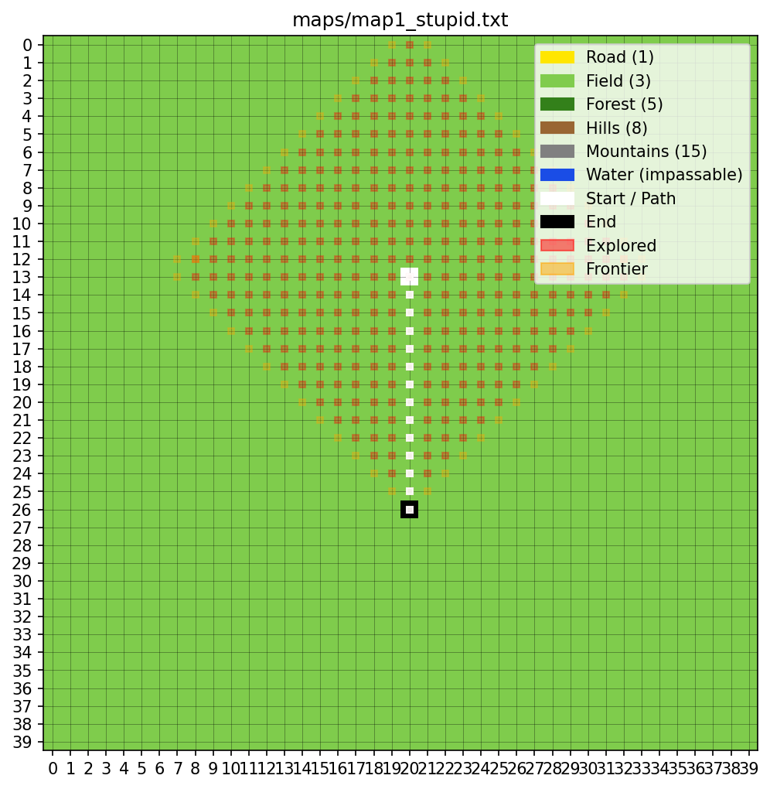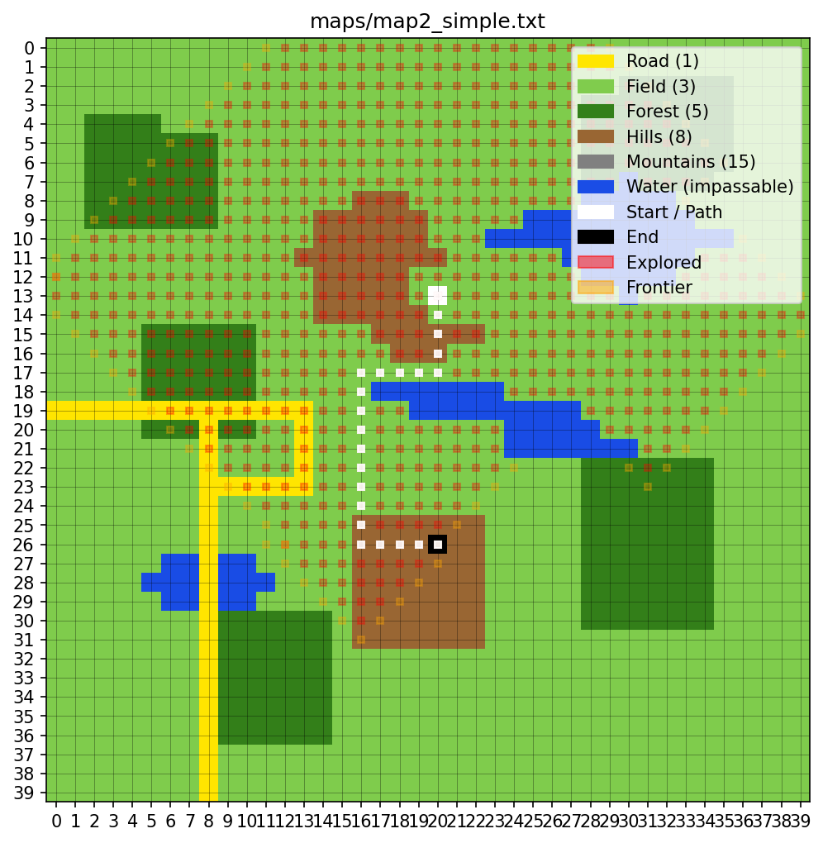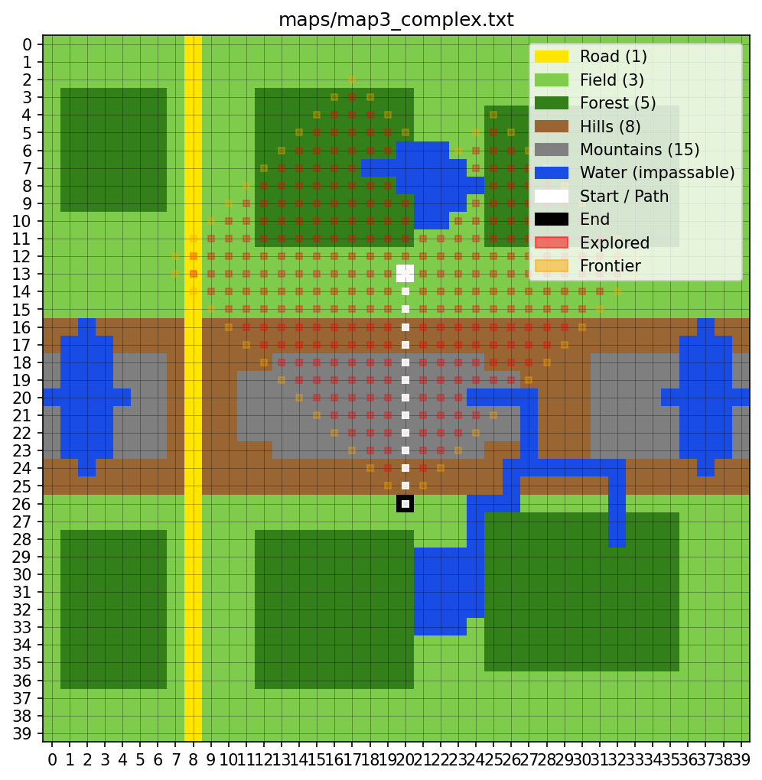

Uniform Cost Searches
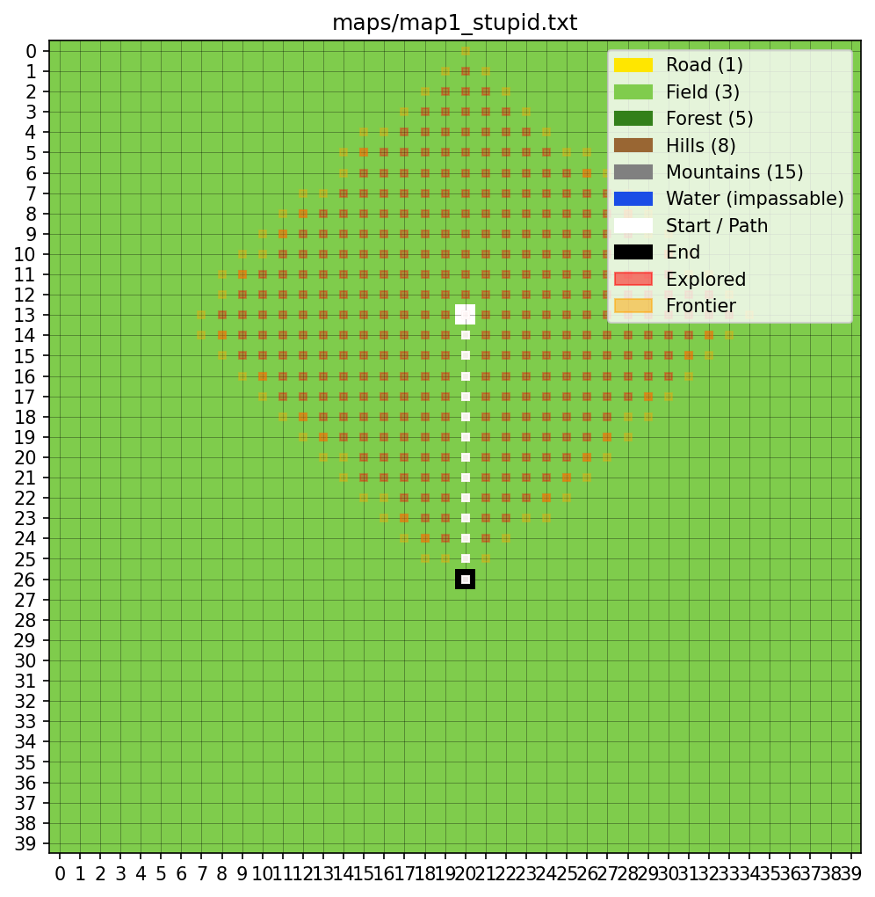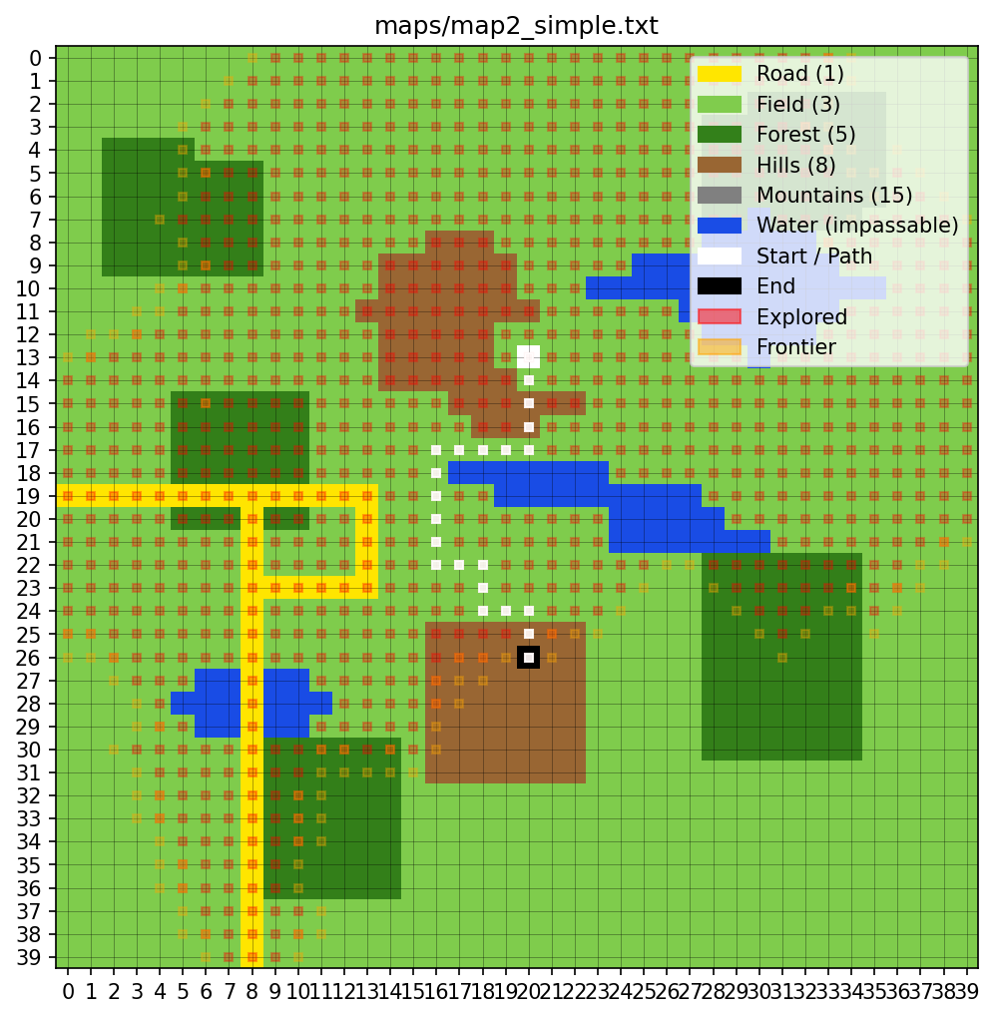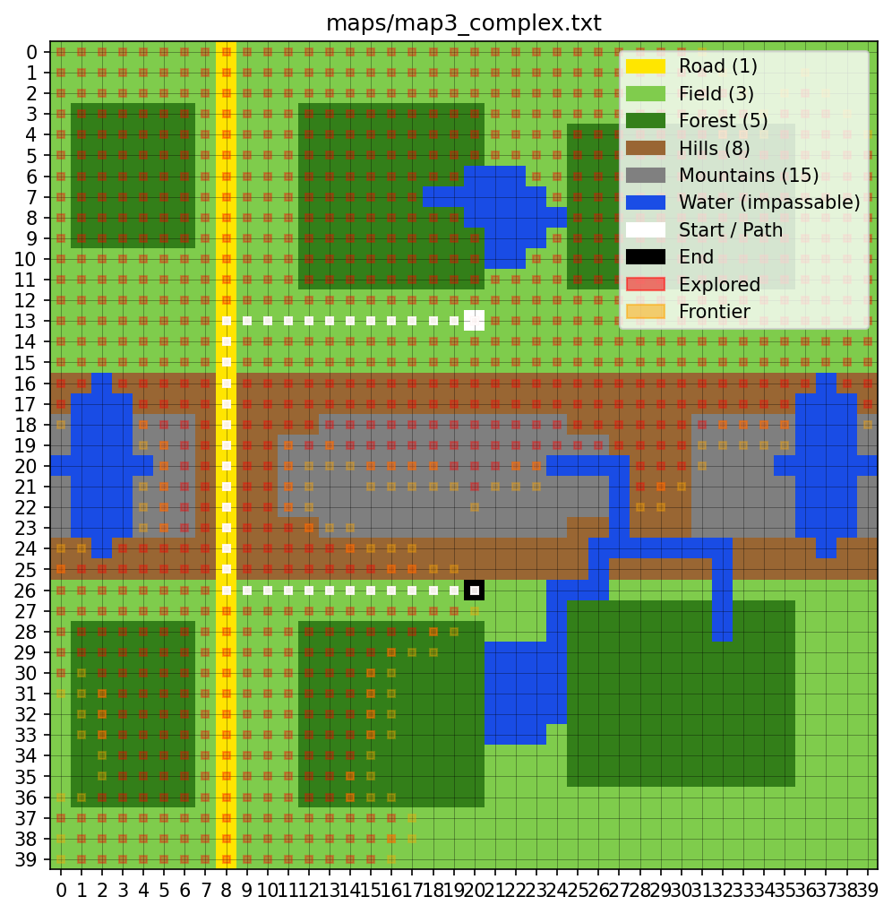

Greedy Best-First Searches
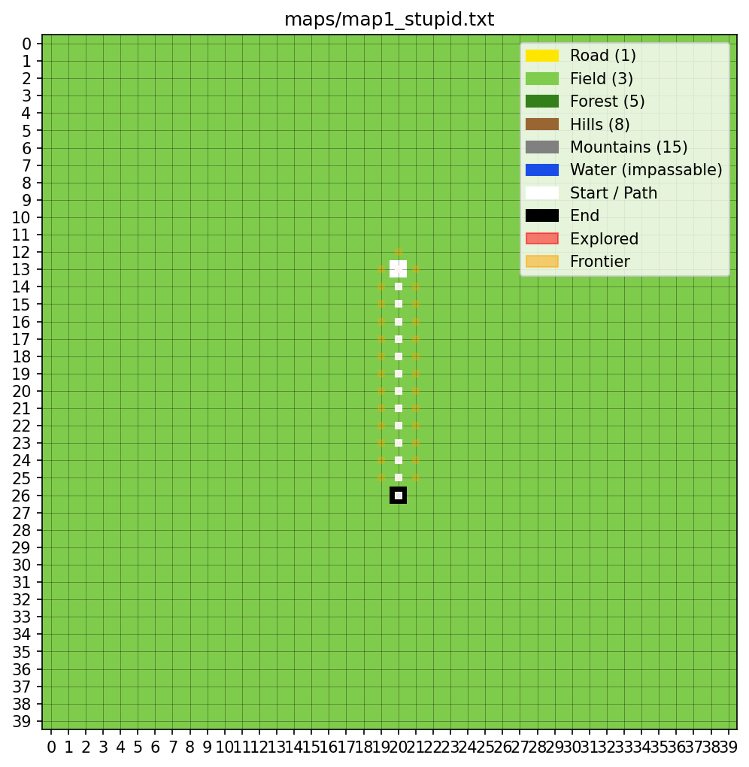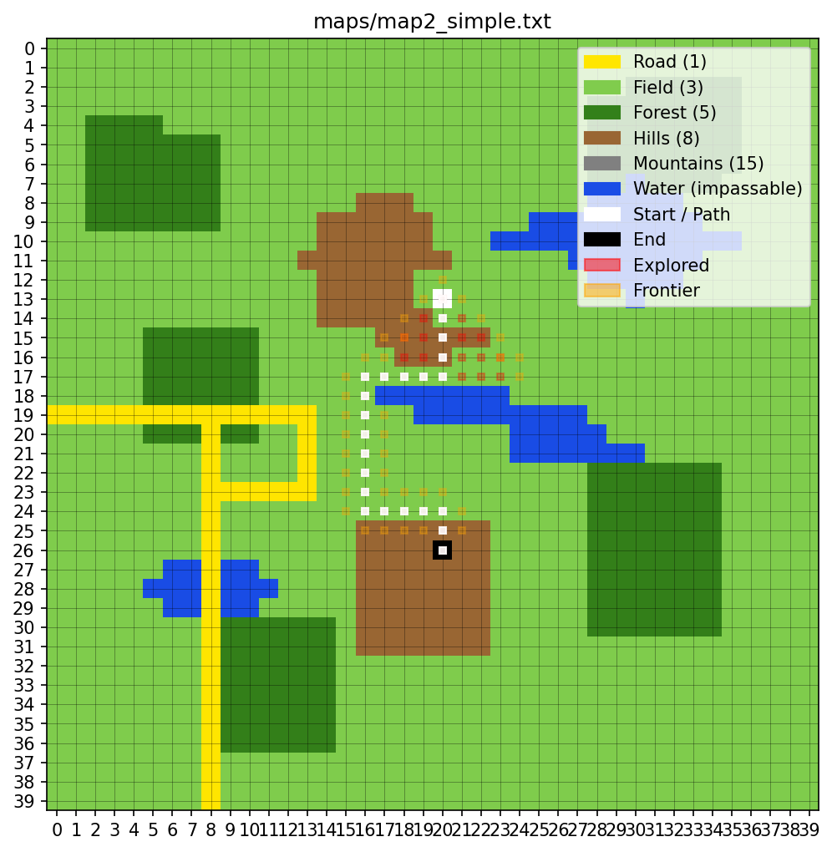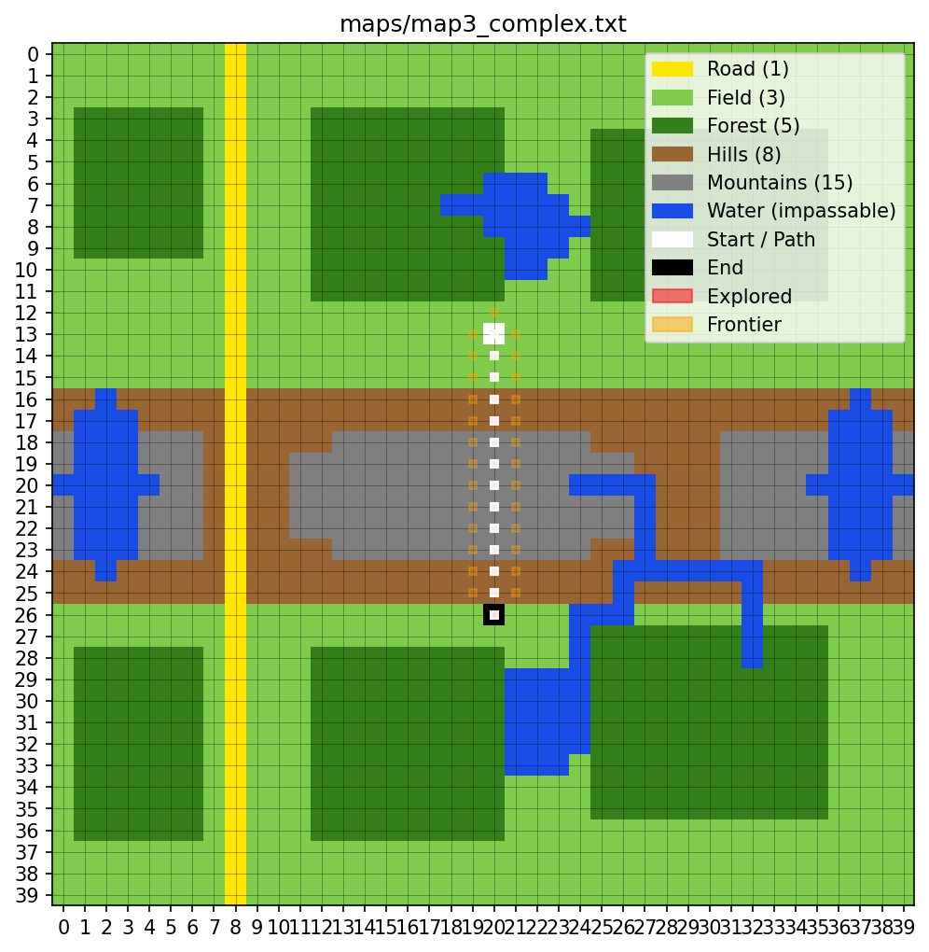

A* With Manhattan Heuristic
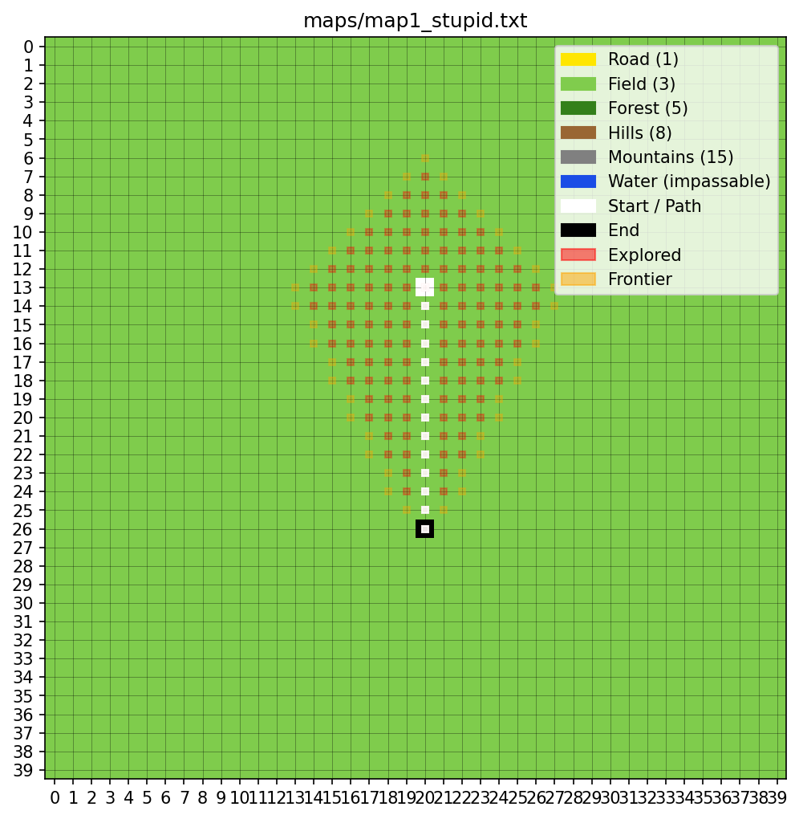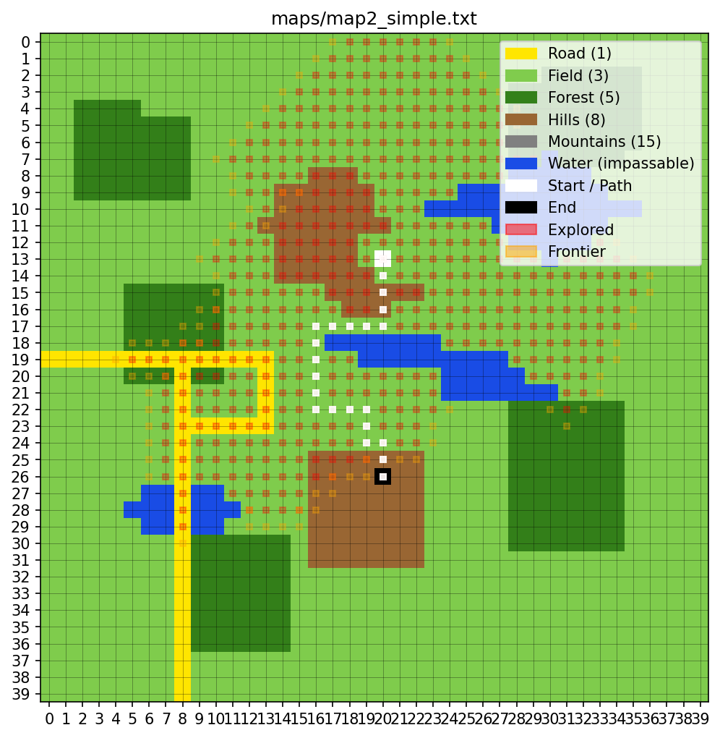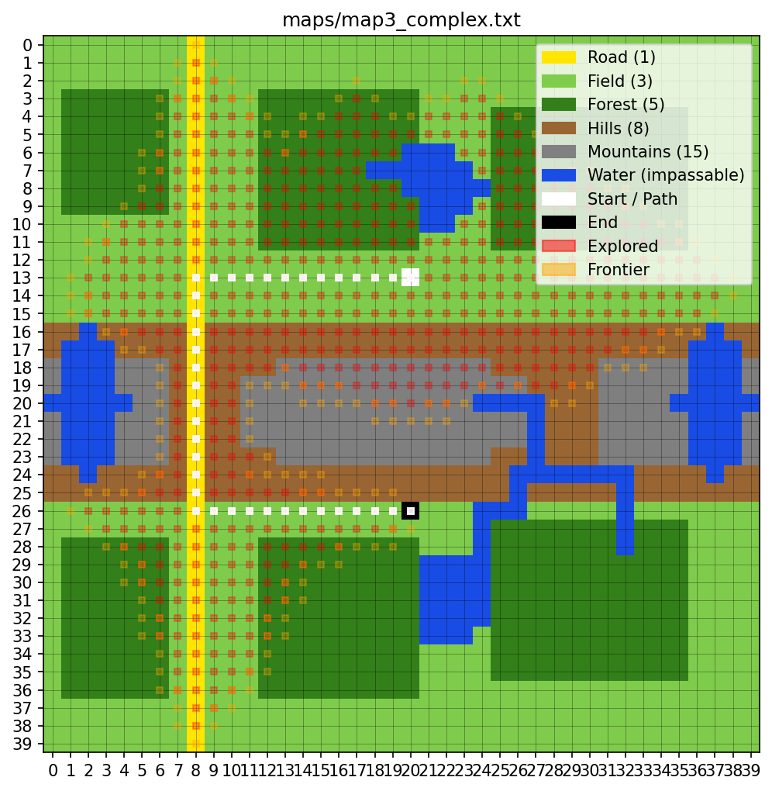

A* With Euclidean Heuristic
