Paper A Methods: MSSD Decision Engine, Synthetic Data, Calibration and Robustness
Tien (Tyler) Le
October 2026
This document merges and replaces the two earlier drafts, “Algorithmic Calibration and Micro-Randomized Decision Engine” and “Synthetic Data Generation and Algorithmic Robustness”. Every simulation result reported here uses the production 1–7 Likert scale. Earlier 1–5 results are superseded.

MSSD Definition and Decision Rules

Notation
Throughout, $t$ is the prompt index: $t=1,2,…,n_{i}$ counts participant $i$’s check-in prompts in time order. It is not a day count. Day $d$ and within-day position $k$ are derived from $t$ where needed (Section 2.4).

Mathematical Definition
Let $x_{i,t}∈\{1,2,…,7\}$ be participant $i$’s integer Likert response to a target Ecological Momentary Assessment (EMA) item at prompt $t$. The full-series mean square of successive differences (MSSD) is
$${\text{MSSD}}_{i}=\frac{1}{n_{i}−1}\sum_{t=2}^{n_{i}}{(}x_{i,t}−x_{i,t−1})^{2}.$$
A full-series value is not suited to real-time use, because it averages over earlier shifts in a participant’s baseline rather than isolating recent swings. The decision engine therefore uses a rolling form over the most recent $w$ successive differences, with $w$ = 3:
$${\hat{\text{MSSD}}}_{i,t}=\frac{1}{min(w, t−1)}\sum_{k=max(2, t−w+1)}^{t}{(}x_{i,k}−x_{i,k−1})^{2}.$$
At prompts 2 and 3 the engine averages the differences available so far. A difference involving a missed prompt is dropped, not bridged. Offline audits should use the value logged at decision time in JITAILog.observed_mssd, not a recomputed full-series MSSD, because the rolling and full-series quantities differ.

Decision Pipeline
At each completed check-in the production engine applies the following gates in order. A decision point that fails a gate is logged with its reason and is not randomized.
- Run-in. Per the protocol, the first seven days after enrollment are a run-in. Check-ins are collected and the threshold history accrues, but no decision point is randomized (RUN_IN_DAYS = 7).
- Distress override. An active baseline or momentary distress flag suspends randomization for that participant, and the app shows a resource card instead (protocol Section 11).
- Minimum history. The threshold below needs at least three earlier rolling MSSD values. Prompt 1 has no difference, and prompts 2–4 produce MSSD values but cannot yet be compared with a threshold. The earliest prompt that can be eligible is therefore prompt 5. This is a property of the prompt sequence and is separate from the seven-day run-in.
- Within-person threshold. The cutoff is the 80th percentile of the participant’s own earlier rolling MSSD values:
$$Θ_{i,t}={\text{Quantile}}_{0.80}\left(\{{\hat{\text{MSSD}}}_{i,1},…,{\hat{\text{MSSD}}}_{i,t−1}\}\right).$$
- The current prompt is excluded, so it cannot raise its own bar. The window is expanding: every earlier value is kept.
- MSSD gate. A decision point passes when ${\hat{\text{MSSD}}}_{i,t}>Θ_{i,t}$. A value equal to the threshold does not pass. The gate responds to volatility relative to the participant’s own history, not to the level of any response.
- Cooldown. No prompt is sent within 60 minutes of a prompt already sent.
- Daily cap. No more than 4 prompts are sent per participant per calendar day.
- Micro-randomization. A decision point that passes every gate above is available. It is randomized to send with probability 0.5:
$$A_{i,t}∼\text{Bernoulli}(p), p=0.5.$$
The simulation engine (apply_decision_rules) implements gates 3–7 only. Section 3 lists the differences.

Synthetic Data Generation

Generative Process
Each simulated participant’s EMA series is a stationary first-order autoregressive (AR(1)) Gaussian process, generated independently per participant $i$:
$$\begin{aligned}z_{i,1}&∼N(0, σ_{i}^{2}), \\ z_{i,t}&=ρ_{i}z_{i,t−1}+ε_{i,t}, ε_{i,t}∼N\left(0, σ_{i}^{2}(1−ρ_{i}^{2})\right), \\ x_{i,t}&=\text{clip}\left(\text{round}(μ_{i}+z_{i,t}), 1, 7\right).\end{aligned}$$
Here $σ_{i}$ is the participant’s stationary standard deviation (volatility), $ρ_{i}$ is the lag-1 autocorrelation (inertia), and $μ_{i}$ is the set point on the 1–7 scale. Scaling the innovation variance by $σ_{i}^{2}(1−ρ_{i}^{2})$ keeps the marginal variance of $z_{i,t}$ equal to $σ_{i}^{2}$ at every prompt, so the process reverts to $μ_{i}$ and has no drift. Rounding and clipping to 1–7 match the production validators on EMA items (MinValueValidator(1), MaxValueValidator(7)).

Participant Parameters
Parameters are drawn independently and uniformly for each participant. The ranges depend on the analysis:
Parameter ranges for simulated participants. The set point is centered on the scale midpoint of 4.
Analysis | Set point $μ$ | Volatility $σ$ | Inertia $ρ$
Recovery and calibration (Sections 4–6) | U(3.0, 5.0) | U(0.3, 1.5) | U(0.1, 0.8)
Robustness (Section 7.2) | U(3.0, 5.0) | U(0.4, 1.4) | U(0.2, 0.8)
Controlled grid (Section 6.3) | 4.0 fixed | 0.3 to 1.5 fixed | 0.2 to 0.8 fixed
The recovery and calibration cohorts come from the repository’s synthetic-data generator, and the robustness cohorts from the misspecification notebook.

Missing Data
Non-response is generated by a two-state Markov chain rather than independently at random, so missed prompts arrive in runs, as they do when a phone is silenced or set aside. Let $M_{i,t}=1$ when prompt $t$ is missed. With target response rate $R$ (default 0.80), missing rate $m=1−R$, and mean run length $λ$ (default 3 prompts),
$$\begin{aligned}β&=P(M_{i,t}=0∣M_{i,t−1}=1)=1/λ, \\ α&=P(M_{i,t}=1∣M_{i,t−1}=0)=\frac{mβ}{1−m}.\end{aligned}$$
The first prompt is missed with probability $m$. A missed prompt is recorded as missing and drops out of every successive difference it touches. The long-run response rate stays at $R$ whatever the run length.
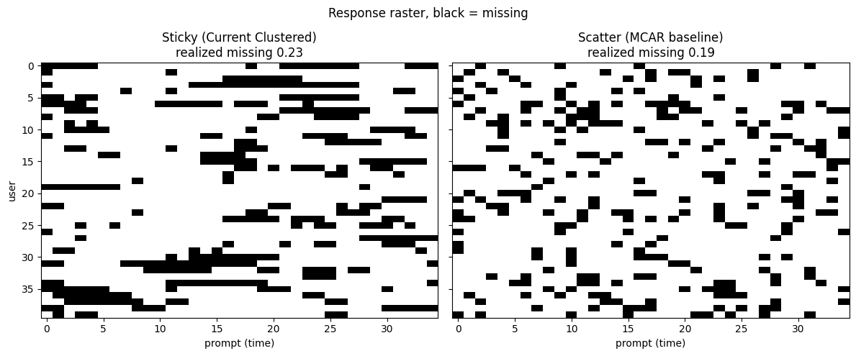
Missed prompts (black) for 40 simulated participants under Markov missingness, against an independent-miss baseline (R = 0.80).
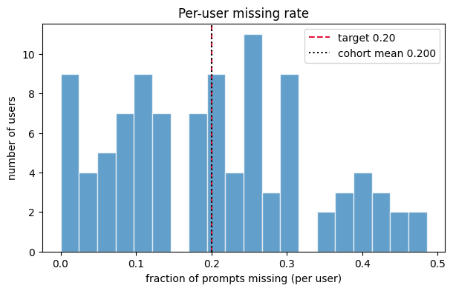
Per-participant missing rate across 100 simulated participants. The cohort mean (0.195) matches the target of 0.20.

Prompt Schedule
Every Paper A simulation schedules 5 prompts per day at 09:00, 12:00, 15:00, 18:00 and 21:00. Prompt $t$ (counting from 0 here) falls on day $d=⌊t/5⌋$ at position $k=t mod 5$, at 09:00 plus 3$k$ hours. The 3-hour spacing keeps consecutive prompts outside the 60-minute cooldown. An earlier draft listed 09:00, 11:00, 13:00, 15:00 and 17:00. That grid belongs to a separate feasibility-report fixture (react_cohort.py) and is not used by any result in this paper.
The production app instead divides 09:00–21:00 into six 2-hour check-in slots, with a reminder 30 minutes after a slot opens if no check-in has arrived. Each prompt has a 30-minute response window in both the simulation and the app.

Physiological Variables
The legacy generator can also produce minute-level heart rate, a derived stress score and heart-rate variability. These variables are not inputs to the decision engine, which uses only EMA responses, and no result in this paper uses them. They are not described further.

Ground Truth and Volatility Groups
Ground truth is analytic. For a stationary participant the expected squared successive difference is
$$E[{\text{MSSD}}_{i}]=2σ_{i}^{2}(1−ρ_{i}),$$
and empirical MSSD and recovered parameters are scored against it. For descriptive summaries, participants are grouped as Stable when this expectation is 0.4 or below, Volatile when it is 1.6 or above, and Moderate in between. In the robustness analysis (Section 7.2), $σ$ is replaced by a time-varying path $σ_{i,t}$ from day 14, and the expectation becomes $2σ_{i,t}^{2}(1−ρ_{i})$.

Parameters: Simulation and Production
Table 1 is the single reference for every design parameter. The last column states where the simulation departs from the production app.
Design parameters in simulation and in the production app.
Parameter | Simulation | Production app | Difference
Check-in prompts per day | 5 | 6 | Simulation uses one fewer prompt per day.
Prompt times | 09:00, 12:00, 15:00, 18:00, 21:00 | Six 2-hour slots, 09:00–21:00 | Fixed times vs. slots.
Decision points | Every scheduled prompt (a missed prompt is unavailable) | Every completed check-in, including post-prompt and extra check-ins (up to 10 per day) | Production can have more decision points per day.
Response window | 30 minutes | 30 minutes | None.
Cooldown | 60 minutes, counted from earlier eligible decision points | 60 minutes, counted from prompts actually sent | Simulation is slightly stricter.
Daily cap | 4 per day, UTC days | 4 per day, Eastern days | Day boundary only.
Threshold | 80th percentile, expanding, within person | Same | None.
MSSD window | 3 differences | 3 differences | None.
Minimum history | 3 earlier MSSD values | Same | None.
Run-in | None; burn-in varied 0–7 days in Section 4 | 7 days per protocol | Production always has a 7-day run-in.
Distress override | Not simulated | Active (protocol Section 11) | Production suppresses some decision points.
Randomization probability | 0.5 | 0.5 | None.
Response scale | 1–7 integer | 1–7 integer | None.
Response rate | 0.80 default; 0.50–0.95 swept | 75% feasibility benchmark | Assumption vs. benchmark.
Study length | Per analysis: 7, 14, 28 or 35 days | 35 days (7 run-in + 28 randomized) | Shorter in some analyses.

Threshold Calibration and Dosage

Sensitivity Grid
The 80th-percentile threshold was compared with alternatives in a factorial simulation: threshold percentile 70, 75, 80, 85 or 90 crossed with a burn-in of 0, 1, 2, 3, 5 or 7 days, at response rates of 70%, 80% and 90%. Each cell used 150 simulated participants over 28 days at 5 prompts per day, repeated over 10 replications (1,500 participant realizations per cell). Prompts were counted only after the burn-in and are expressed per participant per week.
At an 80% response rate and a 7-day burn-in, the number of eligible decision points per participant per week was:
Eligible decision points per participant per week (R = 0.80, 7-day burn-in, n = 1,500 per cell).
Threshold percentile | 70th | 75th | 80th | 85th | 90th
Eligible per week | 6.42 | 5.35 | 4.29 | 3.28 | 2.22
At the 80th percentile the value was 4.48 with no burn-in and 4.45 with a 3-day burn-in (95% CI half-width 0.10 or less in every cell). Burn-in lowered dosage by about 0.2 per week at every percentile. Response rate moved the whole grid up or down without changing its shape: at the 80th percentile and a 7-day burn-in, the value was 3.7 at 70% response and 4.8 at 90%.
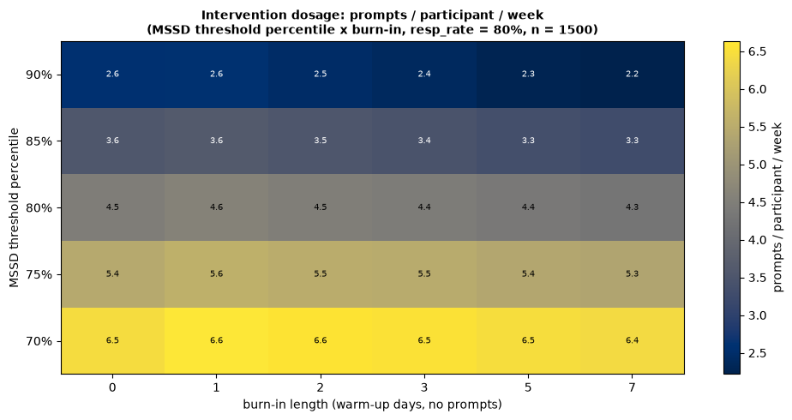
Eligible decision points per participant per week by threshold percentile and burn-in (R = 0.80, n = 1,500 per cell).
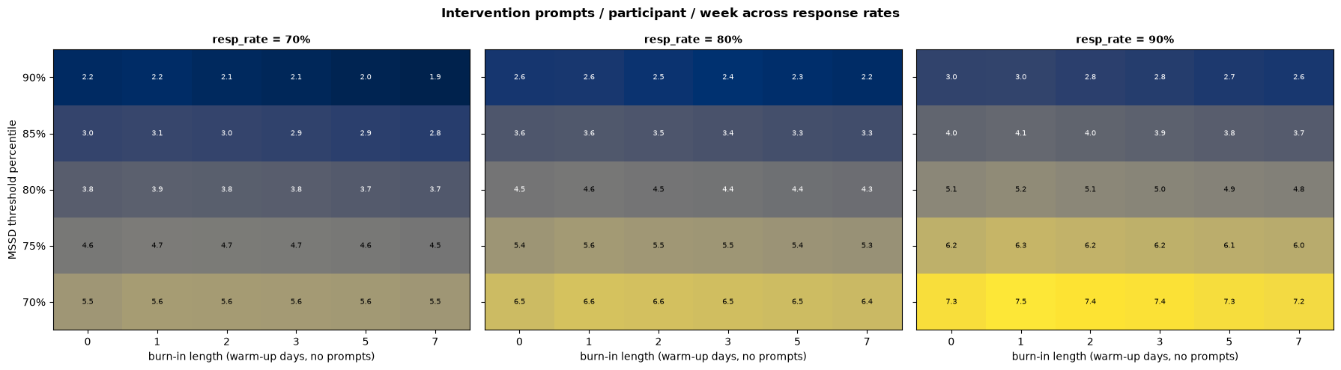
The same grid at response rates of 70%, 80% and 90%.

Delivered Dosage and the Protocol
Randomization at p = 0.5 halves the eligible count. At the 80th percentile, the simulation therefore delivers about 2.1 prompts per participant per week, or about 0.3 per day. For the production app, Paper B estimates about 0.6 delivered prompts per day: six daily decision points, times the availability of 0.21 defined in Section 5, times the send probability of 0.5.
Neither figure meets the protocol’s statement (Section 9.3) that participants receive “on average about two to three prompts per day”. That statement does not follow from an 80th-percentile threshold. Consistent with Paper B, we recommend amending Section 9.3 to “about one prompt every one to two days, never more than four in a day”. The cap of 4 per day remains an upper bound, not a typical rate.
Protocol Section 7 is a sample-size assumption: it describes the decision points expected to feed the power calculation, not a dosage that each participant must receive. Paper B shows that the power target still holds at the availability built here (minimum detectable effect 0.109 at full engagement, 0.126–0.156 under the benchmark engagement and retention scenarios, within the protocol’s stated 0.10–0.15).

Eligibility Rate: Definition
This paper reports one eligibility rate: availability, the share of decision points that pass every gate in Section 1.3 and receive a randomization draw. The planned value is 0.21, the figure Paper B’s power calculation uses. The other figures that appeared in earlier drafts measure different things:
- 20% is the design value of an 80th-percentile threshold: one decision point in five exceeds it when ties are rare.
- 16.8% is the threshold-crossing rate in the stationary robustness simulation. It falls below 20% because tied values (11.6% of evaluable decision points on the 1–7 scale) do not pass the gate.
- About 13% (12.8%) is the share of all scheduled prompts that were eligible in the simulated decision log. That denominator includes missed prompts and the first four prompts; among evaluable decision points the same log gives 0.20, consistent with 0.21.
- 2.6% appeared in an earlier draft. It could not be reproduced from any saved output and is withdrawn.

Parameter and Metric Recovery
All recovery figures in this section were produced on the 1–7 scale.

MSSD Recovery
The recovery cohort had 100 simulated participants over 7 days at 5 prompts per day, run through the production decision engine. Each participant’s nominal response rate was set between 0.65 and 0.93; the realised mean was 0.79. All 100 participants answered at least 10 prompts and were analyzed. Empirical MSSD tracked the true expected MSSD with Pearson r = 0.849 (Spearman 0.871), above the construct-validity criterion of 0.70. The OLS slope was 0.73. Mean empirical MSSD was 1.086 (SD 0.776) against a true expected value of 1.107 (SD 0.906). Volatility recovered at r = 0.888 and inertia at r = 0.552.
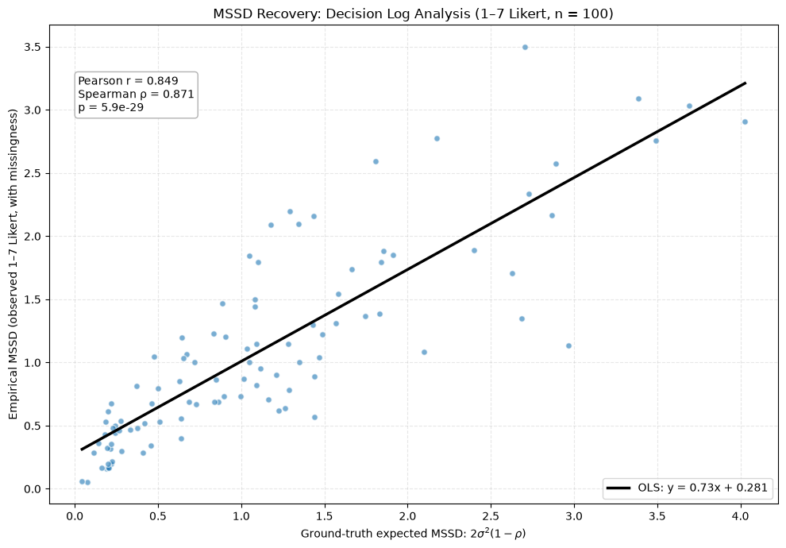
Empirical vs. true expected MSSD (1–7 scale, n = 100).
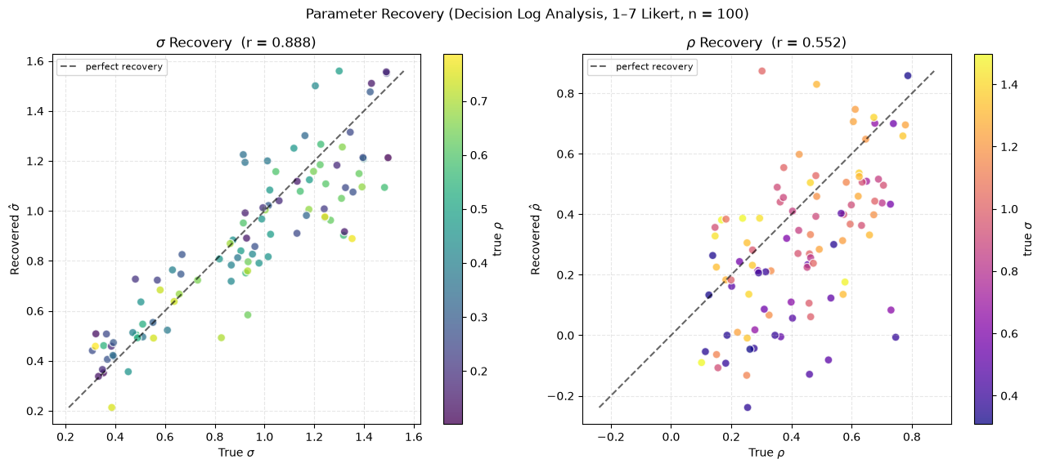
Recovered vs. true volatility ($σ$) and inertia ($ρ$) (1–7 scale, n = 100).

Recovery and Response Rate
A separate sweep set the response rate from 0.50 to 0.95 in steps of 0.05, with 200 participants per level over 14 days.
- Inertia error fell steadily with response rate, from 0.209 at 0.50 to 0.116 at 0.95 (0.167 lower per unit of response rate; p under 0.001).
- Volatility error also fell significantly (0.062 lower per unit of response rate; p under 0.001), but only by about 0.02 across the whole range.
- The MSSD correlation rose from 0.84 at 0.50 to 0.93–0.95 at 0.85 and above, and stayed above 0.70 at every level.
The decline in error is gradual. There is no response rate below which recovery breaks down, so the earlier draft’s “70% breakdown floor” is withdrawn. The 75% preregistered feasibility benchmark is a feasibility target, not a recovery threshold.
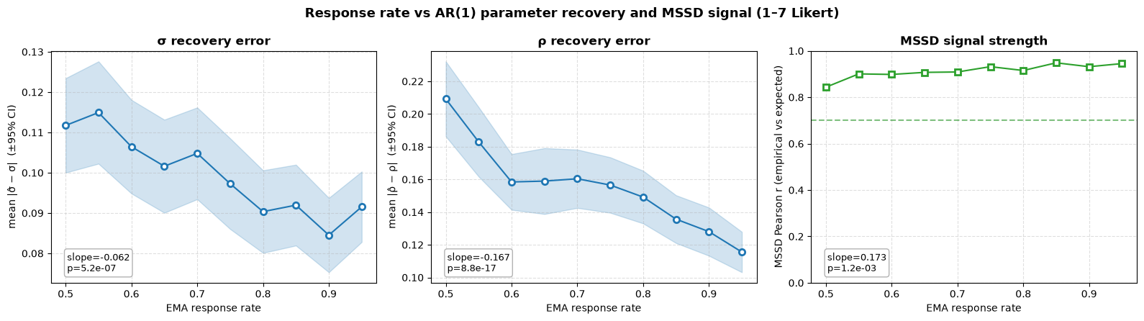
Recovery error for volatility and inertia, and MSSD correlation, by response rate (1–7 scale, 200 participants per level).
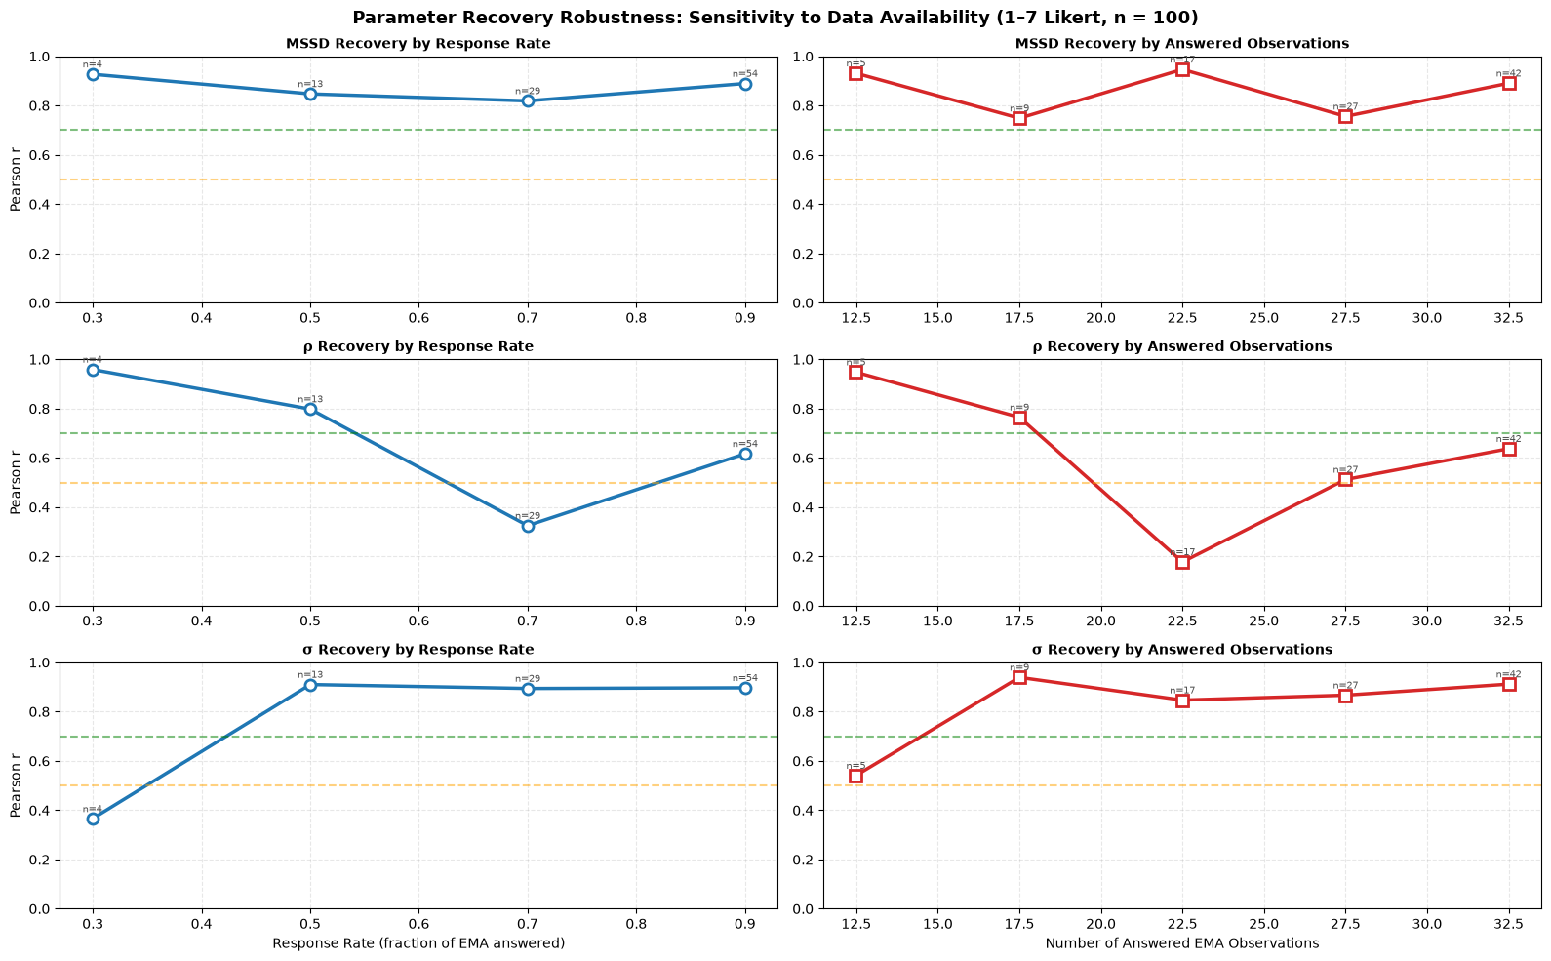
Recovery correlation in the recovery cohort, by realised response rate and by number of answered prompts (1–7 scale, n = 100).

Controlled Parameter Grid
On a controlled grid of five volatility levels (0.3 to 1.5) and three inertia levels (0.2, 0.5, 0.8), with 12 participants per cell and the set point fixed at 4.0, empirical MSSD tracked the true expected value with r = 0.953 (Spearman 0.964, slope 0.985, 180 participants).

Sensitivity and Robustness Analyses

Compliance and Burn-in
The grid in Section 4 shows that response rate and threshold percentile act as separate dials. Response rate mainly affects how well each participant’s parameters are estimated, and the percentile mainly sets dosage.

Robustness to Non-Stationary Volatility
The engine’s expanding threshold assumes that each participant’s volatility is a stable trait. To test what happens when it is not, cohorts of 150 participants were simulated over 35 days (5 prompts per day, R = 0.80) in 10 replications, giving 1,500 participant trajectories per scenario. Participants and their random innovations were held identical across scenarios, so only the volatility path differs. From day 14, four volatility paths were applied:
Volatility scenarios.
Scenario | Volatility path | What it represents
Stationary | $σ_{t}=σ_{0}$ | Control: no change.
Shift up | $σ_{t}=2σ_{0}$ from day 14 | A new stressor.
Shift down | $σ_{t}=0.5σ_{0}$ from day 14 | Recovery or habituation.
Drift | $logσ_{t}=logσ_{0}+0.97(logσ_{t−1}−logσ_{0})+0.10 η_{t}$ | Slow, undirected change.
Four threshold rules were compared: the production expanding window; a rolling 7-day window (35 prompts); an exponentially weighted moving quantile (EMQ) with a fixed anchor to the first week; and an EMQ whose anchor decays with a 14-day half-life.
True high-volatility moments were defined from the noise-free latent series as each participant’s top 20% of standardized instability within their current regime. Detection was scored on threshold crossings, before cooldown and cap. Because the 1–7 scale rounds small changes to zero, the converged threshold has a floor of about 0.33 for participants with $σ$ below 0.4. Thresholds were therefore compared with an empirical oracle (the converged production threshold for a participant’s current expected MSSD), and the tracking ratio is threshold divided by oracle, where 1.00 is correct calibration.
Detection and dosage under non-stationary volatility (150 participants, 10 replications). TPR, FPR and precision are scored on threshold crossings. Prec.: precision. Pre and Post: eligible decision points per participant per week, before and after day 14. Ratio: threshold divided by oracle threshold. Readapt: days until the ratio stays within 25% of 1.00; none means it did not readapt within the study. EMQ fixed and EMQ decaying: exponentially weighted moving quantile with a fixed or decaying first-week anchor.
Scenario | Rule | TPR | FPR | Prec. | Pre | Post | Ratio post | Ratio final | Readapt
Stationary | Expanding (prod.) | 0.511 | 0.082 | 0.611 | 4.59 | 4.08 | 1.00 | 1.00 | 0
 | Rolling 7-day | 0.516 | 0.098 | 0.571 | 4.69 | 4.58 | 1.00 | 1.00 | 0
 | EMQ fixed | 0.555 | 0.103 | 0.575 | 4.92 | 4.93 | 1.00 | 1.00 | 0
 | EMQ decaying | 0.555 | 0.104 | 0.574 | 4.92 | 4.95 | 1.00 | 1.00 | 0
Shift up | Expanding (prod.) | 0.697 | 0.192 | 0.478 | 4.59 | 9.21 | 0.62 | 0.74 | none
 | Rolling 7-day | 0.606 | 0.134 | 0.532 | 4.69 | 6.54 | 0.86 | 0.97 | 5
 | EMQ fixed | 0.718 | 0.214 | 0.458 | 4.92 | 9.89 | 0.65 | 0.75 | 19
 | EMQ decaying | 0.696 | 0.190 | 0.480 | 4.92 | 8.93 | 0.72 | 0.89 | 10
Shift down | Expanding (prod.) | 0.256 | 0.056 | 0.537 | 4.59 | 1.02 | 1.71 | 1.50 | none
 | Rolling 7-day | 0.366 | 0.096 | 0.491 | 4.69 | 3.25 | 1.00 | 1.00 | 6
 | EMQ fixed | 0.295 | 0.069 | 0.519 | 4.92 | 1.57 | 1.72 | 1.52 | none
 | EMQ decaying | 0.313 | 0.074 | 0.518 | 4.92 | 1.87 | 1.55 | 1.20 | 17
Drift | Expanding (prod.) | 0.464 | 0.110 | 0.515 | 4.82 | 4.42 | 1.00 | 1.00 | 0
 | Rolling 7-day | 0.476 | 0.121 | 0.497 | 4.91 | 4.85 | 1.00 | 1.00 | 0
 | EMQ fixed | 0.501 | 0.130 | 0.492 | 5.14 | 5.17 | 1.04 | 1.07 | 0
 | EMQ decaying | 0.499 | 0.129 | 0.494 | 5.12 | 5.13 | 1.04 | 1.05 | 0
Under the production expanding threshold, the response to a shift depends on its direction.
- Shift down. Earlier high-volatility values keep the threshold high (final ratio 1.50). Eligible decision points fall from 4.59 to 1.02 per week, and sensitivity falls from 0.511 to 0.256. This is a silent failure: prompts become rare, but nothing in the engine flags it, and the threshold does not readapt within the remaining 21 days.
- Shift up. Earlier low-volatility values hold the threshold down (ratio 0.62 just after the shift). Eligible decision points rise to 9.21 per week, the false-positive rate rises to 0.192 and precision falls to 0.478. The daily cap of 4 limits the increase in sent prompts.
- Drift. Slow, undirected change is tolerated: the ratio stays at 1.00, with TPR 0.464 and precision 0.515.
The rolling 7-day window readapts in 5 days after a shift up and 6 days after a shift down. Its threshold is noisier from day to day (SD 0.030–0.040 vs. 0.010–0.014 for the expanding window), and precision under stationarity is a little lower (0.571 vs. 0.611). The EMQ with a decaying anchor readapts in 10 and 17 days with little added noise (SD 0.023 or less).
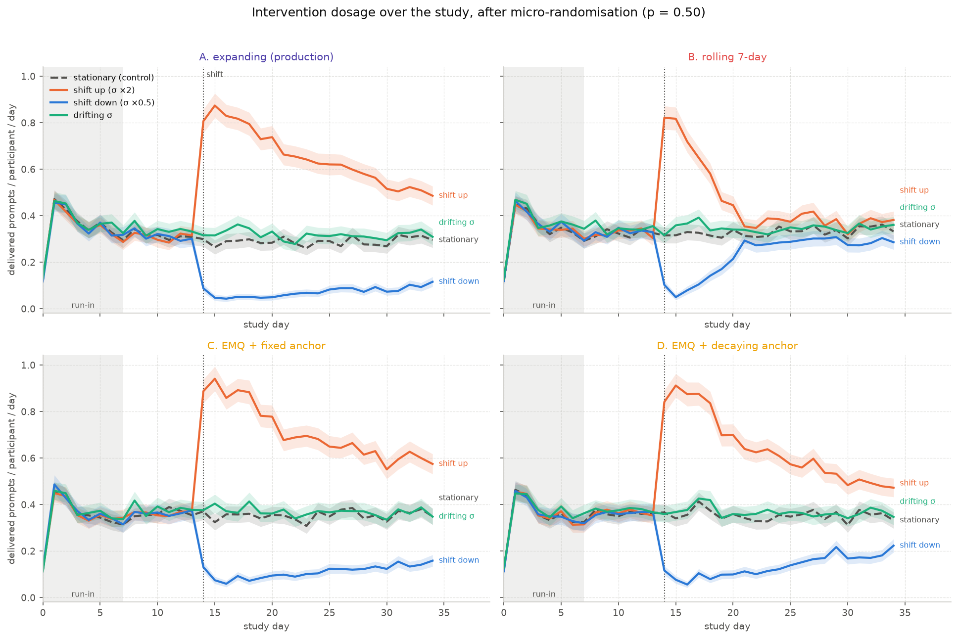
Delivered prompts per participant per day (after randomization at p = 0.5) across study days, for each threshold rule and scenario.
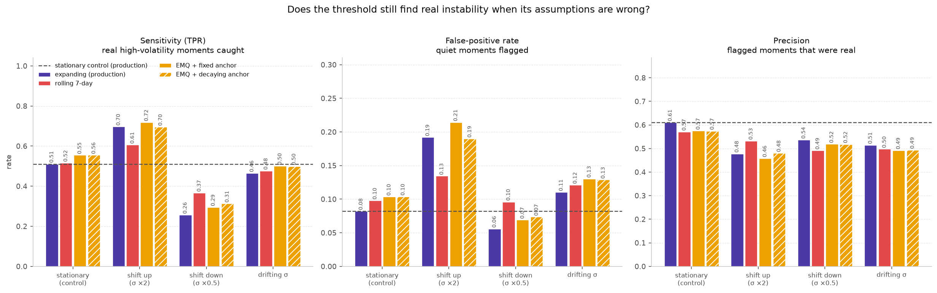
Sensitivity, false-positive rate and precision across scenarios and threshold rules. Dashed lines mark the stationary production values.
These results support monitoring each participant’s prompt rate during field deployment, so that a sustained drop after a change in volatility is noticed by staff.

Considerations for Future Deployments
The following points are offered for future studies that use this engine. They are not changes proposed for REACT, which keeps the 80th-percentile expanding threshold and the protocol’s stated detectable-effect range.
- A lower threshold percentile. A 70th-percentile threshold would raise eligible decision points from 4.29 to 6.42 per participant per week in simulation, and with them availability. The cost is more crossings by low-volatility participants near the 1–7 scale’s floor of about 0.33, where added prompts reflect rounding more than real change.
- Power planning. With availability near 0.21, each participant contributes roughly 20 to 35 randomized decision points (Paper B). A future trial with similar availability, fewer participants or lower engagement might plan its power around a minimum detectable effect of 0.20 to 0.25 rather than 0.10 to 0.15.

