**C# Reference**

**Adding 2 Integers**

**Finding Area of a Square**

**Finding the Area of a Rectangle**

**Finding Area of a Circle**

**Coding a Leaderboard (Else If)**

**WriteLine – Prints on new line**

**Write – Prints on same line**

**Using For Loop to Write Alphabet**

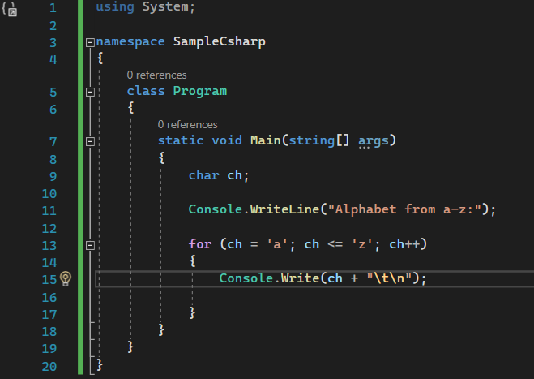

**Coding A Leaderboard (Array)**

**Swapping 2 Integers**

**Determining if a number is Positive or Negative**

**If – Checks to see if statement is true, if true it executes, if false it goes to else if.**

**Else if – Checks to see if statement is true, if true it executes if false it runs else.**

**Using a For Loop to Make a Right Angle Triangle**

**Using Switch**

