# Introduction

Throughout the course of project one, we decided to take analyze whether going to college and receiving a degree is "worth it". We measured “worth it” by several questions that we were able to retrieve data for, some of the items we are comparing are different degrees and degree fields and whether if receiving a bachelors in those specific fields is worth it by comparing income, and also the number of people with a degree that are in jobs that do not require college degrees. Below are the questions that we hope to answer from the data that we analyzed.

## Question 1: What are the 10 highest paying degrees?

From the gathered from the United States Census Bureau, we were able to find the highest paying college degrees across the United States. The top 10 highest paying college degrees in the United are listed in the chart below. The chart demonstrates the average salary for each degree across the United States in descending order.

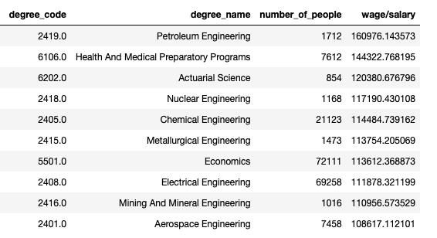

## Question 2: What are the 10 lowest paying degrees?

Since we found the highest paying degrees in the United States we then decided to show 10 of the lowest paying degrees. This data was also gathered from the United States Census Bureau. The DataFrame below demonstrates the lowest paying college degrees in ascending order.

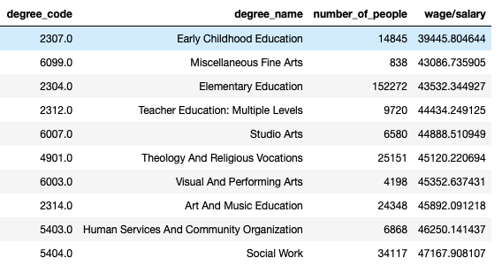

## Question 3: How many men and women are pursuing a particular college degree?

In question three we were able to find that men heavily outnumber women in engineering related fields. On the other end, we found that women outnumber men in education fields and in nursing. The charts show the percentage of men and women with particular degrees.

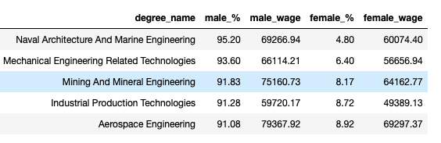

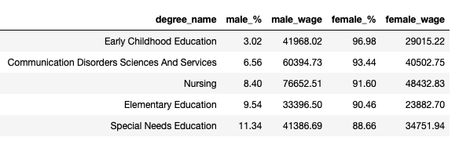

## Question 4: How does the expected median salary of a particular degree compare with the average salary in the United States?

In question 4 we measured which college degree earn less than the average salary of a college graduate in the United States. The average of the US salary was calculated by finding the mean of all wages entered in the census data that we gathered. The chart below demonstrates a small list of college degrees that have earned less than the average US salary.

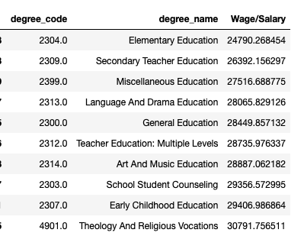

## Question 5: Which college degrees have the largest amount of people working in jobs that do not require a college degree?

With question five, we wanted to visualize which college degrees have the largest number of college graduates working in jobs that do not require a college degree. The college degrees listed in this chart have the most college graduates that have a bachelors, however, work non-degree related fields. We can see that business and psychology have the largest number of students that do not work in their field of expertise.

