**Programming Project Report**

Tyler Tracy

010805685

**Problem Statement:**

The goal of this programming assignment is to get familiar with openGL by creating a program that outputs graphs in a window by reading in data from a file. The inputs to this program is a data file filled with numbers. The output is a scaled graph that represents those data points. Another input to this program is the type of graph that the data should be represented in, this changes the type of graph: dot, line, bar, area.

**Design:**

I created two programs to solve this problem. One program to handle the inputted data and to compute the coordinates of all of the lines and polygons that should be drawn and outputs those commands to a txt file. Then I made another program that reads in that data and draws the graph according to those commands. I used vectors to store the polygon points since the size was not always know before the data was read in. Other than that I did not use any ADTs. The program mostly used string parsing to read the data.

**Implementation:**

I started the first program from scratch because it was a fairly simple program all it did was read in text and output a file. For the second program I copied the square program from the src folder. I had to change to ortho from [-1,1] to [0,500] so it would be easier to draw the graph. I also extended this by creating four functions (drawLine, drawPoly, setColor, drawPoint) that I called depending on the command I sent the program. This program took me about a week to get working. I spent three one hour long sessions working on it.

**Testing:**

I tested my program by giving it a bunch of different data points. Some data was descending, some data was all acceding, some did both. Everything worked in my program as expected. I have included some pictures from sample data.

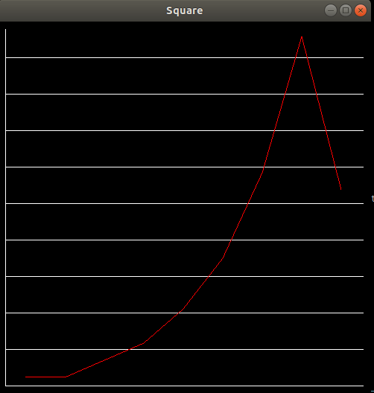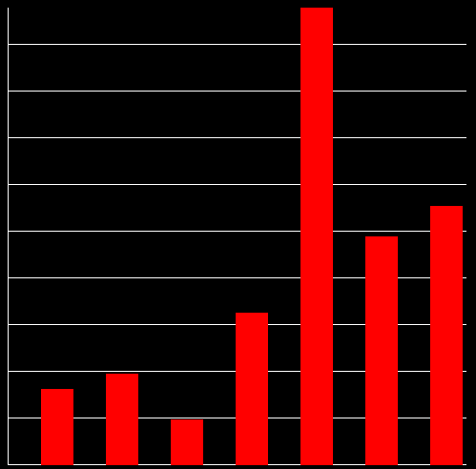

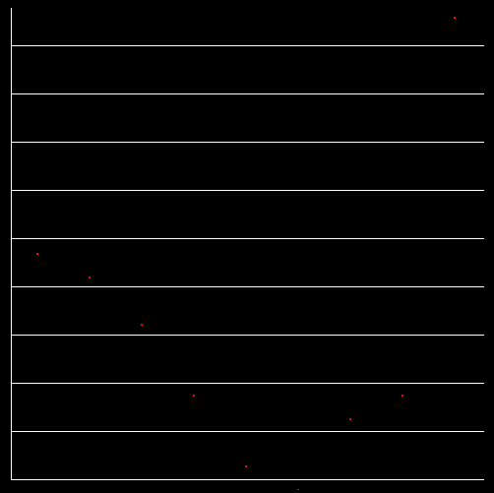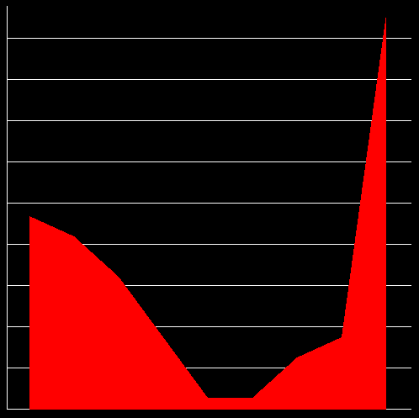

**Conclusions:**

The result of the assignment is a very advanced graphing that rivals excel. You can invest in my new software (GauchGrapher) starting on February 12th. But yes the program was a success. If I were to do this again I would probably make the graphs a bit more pretty and add shading to the area graph and display numbers on the side of the axis. This program took me about a week to get to work, but once I got my first line drawn everything fell into place.