**Programming Project Report**

Tyler Tracy

010805685

**Problem Statement:**

The goal of this programming assignment was to learn more of how openGL works and to get familiar with mouse callback and drawing 3D shpaes. The inputs to this program are the user’s mouse position and mouse clicks and the output is a rotating cube that bounces around the screen.

**Design:**

I created one program to do this task. The program kept track of the the x, y, z, and rotation of the cube. There was a main clock loop that updated the position of the cube based on gravity and bounced it off walls. The program also listened to mouse input and stop all physics while the user is moving the cube. It also keep track of how far the user dragged the cube and “launches” it. The program did not use any data structures more complicated than atomic variables. The meat of the program is just checking the position and updating them based on all the other variables.

**Implementation:**

I started by getting the physics to work for a rectangle. I justed copied my code from the last project to get it to draw the rectangle. Then i copied Gauch’s cube program to draw the cube and studied it to make it work with my “physics engine”. Then I looked through more of gauch’s code to figure out how to rotate the cube the correctly. Took me about three 1 hour sessions to get the entire thing to work.

**Testing:**

I tested my program by playing around with it and ”launching” it around to make sure it bounced off the walls correctly and it rotated correctly. I have some screenshots of the cube below.

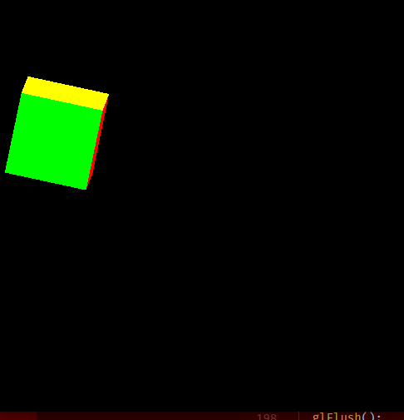

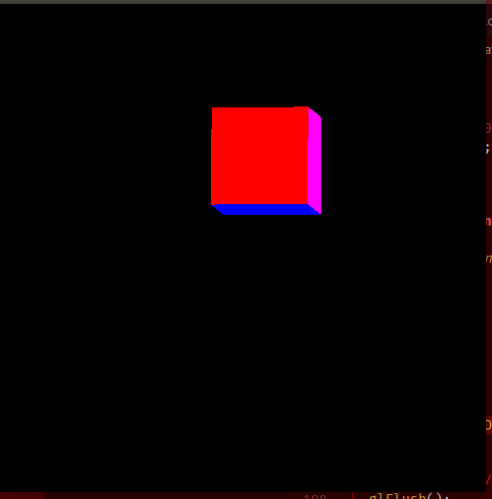

**Conclusions:**

The result of this assignment was an overall success. I got the cube to bounce and rotate and it is rather fun to launch around the screen. It took me about a week to get this all working but once I got the rectangle drawn everything else was easy. If I were to do this again I would make it where you can spawn other cubes and have them interact with each other. That would be fun :)