MEMORANDUM

To: Tom Tompson, Intergalactic Travel Project Manager

From: Tyler Sikkema, Head of HR

Date: February 13, 2014

Re: Sales Target Results for California, January

Dear Tom,

I am glad to hear that we have closed the deal with the lizard people. I believe that their presence will get our new StarGate up and running 10 years ahead of schedule.

That said, I have heard that there is some resistance among the crew. I understand that working with an alien race can be somewhat frightening, but this is the most efficient way for the human race to join the intergalactic community. The chart below details how much faster our progress could be with alien involvement.

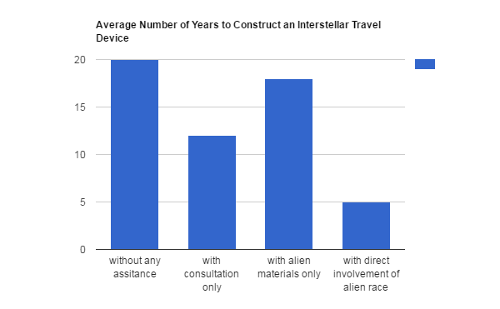

Due to this, I suggest that your team attend diversity training. When they understand the Reptilians more, they will likely be much less resistance to their involvement. Let me know what you think, and feel free to come to me with any questions as this project moves along.

Tyler Sikkema

Head of HR

517 867 5309