CS472 Group 1 — Phase 1, 2 & 3 Report
Finn Wantland · September 18, 2026
Covers Phase 1 (Test Coverage Lab), Phase 2 (TDD Lab), and Phase 3 (CI Lab) work on Group 1's shared bank-account and counter services.

Phase 1 — Test Coverage Lab

Setup evidence
cd test_coverage_lab
pip install -r requirements.txt -r requirements-dev.txt
pytest --cov=models
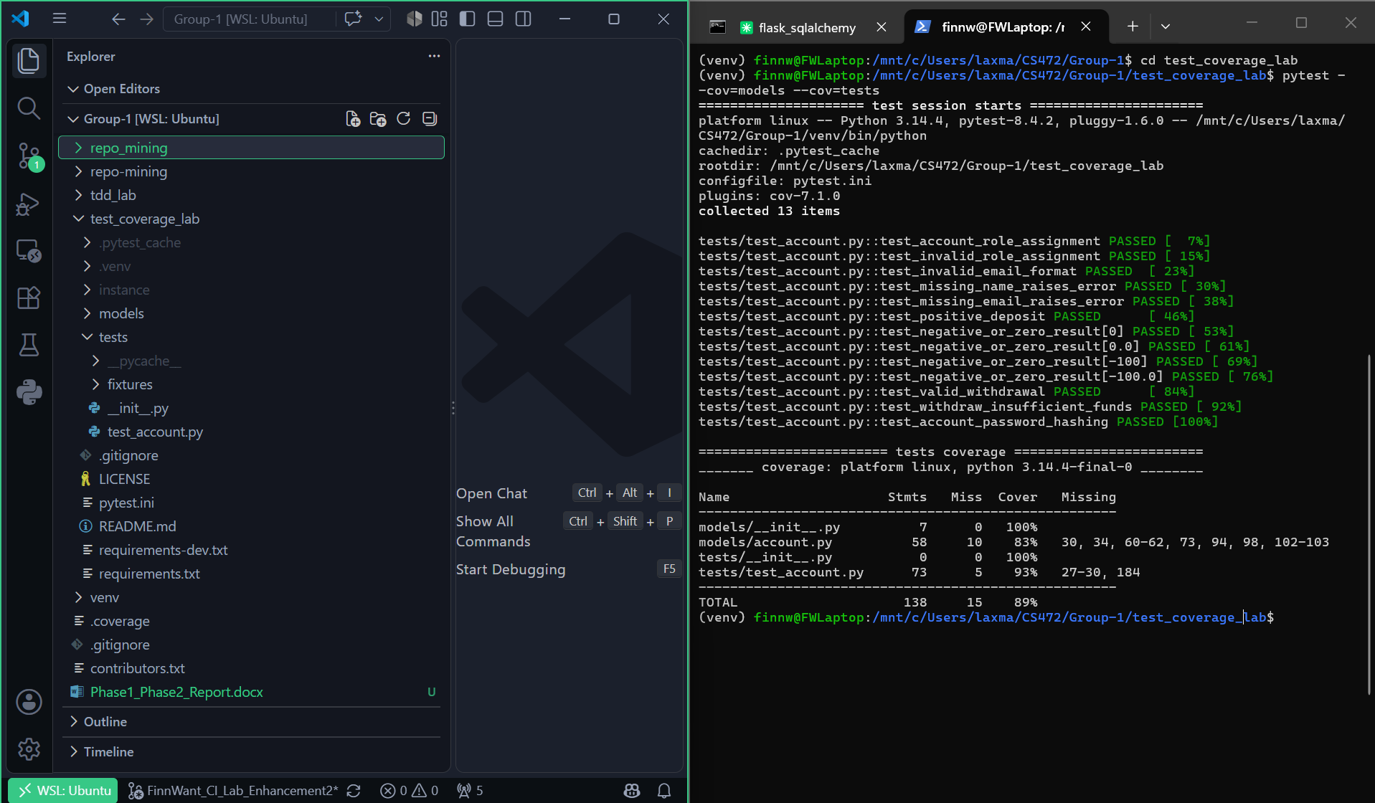
Figure 1. test_coverage_lab folder + passing pytest run.
Team's Test Coverage Lab setup PR: #37 — Add test_coverage_lab folder
Its issue: #36 — Test Coverage Setup

My issue and acceptance criteria
#48 — Add a test for valid withdrawal
#49 — Add a test for insufficient-funds withdrawal
Acceptance criteria (both issues):
- The test exercises withdraw().
- The test verifies the behavior when a withdrawal is valid, and when funds are insufficient.
- The assertions verify the expected result.
- The test passes locally.
- The relevant uncovered code is exercised.
- The PR links to the issue.

My PR
#50 — Added test to validate the withdrawal function, added a test to check for insufficient funds (closes #48 and #49)

Coverage results
Ran locally on test_coverage_lab (pytest --cov=models):
tests/test_account.py::test_account_role_assignment PASSED
tests/test_account.py::test_invalid_role_assignment PASSED
tests/test_account.py::test_valid_withdrawal PASSED
tests/test_account.py::test_withdraw_insufficient_funds PASSED
Name Stmts Miss Cover Missing
-----------------------------------------------------
models/__init__.py 7 0 100%
models/account.py 58 22 62% 30, 34, 47-49, 53-56, 60-62, 66-68, 73, 80, 84, 94, 98, 102-103
tests/__init__.py 0 0 100%
tests/test_account.py 44 4 91% 27-30
-----------------------------------------------------
TOTAL 109 26 76%
4 passed in 17.44s

What the tests verify
Two tests target Account.withdraw():
- test_valid_withdrawal creates an account with a $100 balance, withdraws $40, and asserts the balance drops to exactly $60 — confirming a valid withdrawal decreases the balance by the withdrawn amount.
- test_withdraw_insufficient_funds creates an account with a $50 balance and attempts to withdraw $100, asserting a DataValidationError is raised and the balance is left unchanged at $50 — confirming the method rejects overdrafts instead of allowing a negative balance.

Teammate PR reviewed
#68 — Add test for deleting an account (Cheda-prog, test_coverage_lab)
Review comments:
“Validated: Uses the setup_account fixture to create a real account in the test database. Calls db.session.get(Account, account_id) before deletion to confirm the account exists. Calls setup_account.delete(). Calls db.session.get(Account, account_id) again and asserts it returns None, confirming removal. Merge Approved!”
Comment: PR #68 review comment

Feedback received and how it was addressed
Reviewer @tylervu-unlv requested changes on PR #50: the withdrawal tests needed to be added under the existing Student #6 / Student #7 comment sections instead of replacing them, to avoid future merge conflicts. This was fixed in commit 6bcf680 (“Added requested changes for proper formatting in file to avoid merge conflicts”), after which the reviewer approved.
Fix commit: 6bcf680

Approved PR / merge commit
PR #50 — approved and merged via commit
1905b0e

Phase 2 — TDD Lab

Setup evidence
cd tdd_lab
pip install -r requirements.txt
pytest --cov=src
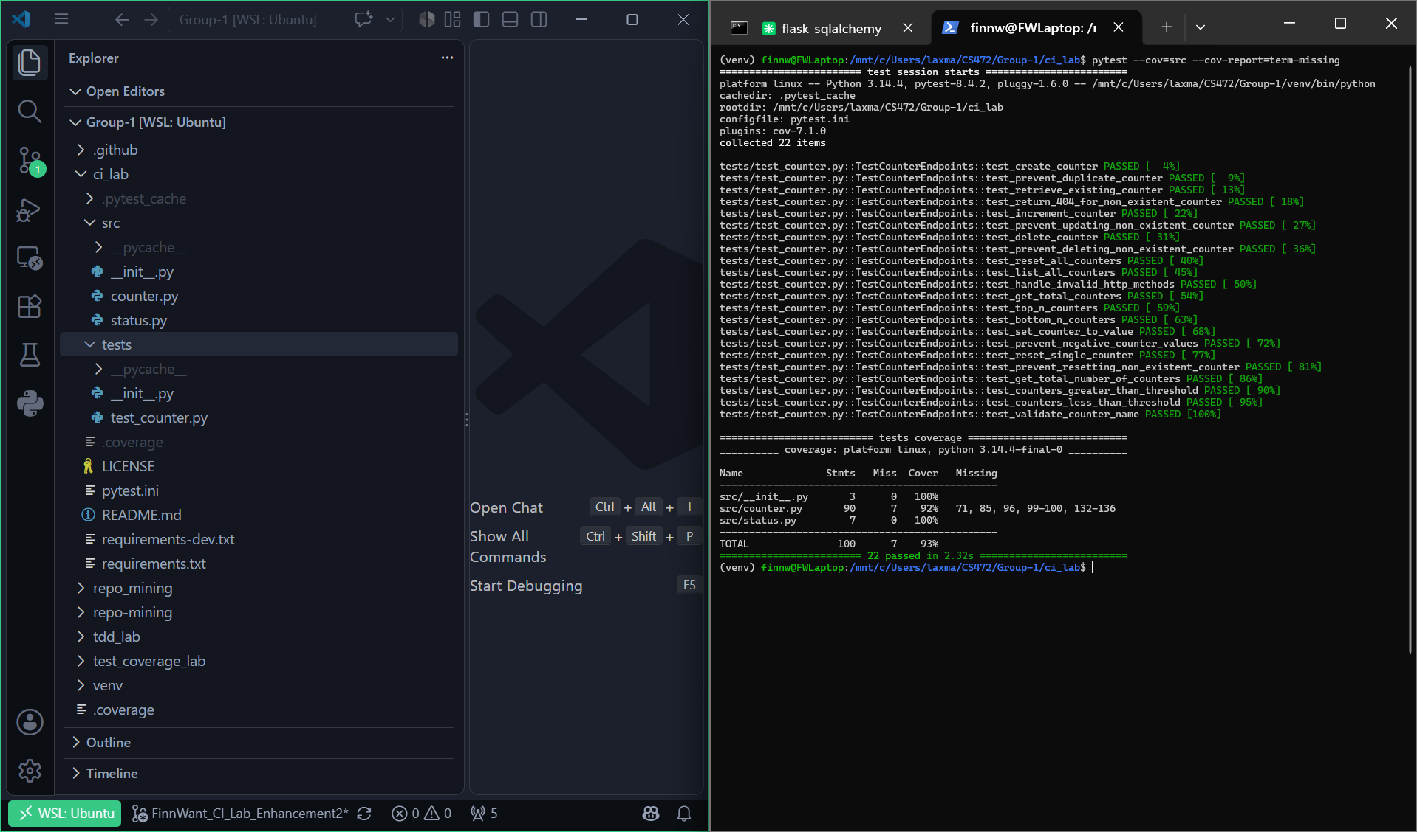
Figure 2. tdd_lab folder + passing pytest run.
Team's TDD Lab setup PR: #53 — tdd lab setup
Its issue: #52 — Set-up tdd_lab

My issue and acceptance criteria
#51 — Create tests for deleting a counter and prevent deleting non-existent counter
Acceptance criteria:
- The test exercises delete().
- The test verifies the behavior of deleting a counter.
- The test verifies the behavior of preventing the deletion of a non-existent counter.
- The test passes locally.
- The relevant uncovered code is exercised.
- The PR links to this issue.
- All expected fields are included in the output.

My TDD PR and test case
#59 — Implement test for deleting a counter and test to avoid deleting a non-existent counter (closes #51)
Test case: test_delete_counter and test_delete_counter_not_found in tdd_lab/tests/test_counter.py.

Feature being tested
A DELETE /counters/<name> endpoint on the counter service:
- test_delete_counter creates a counter named bar, deletes it, and asserts a 204 No Content response; it then re-creates a counter with the same name and asserts 201 Created, confirming the counter was actually removed rather than just hidden.
- test_delete_counter_not_found calls delete on a counter name that was never created and asserts a 404 Not Found response, confirming the endpoint validates existence before deleting.

RED / GREEN / REFACTOR evidence
RED — reproduced locally by running the tests against the code as it stood before the delete route existed (src/counter.py had no /counters/<name> DELETE handler, so Flask's default response for an unrouted method is 405 Method Not Allowed):
tests/test_counter.py::TestCounterEndpoints::test_create_counter PASSED
tests/test_counter.py::TestCounterEndpoints::test_delete_counter FAILED
tests/test_counter.py::TestCounterEndpoints::test_delete_counter_not_found FAILED
assert 405 == 204 (test_delete_counter)
assert 405 == 404 (test_delete_counter_not_found)
2 failed, 1 passed in 2.99s
GREEN — added the delete_counter route in src/counter.py (commit 5d308a8):
@app.route('/counters/<name>', methods=['DELETE'])
def delete_counter(name):
"""Delete a counter"""
if not counter_exists(name):
return '', status.HTTP_404_NOT_FOUND
del COUNTERS[name]
return '', status.HTTP_204_NO_CONTENT
All tests then pass:
tests/test_counter.py::TestCounterEndpoints::test_create_counter PASSED
tests/test_counter.py::TestCounterEndpoints::test_delete_counter PASSED
tests/test_counter.py::TestCounterEndpoints::test_delete_counter_not_found PASSED
3 passed in 1.83s
REFACTOR — the handler mirrors the existing create_counter pattern (guard clause + dict mutation + status code), so no further refactor was needed; src/counter.py finishes at 94% coverage (1 line uncovered).
Commit: 5d308a8

Reviewer feedback and how it was addressed
Reviewer @tylervu-unlv approved PR #59 with no changes requested, verifying that delete() is exercised, both the delete and not-found behaviors are checked, assertions confirm the expected result, the tests pass locally, the relevant uncovered code is exercised, the PR links the issue, all expected fields are in the output, and that the RED phase was shown. No rework was required before merge.

Teammate PR reviewed
#70 — Handle invalid HTTP methods on counter endpoint (Cheda-prog, tdd_lab)
Review comments:
“Check and resolve any merge conflicts but once done merge can be approved and all 3 phases verified”
Comment: PR #70 review comment

Evidence examined while reviewing
PR #70 follows the same RED/GREEN/REFACTOR format as this lab: I checked the RED-phase failure (a PUT to /counters/<name> returning a bodyless 405, asserted via get_json() is not None) and the GREEN-phase test results showing all 4 tests passing after adding a Flask @app.errorhandler for HTTP 405 that returns a JSON error body, plus the coverage table (97% on src/) included in the PR description.

Approved PR / merge commit
PR #59 — approved and merged via commit
d17c468

Phase 3 — CI Lab

Repository

Fork
https://github.com/FinnWant/Group-1

Fork synchronized with upstream
The CI Lab work was built on a branch (FinnWant_CI_Lab_Enhancement2) created directly from upstream tylervu-unlv/Group-1's main branch, and the fork's own main branch was then fast-forwarded to match upstream/main (git push origin upstream/main:main — a read from upstream, written only to the fork; nothing was pushed to upstream). GitHub's compare API confirms the fork is fully caught up:
GET /repos/FinnWant/Group-1/compare/main...tylervu-unlv:Group-1:main
"status": "identical"
"ahead_by": 0
"behind_by": 0
Both FinnWant/Group-1:main and tylervu-unlv/Group-1:main point to
commit 3ff82bfd98457479c126cea13e7ee3ffbe034f35
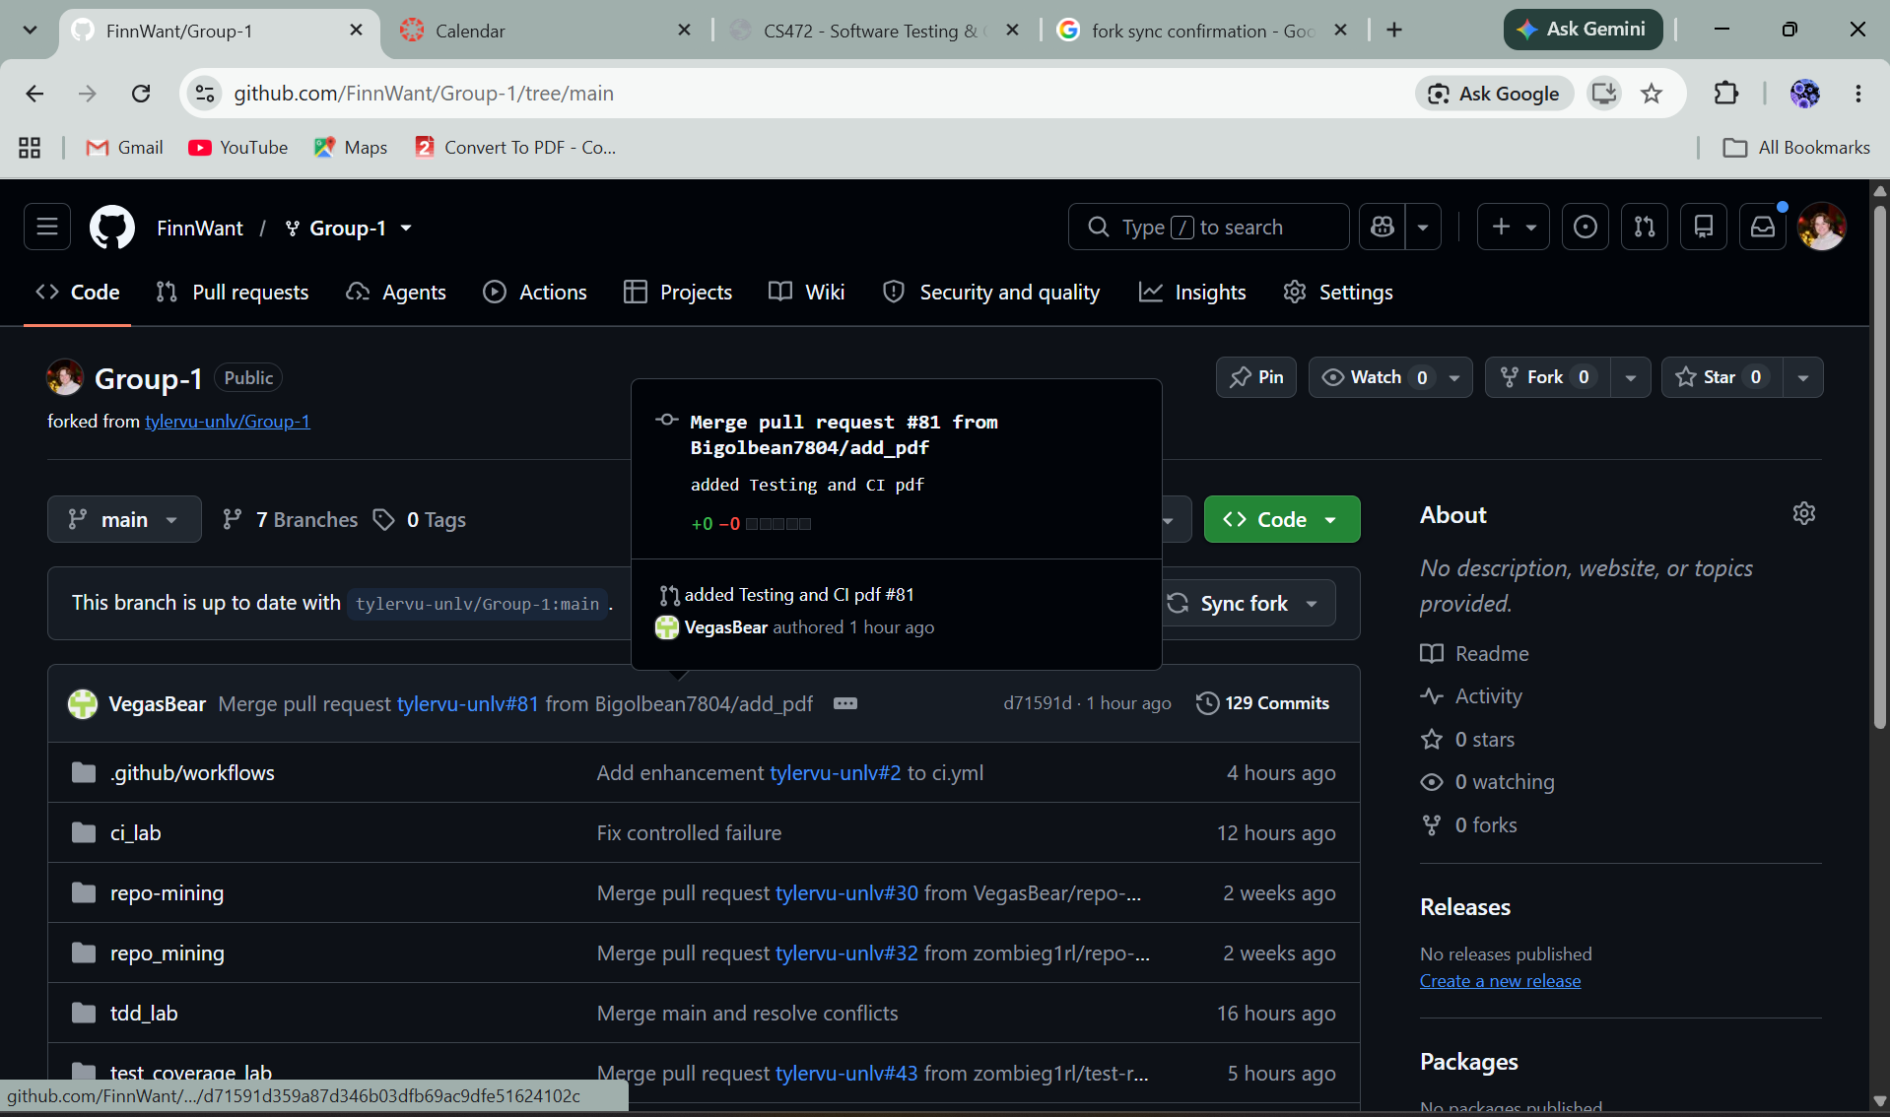
Figure 3. Fork sync confirmation.

ci_lab starter workflow ran successfully
The .github/workflows/ci.yml CI Workflow (matrix over Python 3.9/3.10/3.11) ran successfully against ci_lab on PR #85:
CI run 35398271143 — all 3 jobs green

Combined CI PR

My issue and acceptance criteria
#84 — Enhancement #2 Dependency Caching
Acceptance criteria:
- CI logs showing a cache hit on a subsequent run.
- Correct folder and starter files are included.
- Dependencies can be installed.
- Baseline tests/workflow run successfully.

My PR
#85 — Enhancement #2: Dependency Caching (closes #84)

Workflow excerpt
Added to .github/workflows/ci.yml — a pip cache keyed on OS + Python version + a hash of ci_lab/requirements.txt, plus a step that echoes the cache-hit result into the logs:
- name: Cache pip dependencies
id: cache-pip
uses: actions/cache@v4
with:
path: ~/.cache/pip
key: ${{ runner.os }}-pip-${{ matrix.python-version }}-${{ hashFiles('ci_lab/requirements.txt') }}
restore-keys: |
${{ runner.os }}-pip-${{ matrix.python-version }}-
- name: Report cache result
run: echo "cache-hit=${{ steps.cache-pip.outputs.cache-hit }}"
Figure 4. Dependency-caching addition to ci.yml.

Failing CI log and root-cause summary
CI run 35397681672 — build (3.9/3.10/3.11) all failing on “Run Tests with Pytest”
Root cause: the controlled-failure commit widened the counter-name validation regex in is_valid_counter_name() from ^[a-zA-Z0-9_]$ to ^[a-zA-Z0-9_@]$, so POST /counters/test@123 returned 201 Created instead of the expected 400 Bad Request. test_validate_counter_name asserted response.status_code == 400 and got assert 201 == 400, failing the pytest step (“Process completed with exit code 1”) identically across all three Python versions in the matrix — confirming the bug was in the shared validation logic, not version-specific behavior.

Fix commit / PR diff
Fix commit: be7881d
PR diff: PR #85 — Files changed

Successful CI run
CI run 35398271143 — all 3 jobs green (22/22 tests passing)
Re-running that same completed run (attempt 2, same requirements.txt so the same cache key) produced the dependency-caching evidence required by issue #84:
Run actions/cache@v4
Cache hit for: Linux-pip-3.10-24b8f8c017524ff7e21b6657139b6d89f2f8b51f43b85a15b460dd734839d595
Received 4288543 of 4288543 (100.0%), 24.2 MBs/sec
Cache Size: ~4 MB (4288543 B)
Cache restored successfully
Cache restored from key: Linux-pip-3.10-24b8f8c017524ff7e21b6657139b6d89f2f8b51f43b85a15b460dd734839d595
Run echo "cache-hit=true"
cache-hit=true

Teammate PR reviewed
Pr Link: https://github.com/tylervu-unlv/Group-1/pull/91
Review comment link: https://github.com/tylervu-unlv/Group-1/pull/91#issuecomment-5739326972

Reflection
Working through all three labs end to end changed how I think about “done.” In the Test Coverage and TDD labs, done meant a green pytest run on my own machine; the CI lab showed how thin that guarantee actually is — my delete-counter and withdrawal tests only really counted once they passed the same way on a clean runner, on three separate Python versions, with no assumptions carried over from my own environment. Automated testing stopped being a personal habit and became a shared contract: a red build blocks everyone, not just me, so the tests have to be honest rather than convenient.
Coverage and quality gates (the --cov reports, the flake8 lint step, and the acceptance criteria baked into every issue) turned “I tested it” into something checkable instead of something I had to be trusted on. Adding the dependency-caching enhancement made me look at the workflow itself as something worth engineering — not just what the pipeline tests, but how efficiently it runs, since a 24 MB/s cache restore versus a full pip install is the difference between a CI run people actually wait for and one they start avoiding.
Diagnosing the controlled failure was the most useful exercise in the lab. I already knew the bug because I planted it, but reconstructing the diagnosis the way I'd have to for a real regression — reading job/step conclusions, matching the failure to the same assertion across all three matrix jobs, and ruling out a version-specific cause because all three failed identically — made it clear that CI logs are a debugging tool with their own reading skill, separate from reading a local traceback. I also hit a very real, non-code failure mode: SSH signing and GitHub push credentials that only work from an interactive terminal with a real TTY, not from an automated shell. That was its own small lesson in how much of “CI/CD” is really about authentication and environment boundaries, not just code.
Reviewing teammates' PRs (Cheda-prog's account-deletion and counter-endpoint work in earlier phases) reinforced that a good review checks evidence, not just intent — confirming the fixture setup, the specific assertions, and that the linked issue's acceptance criteria were actually exercised, rather than skimming the diff and trusting the description. Combined with getting review feedback myself (the Student #6/#7 formatting request on PR #50), it made peer review feel less like gatekeeping and more like a second, independent pass at the same acceptance criteria — which is really the core of collaborative software development: everyone is working off the same shared, checkable definition of correct, enforced by the same pipeline, rather than everyone's private definition of “works on my machine.”

