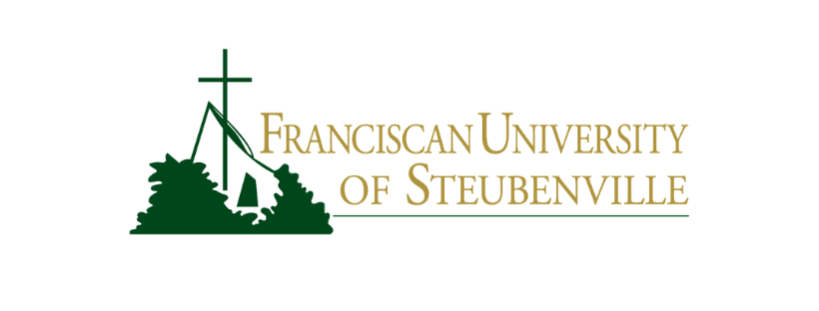

**COURSE INFORMATION SHEET**

CSC 310 - Programming Languages

|  |  |
| --- | --- |
| Professor: Dcn. Stephen Frezza Office: CTT G06 Office Hours: MF 10-12, R 2-3 Phone: 740-283-6287 Email: tabrown@franciscan.edu | Semester: Spring 2025 Classroom: CTT G03 Class Meeting Days: TR Class Meeting Times: 12:45-2:00PM |

**Course Description**  
Examines the basic concepts of programming languages: programming language processors, elementary and structured data types, subprograms, sequence control, data control, storage management, syntax and translation, and programming environments. The student will also study three different programming languages and write a short project in each.

**Required Resources:**

* Laptop that can run Windows (If you don't have one, the school can provide one for you)
* Happy Attitude
* Brain that is willing to learn

**Assessment Overview**  
This class will start with most of your grades coming from exercises that you and peers solve before a deadline. Later, around halfway through the course we move to less frequent exercise sets (which will become conceptual rather than problems-based) and shift more toward projects.

**Pre-Class Preparation**  
Occasionally, there will be short assignments or videos for you to watch before class, along with an associated bit of work you need to do. These will help your understanding of what is covered during class. For those Pre-Class Prep assignments you need to produce something for, please submit your work to the associated assignment on Canvas before the start of class. While these assignments are not technically graded, they are formative and helpful… and they tend to be pretty quick.  
  
These are not formally graded because they are irregularly assigned. I don’t want you to lose points because one “pops up” when you least expect it.