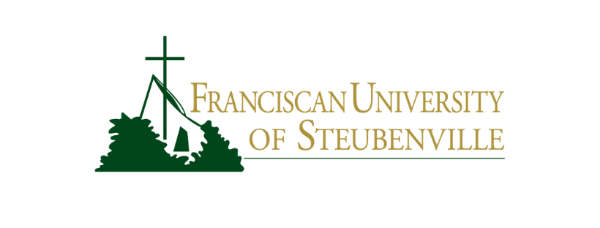

**COURSE INFORMATION SHEET**

Test

|  |  |
| --- | --- |
| Professor: Test Office: Test Office Hours: Test Phone: Test Email: Test@test.com | Semester: Test Classroom: Test Class Meeting Days: Test Class Meeting Times: TEst |

**Course Description**  
Examines the basic concepts of programming languages: programming language processors, elementary and structured data types, subprograms, sequence control, data control, storage management, syntax and translation, and programming environments. The student will also study three different programming languages and write a short project in each.

**Test**  
Test