**SQL Developer GUI tool and HR schema script**

1. GOTO MyApps and provide your Credentials
2. In the SEARCH icon type ORACLE
3. Launch ORACLE 12c CLIENT 32 app
4. Launch SQL DEVELOPER 18.2 app
5. Open the SQL Developer Aplication. There should be an icon on your lower desktop bar OR in the start menu search for SQL Developer.
6. This screen will appear. If you previously logged on and made connection, there will be entry below the word connections. You can then **click on that entry** and it will save entering **Connection Data** each time.   
   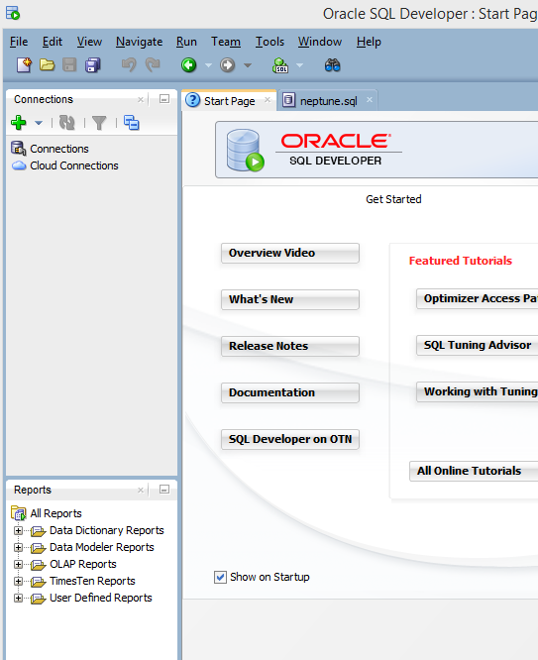
7. If you are for the First Time here, click on the green PLUS to create a **new connection** and fill in the data as shown below. The connection name can be anything you like.
   1. Connection Name: Anything you want to call it: example: MyConnection OR **501_Summer**
   2. UserName and Password: have been assigned to you in BB with Grades link. Be careful and open that field completely. **Password has 8 digits.**
   3. Save Password: is optional, I would save it for class purposes, but in the real world, we would not save that information
   4. Hostname:  **myoracle12c.senecacollege.ca**
   5. Port: **1521**
   6. Click the Service Name radio button and enter: **oracle12c**
   7. Test the connect, if successful, click Save and then Connect

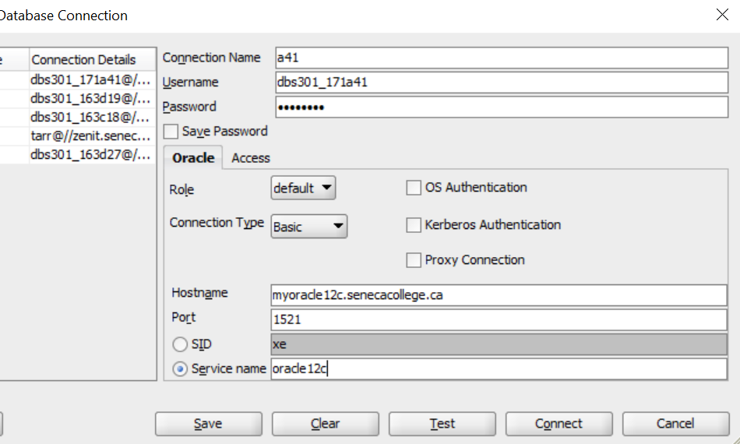

1. Once you successfully connect, the following screen appears:  
   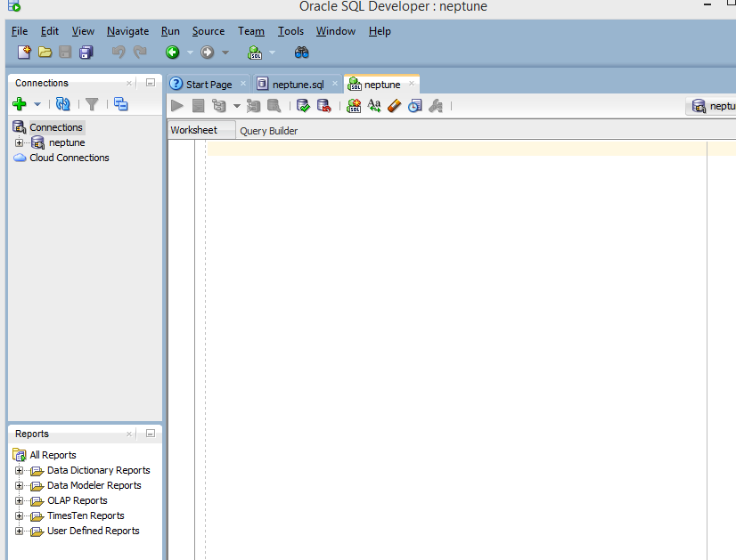
2. The first time you connect to the Oracle server through SQL Developer, you will need to run **hrbld** script to create the tables, data, constraints, etc. for the course sample database. The creation script file should be provided by your professor in BB.
   1. Open the provided file in your favourite text editor (example: Notepad++)
   2. copy all of the content ctrl-A, and paste it ctrl-V into the large editor window shown above.
   3. Select all the content ctrl-A and run the script using the Run Statement button Or ctrl-enter: It looks like a green arrow near the top left corner (PLAY icon)
3. Expand the connection and then the “Tables” section from the left menu. If the tables do not appear, try clicking the refresh button and the expanding tables again.
4. Erase the creation script from the SQL Worksheet window (ctrl-A and delete key).
5. Enter a simple SQL Select statement to test the data is present:

EXAMPLE:

SELECT * FROM departments; 🡪 you will get 27 entries

Highlight the code and click the run button or just press PLAY icon

1. If the data appears in the Query Results window at the bottom, you have successfully connected.