Modules
Program Memory. Instructions are stored in program memory. The memory module defines the source of the program to be run, and loads it at synthesis or simulation time.
Stack: A stack is required for subroutines calls. On CALL, the next program memory address is pushed onto the stack. On return, the previous address is popped from the stack.
Parameters.h There is a principle in software development DRY: Do Not Repeat Yourself. That way all of the different modules can use the same parameters. When the design is changed they only need to be updated in one place. This is particulaly important in team projects, so a parameter file was created.
Decentralized Design.

An alternative decentralized design was also written. All of the opcodes were the same between the two designs. Most of the modules were also the same. In this approach, rather than a centralized controller, logic was devolved to the specific modules. Those modules received copies of the opCode, and were responsible for figuring out how to respond to it. They are described here.

Stack responded to RET, CALL and RST opcodes.

Parser only parses the input instructions and does not operate on the input.

Program Counter responds to RET, CALL, JMP, IF0JUMP, IF1JUMP and RST q

This design also supports iteration by incrementing a register as the memory address. The instruction layout is presented below.

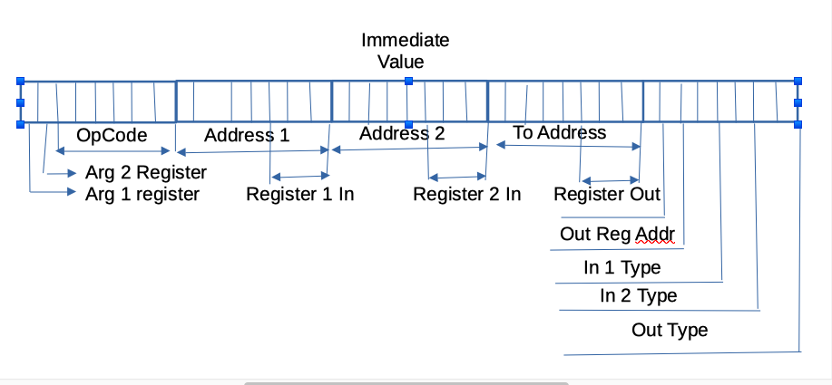

Basically the first two bits on the left, and bit [6] from the right determined if the memory address should be taken from a register. If arg 1 register is TRUE, then the address for argument 1 comes from register [5]. If the arg 2 register is TRUE, then the address for argument 2 comes from register [6]. If the aout register is TRUE, then the result is wrtten to the address given in register [7]. It turns out that the final project did not need this functionality.

Milestones
Mon Jan 1 10:15:21 2024 +0100
Integrated a complete CPU with Orszo’s PBLcpu. He did such a great job. We had a nice demo. It set the bit memories, set the word memories, then iterate through them, the product shows up in the next clock cycle.

INITIALIZING BIT MEMORY
ADDRESS DATA
0 1
1 1
2 0
3 1
4 1
5 0
6 1
7 1
INITIALIZING WORD MEMORY
ADDRESS DATA
0 0
1 1
2 2
3 3
4 4
5 5
6 6
7 7
BitA WordB Product
1 0 x
1 1 0
0 2 1
1 3 0
1 4 3
0 5 4
1 6 0
1 7 6

Mon Jan 22 09:39:01 2024 +0100
Integrated with Lukasz’s work. His assembler is essential for this type of work. Here we have the text file, and the resulting assembler.

LD 1 2 030 //Load a 1 into register 2 the accumulator
LD 1 3 030 //Load a 1 into register 3
LD 1 1 031 //Load a 1 into bitMemory addr 1
LD 1 1 032 //Load a 1 into wordMemory addr 1
MUL 1 1 2 120 //Multiply bit memory 4 by word memory 6 into reg 2 accumulator
LD 2 2 030 //Load a 2 into register 2 the accumulator
LD 2 3 030 //Load a 2 into register 3
LD 1 1 031 //Load a 1 into bitMemory addr 1
LD 2 1 032 //Load a 2 into wordMemory addr 1
MUL 2 2 2 120 //Multiply bit memory 4 by word memory 6 into reg 2 accumulator
LD 3 2 030 //Load a 3 into register 2 the accumulator
LD 3 3 030 //Load a 3 into register 3
LD 0 1 031 //Load a 1 into bitMemory addr 1
LD 3 1 032 //Load a 3 into wordMemory addr 1
MUL 3 3 2 120 //Multiply bit memory 4 by word memory 6 into reg 2 accumulator

1F0001020C
1F0001030C
1F0001010D
1F0001010E
0901010218
1F0002020C
1F0002030C
1F0001010D
1F0002010E
0902020218
1F0003020C
1F0003030C
1F0000010D
1F0003010E
0903030218

The newest version of his assembler is even better. I may use it in the future.

