Walking the Line: Privacy or Protection?

Tyler Gabriel

Binghamton University

**Abstract**

After researching the topic of gait recognition, specifically as it relates to image-based processing and ground-based sensors, I have noticed that they can lend themselves to surveillance and furthermore, counterterrorism efforts. The sources that I gathered have led me to conclude that non-wearable, pedobarography-based gait recognition will surpass markerless gait capture to benefit society by improving security and deterring terrorist threats. I assert that, although image-based processing for gait recognition is an effective method of surveillance, it is inferior to floor-based systems implemented through sensors in the ground. This difference is due to the fact that fact that floor-based systems are non-invasive, and that people generally oppose surveillance, especially when they are aware of it. Because of this, Pedobarography based systems can serve in various applications related to counterterrorism, crime, or security.

**Introduction**

Terrorism plagues modern society. The ability to recognize individuals for security purposes has become a significant concern for many governments and businesses. Because of this, various organizations are developing methods to identify people of interest through different means. The development of technology has led to an increase in surveillance power for such parties. Despite this, concerns about effectiveness and invasiveness remain. Different techniques to improve security are more suitable for different applications, but a primary concern for governments and venue owners is preventing access and entry for certain individuals. An emerging method of doing so is gait recognition, the analysis of unique walking patterns to identify such individuals, either by wearable or non-wearable systems. Non-wearable systems lend themselves to more large-scale applications due to their tendency to be based on image processing or pressure-based sensors. Non-wearable, pedobarography based gait recognition will surpass markerless gait capture to benefit society by improving security and deterring terrorist threats.

These pedobarography based sensors can be developed to identify large groups of people in a non-invasive manner; individuals are often hesitant or resistant to more forceful searches. In fact, some methods that are currently in use are designed to be unobtrusive to the subjects.

**Background**

Today, methods of surveillance are implemented in a vast amount of applications. The general public is often aware of the fact that they are monitored via cameras, microphones, and even the sensors on their phones. However, the potential applications of developing technologies for surveillance purposes may prove to be more invasive than these current methods. Alvaro Muro-de-la-Herran, Begonya Garcia-Zaparain, and Amaia Mendez-Zorilla (2014), researchers from Deusto, Spain, demonstrate in their paper, “Gait Analysis Methods: An Overview of Wearable and Non-Wearable Systems, Highlighting Clinical Applications” that a variety of techniques can be effectively and practically used to identify individuals by how they walk (Muro-de-la-Herran, et al. 2014, p3362).Gait recognition systems can be simply divided into two main categories, wearable and non-wearable systems. For the purposes of terrorism prevention and security, wearable devices may prove ineffective due to the fact that a user can simply not wear the device or object required by a particular system; for this reason, non-wearable systems are more appropriate given the application of security. Among these non-wearable methods, Muro-de-la-Herran, Garcia-Zaparain, and Mendez-Zorilla specify the use of a few gait recognition systems using either “image processing” or “floor sensors” (Muro-de-la-Herran, et al., 2014, pp.3368-3371).While the image processing systems mentioned by the authors face their own set of challenges, floor-based systems may prove to be more effective for 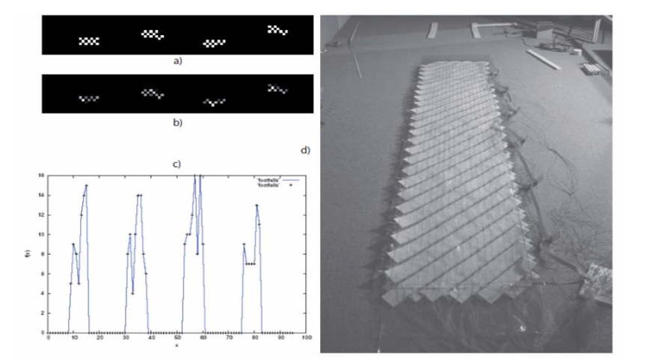security applications.

*Figure 1.* Data representation of interpreted data and hardware of a ground-based floor system

Most floor-based systems measure the pressure and unique planar pattern of the foot in order to identify individuals by calculating parameters such as “velocity, step angle, step width, ground reaction forces, cadence, and stride…” (Muro-de-la-Herran, et al., 2014, p. 3366).These types of systems allow for the accurate measurement of such data in a manner that is unobtrusive to those being surveyed. Floor-based systems may prove to be the more simple, effective, and accurate method of gait recognition compared to image processing systems.

**Precedents and Related Work**

The field of image processing has allowed for gait recognition to be implemented through the use of cameras. The aforementioned Spanish authors provide detail on the functions of these image processing systems by outlining the possible techniques that could be used, including “stereoscopic vision, time-of-flight systems (ToF), structured light, and infrared thermography (IRT)...” (Muro-de-la-Herran, et al., 2014, pp. 3368-3371). These techniques are often combined in one image processing system to identify how a particular individual walks by identifying and calculating a variety of crucial parameters, although a fewer amount than those measured by floor-based sensors. Although these image-based markerless gait capture systems may prove to be an effective method of non-wearable gait recognition, their obtrusiveness and large-scale impracticality deems them inferior compared to possible alternatives, such as floor-based systems.

While both types of non-wearable gait recognition techniques may be convenient, clandestine, and effective, their implementation parallels those of previously seen methods, such as thermal imaging, closed circuit television, and body scanners. The relation between these focuses on the public concern regarding the invasion of privacy. The American public is generally opposed to mass surveillance, with about 54% of citizens believing so (Gao, 2015). Likewise, about 74% of Americans believe that they should not have to “give up privacy and freedom for the sake of safety” (Gao, 2015). These statistics illustrate a general disposition against the idea of mass surveillance, supported by Figure 2.

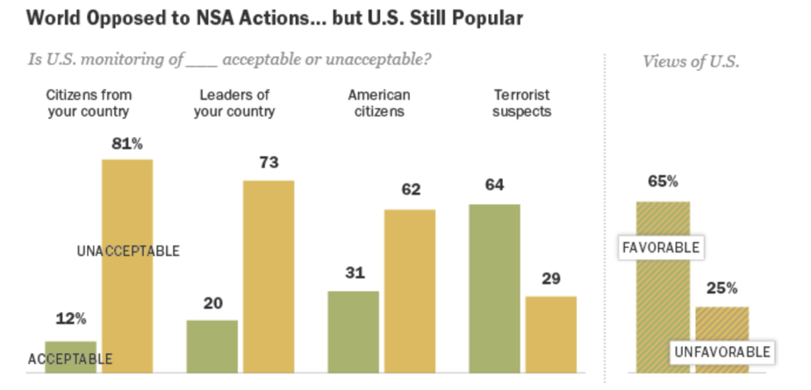

*Figure 2.* American opinion on which parties would be acceptable to monitor.

This sentiment is corroborated by international studies on a similar subject, such as one conducted by Jenela Budak (2013), a Croatian researcher with a doctorate from the University of Osijek. Published in the peer reviewed journal, *Innovation: The European Journal of Social Science and Research,* her paper, “Public attitudes towards privacy and surveillance in Croatia”, she conducted a public survey to obtain the general opinions regarding surveillance (Budak, 2013, p100). Budak finds that “… citizens in Croatia show the highest concern about personal data manipulation, and are more cautious about the effectiveness of surveillance, privacy concern procedures and the need for surveillance enforcement” (Budak, 2013, p112). Although it is not a completely universal indicator, this demonstrates that surveillance is generally regarded in a negative light, regardless of nationality. Related to this are American judicial rulings that have drawn boundaries on the extent of the government’s powers regarding such matters. The 2001 case of Danny Lee Kyllo sets a precedent for searches of a more clandestine nature after the United States ruled the warrantless use of thermal imaging to detect high-power lamps (commonly used to grow marijuana) was unconstitutional (Kyllo v. United States, 2001). This precedent could also apply to pressure-based gait recognition systems as individuals may not be aware of the fact that they are being monitored. Related to this is the idea that the body itself is entitled to privacy. This is outlined in a study done by Charlotte Epstein, a researcher from the University of Sydney (2016). In her study published in *Body and Society*, a peer-reviewed journal, Epstein establishes the right of bodily privacy as it was outlined in a previous version of the English constitution (Epstein, 2016, p51). In addition to this, she claims that people are willing to give up biometrics for convenience even though this idea conflicts with the general public’s concept of the privilege of privacy (Epstein, 2016, p51). This could possibly support the use of ground-based floor systems for gait recognition. The concept of the body having privacy and rulings such as Kyllo v. United States bolster the rights provided by the Fourth Amendment and developers of gait recognition systems may need to consider this fact as the technology progresses.

**Support**

**Viability**

The most imperative aspect of a system for identification consists of its effectiveness for recognizing certain individuals. Gait recognition itself is a rather new field and, thus, a significant amount of research has been conducted in order to determine its effectiveness and possible applications. Sensors based on pedobarography, the field of patterns of the feet, are often implemented into floor sensors that can be used in a concealed manner. In their paper, “Human Recognition Based on Plantar Pressure During Gait,” researchers Yu-Chih Lin and Yu-Tzu Lin (2013), from Yuanpei University and National Taiwan Normal University, respectively, claim that gait recognition is a valid and “non-invasive” form of personal identification, due to the fact that “gait is unique” (Lin & Lin, 2013, p.1350039-2). These researchers conducted a study on twenty individuals and performed an analysis of “plantar pressure patterns” based on data from “heel, midfoot, lateral forefoot, central forefoot, medial forefoot, lesser toes, and hallux” in order to calculate and evaluate various parameters (1350039-3).

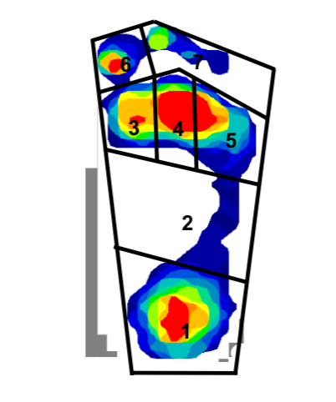

*Figure 3.* A plantar pressure pattern visualization based on various unique parameters.

Using the SOM neural network algorithm, Lin and Lin then used this information to evaluate the effectiveness of floor-based sensors through the analysis of the data gathered from these parameters (Lin & Lin, 2013, 1350039-4). If the study proved successful, the researchers would have concluded that plantar pattern recognition is a viable method of identification. Following this experiment, the researchers concluded that “insole plantar values are feasible for human recognition” (1350039-10). This fact establishes the existence of floor-based gait recognition systems that often implement sensors in order to measure pressure and other variables. These types of systems also relate to counterterrorism because of their tendency to operate in a clandestine manner.

**Applications**

The aforementioned Taiwanese researchers also noted at the end of their paper that “This study (plantar pressure patterns) should be of particular value because it is easy to monitor foot pressure in a clandestine manner” (Lin & Lin, 2013, 1350039-11). This feature clearly lends itself to counterterrorism due to the covert nature of surveillance required. Joan Condell, Priyanka Chaurasia, James Connelly, Patheepan Yogarajah, Girijesh Prasad, and Rachel Monaghan, computer science researchers primarily from Ulster University, in Ireland, claim that gait recognition technologies can be used in counterterrorism efforts. Their paper, “Automatic Gait Recognition and its Potential Role in Counterterrorism,” outlines a “novel gait biometric methodology that could contribute to counterterrorism effort and the identification of individuals involved in crime” (Condell, et al., 2018, p. 151). The researchers further dive into this methodology by describing the various processes such as “Gait Energy Image, Body-related Covariate Factors, and Dynamic Silhouette Template” that are used to evaluate images from cameras (Condell, et al., 2018, pp.156-159).

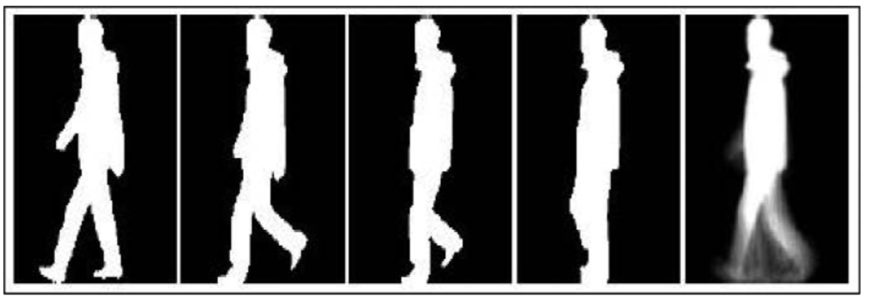

*Figure 4.* Gait Energy Image, as interpreted by image-based processing.

Recent research from the University of Manchester and the Universidad Autonoma de Madrid has also corroborated the fact that gait recognition can be used in practical settings. A recent article published in the Communications of the ACM detailed such research, claiming that the collaborative efforts between the two schools have produced an algorithm with an error rate as small as .7% (AI footstep recognition system could be used in airport security, 2018). The researchers used a database of footsteps and gathered patterns from them to create a system that they believe could be used in settings such as airports or other high security areas. These developments show strong potential for counterterrorism efforts and recent research only bolsters this possibility.

**Issues**

Gait recognition has the potential to forever change the state of surveillance. This ability can be contributed to its clandestine nature that can effectively and accurately identify certain citizens. While image-based processing and ground-based floor sensors can both contribute to counterterrorism and security efforts, there are many factors that prove the latter to be more effective given the proposed nature of the application. Firstly, image-based systems have a greater potential for workarounds and exploitations. This vulnerability is due to many factors that can conflate the results of image-based processing. While Nahid A. Makhdoomi (2013), a researcher from the University of Malaysia, does claim that image-based processing is an effective method of human recognition, he also mentions various instances in which camera-based technologies may be ineffective. These include the use of coats, bags, and other accessories in addition to climate conditions such strong weather, and poor visibility (Makhdoomi, N et al, 2013, pp. 4-5). It is common knowledge that coats and bags are everyday items and thus, many image-based systems could be easily bypassed. Likewise, bad weather and poor visibility are factors that are simply independent from the system operator and could allow for compromises in the system’s integrity. Conversely, ground-based systems are not significantly affected by apparel or the weather. Another aspect of these ground-based systems is that they are less obtrusive to the user and equally or more effective than image-based systems.

**Impact and Changes**

The nature of ground-based systems allows them to be implemented under walking surfaces. This means that they are often invisible to individuals who may not even realize that they are being monitored. As mentioned before, the aforementioned Taiwanese researchers mention that ground-based floor systems based on plantar pressure patterns make it “easy to monitor foot pressure in a clandestine manner.” (Lin & Lin, 2013, 1350039-11). Not only does this fact “smooth out” the process of surveillance, but it can even appease those being monitored. As mentioned above, the Pew Research Center has found that many Americans are not willing to sacrifice their civil liberties in order to ensure their safety (Gao, 2015). However, this same study also claims that about half of Americans believe that the government has not done a sufficient job in their measures to ensure their safety (Gao, 2015). The fact that ground-based floor systems are not apparent to the individuals being monitored makes it less of a constant reminder that they are under surveillance. This discrete placement is in stark contrast to cameras, which are often installed above the ground in areas that many individuals can see, surely instilling discontent in the public. This concept of mass surveillance is not unprecedented; our cell phones and other devices currently serve a similar purpose. What is truly striking about this form of monitoring is that there are very few ways to bypass walking if certain points of entry are designed correctly. The amount of information that can be gathered by this method is also different because it is convenient to both those being monitored. This convenience is due to the fact that the subjects are often unware and it does no impose any burden of knowledge upon them. According to the theory of John Locke, one could argue that this surveillance is an infringement upon the rights of ordinary citizens. Some may even argue that it is an unlawful search. In such cases, a government may need to issue a warrant given the complexity and purpose of the situation. That being said, gait recognition systems truly have the potential to change how citizens behave and also how they are monitored. Because of the effectiveness and viability of pedobarography based gait recognition systems, their implementation could have a significant contribution to counterterrorism efforts.

**Ethical Analysis**

Although floor-based gait recognition systems have the potential to be extremely effective, they do pose some ethical concerns that may deem it unusable to some people. From a utilitarian standpoint, in accordance with the ideas of John Stuart Mill, the idea of such surveillance is justified, as mentioned before. Although some may argue that these types of systems may violate the privacy of the public, ultimately, surveillance provides security and contributes to the supposed “greater good”. This ideology is typically used to justify surveillance by states in modern society. Contrary to this is the ideology of Immanuel Kant, who would likely argue that an objective standard of “goodness” would be violated by surveillance such as this. Any violation in itself would be wrong, regardless of the ends of such action. Juxtaposed with these two concepts is the ideology of John Rawls, who argued for the “veil of ignorance”. A ground-based floor sensor does not necessarily discriminate towards the less fortunate or any particular group. However, the potential for the operators of the system to isolate and view certain data based on the race or ethnicity of the individual still remains. However, this negative bias is associated with the people involved in operating the system and not the system itself. Despite the differences in viewpoints, the ground-based system itself is viable but its implementation should be carried out in an ethical manner, if at all.

**Conclusion**

The power of pedobarography-based gait recognition systems may prove a useful tool for law enforcement and other government organizations. Various research has been conducted in order to verify plantar pressure patterns as a valid method of identification, and this knowledge has been applied to the development of assorted technologies. Some of these methods include the image-based systems and the floor-based sensors, both covered earlier in great detail. While the image-based systems are effective, their flaws and downsides are obstacles to its implementation that prove it to be less effective. One of the more practical methods is the ground sensor system. This system’s ability to monitor individuals in a non-invasive manner, and the fact that it has relatively fewer shortcomings, proves that it is the most promising type of system in the field of gait recognition. Non-wearable, pedobarography-based floor sensor gait recognition systems, are far superior to markerless, image-based gait capture systems, as they will more effectively benefit society by improving security and deterring terrorist threats. Surveillance remains as a necessary evil in society; the opinions of the public even reflect the people’s acceptance of this fact. However, moving forward, it is necessary for those in related fields to proceed with caution. Gait recognition and related technologies have the potential for abuse if their scope and power are not kept in check. Ultimately, methods such as these have the potential to limit crime and terrorism. Computing professional in various niches of the field must consider the implication of surveillance methods such as this when integrating systems into society. Looking to the future, it is with optimism that these technologies can be implemented to better the world we live in.

References

AI footstep recognition system could be used in airport security (2018) *Communications of the ACM*. Retrieved from https://cacm.acm.org/news/228269-ai-footstep-recognition-system-could-be-used-for-airport-security/fulltext

Budak, J., Anić, I.-D., & Rajh, E. (2013). Public attitudes towards privacy and surveillance in Croatia. *Innovation: The European Journal of Social Science Research*, *26*(1–2), 100–118. https://doi.org/10.1080/13511610.2013.723404

Condell, J., Chaurasia, P., Connolly, J, et. al. (2018) Automatic gait recognition and its potential role in counterterrorism. *Studies in Conflict and Terrorism*. *41(2)*, 151-168. doi:10.1080/1057610X.2016.1249777

Epstein, C. (2016). Surveillance, Privacy and the Making of the Modern Subject: *Habeas* what kind of *Corpus*? *Body & Society*, *22*(2), 28–57. https://doi.org/10.1177/1357034X15625339

Gao, G. (2015). *What Americans think about NSA surveillance, national security and privacy*. Pew Research Center*.* Retrieved from<http://www.pewresearch.org/fact-tank/2015/05/29/what-americans-think-about-nsa-surveillance-national-security-and-privacy/>

Kyllo v. United States. 533 U.S. 27. Supreme Court of the United States. (2001).

Lin, Y. & Lin, Y. (2013). Human recognition based on plantar pressure patterns during gait. *Journal of Mechanics in Medicine and Biology*. 13(2), 135009-1 - 135009-12. doi.org/10.1142/S0219519413500395

Makhdoomi, N et al (2013) *IOP conference series: materials science and engineering: human gait recognition and classification using similarity index for various conditions*. http://iopscience.iop.org/article/10.1088/1757-899X/53/1/012069/pdf

Muro-de-la-Herran, A., Garcia-Zapirain, B., & Mendez-Zorrilla, A. (2014). Gait analysis methods: an overview of wearable and non-wearable systems, highlighting clinical applications. *Sensors*.14. 3362-3394. doi: 10.3390/s140203362