**Client- Server Chatting.**

This project will help the Client to exchange message with a server on a specific port(8081).

I have only sent messages from client to server however we can make it more chatty by allowing the server to send messages during runtime just like client.

Using TCP(Transmission Control Protocol).

Two main methods are there each for Server and Client.

1. Server
2. **Listen ()** – Creates a server by taking two arguments (network protocol, port number) and returns Listener object and error if any.
3. **Accept ()** – With the help of Listener object which **Listen()** returns.

We simple called the **Accept()** method. Which accepts the connection request on the port and returns connection object (which is type of read and write) and error if any.

1. In server we are waiting for the message from client.

With the help of Connection object we called the **Read()** method, which gives us the byte array, after converting it to string we simply print the value.

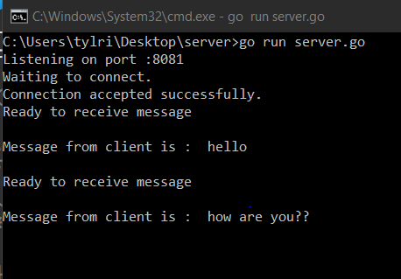

1. Client
2. **Dial ()** – Connects to the server by taking two arguments (network protocol, port number) and returns Connection object and error if any.
3. With the help of Connection object we call the **Write()** methodin which we send our message by converting it into byte array.

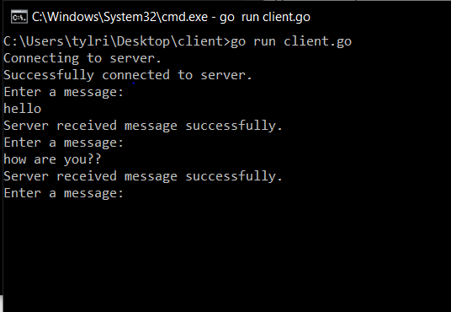

In case any error is encountered, the connection is disconnected from both side(using **defer <connection_object>.close()**) .

**Failure cases –**

1. Error encountered while making connection.
2. Error encountered while accepting a port.
3. Error encountered while sending a message.
4. Error encountered while receiving a message.
5. Error encountered while reading a message.
6. Error encountered while sending acknowledgement from server.
7. Error encountered if client or server is disconnected.
8. Error encountered if one of the client or server is not getting up.

Other errors will be added too if encountered.