**Capstone Final Presentation Plan**

Date: Sunday, April 5, 2020 Prepared by: Thong Ba Nguyen

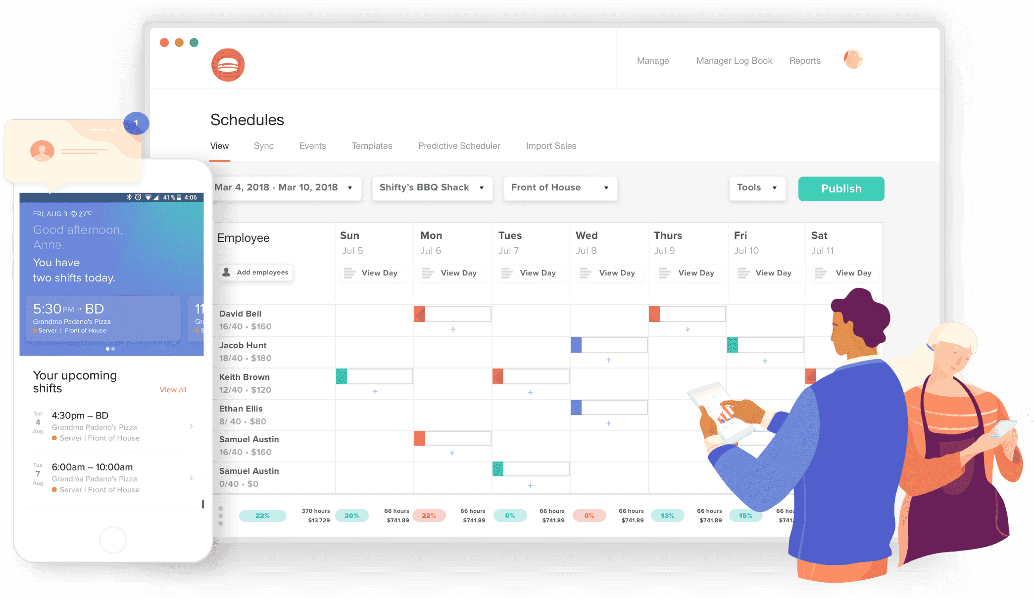

**Part 1:** Overall Report

**Responsibility:** Thong Nguyen

**Content:** Reporting the overall health of the project

**Questions to answer when reporting:**

1. Is the project considered a successful project?
2. What are the missing parts or parts that can be improved based on the System Requirements implemented in sprint 3?
3. What is successfully done in both version web and mobile?

**Part 2:** Business Website

**Responsibility:** Quang Pham

**Content:** Reporting the specific tasks given to business website team

**Questions to answer when reporting:**

1. How did you get the most important part of the application (Stripe) done?
2. How well do you believe that your API can handle payment?
3. How trustworthy is your payment feature of your application?
4. Tell the teacher about how you get the UI done, external libraries for your UI implementation.

**Part 3:** Mobile Version Report

**Responsibility:** Thanh Quan, Tu Nguyen

**Content:** Reporting specific tasks given for mobile version of the application

1. What are the difficulties in designing the UI/UX of the mobile app?
2. Did all of the previous system report failure or mistake fix?
3. What are the problems with deployment for both IOS and Android?
4. What is the current situation and problem of the application right now?
5. What is the next step for the application ?

**Part 4:** Web Version Report

**Responsibility:** Thong Nguyen

**Content:** Reporting specific tasks given for web version of the application

**Questions to answer when reporting:**

1. Were things missing from the previous system report done in this time?
2. How did you get it done, what are the challenges and solutions?
3. The future of this application