**Project Plan, Team Charter**

**Restaurant Management Application**

|  |  |
| --- | --- |
| Primary Instructor | Anjana Shah |
| Team Member | Thong Nguyen |
| Team Member | Thanh Quan |
| Team Member | Tu Nguyen |
| Team Member | Quang Pham |

Document Revision History

|  |  |
| --- | --- |
| Revision # | Date |
| 2.0 | October 14th, 2019 |

**Table of Contents**

*1. Executive Summary*

*2. Project Approvals, Reviews, and Distribution List*

*3. Scope*

*4. Deliverables*

*5. Assumptions*

*6. Dependencies*

*7. Risk management*

*8. Communication*

*9. Task Listing*

*10. Gantt Chart*

*11. Milestones*

*12. RAM*

*13. Approval*

**1. Executive Summary**

The following describes the project to be executed.

|  |  |
| --- | --- |
| Objective | The restaurant management system project is for the creation of a contemporary restaurant management web application. Our target is all of medium-sized or large-sized restaurant in Ontario, whic­h need a complicated system to simply the processes of managing and communicating in their business |
| Corporate Goals Addressed | Our team is willing to provide a project which contains:   * An up-to-date user interface, which is user-friendly an easy-to-use dashboard that visualizing profits, human and other resources * A comprehensive management system, which is functional and easy-to-use to help simplify managing restaurant resources (such as scheduling, view schedule) and checking inventory * A functional operation which can assist the FOH and BOH team in tracking and handling order more efficiently and effectively |
| Planned Start Date | September 23th, 2019 |
| Planned End Date | March 27th , 2020 |

**2. Project Approvers, Reviews and Distribution List**

Approvers, reviewers and distribution list

|  |  |  |  |
| --- | --- | --- | --- |
| Project Role | Name | E-mail | Date |
| Project Manager | Thong Nguyen | Thong.Nguyen@georgebrown.ca | October 14th, 2019 |
| Developer | Thanh Quan | quantrithanh1999@gmail.com | October 14th, 2019 |
| Developer | Quang Pham | quangpham9199@gmail.com | October 14th, 2019 |
| Developer | Tu Nguyen | nguyenvoanhtu129@gmail.com | October 14th, 2019 |

**3. Scope**

Define the sum total of all of its products and their requirements or features.

|  |  |
| --- | --- |
| In Scope | Out of Scope |
| Restaurant Management Tasks | Online Payment Handling (must be purchased separately due to licensing) |
| Inventory Management | Collaborating with third-party shipping services (UberEats, DoorDash) |
| Staff Scheduling | Social Media Integration |
| System security monitoring & protection | Staffs or manager’s mistakes |
| Order Handling | Business Marketing |
| Daily Report | Chat box for restaurant staffs |
| Staff Schedule Visualization | N/A |

**4. Deliverables**

This project will deliver the following.

|  |  |
| --- | --- |
| Deliverable | Description |
| Restaurant Dashboard | A dashboard that helps managers visualize profits, both human and physical resources. |
| Staff scheduling | A feature that assists manager in scheduling their staffs’ shift, and also in tracking of staff’s working hours |
| Inventory Management | An operation which will help the manager and kitchen staffs to simplify their process of checking and managing their resources in an efficient and effective way. |
| View Schedule | A function that allows staff to view their schedule, which is sent by the manager, directly from the app |
| Order Handling | An operation that helps FOH and BOH staffs communicate accurately and quickly with each other |
| Availability Report | A functions that helps staffs send their following week’s availability to the manager, so that the manager can be more accurate when scheduling staff’s schedule |

**5. Assumptions**

The following assumptions were made in preparing Project Vision Document:

- Our team members are willing to learn new technology which is NativeScript, Docker, and Kubernetes

- Those mentioned industrial specialists are ready to help wherever they can

- The developing process cost will not go over the planned budget so that we can keep our product price reasonable

- Project team members can collect a comprehensive data set to train a model and include in the application

- Number of project stakeholders will change since we are still approaching to more industrial experts

**6. Dependencies**

The following are the internal and external dependencies that will have to be acknowledged and addressed;

|  |  |
| --- | --- |
| **PROJECT DEPENDENCIES** | |
| **Internal** | **External** |
| - The application wireframe of the project must be done by the Front-End team be fore the entire team can start the project | The practicality of our app will increase if we can receive the supports from stakeholders and industrial experts (Eg: By now, we are still looking for a stakeholder) |
| - Every small functions have to be done be fore our team can design the dashboard for manager | - Other courses’ project are taking place simultaneously with this project |
| - Technology selection have to be done before our team starts the project (EG: technology expenses are the headache for our team since our budget is limited) |

**7. Risk Management**

|  |  |  |  |
| --- | --- | --- | --- |
| **Potential Risk** | **Severity (H/M/L)** | **Likelihood (H/M/L)** | **Management Strategy** |
| Estimated Project Schedule | H | H | Created comprehensive project time line with frequent baseline reviews |
| Project budget went over the calculated number | H | H | Listed all paid tools and resources and calculated the total costs of them |
| Project Scope Creep | M | M | Project Scopes are provided in Project Vision , and Project Plan, reviewed bi-weekly by team members |
| Poor -quality Project Documentation | M | M | Provided a well-prepared and understandable project documentation for everybody |
| Team Estimates Unrealistic | M | M | Timeline reviewed bi-weekly by team members |
| Team members are not working fairly | H | H | Using a tool named Trello to assign specific tasks for team members and track team members’ process |
| Team members are not knowledgeable of business | L | L | Project managers will test and provide training if needed |
| Team Members Availability  Are Different | H | H | Organizes online meeting on Google Hangouts and Slack |

**8. Communication**

**Reporting**

The following reports will be produced;

|  |  |  |
| --- | --- | --- |
| Report | Audience | Frequency |
| - Technology Research Report | - Thong Nguyen (Project Manager)  - Thanh Quan (Developer)  - Quang Pham (Developer)  - Tu Nguyen (Developer) | - Once a week |
| - Project Documentation Development Report | - Thong Nguyen (Project Manager)  - Thanh Quan (Developer)  - Quang Pham (Developer)  - Tu Nguyen (Developer) | - Twice a week |
| - Stakeholder Searching Report | - Thong Nguyen (Project Manager)  - Thanh Quan (Developer)  - Quang Pham (Developer)  - Tu Nguyen (Developer) | - Once a week |

**Meetings**

The following meetings/communication will be established;

|  |  |  |  |
| --- | --- | --- | --- |
| Meeting | Purpose | Attendees | Frequency |
| Weekly meeting | This weekly meeting is for every team member report their progress on tasks that they are assigned. Also, this meeting helps our team to discuss and develop more on our application | - Thong Nguyen (Project Manager)  - Thanh Quan (Developer)  - Quang Pham (Developer)  - Tu Nguyen (Developer) | Once a week |

**9. Task Listing (WBS- Work Breakdown Structure)**

The following resource proposal template summarizes the resource hours committed to this project, upon final approval of this document.

|  |  |  |  |
| --- | --- | --- | --- |
| Reference | Tasks | Duration | Dependency |
| A | Sprint I (Project Vision, Business Requirements, Project Summary, High-Level Requirements) | 1 week | Team members  working attitude, The ability to to recall knowledge from last semesters (Agile Methodology) |
| B | Sprint II (Project Plan, Team Charter, Product Backlog, Sprint Backlog) | 1 week | A |
| C | Documentation Finalized | 0.5 week | B |
| D | Analyze System Requirements | 1.5 week | C |
| E | Design the system | 1 week | D |
| F | Wireframe and prototype | 2 weeks | E |
| G | Design System Database | 1 week | F |
| H | Environment Set Up | 1 week | G |
| I | User Authentication | 1 week | H |
| J | **Dashboard components**: Profits Calculation, and Data Visualization for Profits | 2 weeks | H |
| K | **Dashboard components**: Staffs availability presentation, Schedule sheet of each week | 2 weeks | H |
| L | **Dashboard components**: Inventory management , Staff work hours summary and auto-generate wages | 2.5 weeks | H |
| M | **Dashboard components**: Auto-generate employees’ paystub, Reports viewer | 1 week | H |
| N | **BOH features:**  Inventory compilation and supplement sending features | 1 week | L |
| O | **BOH Features:** To-do list, Staff viewers for paystub and schedule | 1.5 week | K, L |
| P | **FOH Features:** Daily sell calculation, Daily report sending function, Reservation Viewers | 2 weeks | M |
| Q | Development Phase Review | 0.5 week | J, K , L ,M, N , O, P |
| R | **Testing:** Unit Test | 1.5 week | Q |
| S | **Testing:** Integration Test | 1 week | Q |
| T | Review and Improve | 0.5 week | R, S |
| U | Deploy Application | 0.5 week | T |
| **Tasks Total: 21**  **Week Total: 23** | | | |

**10. Gantt Chart**

Create a detailed Gantt Chart from your Task Listing(Use any software tool and paste the image or upload as a separate file that can be opened as pdf/doc/xls) – Below is an example:

Uploaded in a separate file

**11. Milestones**

|  |  |  |
| --- | --- | --- |
| Major Activity or Milestone | Estimated Milestone Target date | Owner/Reviewer Team Members |
| Complete the design of the system | 15/10/2019 | Quang Pham  Tu Nguyen |
| Deliver final design (wireframe) | 31/10/2019 | Thong Nguyen Thanh Quan |
| Complete restaurant manager’s features | 22/01/2020 | All team members |
| Complete kitchen staff features | 12/02/2020 | All team members |
| Complete general features (search function, develop views for staffs) | 25/02/2020 | All team members |
| Complete FOH staffs features | 06/03/2020 | All team members |
| Project implementation complete | 09/03/2020 | All team members |
| Application accomplished | 27/03/2020 | All team members |

**12. RAM – Responsibility Assignment Matrix**

Create a RAM from your Task Listing. A sample is shown below:

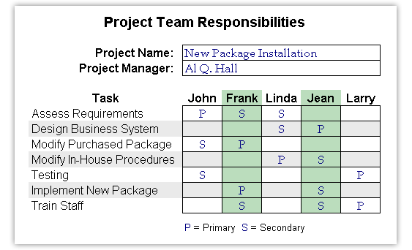

RAM is shown below:

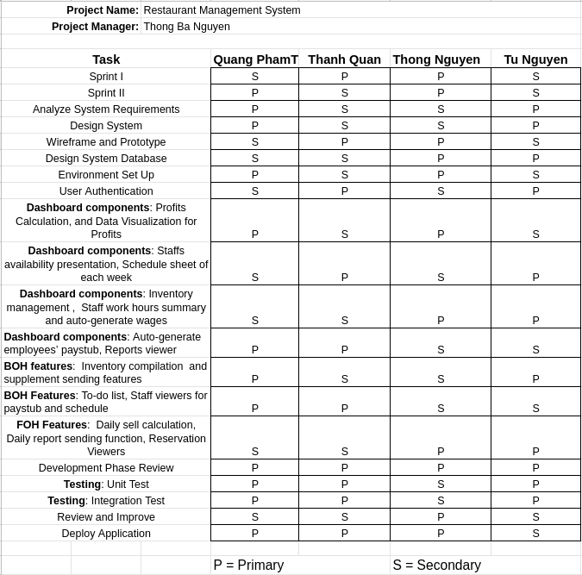

**13. Approval**

The signatures below indicate their approval of the contents of this document.

|  |  |  |  |
| --- | --- | --- | --- |
| Project Role | Name | Signature | Date |
| Project Manager | Thong Nguyen | Thong Nguyen | 14/10/2019 |
| Developer | Thanh Quan | Thanh Quan | 14/10/2019 |
| Developer | Quang Pham | Quang Pham | 14/10/2019 |
| Developer | Tu Nguyen | Tu Nguyen | 14/10/2019 |

**TEAM CHARTER**

Multiple reasons exist for preparing a team charter. One is to document the team's purpose and clearly define individual roles, responsibilities, and operating rules. Next, it establishes procedures for both the team and management/industry partner on communicating, reporting, and decision-making procedures. It lays out a blueprint for conducting business for the acquisition and defines how the team works in an empowered manner, including setting out responsibility and authority. Finally it facilitates stakeholder buy in by including key members in the decision making process and obtaining their concurrence along the way.

The charter includes the following sections:

1. **Purpose**

* This team is formed to simplify the management of restaurant managers. Ideally, managers will focus more on their business development process, and put less effort to manage restaurant resources.

2. **Background**

* The project that this team is supporting is Restaurant Management Application. This project will focus on medium-sized and large-sized restaurants in Ontario to help them simplify their complicated management systems. With regard to the stakeholders, we are completely aware of the benefits of having a stakeholder who we can consult about the industry needs. However, we are still struggling with finding a reliable stakeholder for ourselves

3**. Scope**

* As far as the scope is concerned, all management tasks such as staff scheduling, inventory managing, profits visualizing include in the scope. Other aspects like online payment handling, and customer service enhancing are out of our scope.

4. **Team composition**

* Our team is divided into 3 small teams:

1. Front-End Team: Thanh Quan, Quang Pham

2. Back-End Team: Tu Nguyen

3. Design Team: Thong Nguyen

* Aside from designing, Thong Nguyen is the team leader who is responsible for managing both Front-End and Back-End teams using his web development experiences and knowledge

5. **Team empowerment**

* Our team’s existing authority:

1. Team Leader (Project Manager): Thong Nguyen

2. Team Member (Project Front-End Developer): Thanh Quan

3. Team Member (Project Front-End Developer: Quang Pham

4. Team Member (Project Back-End Developer): Tu Nguyen

* In our team, everyone is encouraged to present their ideas, and if those ideas are appropriate to our objectives, they will definitely be put into our plan

6. **Team operations**

* Our team has a weekly meeting where we usually share the status of tasks that we are currently working on.
* For the decision making processes, whenever we encounter a problem that needs to be decided, the team leader will provide all team members with choices that are based on careful researches. After considering the pros and cons of those choices, we will perform a vote to figure out which one is the best choice for our team.

**Example:** when we selected the technology to use for this project, we have a variety of different technologies to employ. Therefore, in order to solve this issue, the team leader provided 4 selected technologies that team members all know or are able to learn quickly. Subsequently, we ended up choosing MEAN stack as the package that we will use for this application.

* When a team member is absent from a meeting, he has to submit his required documents for that day, and the reason of his absence. - Regarding the progress updates, we created a repository on GitHub to track of everything that we do from documentation developing to application implementing. Everything is kept and tracked appropriately.

7. **Team Performance Assessment**

* Team member assessment will be performed every week in our team weekly meeting. The criteria used to evaluate members include

1. Punctuality

2. Attitude

3. Contribution

4. Knowledge

* The purpose of this assessment not to let someone down or to punish everyone in our team, but to let them know what they are doing right or wrong so that can continue or stop the good or bad things

8. **Signature Page**

October 14th, 2019

Team Leader: Thong Nguyen

Team Member: Thanh Quan

Team Member: Quang Pham

Team Member: Tu Nguyen