Project Identification

Project: | Restaurant Management System
Prepared By: | Thong Nguyen
Document Version: | 1.0
Published Date: | September 30th, 2019

Contributors
The following individuals contributed to this document.
Name | Title
Thong Nguyen | Project Manager
Quang Pham | Developer
Thanh Quan | Developer
Tu Nguyen | Developer

Distribution
This document is distributed to all the following people.
Name | Title
Anjana Shah | Professor
Thong Nguyen | Project Manager
Thanh Quan | Developer
Quang Pham | Developer
Tu Nguyen | Developer

Referenced Documents
This document refers to the following materials
Version number | Title | Author | Date | Source / Location
1.0 | Defining The Scope of Business Analysis With A Context Diagram | Business Analyst Learnings Team | February 11th, 2017 | Business Analyst Learnings

Revision History

Version Number | Revision Date | Summary of Changes | Modified by
1.0 | Sep 26th ,2019 | Complete the High-Level Requirements | Thong Nguyen
[Note: It is recommended that drafts be numbered 0.1 to 0.9, and that the first approved version be numbered 1.0. Thereafter, new version numbers will depend upon changes: 1.01, 1.1, etc for minor updates, 2.0, 3.0 etc for major changes.]
TABLE OF CONTENTS
1. Business Context Diagram 3
2. REquirements Scope Statements 4
3. High Level Business Requirements (HLR) Traceability 4
4. High Level Business Requirements Sign-Off 5

- Business Context Diagram
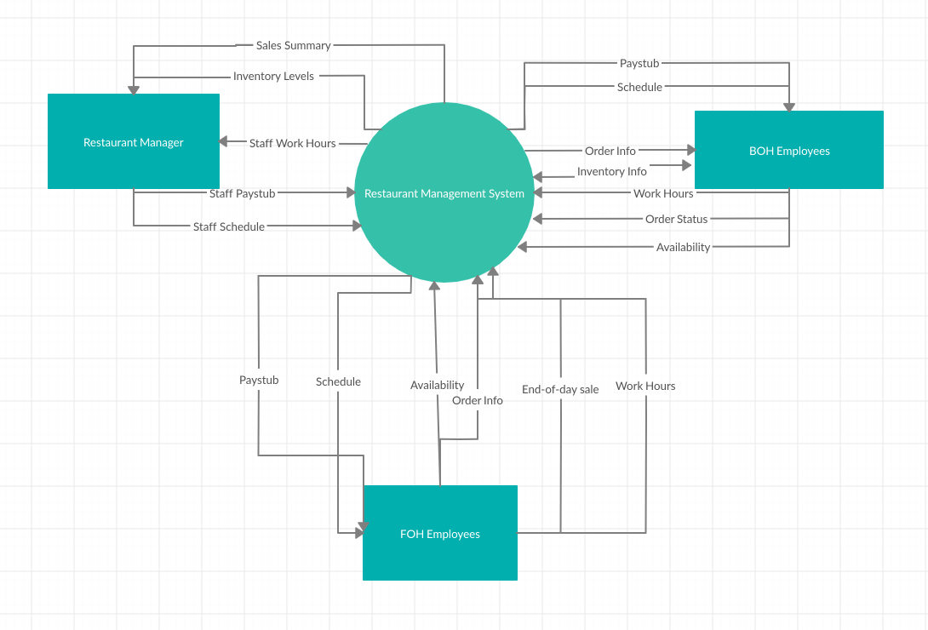

Requirement Scope Area | Description
Restaurant Management System | Area responsible for processing customer orders, providing storage and access to staff and sources information

External Entity | Description
Restaurant Manager | Restaurant manager is the one who generates documents such as staff schedule, staff paystub. In return, everyday, he/she will receive the sales report, inventory levels, and staff work hours
BOH Employees | Back-of-house employees who can interact with system by submitting their daily work hours, order status, availability, and inventory info. In return, they receive their paystubs and schedule which are generated by restaurant manager
FOH Employees | Front-of-house employees who can interact with system by submitting their daily work hours, order status, availability, and end-of-day sale report.

Information Flows | Description
Sales Summary | The end-of-day sales report which is summarized by FOH employees and submitted to restaurant manager
Inventory Levels | Inventory levels are submitted to manager by the BOH Employees at the end of the day or every time that the restaurant is short of resources
Staff Work Hours | The total working hours of staffs automatically calculated by the system based on the in and out time that staffs submit
Staff Paystub | Document includes total work hours and the amount of money that staff will get paid for every pay period. Total work hours are filled in by restaurant manager or owner, but the paystub will be automatically generated by the system using a specific third-party software
Staff Schedule | The weekly schedule that is created by the restaurant manager based on the availability of staffs
Order Info | The detailed information of foods and drinks included in a order which is sent from FOH employees to BOH employees
End-of-day sale report | The total amount of money that the business earn in a business day sent from FOH employees to restaurant manager
Availability | The employees’ available working hours which will be a good source for restaurant manager to plan ahead for the next week
- Requirements Scope Statements
HLR# | Description | Priority  (H, M, L)
 | Restaurant Manager must receive the sales report from FOH Employees at the end of the day | H
 | BOH Employees must be able to see the order info that is sent from FOH Employees | H
 | All employees must be able to see their schedule at least 2 days before their working days | H
 | Restaurant Manager must receive the Inventory Levels at the end of each day | H
 | BOH Employees must be able to modify the order status to notify the FOH Employees | H
 | All employees must receive their paystub for every pay period | H
 | Employees must be able to mark their in and out time for every shift | H
 | Employees must report their availability to the manager at least one day before the day that manager usually work on the new schedule | M

- High Level Business Requirements Sign-Off
The undersigned acknowledge their agreement with the contents of Version <x.x> of the High-Level Requirements document for <Project Name>.

Following approval of this document, requirements changes will be governed by the project’s change management process, including impact analysis and appropriate reviews and approvals, under the general control of the Project Plan and according to company policy. Approved Change Request Documents, if present, will be attached to this Requirements Document as updates.

Name | Project Role and  Functional Area | Date Signed
Thong Nguyen | Project Manager | September 30th ,2019
Quang Pham | Developer | September 30th ,2019
Thanh Quan | Developer | September 30th ,2019
Tu Nguyen | Developer | September 30th ,2019

* Note: physical signatures are not required. Email approvals are acceptable and should be appended to project documents.

