Ty Madsen

ECEN 220

20 November 2013

Lab 10 - LC-3 Functional Units

EAB:

Verilog:

module EAB(

input [10:0] IR,

input [15:0] Ra,

input [15:0] PC,

input selEAB1,

input [1:0] selEAB2,

output [15:0] eabOut

);

wire [15:0] opA, opB;

assign opA = (selEAB2 == 2'b00) ? (16'b0000000000000000) :

(selEAB2 == 2'b01) ? {{10{IR[5]}} , IR[5:0]} :

(selEAB2 == 2'b10) ? {{7{IR[8]}} , IR[8:0]} :

{{6{IR[10]}} , IR[10:0]};

assign opB = selEAB1 == 1'b0 ? PC : Ra;

assign eabOut = (opA + opB);

endmodule

Simulation:

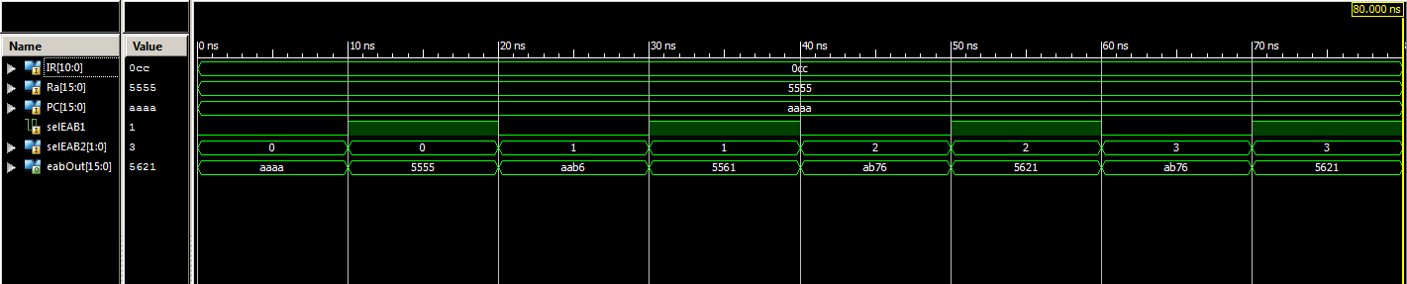

MARMux:

Verilog:

module MARMux(

input [7:0] IR,

input selMAR,

input [15:0] eabOut,

output [15:0] MARMuxOut

);

assign MARMuxOut = selMAR == 1'b0 ? eabOut : {{8{1'b0}}, IR};

endmodule

Simulation:

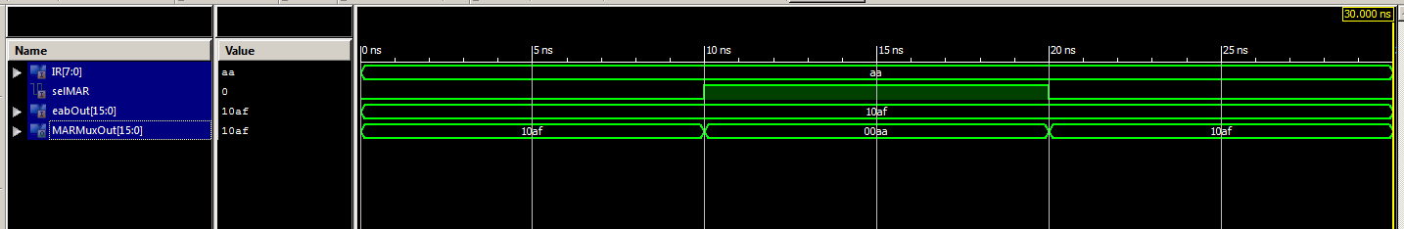

PC:

Verilog:

module PC(

input ldPC,

input clk,

input reset,

input [1:0] selPC,

input [15:0] Buss,

input [15:0] eabOut,

output [15:0] PC

);

wire [15:0] muxOut;

assign muxOut = selPC == 2'b00 ? (PC + {{15{1'b0}}, 1'b1}) :

selPC == 2'b01 ? eabOut :

selPC == 2'b10 ? Buss :

PC;

register PCReg(PC, clk, muxOut, reset, ldPC);

endmodule

Simulation:

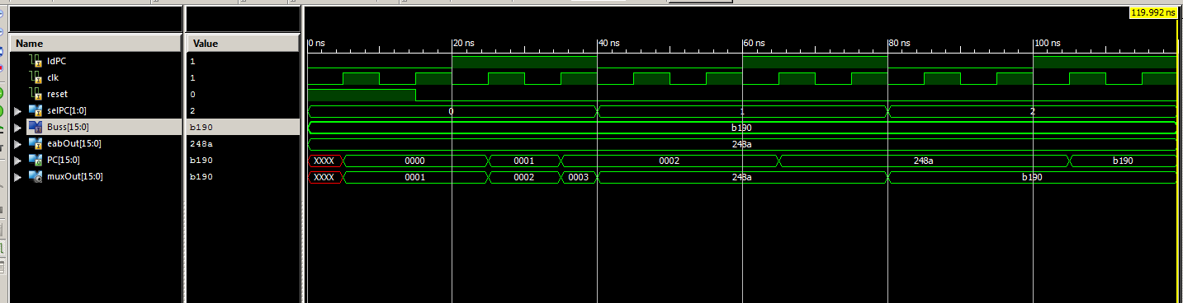

IR:

Verilog:

module IR(

input ldIR,

input clk,

input reset,

input [15:0] Buss,

output [15:0] IR

);

register IRReg(IR, clk, Buss, reset, ldIR);

endmodule

Simulation:

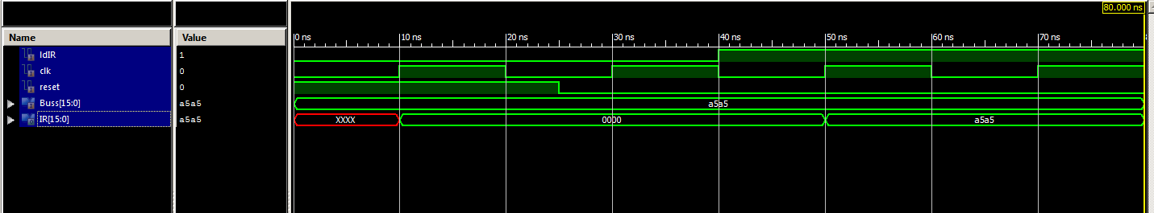

NZP:

Verilog:

module NZP(

input [15:0] Buss,

input reset,

input clk,

input flagWE,

output N,

output Z,

output P

);

wire pos, zero;

assign pos = ~Buss[15];

assign zero = &(~Buss);

ff_dce ff1(N, clk, ~pos, reset, flagWE);

ff_dce ff2(Z, clk, zero, reset, flagWE);

ff_dce ff3(P, clk, pos&~zero, reset, flagWE);

endmodule

Simulation:

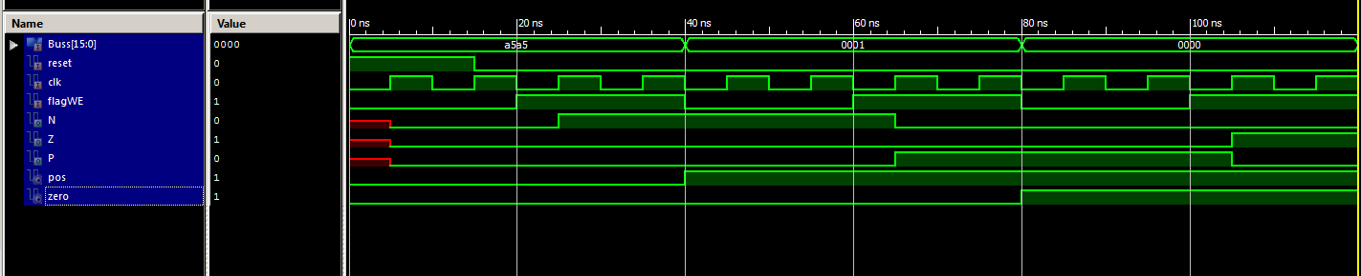

ALU:

Verilog:

module ALU(

input [15:0] Ra,

input [15:0] Rb,

input [5:0] IR,

input [1:0] aluControl,

output [15:0] aluOut

);

wire [15:0] opA;

assign opA = (IR[5] == 1'b0) ? Rb : {{11{IR[4]}}, IR[4:0]};

assign aluOut = aluControl == 2'b00 ? Ra :

aluControl == 2'b01 ? (Ra + opA) :

aluControl == 2'b10 ? (Ra & opA) :

~Ra;

endmodule

Simulation:

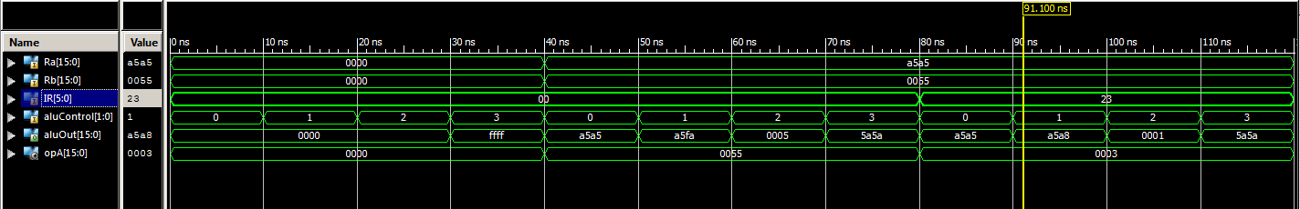

RegFile:

Verilog:

module RegFile(

input [2:0] DR,

input [2:0] SR1,

input [2:0] SR2,

input regWE,

input clk,

input reset,

input [15:0] Buss,

output [15:0] Ra,

output [15:0] Rb

);

wire [15:0] R0, R1, R2, R3, R4, R5, R6, R7;

register reg0(R0, clk, Buss, reset, (regWE & DR == 3'b000));

register reg1(R1, clk, Buss, reset, (regWE & DR == 3'b001));

register reg2(R2, clk, Buss, reset, (regWE & DR == 3'b010));

register reg3(R3, clk, Buss, reset, (regWE & DR == 3'b011));

register reg4(R4, clk, Buss, reset, (regWE & DR == 3'b100));

register reg5(R5, clk, Buss, reset, (regWE & DR == 3'b101));

register reg6(R6, clk, Buss, reset, (regWE & DR == 3'b110));

register reg7(R7, clk, Buss, reset, (regWE & DR == 3'b111));

assign Ra = SR1 == 3'b000 ? R0 :

SR1 == 3'b001 ? R1 :

SR1 == 3'b010 ? R2 :

SR1 == 3'b011 ? R3 :

SR1 == 3'b100 ? R4 :

SR1 == 3'b101 ? R5 :

SR1 == 3'b110 ? R6 :

R7;

assign Rb = SR2 == 3'b000 ? R0 :

SR2 == 3'b001 ? R1 :

SR2 == 3'b010 ? R2 :

SR2 == 3'b011 ? R3 :

SR2 == 3'b100 ? R4 :

SR2 == 3'b101 ? R5 :

SR2 == 3'b110 ? R6 :

R7;

endmodule

Simulation:

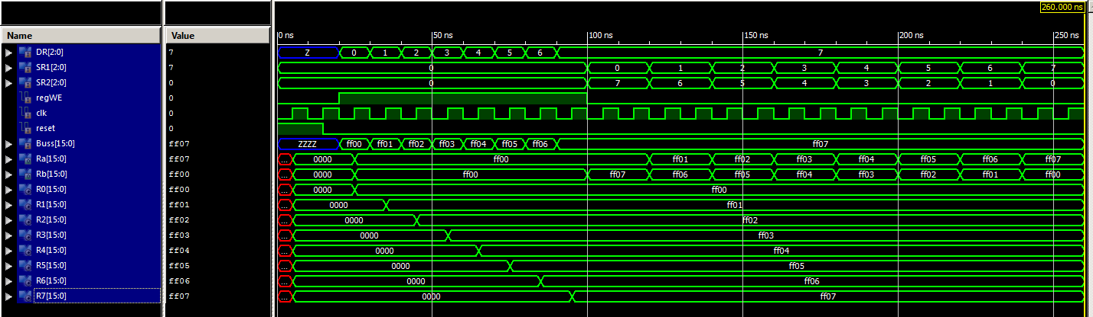

ts_driver:

Verilog:

module ts_driver ( din, dout, ctrl );

input [15:0] din;

input ctrl;

output [15:0] dout;

assign dout = (ctrl)? din:(16'bZZZZZZZZZZZZZZZZ);

endmodule

Simulation:

